**KALEO RETURNS WITH NEW SINGLE “LONELY COWBOY”**

**SHARE PERFORMANCE VIDEO SHOT INSIDE ROME’S HISTORIC COLOSSEUM**

**LISTEN** [**HERE**](https://kaleo.lnk.to/lonelycowboy) **| WATCH** [**HERE**](https://youtu.be/IfzGg4aPiqM)

**ANNOUNCE NORTH AMERICAN TOUR DATES - TICKETS ON SALE TODAY AT 10AM LOCAL TIME**

**MORE NEW MUSIC COMING SOON**

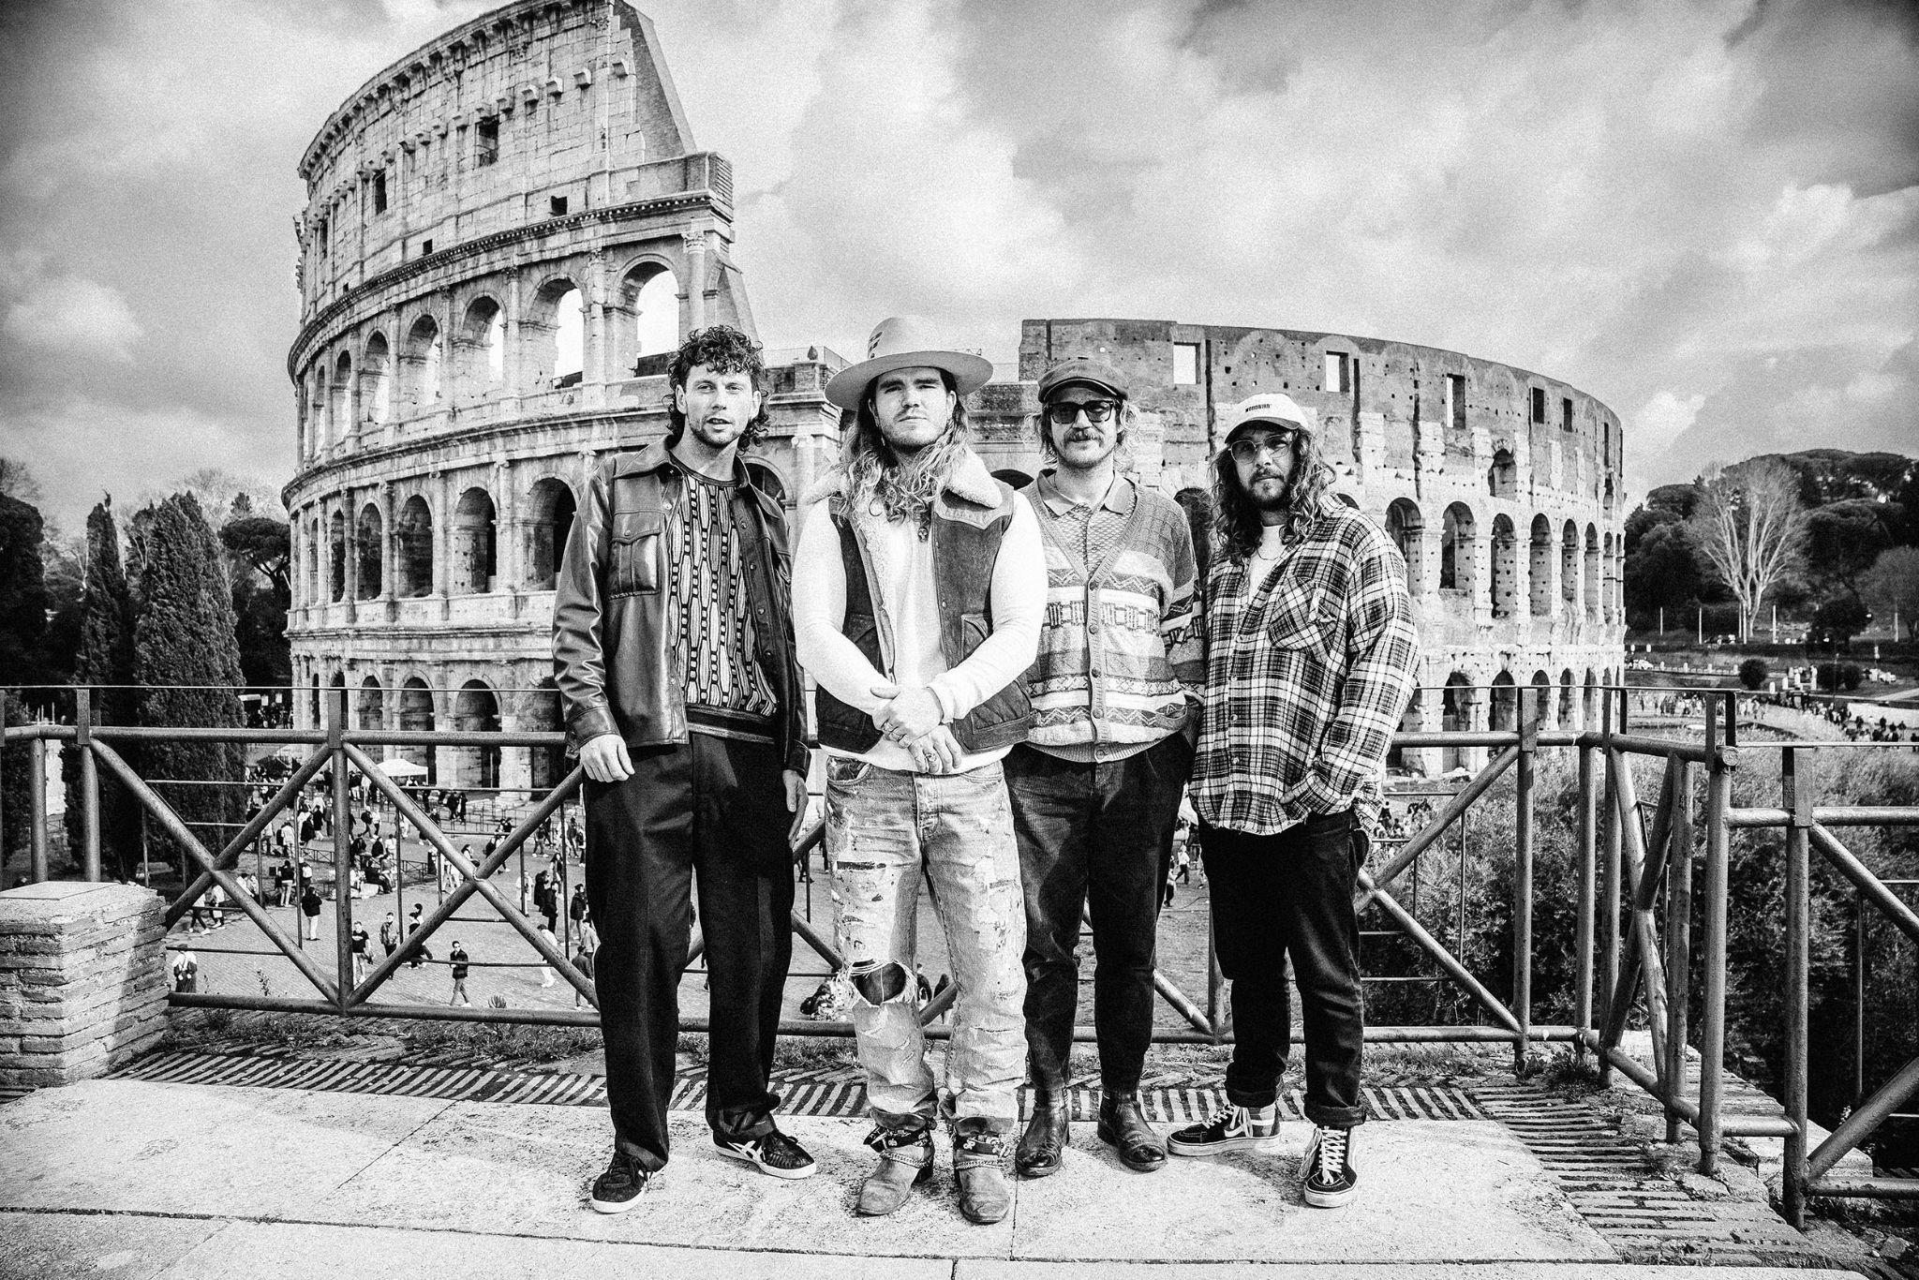

**PHOTO COURTESY OF VERTIGO LIVE**

**DOWNLOAD HI-RES ASSETS** [**HERE**](https://warnermusicgroup.box.com/s/s3nigzht3rd8a9s0rbsh21g113fj8lkj)

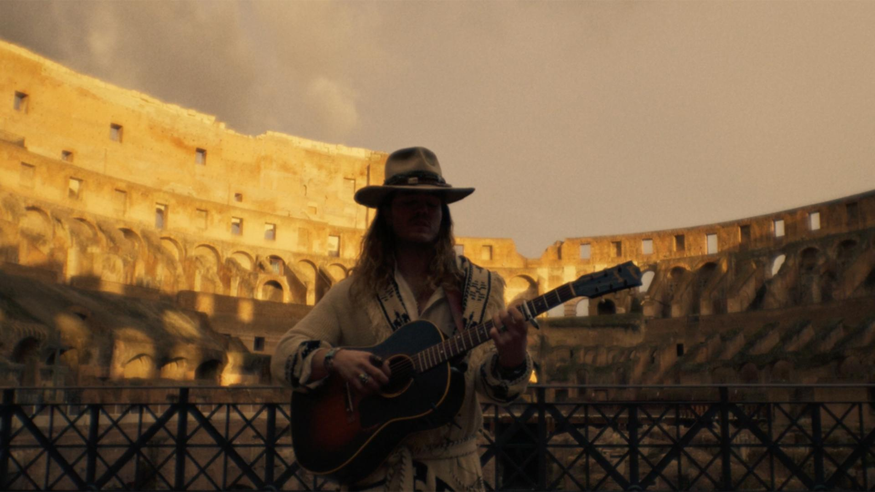

**KALEO - “LONELY COWBOY” LIVE AT THE COLOSSEUM**

**March 29, 2024 *–*** Today,multi-platinum, GRAMMY-nominated Icelandic rockers **KALEO** have returned with their new single **“Lonely Cowboy”** available via **Elektra**. “Lonely Cowboy” is available on [**all streaming platforms**](https://kaleo.lnk.to/lonelycowboy)and isalso joined by a stunning [**performance video**](https://youtu.be/IfzGg4aPiqM) shot inside Rome’s Historic Colosseum – [**watch it HERE**](https://youtu.be/IfzGg4aPiqM). The standalone track notably marks the group’s first new original music in three years.

**“Lonely Cowboy”** hinges on a softly plucked acoustic guitar and sparse orchestration, while gruff, yet warm vocals remain the guiding force. *“Guess it’s time to say goodbye to the rider of the night”* sings vocalist, guitarist, pianist, songwriter, and producer **JJ Julius Son** as he paints a vivid picture underscored by a proud and intentional homage to Ennio Morricone.

**JJ** commented on the song sharing, *“It feels like a Spaghetti Western, and I love those vibes. My friends and family have always encouraged me to put it out, but now was the right time. It’s an important one for me*.*”*

Next up, **KALEO** will return to the road in North America this summer. The band have announced a run of dates kicking off at Dillon Amphitheatre in Dillon, CO on June 14th followed by a sold-out performance at the legendary Red Rocks Amphitheatre in Morrison, CO on June 16th. The trek visits major markets on the West Coast, and concludes in Carnation, WA at Remlinger Farms on June 26th [tour itinerary below]. Tickets for all dates are on sale today at 10am local time. For more information visit [www.officialkaleo.com](http://www.officialkaleo.com).

Earlier this month, KALEO celebrated their 10th anniversary bydelivering a stunning live performance before 250 of their biggest fans at the Archeological Park of the Colosseum, Rome, and in the shadow of the world-famous amphitheater. With the performance, KALEO joined the ranks of Ray Charles, Stevie Wonder, Billy Joel, The Cure, Elton John, and Paul McCartney as the only artists to ever perform an electric concert in front of the iconic monument. Presented by VERTIGO LIVE, a leading producer of cinematic live experiences, the momentous night was captured on film and will be released as *KALEO: Viva Roma in the Shadow of the Colosseum* later this summer - watch an official teaser [HERE](https://www.youtube.com/watch?v=0n-hRRQCYzs).

**KALEO 2024 TOUR DATES**

April 13 - Gonzales, TX - Cattle Country Fest*  
June 14 - Dillon, CO - Dillon Amphitheater  
June 16 - Morrison, CO - Red Rocks Amphitheatre  
June 17 - Salt Lake City, UT - Red Butte  
June 19 - San Diego, CA - Gallagher Square at Petco Park  
June 20 - Los Angeles, CA - The Wiltern  
June 23 - San Francisco, CA - The Masonic  
June 25 - Forest Grove, OR - Grand Lodge  
June 26 - Carnation, WA - Remlinger Farms

September 21 - Louisville, KY - Bourbon & Beyond 2024*

*\*Festival Date*

**About KALEO:**

Akin to steadying a ship on rough seas, KALEO deftly navigates life’s extremes via music. Emerging out of Reykjavík, KALEO—JJ Julius Son [vocals, guitar, piano], Rubin Pollock [lead guitar], Daniel Kristjansson [bass], and David Antonsson [drums] —buzzed to the forefront of the global conversation with the platinum-certified *A/B* in 2016. The album took flight as a phenomenon uplifted by the double-platinum #1 single “Way Down We Go,” gold-certified “All The Pretty Girls,” and “No Good,” which garnered a GRAMMY® Award nod in the category of *“Best Rock Performance*.*”* They maintained this momentum with *Surface Sounds* [2021], cracking the Top 6 on AAA with “I Want More” and “Break My Baby.” Their music surged through popular culture with dozens of film and television syncs, including Marvel flicks like *LOGAN* and hit TV shows such as *Grey’s Anatomy* and *Riverdale*. Additionally, the guys made their mark with performances on *Late Night with Seth Meyers*, *Jimmy Kimmel Live!*, *The Late Show with Stephen Colbert*, *Good Morning America*, and more. Beyond selling out headline tours on multiple continents, they shined as a live force of nature who could hold their own on a bill with The Rolling Stones or ignite festival crowds at *Coachella*, *Lollapalooza*, *Bonnaroo*, and beyond. To date, they have notably tallied north of 4 billion global streams and earned 60 international certifications. As always, the band encompass a vast spectrum of sound and feeling, which manifest on their 2024 single “Lonely Cowboy” where delicate finger-picking underscores cinematic lyricism. KALEO originally debuted the tune in front of a sold-out audience at The Grand Ole Opry in 2022, and more recently delivered a stunning performance of the track inside the world-famous Colosseum in Rome, Italy. Musically, it proudly tips a Stetson hat to Ennio Morricone.

**For more information on KALEO, contact:**

[Glenn.Fukushima@300elektra.com](mailto:Glenn.Fukushima@300elektra.com) | [Ross.Anderson@300elektra.com](mailto:Ross.Anderson@300elektra.com) | [Sydney.Worden@300elektra.com](mailto:Sydney.Worden@300elektra.com)

**CONNECT WITH KALEO:**

[Website](https://www.officialkaleo.com/) | [YouTube](https://www.youtube.com/user/Kaleoofficial) | [Facebook](https://www.facebook.com/officialkaleo) | [Instagram](https://www.instagram.com/officialkaleo/) | [X](https://twitter.com/officialkaleo) | [Apple Music](https://music.apple.com/us/artist/kaleo/960112019) | [Spotify](https://open.spotify.com/artist/7jdFEYD2LTYjfwxOdlVjmc)