**KALEO ANNOUNCE NORTH AMERICAN “PAYBACK TOUR”**

**SUMMER HEADLINE DATES GET UNDERWAY AUGUST 25TH**

**TICKET PRESALES BEGIN TOMORROW AT 10AM LOCAL**

**SUPPORTING THE ROLLING STONES ON JUNE 11TH IN PHILADELPHIA, PA**

**NEW SINGLE “LONELY COWBOY” FEATURES**

**PERFORMANCE VIDEO SHOT INSIDE ROME’S HISTORIC COLOSSEUM**

**LISTEN** [**HERE**](https://kaleo.lnk.to/lonelycowboy) **| WATCH** [**HERE**](https://youtu.be/IfzGg4aPiqM)

**MORE NEW MUSIC COMING SOON**

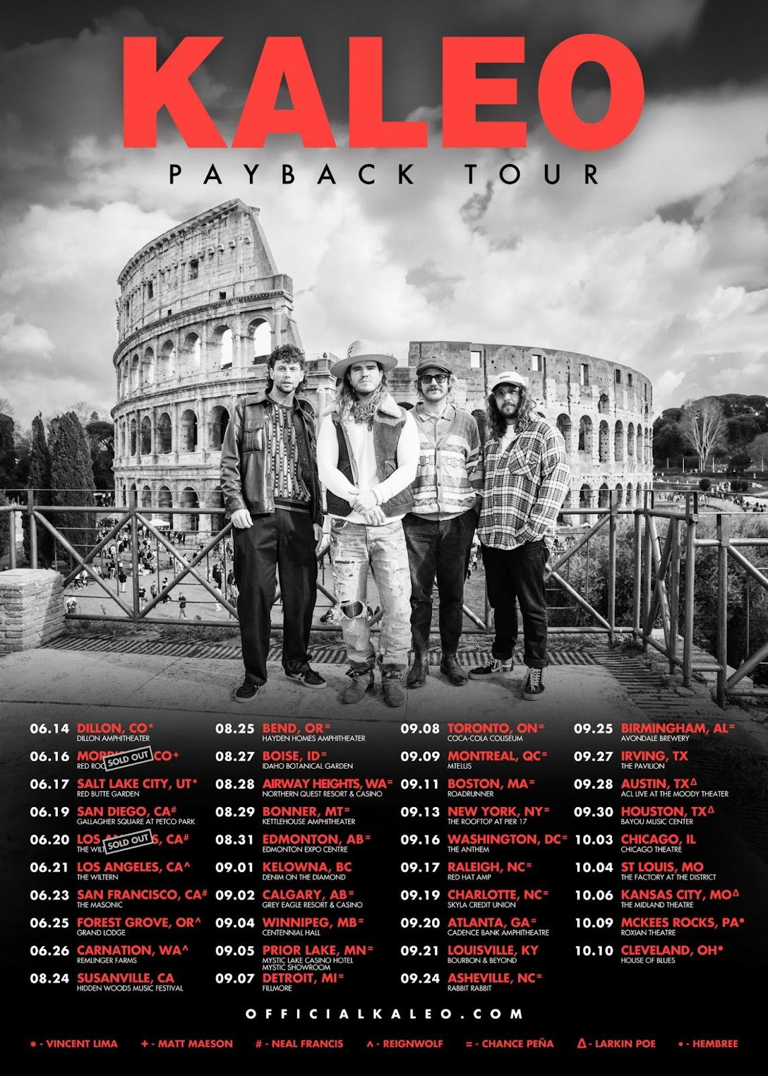

**DOWNLOAD PRESS ASSETS** [**HERE**](https://warnermusicgroup.box.com/s/s3nigzht3rd8a9s0rbsh21g113fj8lkj)

**April 29, 2024 *–*** Today,multi-platinum, GRAMMY-nominated Icelandic rockers **KALEO** have announced their North American “**Payback Tour**,” which will see the group headlining amphitheaters across the continent through the fall. The newly announced dates kick off at Hayden Homes Amphitheatre in Bend, OR on August 25th and run through the middle of October [tour itinerary below]. The upcoming run will feature support from Chance Peña, Hembree and Larkin Poe on select dates with additional support to be announced in the coming weeks. Ticket presales for the newly announced dates begin tomorrow, Tuesday, April 30th at 10am local time, with general on-sale starting this Friday, May 3rd at 10am local. For more information on KALEO’s upcoming “Payback Tour” visit [www.officialkaleo.com](http://www.officialkaleo.com/).

Just last week, KALEO was announced as direct support for **The Rolling Stones** show at Lincoln Financial Field in Philadelphia, PA on June 11th, as part of their **STONES TOUR ‘24 HACKNEY DIAMONDS**. Immediately following KALEO will embark on a run of headline dates starting at Dillon Amphitheatre in Dillon, CO on June 14th, followed by a sold-out performance at the legendary Red Rocks Amphitheatre in Morrison, CO on June 16th. The previously announced summer trek will feature support from Matt Maeson, Vincent Lima, Neal Francis, and Reignwolf on select dates, and is set to visit major markets on the West Coast, wrapping up in Carnation, WA at Remlinger Farms on June 26th.

Last month, KALEO returned with their new single **“Lonely Cowboy”** which is available on [**all streaming platforms**](https://kaleo.lnk.to/lonelycowboy)and joined by a stunning [**performance video**](https://youtu.be/IfzGg4aPiqM) shot inside Rome’s Historic Colosseum – [**watch it HERE**](https://youtu.be/IfzGg4aPiqM). The standalone track notably marks the group’s first new original music in three years.

**“Lonely Cowboy”** hinges on a softly plucked acoustic guitar and sparse orchestration, while gruff, yet warm vocals remain the guiding force. *“Guess it’s time to say goodbye to the rider of the night”* sings vocalist, guitarist, pianist, songwriter, and producer **JJ Julius Son** as he paints a vivid picture underscored by a proud and intentional homage to Ennio Morricone.

**JJ** commented on the song sharing, *“It feels like a Spaghetti Western, and I love those vibes. My friends and family have always encouraged me to put it out, but now was the right time. It’s an important one for me*.*”*

KALEO recently celebrated their 10th anniversary bydelivering a stunning live performance before 250 of their biggest fans at the Archeological Park of the Colosseum, Rome, and in the shadow of the world-famous amphitheater. With the performance, KALEO joined the ranks of Ray Charles, Stevie Wonder, Billy Joel, The Cure, Elton John, and Paul McCartney as the only artists to ever perform an electric concert in front of the iconic monument. Presented by VERTIGO LIVE, a leading producer of cinematic live experiences, the momentous night was captured on film and will be released as *KALEO: Viva Roma in the Shadow of the Colosseum* later this summer - watch an official teaser [HERE](https://www.youtube.com/watch?v=0n-hRRQCYzs).

**KALEO 2024 TOUR DATES**

“PAYBACK TOUR” - 8/25 - 10/10

*Newly announced dates in* ***bold***

**6/11 - Philadelphia, PA - Lincoln Financial Field ^**

6/14- Dillon, CO - Dillon Amphitheater  
6/16 - Morrison, CO - Red Rocks Amphitheatre [SOLD OUT] %  
6/17 - Salt Lake City, UT - Red Butte $  
6/19 - San Diego, CA - Gallagher Square at Petco Park @  
6/20 - Los Angeles, CA - The Wiltern [SOLD OUT] @

**6/21 - Los Angeles, CA - The Wiltern [2ND SHOW ADDED] !**

6/23 - San Francisco, CA - The Masonic @  
6/25 - Forest Grove, OR - Grand Lodge !  
6/26 - Carnation, WA - Remlinger Farms !

**8/25 - Bend, OR - Hayden Homes Amphitheatre ~**

**8/27 - Boise, ID - Outlaw Field at Idaho Botanical Garden ~**

**8/28 - Airway Heights, WA - Northern Quest Resort & Casino ~**

**8/29 - Bonner, MT - KettleHouse Amphitheater ~**

**8/31 - Edmonton, AB - Edmonton Expo Centre ~**

9/01 - Kelowna, BC - Denim on the Diamond*

**9/02 - Calgary, AB - Grey Eagle Resort & Casino - Grey Eagle Event Centre ~**

**9/04 - Winnipeg, MB - Centennial Concert Hall ~**

**9/05 - Prior Lake, MN - Mystic Lake Casino Hotel - Mystic Showroom ~**

**9/07 - Detroit, MI - The Fillmore Detroit ~**

**9/08 - Toronto, ON - Coca-Cola Coliseum ~**

**9/09 - Montreal, QC - MTELUS ~**

**9/11 - Boston, MA - Roadrunner ~**

**9/13 - New York, NY - The Rooftop at Pier 17 ~**

**9/16 - Washington, DC - The Anthem ~**

**9/17 - Raleigh, NC - Red Hat Amphitheater ~**

**9/19 - Charlotte, NC - Skyla Credit Union Amphitheatre ~**

**9/20 - Atlanta, GA - Cadence Bank Amphitheatre at Chastain Park ~**

9/21 - Louisville, KY - Bourbon & Beyond 2024*

**9/24 - Asheville, NC - Rabbit Rabbit ~**

**9/25 - Birmingham, AL - Avondale Brewery ~**

**9/27 - Irving, TX - The Pavilion at Toyota Music Factory**

**9/28 - Austin, TX - Moody Amphitheater +**

**9/30 - Houston, TX - Bayou Music Center +**

**10/3 - Chicago, IL - The Chicago Theatre**

**10/4 - St Louis, MO - The Factory at the District**

**10/6 - Kansas City, MO - Midland Theater**

**10/9 - McKees Rocks, PA - Roxian Theatre >**

**10/10 - Cleveland, OH - House of Blues >**

*% With Matt Maeson*

*$ with Vincent Lima*

*@ with Neal Francis*

*! with Reignwolf*

*~ with Chance Peña*

*> with Hembree*

*+ with Larkin Poe*

*\*Festival Date*

*^Supporting The Rolling Stones*

**About KALEO:**

Akin to steadying a ship on rough seas, KALEO deftly navigates life’s extremes via music. Emerging out of Reykjavík, KALEO—JJ Julius Son [vocals, guitar, piano], Rubin Pollock [lead guitar], Daniel Kristjansson [bass], and David Antonsson [drums] —buzzed to the forefront of the global conversation with the platinum-certified *A/B* in 2016. The album took flight as a phenomenon uplifted by the double-platinum #1 single “Way Down We Go,” gold-certified “All The Pretty Girls,” and “No Good,” which garnered a GRAMMY® Award nod in the category of *“Best Rock Performance*.*”* They maintained this momentum with *Surface Sounds* [2021], cracking the Top 6 on AAA with “I Want More” and “Break My Baby.” Their music surged through popular culture with dozens of film and television syncs, including Marvel flicks like *LOGAN* and hit TV shows such as *Grey’s Anatomy* and *Riverdale*. Additionally, the guys made their mark with performances on *Late Night with Seth Meyers*, *Jimmy Kimmel Live!*, *The Late Show with Stephen Colbert*, *Good Morning America*, and more. Beyond selling out headline tours on multiple continents, they shined as a live force of nature who could hold their own on a bill with The Rolling Stones or ignite festival crowds at *Coachella*, *Lollapalooza*, *Bonnaroo*, and beyond. To date, they have notably tallied north of 4 billion global streams and earned 60 international certifications. As always, the band encompass a vast spectrum of sound and feeling, which manifest on their 2024 single “Lonely Cowboy” where delicate finger-picking underscores cinematic lyricism. KALEO originally debuted the tune in front of a sold-out audience at The Grand Ole Opry in 2022, and more recently delivered a stunning performance of the track inside the world-famous Colosseum in Rome, Italy. Musically, it proudly tips a Stetson hat to Ennio Morricone.

**For more information on KALEO, contact:**

Glenn.Fukushima@300elektra.com | Ross.Anderson@300elektra.com | Sydney.Worden@300elektra.com

**CONNECT WITH KALEO:**

[Website](https://www.officialkaleo.com/) | [YouTube](https://www.youtube.com/user/Kaleoofficial) | [Facebook](https://www.facebook.com/officialkaleo) | [Instagram](https://www.instagram.com/officialkaleo/) | [X](https://twitter.com/officialkaleo) | [Apple Music](https://music.apple.com/us/artist/kaleo/960112019) | [Spotify](https://open.spotify.com/artist/7jdFEYD2LTYjfwxOdlVjmc)