JXDN RELEASES SPOTIFY SINGLES COVER OF COLDPLAY’S “YELLOW”

NEW ALBUM WHEN THE MUSIC STOPS ARRIVES JUNE 28TH

“WHEN THE MUSIC STOPS TOUR” GETS UNDERWAY JULY 4TH

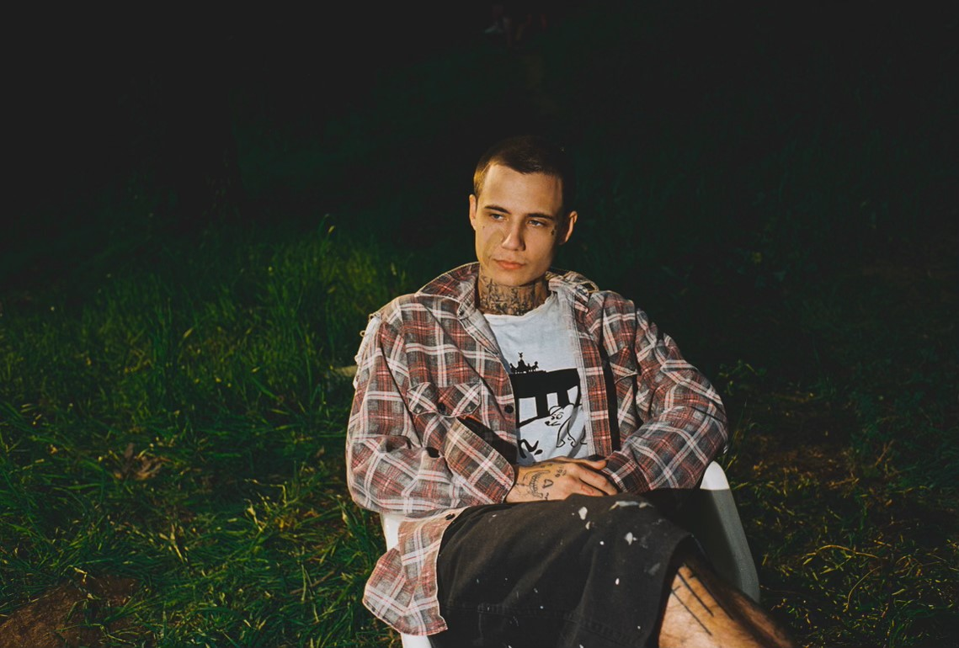
PHOTO CREDIT: HARRY TOOHEY
DOWNLOAD PRESS ASSETS HERE
APRIL 12, 2024 – LA-based singer-songwriter jxdn has released his Spotify Singles cover of Coldplay’s breakout smash “Yellow” - Listen HERE.

The Spotify Single release follows jxdn’s recent announcement of his “WHEN THE MUSIC STOPS TOUR,” which will see him returning to stages across the U.S., Europe, and the U.K. later this year in support of his forthcoming LP, WHEN THE MUSIC STOPS, arriving June 28th via Travis Barker’s DTA Records [album artwork / tracklist below].

The U.S. leg of the “WHEN THE MUSIC STOPS TOUR,” which will feature special guests LØLØ and GUNNAR, is set to get underway on June 6th at Minneapolis, Minnesota’s First Avenue and will make stops in Chicago, Brooklyn, Denver and other major markets before concluding with a hometown show at The Belasco in Los Angeles, California on July 27th. On September 12th, the European leg of the tour will pick up in Paris, France at Bataclan and will visit Germany, Spain, Italy and other European territories before a run of shows across the U.K. which will commence with an October 2nd performance at London’s O2 Shepherd's Bush Empire [see tour itinerary below]. Furthermore, $1.00 from every ticket sold will go towards supporting The Coop’s Advice Foundation, a non-profit organization founded after the passing after jxdn’s best friend Cooper Noriega, which is aimed at becoming a leader in the movement to rethink how society understands and addresses mental health and addiction. For tickets and more information on jxdn’s “WHEN THE MUSIC STOPS TOUR,” visit www.jxdnmusic.com.

Earlier this year jxdn announced his widely anticipated new album, WHEN THE MUSIC STOPS, and shared the album’s lead single, “WHAT THE HELL,” which is available on all streaming platforms and accompanied by an official music video directed by Hunter Moreno. WHEN THE MUSIC STOPS marks jxdn’s long awaited follow up to his celebrated debut album Tell Me About Tomorrow.

Having reached RIAA gold status and amassed over one billion streams worldwide, jxdn has established himself as a gen-z ambassador for a generation of fans too young to have experienced pop punk’s initial explosion in the 2000s. Co-produced by Barker and Andrew Goldstein, WHEN THE MUSIC STOPS, wades deeper into the genre and features seventeen songs including the album’s title track which was released earlier this year. WHEN THE MUSIC STOPS is available for pre-order today in a variety of physical formats including limited-edition signed vinyl and CDs with additional products launching in the coming weeks. For more information and full pre-order offerings, visit www.jxdnmusic.com.

WHEN THE MUSIC STOPS follows the release of jxdn’s 2023 standalone singles “Chrome Hearted,” “Elevated Heartbreak,” and his cover of d4vd’s “Romantic Homicide.”

jxdn’s celebrated debut album Tell Me About Tomorrow arrived in 2021 to critical acclaim and has since amassed more than one billion global streams to date. Upon its arrival, the album earned jxdn a #3 Alternative New Artist Albums, #5 Top New Artist Albums, and #11 Digital Albums on the Billboard charts. Furthermore, jxdn was included in Variety’s ‘Power of Young Hollywood’ 2021 Music impact list and Billboard’s ‘21 Under 21’ list for the two consecutive years he was eligible (2020 and 2021), in addition to garnering nominations for both a MTV VMA and MTV EMA in 2021.

[Tour Itinerary / Admat / Album Art / Track Listing Below]
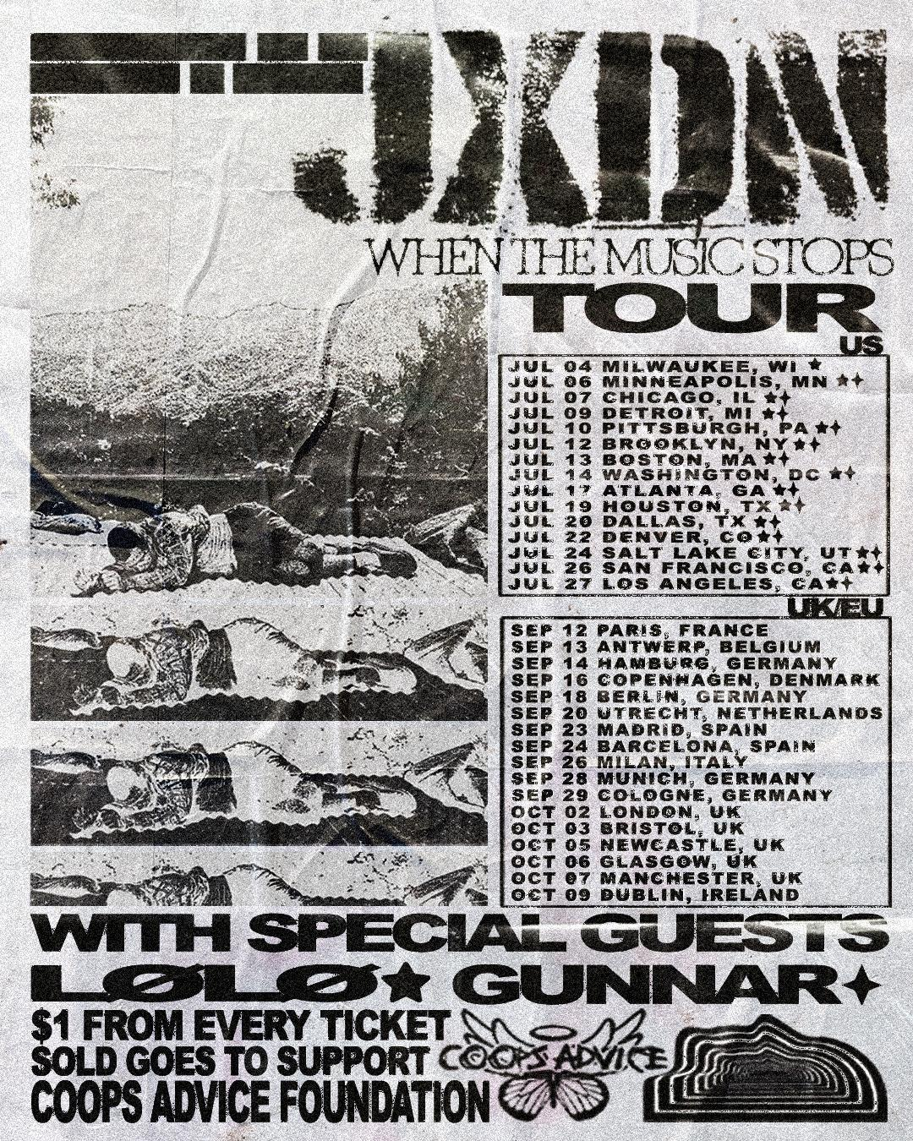

U.S.
With LØLØ & GUNNAR
* Festival Date - jxdn and LØLØ Only

July 04 - Milwaukee, WI - Summerfest*
July 06 - Minneapolis, MN - First Avenue
July 07 - Chicago, IL - Concord Music Hall
July 09 - Detroit, MI - Saint Andrew’s Hall
July 10 - Pittsburgh, PA - Stage AE
July 12 - Brooklyn, NY - Brooklyn Steel
July 13 - Boston, MA - Royale
July 14 - Washington, DC - 9:30 Club
July 17 - Atlanta, GA - Buckhead Theatre
July 19 - Houston, TX - White Oak Music Hall
July 20 - Dallas, TX - The Factory in Deep Ellum
July 22 - Denver, CO - Gothic Theatre
July 24 - Salt Lake City, UT - The Complex
July 26 - San Francisco, CA - The Regency Ballroom
July 27 - Los Angeles, CA - The Belasco

EUROPE & U.K.
Support To be Announced

September 12 - Paris, FR - Bataclan
September 13 - Antwerp, BE - Trix
September 14 - Hamburg, DE - Fabrik
September 16 - Copenhagen, DK - Amager Bio
September 18 - Berlin, DE - Huxleys Neue Welt
September 20 - Utrecht, NL - TivoliVredenburg
September 23 - Madrid, ES - La Riviera
September 24 - Barcelona, ES - Razzmatazz
September 26 - Milan, IT - Fabrique
September 28 - Munich, DE - Tonhalle
September 29 - Cologne, DE - Live Music Hall
October 02 - London, UK - O2 Shepherd's Bush Empire
October 03 - Bristol, UK - O2 Academy
October 05 - Newcastle, UK - NX Newcastle
October 06 - Glasgow, UK - O2 Academy
October 07 - Manchester, UK - O2 Ritz
October 09 - Dublin, IE - 3Olympia Theatre
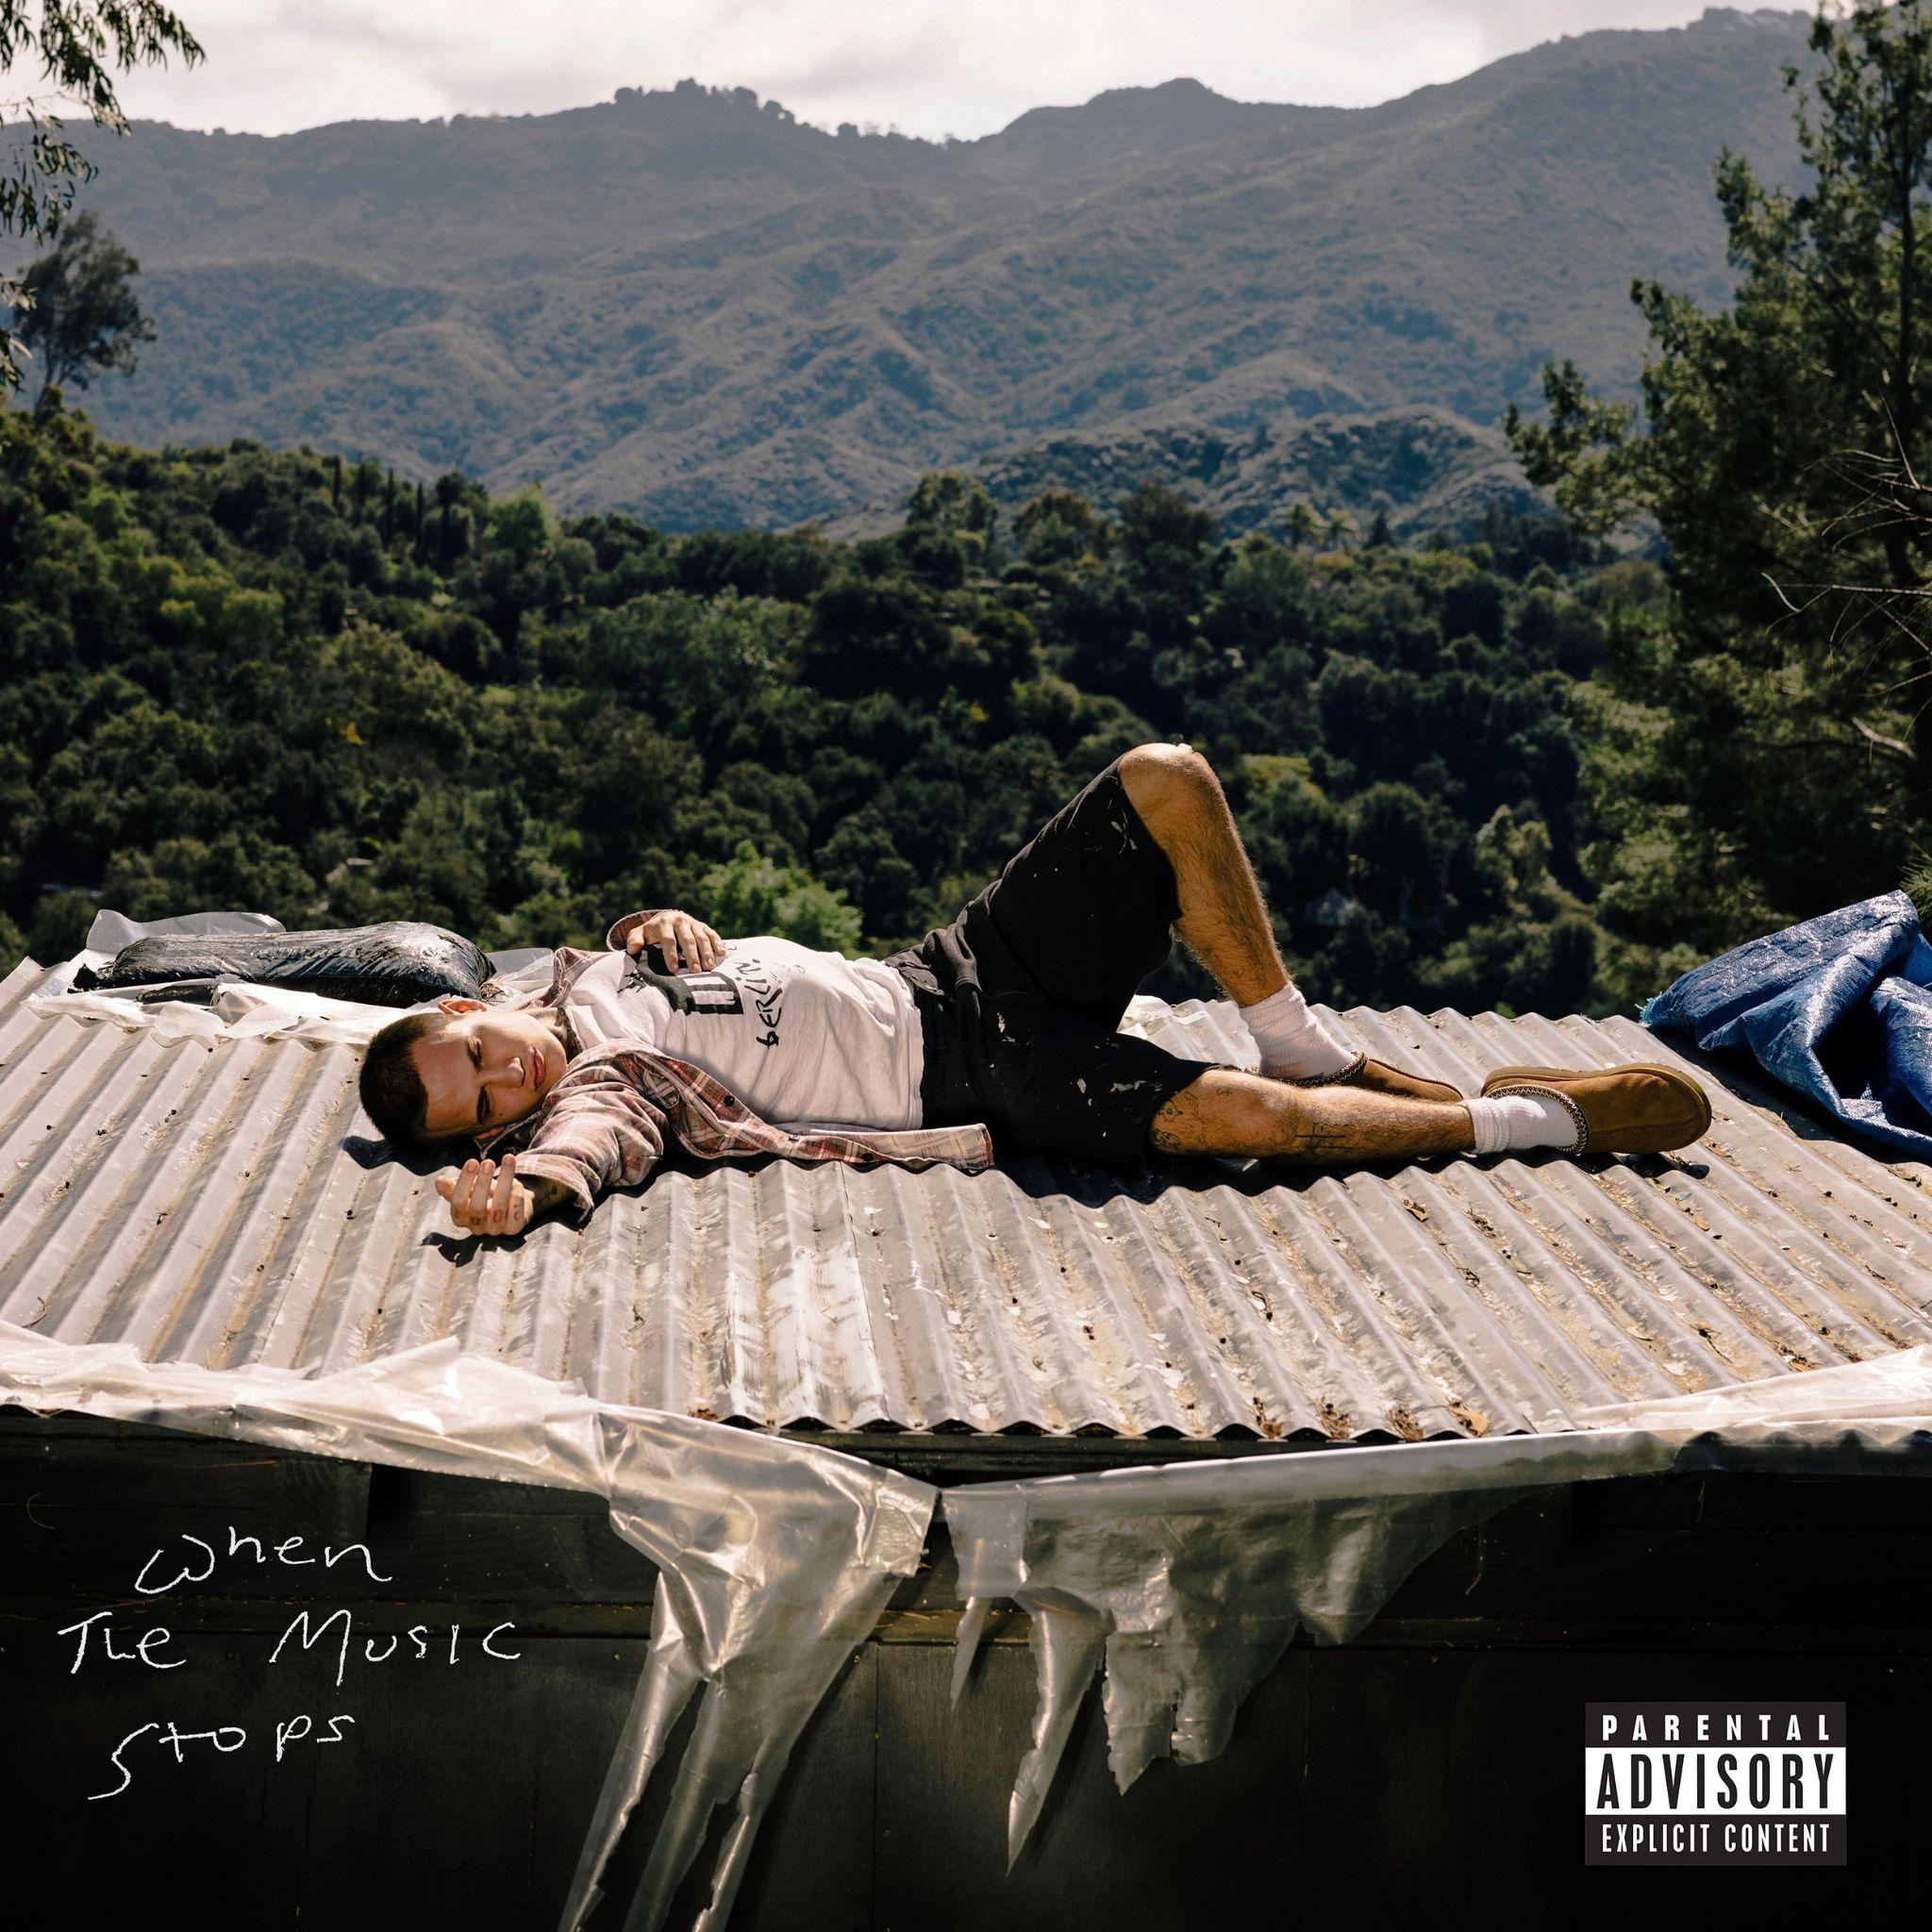
jxdn
WHEN THE MUSIC STOPS

1. LOST ANGEL INTERLUDE
2. CANDLES
3. STRAY
4. SAD OCTOBER
5. WHAT THE HELL
6. IT MUST SUCK TO KNOW YOU
7. SH!T
8. EMPTY ROOMS
9. WHAT CAN I SAY
10. STRANGER
11. JUST LET GO
12. WRECK ME
13. YOU NEED SOMEONE I JUST HAPPENED TO BE THERE
14. HOW FAR
15. WET DREAM (IT’S YOU)
16. DRUGS
17. WHEN THE MUSIC STOPS

ABOUT JXDN:

In 2024 jxdn is letting go of his past and stepping into his future. Up to this point, the breakout star has reached gold status, tallied over one billion streams and counting, collaborated with icons, sold out headline tours, and garnered widespread acclaim. Raised by two pastors, jxdn spent the bulk of his childhood in Texas. Without much money or resources, he retreated into music as an escape. By the time he turned 14, the family relocated to Chattanooga, TN. As a senior in high school, he snuck out to a Juice WRLD concert (his first), and it changed his life. In 2020, he linked up with iconic blink-182 drummer and DTA Records founder Travis Barker who promptly signed him. He served up the gold-certified “ANGELS & DEMONS.” The latter also bulldozed the way for his 2021 full-length debut album, Tell Me About Tomorrow, highlighted by “SO WHAT!,” “BETTER OFF DEAD,” “TONIGHT” [feat. iann dior], and “WANNA BE'' [feat. Machine Gun Kelly]. Beyond television performances on ELLEN and Jimmy Kimmel LIVE!, his showstopping MTV Push rendition of “Think About Me” garnered a nomination for “Push Performance of the Year” at the MTV VMAS. Plus, he packed houses on tour coast-to-coast. In between, he endured loss, struggled through mental health, faced addiction, and realized who he was meant to be all along. Armed with wisdom and a deliberate vision for the future, jxdn reintroduces himself in 2024 with his new full length album WHEN THE MUSIC STOPS slated to arrive June 28th on DTA Records.

CONNECT WITH JXDN:
WEBSITE / TIKTOK / INSTAGRAM / X / FACEBOOK / YOUTUBE / SPOTIFY / APPLE MUSIC

