SOFT LAUNCH UNVEILS DEBUT SINGLE "CARTWHEELS"
GEARING UP FOR UK & EUROPE TOUR SUPPORTING DECLAN MCKENNA
LISTEN HERE | WATCH HERE
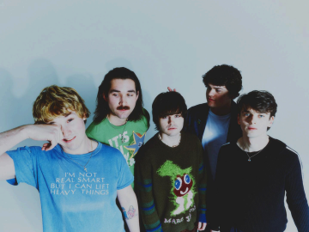PHOTO CREDIT: CLARK FRANKLYN
DOWNLOAD HI-RES PRESS ASSETS HERE
Irish alternative band Soft Launch emerges onto the music scene as a dynamic quintet poised to redefine the traditional boyband archetype. Comprised of Josh McClorey, Benedict Quinn, Conor Price, Henry Pearce, and Limmer, the group introduces themselves with their debut single, "Cartwheels," released via Fueled by Ramen. Watch the energy filled video HERE.
Reminiscent of the heyday of British indie pop, directors Marcus Prouse Jr and Nathan Barlow along with creative direction from Henry in the band, bring the personalities of each member and the tangible chemistry between them to the fore. Their debut marks the commencement of a compelling exploration into their realm of stylish, intelligent, and meticulously crafted melodies.
‘Cartwheels’ received its first play on BBC Radio 1 from Declan McKenna sitting in for Clara Amfo. It’s a self-produced debut that dissects moments within a relationship placed under a microscope. The intense domesticity of the lyrics beautifully offset almost intergalactically grandiose synth melodies and riffs that spark off of one another. Complex bass lines playfully dance with Josh’s clean cut, pitch perfect vocal, but his idiosyncratic Dublinisms allow depth and realness to shine through in verse and chorus, to then be countered with Henry’s bouncy and characterful delivery on verse 2. Clearly, we are not in traditional boy band territory here: unless the boy band in question is as much Vampire Weekend and The Beatles as they are Harry Styles.
All of Soft Launch write, produce, and deftly interchange instruments throughout both the recording process and gigs. Lead vocals come in various waves from Josh, Henry, Conor & Ben with Limmer steadying The Beach Boys-esque ship. Their already packed out live shows is where anyone should head for a Good Time. Wall to wall with eager sub-20-somethings scream-singing every word back to the boys and lapping up the vibe, they sold out The Grace in London a few weeks ago in less than an hour, without a single piece of music out in the world. Here is a band totally realized, at ease with the stage and themselves and will have you wrapped around their little fingers without breaking a sweat.
Soft Launch comes from a serendipitous emergence rarely found in today's fast-paced, content-driven music industry. It was a classic case of being in the right place at the right time: five incredible musicians, genuine artists, who never intended to be in a band, yet fit together so harmoniously in a way that shouldn't be overlooked.

SOFT LAUNCH
“Cartwheels”
AVAILABLE NOW
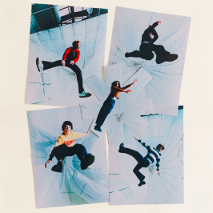

CONNECT WITH SOFT LAUNCH
Instagram | Twitter | TikTok

For US media inquiries, please contact:
Collin Citron | collin.citron@300elektra.com
Destiny Dominguez | destiny.dominguez@300elektra.com

