RAINBOW KITTEN SURPRISE UNVEIL
“OVERTIME” FEATURING KACEY MUSGRAVES

LISTEN HERE | WATCH LYRIC VIDEO HERE

GENRE-DEFYING BAND’S NEW TRACK JOINS PREVIOUSLY RELEASED SINGLES “SUPERSTAR” AND “LOL” FROM FORTHCOMING LP

TINY MUSIC BOX TOUR KICKS OFF MAY 6
FEATURING SOLD OUT UNDERPLAYS AT NASHVILLE’S BROOKLYN BOWL &
NYC’S WEBSTER HALL

ADDITIONAL DATES ADDED IN BOSTON, AUSTIN, & DENVER
DUE TO OVERWHELMING DEMAND

FIRST NEW ALBUM IN SIX YEARS LOVE HATE MUSIC BOX
ARRIVES MAY 10 VIA ELEKTRA

PRE-ORDER & PRE-SAVE HERE

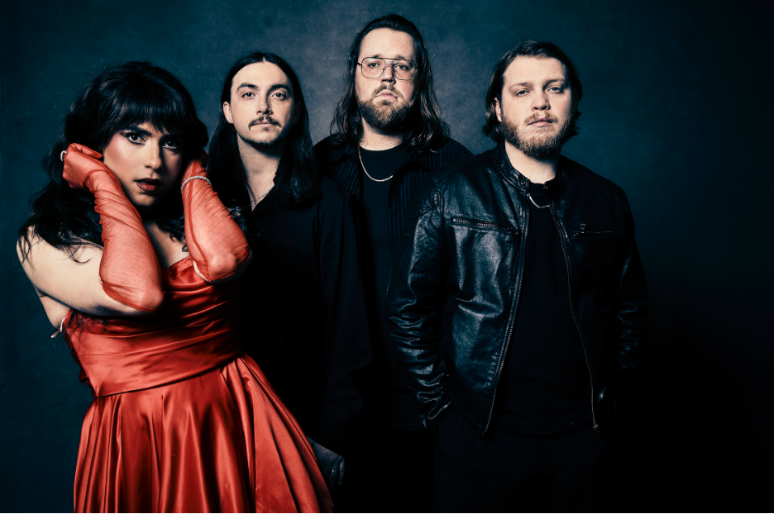
Photo Credit: Jimmy Fontaine
PRESS ASSETS HERE

Multi-platinum live sensations Rainbow Kitten Surprise have released the brand new track “Overtime” featuring 7x-GRAMMY winner Kacey Musgraves (listen HERE). Musgraves shared news of the duet on her socials earlier this week, and expressed her own excitement about the collaboration in a heartfelt message to the band (watch HERE). The effervescent single marks the latest offering from the North Carolina-bred quartet’s first full-length album in six years, LOVE HATE MUSIC BOX, due out May 10, 2024 via Elektra Entertainment and available to pre-order/pre-save HERE.

Rainbow Kitten Surprise singer/songwriter/frontperson Ela Melo explains: “I really believe in serendipity. I wrote ‘Overtime’ on a Saturday, met Kacey the following Monday, and got up the nerve to ask if she’d be down to lay down some vocals for it on Tuesday. It’s the first time we’ve had a feature on an RKS song and we’re still pinching ourselves that it’s her.”

The band recently announced details for their upcoming Tiny Music Box Tour, a run of underplay shows that feature differing set lists each night, highlighting material from LOVE HATE MUSIC BOX alongside fan-favorites from throughout the band’s beloved discography. With most dates already sold out, the tour will kick off May 6 in Nashville at Brooklyn Bowl, followed by a show at New York’s Webster Hall on May 9. Due to overwhelming demand, additional shows have been added to their previously announced 2-night stands in Boston, Austin, and Denver. (Full dates below; additional dates later in the year to be announced soon). Working with Plus 1, $1 per ticket goes towards supporting organizations delivering mental health treatment and access to care.

“Overtime” follows the album’s effervescent, lead single “Superstar” and surprise fan offering “LOL,” both streaming on all platforms now. Each song arrived accompanied by a music video directed by Matthew DeLisi [Paramore, Judah & The Lion] – streaming on the band’s official YouTube channel.

After years of struggling with her own mental health that resulted in writer’s block, on-stage episodes, and tour cancellations, RKS singer/songwriter/frontperson Ela Melo was properly diagnosed and treated in 2023, vastly improving her quality of life. As if suddenly struck by creative intervention, songs once again poured out of her, writing at least one a day for an entire year and forming the backbone of their 22-track opus LOVE HATE MUSIC BOX. This epic mosaic of sound and emotion was fully realized once the band - guitarists Bozzy Keller and Ethan Goodpaster, drummer Jess Haney and former bassist Charlie Holt - reconvened in the studio, adding another dimension sonically.

Produced by Daniel Tashian (Kacey Musgraves) along with Konrad Snyder (Noah Kahan) and Melo, the much-anticipated album ponders life’s ups and downs, and traces the turbulent trajectory of relationships, painted out loud in hues of pop, electronic, rock, and hip-hop. As such, it finds the musicians at their most vulnerable, vibrant, and vital.

###

Tiny Music Box Tour:
May 6 - Nashville, TN - Brooklyn Bowl Nashville - SOLD OUT
May 9 - New York, NY - Webster Hall - SOLD OUT
May 13 - Boston, MA - Roadrunner - SOLD OUT
May 14 - Boston, MA - Roadrunner - LIMITED TICKETS
May 15 - Boston, MA - Roadrunner - ADDED NIGHT
May 23 - Austin, TX - ACL Live at Moody Theater - ADDED NIGHT + SOLD OUT
May 24 - Austin, TX - ACL Live at Moody Theater - SOLD OUT
May 25 - Austin, TX - ACL Live at Moody Theater - SOLD OUT
May 30 - Denver, CO - The Mission Ballroom - ADDED NIGHT + SOLD OUT
May 31 - Denver, CO - The Mission Ballroom - SOLD OUT
June 1 - Denver, CO - The Mission Ballroom - SOLD OUT

LOVE HATE MUSIC BOX Track Listing:
- Peter Pan
- Sickset
- Finalist
- LOL
- Lucky
- Meticulous
- Hot Pink Ice Cube
- SVO
- Code Blue
- Overtime (Feat. Kacey Musgraves)
- Ghoul
- John Woo
- Low As We Go
- Bearwalk
- Superstar
- Cinderella
- Best Man
- Rabbit Run
- Daddy Yankee
- Re-Entry
- No Occasion
- Thanks For Coming

###

ABOUT RAINBOW KITTEN SURPRISE:
As if channeling another dimension where genres simply don’t exist, Rainbow Kitten Surprise finds harmony in unpredictability – weaving together lyrical poetry, hummable melodies, and a rush of instrumental eccentricities. Now boasting over 2 billion global streams across platforms, the band first began building their devoted fanbase with independent albums SEVEN + MARY(2013) and RKS (2015). The band’s breakout full-length debut for Elektra, HOW TO: FRIEND, LOVE, FREEFALL, arrived in April 2018. Produced by GRAMMY® Award-winner Jay Joyce (Cage The Elephant, Lainey Wilson), the album featured RIAA-certified Platinum single “It’s Called: Freefall,” earned widespread praise from Billboard, TIME, Vice, and NPR who described their sound as “…a mix of jam and indie and whatever else you can throw into the soup…very earnest, beautiful, political, loving rock n’ roll,” and saw the band make several national television appearances, including performances on “CBS Saturday Morning,” “The Late Show with Stephen Colbert,” and PBS’s “Austin City Limits.” After gracing the bills of Bonnaroo, Lollapalooza, and Osheaga, to name a few, RKS moved 80,000 tickets of their own on the sold-out 2018/2019 Friend, Love, Freefall Tour. That tour was earmarked by a sold-out debut at Red Rocks Amphitheatre and three consecutive gigs in Athens, GA (the latter of which were chronicled on their first official live album, LIVE FROM ATHENS GEORGIA, released in 2021).

The band released a two-track single Mary (B-Sides) in May 2019 – consisting of “Heart” and “No Vacancy.” The following year brought the release of standalone single “Our Song” – already a fan favorite in their live rotation prior to release – as well as a livestream concert in July, held for thousands of fans on what would’ve been the date of another sold-out Red Rocks performance (cancelled due to the COVID-19 pandemic). In March 2022, the band released the emotionally charged track “Work Out,” marking their first new music in nearly two years.

2022 also saw the band set out on their first full headline trek in nearly 3 years, a run that included their long-awaited, sold-out, two-night return to Red Rocks. And in 2022 alone, with the help of partners PLUS1 and Propeller, Rainbow Kitten Surprise raised over $170k for food banks in local tour markets, LGBTQ+ causes, and mental health initiatives.

Rainbow Kitten Surprise is: Ela Melo (she/her; lead vocals), Darrick “Bozzy” Keller (he/him; guitar, vocals), Ethan Goodpaster (he/him; lead guitar, vocals), Jess Haney (he/him; drums)

For more ticket information and tour updates, please visit [www.rksband.com].

###

