TWENTY ONE PILOTS
ANNOUNCE MASSIVE GLOBAL HEADLINE TOUR

SHARE NEW SONG & OFFICIAL MUSIC VIDEO - “NEXT SEMESTER”

THE CLANCY WORLD TOUR TO TRAVERSE NORTH AMERICA, THE UNITED KINGDOM, EUROPE, AUSTRALIA & NEW ZEALAND THROUGH 2025

US/CA PRESALES BEGIN APRIL 2ND + UK/EU/AU/NZ PRESALES BEGIN APRIL 3RD

NEW ALBUM CLANCY ARRIVES MAY 17TH

ALBUM PRE-ORDERS AVAILABLE NOW

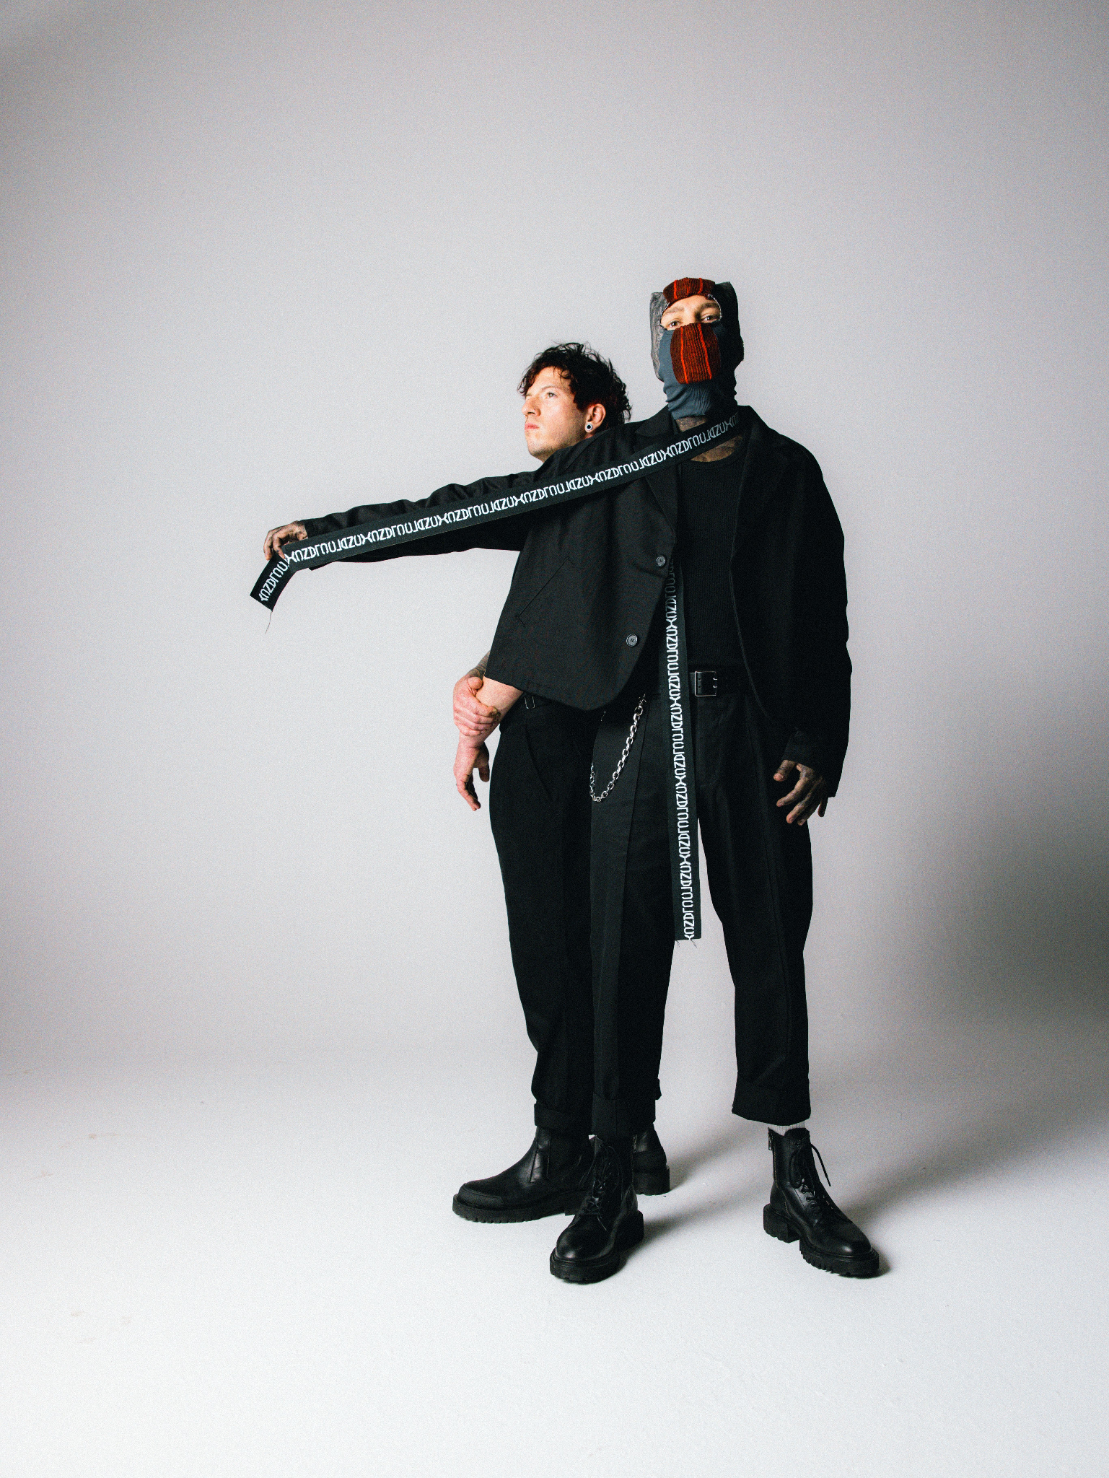
PHOTO CREDIT: ASHLEY OSBORN

MARCH 27, 2024 – GRAMMY® Award winning duo Twenty One Pilots have announced details of their massive global headline The Clancy World Tour and shared “Next Semester,” a new song from their highly anticipated forthcoming album, Clancy, which will be released May 17th via Fueled By Ramen [album artwork / tracklist below]. Watch the Andrew Donoho directed music video for “Next Semester” HERE.
Twenty One Pilots will celebrate the release of Clancy with The Clancy World Tour, their biggest headline tour ever set to get underway August 15th at Denver, CO’s Ball Arena. Produced by Live Nation, the tour will traverse North America through the fall followed by dates in New Zealand, Australia, Europe and the United Kingdom [see tour itinerary below]. Fans can participate in an official artist presale for tickets beginning April 2nd (US/CA) and April 3rd (UK/EU/AU/NZ) with all remaining tickets available during the general on sale at 10:00 AM local time on Friday, April 5th. For tickets and complete details for Twenty One Pilots’ The Clancy World Tour visit www.twentyonepilots.com/tour.
Last month, Twenty One Pilots returned with news of Clancy and released the album’s lead single “Overcompensate” alongside an accompanying official music video directed by Reel Bear Media. The track, which has rocketed up the Alternative Radio chart currently sitting Top 5, made a massive impact upon launch as it welcomed listeners back to the band’s immersive world of ‘Trench.’

Clancy is currently available for pre-order in a variety of physical formats including: two limited-edition deluxe box sets, four vinyl variants with additional retailer exclusives, an exclusive CD + Journal Book and a Cassette + Photocard Wallet, and much more. For the full suite of Clancy pre-order offerings, visit Twenty One Pilots’ official store.

Having amassed over 33 billion streams worldwide and over 3 million tickets sold across global headline tours, the Columbus, OH based duo of Tyler Joseph and Josh Dun have established themselves as one of the most successful bands of the 21st century and redefined the sound of a generation. Co-produced by Joseph and Paul Meany, Clancy marks the final chapter in an ambitious multi-album narrative first introduced in the band's 2015 multi-Platinum breakthrough, Blurryface. Furthermore, Clancy’s forthcoming release on May 17th coincides with the 9th anniversary of Blurryface, which was released exactly nine years prior to the day.

Twenty One Pilots extended the ambitious concept laid out in Blurryface with their 2018 Platinum-certified album TRENCH. Featuring the multi-Platinum and Platinum singles “Chlorine,” “My Blood” and the GRAMMY® Award-nominated “Jumpsuit,” the album graced spots on “Best of” year-end lists by Billboard, KERRANG!, Alternative Press, and Rock Sound—who placed it at #1.

The duo’s 2021 RIAA Gold certified epic Scaled And Icy debuted at No. 1 on Billboard's Top “Rock Albums” and “Alternative Albums” charts while landing at No. 3 on the “Billboard 200,” marking the biggest opening week for a rock album in 2021. The record is highlighted by the #1 Alternative Radio hits “The Outside,” “Saturday,” and “Shy Away,” the latter of which ascended to #1 at the format in just three weeks, placing the duo in an elite group of acts with multiple songs to rise to #1 at the format in three weeks or less including: U2, R.E.M., The Cure, Linkin Park, Red Hot Chili Peppers, and Foo Fighters.

[Tour Admat / Tour itinerary / Album Artwork / Tracklisting Below]

Twenty One Pilots
The Clancy World Tour
Tickets & Information Available at twentyonepilots.com/tour

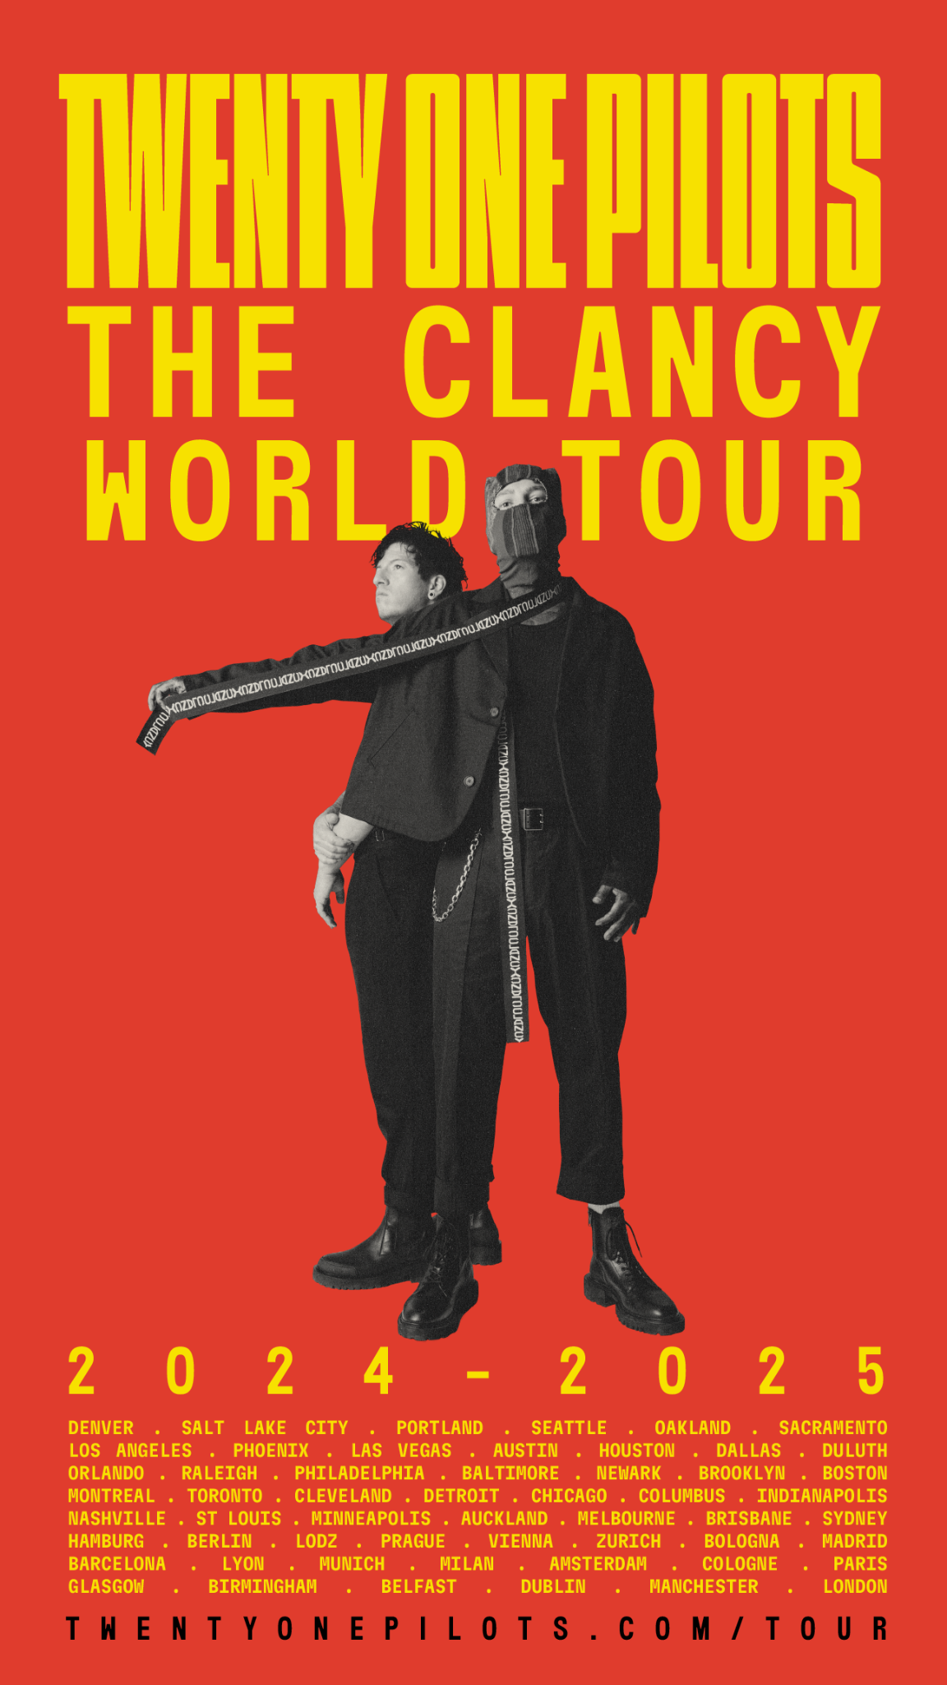

August 15, 2024 Denver, CO Ball Arena
August 18, 2024 Salt Lake City, UT Delta Center
August 21, 2024 Portland, OR Moda Center
August 22, 2024 Seattle, WA Climate Pledge Arena
August 24, 2024 Oakland, CA Oakland Arena
August 25, 2024 Sacramento, CA Golden 1 Center
August 27, 2024 Los Angeles, CA Intuit Dome
August 28, 2024 Los Angeles, CA Intuit Dome
August 30, 2024 Phoenix, AZ Footprint Center
August 31, 2024 Las Vegas, NV MGM Grand Garden Arena
September 3, 2024 Austin, TX Moody Center
September 4, 2024 Houston, TX Toyota Center
September 6, 2024 Dallas, TX American Airlines Center
September 10, 2024 Duluth, GA Gas South Arena
September 11, 2024 Orlando, FL Kia Center
September 13, 2024 Raleigh, NC PNC Arena
September 14, 2024 Philadelphia, PA Wells Fargo Center
September 15, 2024 Baltimore, MD CFG Bank Arena
September 17, 2024 Newark, NJ Prudential Center
September 18, 2024 Brooklyn, NY Barclays Center
September 20, 2024 Boston, MA TD Garden
September 25, 2024 Montreal, QC Bell Centre
September 27, 2024 Toronto, ON Scotiabank Arena
September 28, 2024 Cleveland, OH Rocket Mortgage Fieldhouse
September 29, 2024 Detroit, MI Little Caesars Arena
October 1, 2024 Chicago, IL United Center
October 2, 2024 Chicago, IL United Center
October 4, 2024 Columbus, OH Nationwide Arena
October 5, 2024 Columbus, OH Nationwide Arena
October 8, 2024 Indianapolis, IN Gainbridge Fieldhouse
October 9, 2024 Nashville, TN Bridgestone Arena
October 10, 2024 St. Louis, MO Enterprise Center
October 12, 2024 Minneapolis, MN Target Center
November 17, 2024 Auckland, NZ Spark Arena
November 19, 2024 Melbourne, AU Rod Laver Arena
November 21, 2024 Brisbane, AU Brisbane Entertainment Centre
November 24, 2024 Sydney, AU Qudos Bank Arena
April 7, 2025 Hamburg, DE Barclays Arena
April 8, 2025 Berlin, DE Uber Arena
April 9, 2025 Lodz, PL Atlas Arena
April 12, 2025 Prague, CZ O2 Arena
April 13, 2025 Vienna, AT Wiener Stadthalle
April 16, 2025 Zurich, CH Hallenstadion
April 17, 2025 Bologna, IT Unipol Arena
April 21, 2025 Madrid, ES WiZink Center
April 22, 2025 Barcelona, ES Palau San Jordi
April 24, 2025 Lyon, FR LDLC Arena
April 27, 2025 Munich, DE Olympiahalle
April 28, 2025 Milan, IT Forum
April 30, 2025 Amsterdam, NL Ziggo Dome
May 1, 2025 Cologne, DE Lanxess Arena
May 2, 2025 Paris, FR Accor Arena
May 5, 2025 Glasgow, UK OVO Hydro Arena
May 6, 2025 Birmingham, UK Resorts World Arena
May 8, 2025 Belfast, UK SSE Arena Belfast
May 9, 2025 Dublin, IE 3Arena
May 11, 2025 Manchester, UK AO Arena
May 13, 2025 London, UK The O2
May 14, 2025 London, UK The O2

Twenty One Pilots
Clancy
Pre-orders Available Here: http://top.lnk.to/Clancy

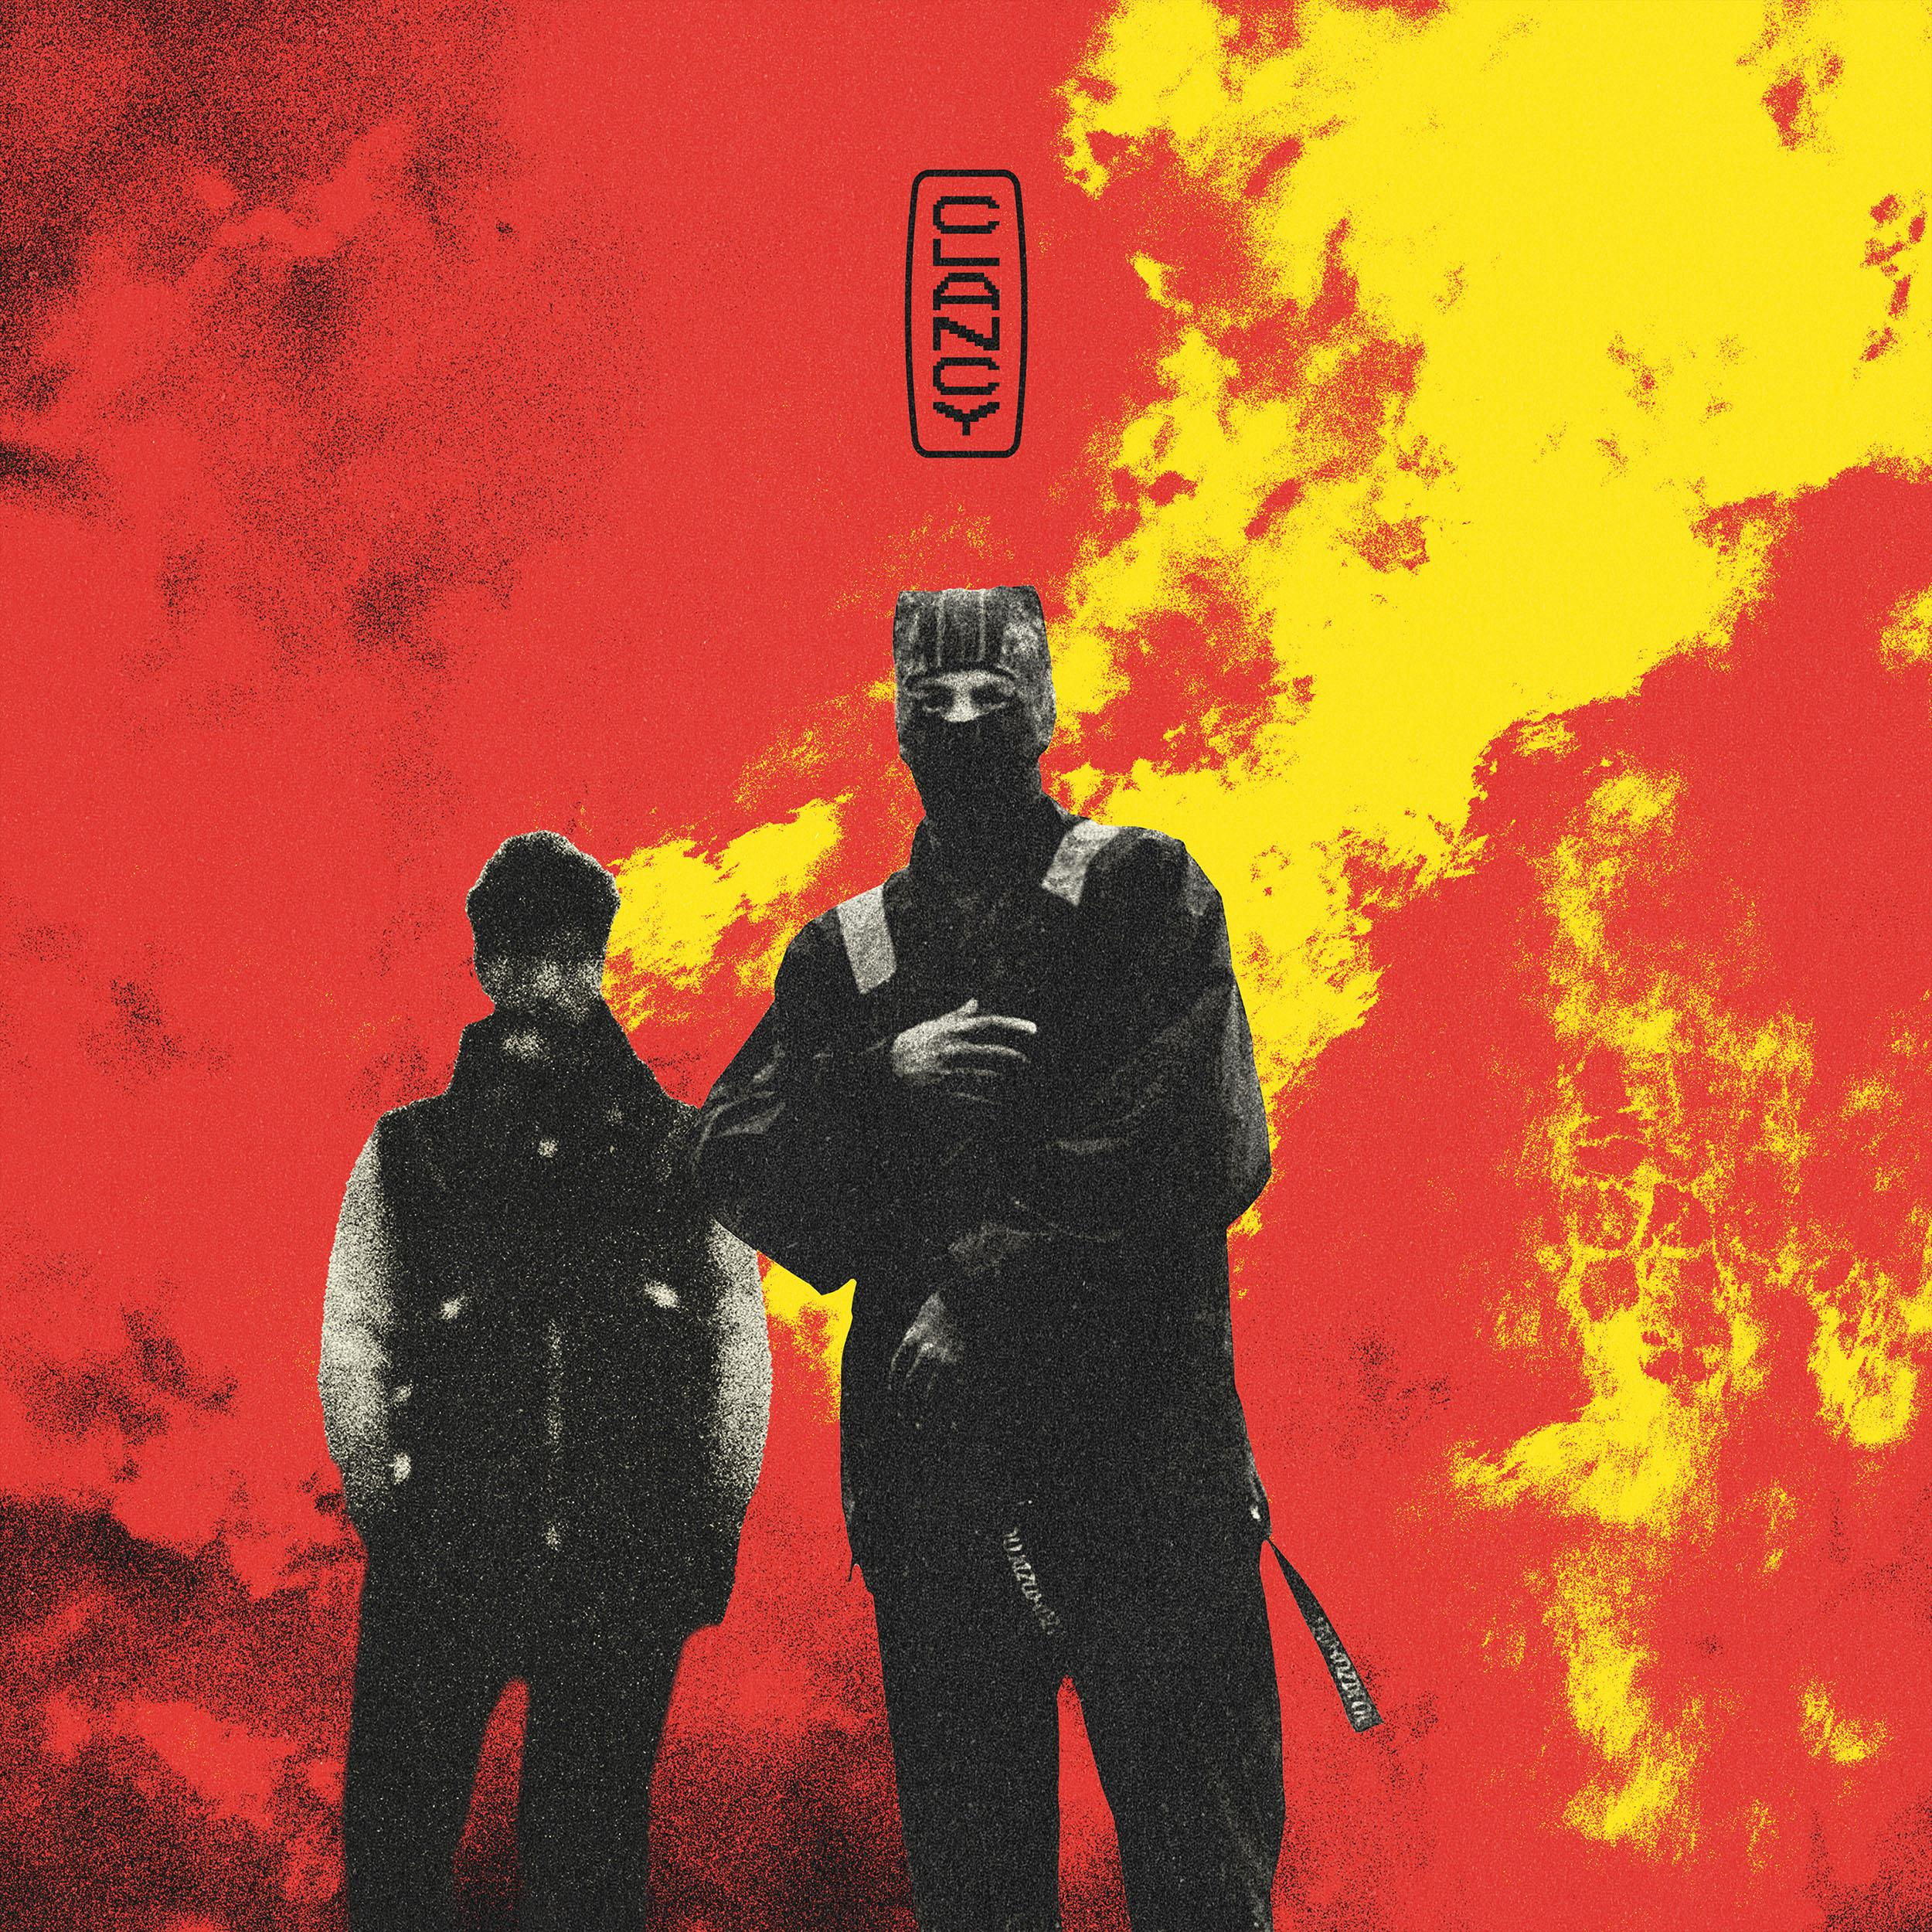

1. Overcompensate
2. Next Semester
3. Midwest Indigo
4. Routines In The Night
5. Backslide
6. Vignette
7. The Craving (Jenna’s Version)
8. Lavish
9. Navigating
10. Snap Back
11. Oldies Station
12. At the Risk Of Feeling Dumb
13. Paladin Strait

About Twenty One Pilots:
Grammy-Award winning band, Twenty One Pilots, have shifted music and culture as an incomparable creative force and with an ever-evolving vision. The Columbus, OH duo—Tyler Joseph and Josh Dun— have tallied over 33 billion global streams and counting, sold north of three million tickets worldwide, notched dozens of multi-Platinum certifications, and even claimed a spot in the Guinness® Book of World Records. In historic fashion, their quadruple-Platinum breakout LP, Blurryface, took flight as “the first album to notch a RIAA Gold or Platinum certification for every one of its songs,” while Vessel followed suit and achieved the same distinction. They elevated to rarified air as “one of only 18 artists to earn multiple RIAA Diamond certifications,” going Diamond with “Stressed Out” and “Heathens.” 2018’s Platinum-certified Trench extended the ambitious concept laid out in Blurryface and delivered the multi-Platinum and Platinum singles: “Chlorine,” “My Blood” and the GRAMMY® Award-nominated “Jumpsuit.” They followed Trench with their Gold-certified LP Scaled And Icy, achieving “the biggest opening week for a rock album in 2021” by capturing #1 on the Billboard Top Rock Albums and Top Alternative Albums charts and crashing the Top 3 of the Billboard 200. Beyond rapturous headline shows at arenas and festivals worldwide, Twenty One Pilots have notably architected an immersive world without comparison, originating a multi-album conceptual arc across Blurryface, Trench, and Scaled And Icy. Exactly nine years to the date of the Blurryface album release, they complete this story on their seventh full-length offering, Clancy [Fueled By Ramen], out May 17, 2024. Led by the single “Overcompensate,” the LP signals the dawn of another era for Twenty One Pilots and alternative rock music at large.

About Live Nation Entertainment
Live Nation Entertainment (NYSE: LYV) is the world’s leading live entertainment company comprised of global market leaders: Ticketmaster, Live Nation Concerts, and Live Nation Sponsorship. For additional information, visit www.livenationentertainment.com.

###

For more information on Twenty One Pilots, contact:
Ross Anderson | Ross.Anderson@300Elektra.com
Destiny Dominguez (Tour) | Destiny.Dominguez@300elektra.com

For more information on Live Nation Concerts, contact:
Monique Sowinski | moniquesowinski@livenation.com
Valeska Thomas | valeskathomas@livenation.com

Follow Twenty One Pilots:
Official | TikTok | Instagram | Twitter | YouTube | Facebook

