TONES AND I SHARES NEW SINGLE “I GET HIGH”

LISTEN HERE

FIRST FEMALE ARTIST TO CROSS 3 BILLION STREAMS ON SPOTIFY &
ONE OF ONLY EIGHT ARTISTS EVER

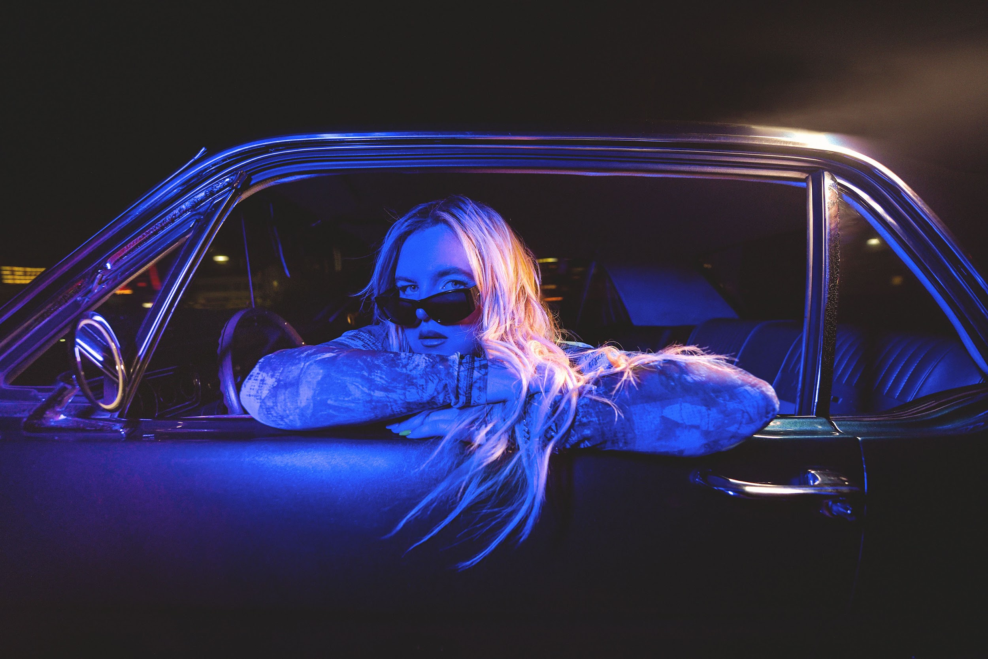
PHOTO CREDIT: GIULIA MCGAURAN

FEBRUARY 12, 2024 – Global superstar and multi-platinum award-winning songwriter Tones And I has shared a new single, “I Get High,” which is available today on all streaming platforms. Written by Tones And I and co-produced with Randy Belculfine, “I Get High” marks the second taste of new music from Tones And I’s much anticipated new album which is expected to arrive later this year.

Elaborating on the lyrics of the new track, Tones And I shared, “‘I Get High’ is about the nostalgia of growing up with friends. Sneaking out and enjoying our youth, looking back and reminiscing about the people that were and are in your life, that make you feel alive. There is magic in this song.”

“I Get High” follows Tones And I’s recent single “Dreaming” which she co-wrote with Sam Nelson of X Ambassadors and co-produced alongside Nelson and Randy Belculfinne. “Dreaming” is available on all streaming platforms and is joined by an official music video directed by Tones And I, Nick Kozakis and Liam Kelly – watch it HERE. Tones And I also shared a special acoustic version of “Dreaming” and an official music video capturing a stunning stripped back live performance of the song - watch it HERE.

Furthermore, Tones And I recently made history as the Australian artist’s monster hit “Dance Monkey” surpassed 3 Billion streams on Spotify. With that feat, Tones And I became the first and only female artist to achieve that streaming milestone, and one of only eight artists ever to cross 3 billion streams with a single song on Spotify.

Tones And I is currently supporting P!NK on her 2024 Australia Stadium Tour. The run is set to continue tonight with a performance at Melbourne’s Marvel Stadium and will continue through the end of the month with a two night stand at Country Bank Stadium in Townsville on March 22-23. Afterwards, she jets off to Asia for a string of dates in May [full itinerary below]. For tickets and more information, visit

Tones And I notably capped off 2023 with the powerful anthem “The Greatest,” which was released in support of the Australia Women’s Football team The Matildas, at the FIFA Women’s World Cup. Earning critical acclaim, Rolling Stone Australia raved, “‘The Greatest’ opens with towering strings before the singer-songwriter’s emphatic words arrive to inspire.” Tones And I was also featured on the track "BRING IT ON [Official FIFA Walkout Anthem]," alongside Bia and Diarra Sylla, and produced by RedOne (Lady Gaga, Britney Spears, Nicki Minaj, Justin Bieber) which served as the official walk-out song for the 2023 Women’s World Cup in Australia, and will continue as the official walk-out music for every FIFA match until 2030. Furthermore, Tones And I performed a captivating set ahead of the FIFA Women’s World Cup final in front of a full house of more than 75,000 spectators at Sydney’s Stadium Australia, and broadcasting out to billions of people worldwide.

Those two tracks landed on the heels of Tones And I’s other 2023 single “I Am Free,” which has gathered millions of streams on DSPs alongside a special ‘Piano Version.’ “I Am Free” followed Tones And I’s single “I Made It” – composed for the Netflix original film True Spirit - her 2022 single “Charlie” and her feature on Macklemore’s “Chant.” The pair debuted the collaboration on Good Morning America with an electrifying performance in New York City’s Central Park. Furthermore, Tones And I also recently wrapped up a run of dates supporting Macklemore on his UK and Europe spring headline tour.

As an inimitable vocalist, clever lyricist, deft producer, and inventive creator, Tones And I stretches the scope of pop music with unpredictable and undeniable anthems of her own design. Since exploding onto the global scene in 2019 as a busker from the Mornington Peninsula, Australia, she has smashed records, garnered multiple awards, sold out tours, surpassed 10 billion streams and reached multi-platinum heights around the world. Her breakout “Dance Monkey” went 6x platinum in the United States, became the most Shazamed song ever, and minted her as “the first female artist to reach 2 billion streams on Spotify with one song,” all while consistently holding a spot in the “Top 10 Most-Streamed Songs of All-Time on Spotify.” Her 2019 EP, The Kids Are Coming, crashed the Top 30 of the Billboard 200 and is certified Gold. Meanwhile, Tones And I’s full-length debut, Welcome To The Madhouse, toppled the Australian Albums Chart at #1 in 2021. Among five career ARIA Awards, “Cloudy Day” closed out 2022 as ARIA’s “Song of the Year.” Beyond selling out shows on multiple continents, she has delivered stunning performances on The Late Show with Stephen Colbert, TODAY, Jimmy Kimmel LIVE!, Good Morning America, The Ellen DeGeneres Show, and many more. Along the way, she has also collaborated with Macklemore, blackbear, Jonas Blue, Sam Feldt and BIA, in addition to contributing music to NETFLIX’s True Spirit and the blockbuster sequel Aquaman and the Lost Kingdom. Taking the helm, she personally shapes her vision by not only writing and performing, but also producing and directing visuals. Tones And I is a creative force and never stops pushing forward.

[ Single Artwork / Tour Itinerary Below]

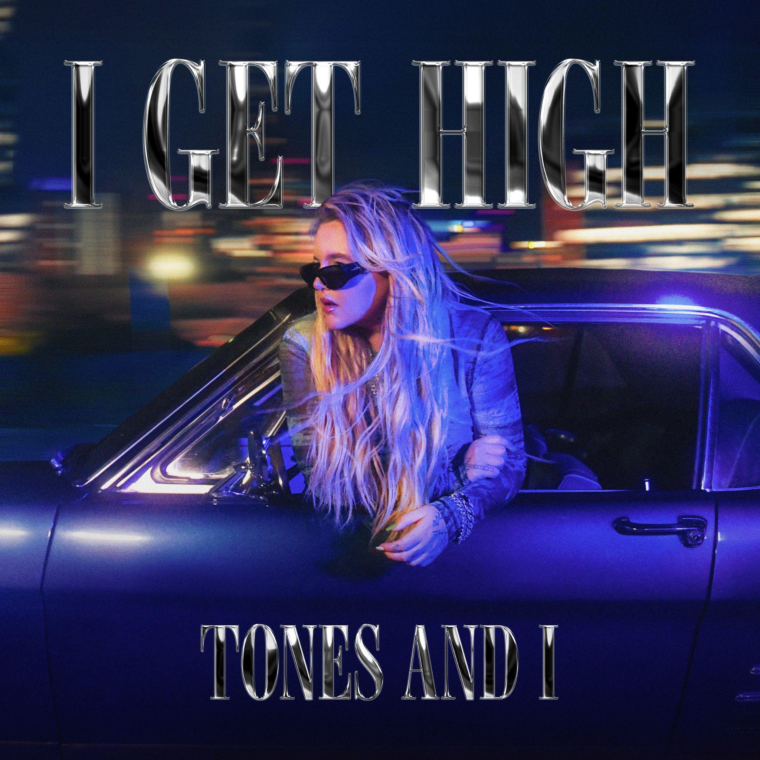

TONES AND I WORLD TOUR DATES

P!NK TOUR
3/12/2024 Marvel Stadium, Melbourne
3/13/2024 Marvel Stadium, Melbourne
3/16/2024 Accor Stadium, Sydney
3/19/2024 Suncorp Stadium, Brisbane
3/22/2024 Country Bank Stadium, Townsville
3/23/2024 Country Bank Stadium, Townsville

ASIA
5/26/2024 Greenroom Festival, Yokohama Red Brick Warehouse, Yokohama
5/28/2024 Spotify O-EAST, Tokyo, JAPAN
5/31/2024 Seoul Jazz Festival, Olympic Park - The 88 Garden, Seoul

FOR MORE INFORMATION ON TONES AND I:
FACEBOOK / TWITTER / INSTAGRAM / YOUTUBE / SPOTIFY / APPLE MUSIC / AMAZON MUSIC

CONTACT FOR TONES AND I:

Glenn Fukushima
Glenn.Fukushima@300Elektra.com

Ross Anderson
Ross.Anderson@300Elektra.com

