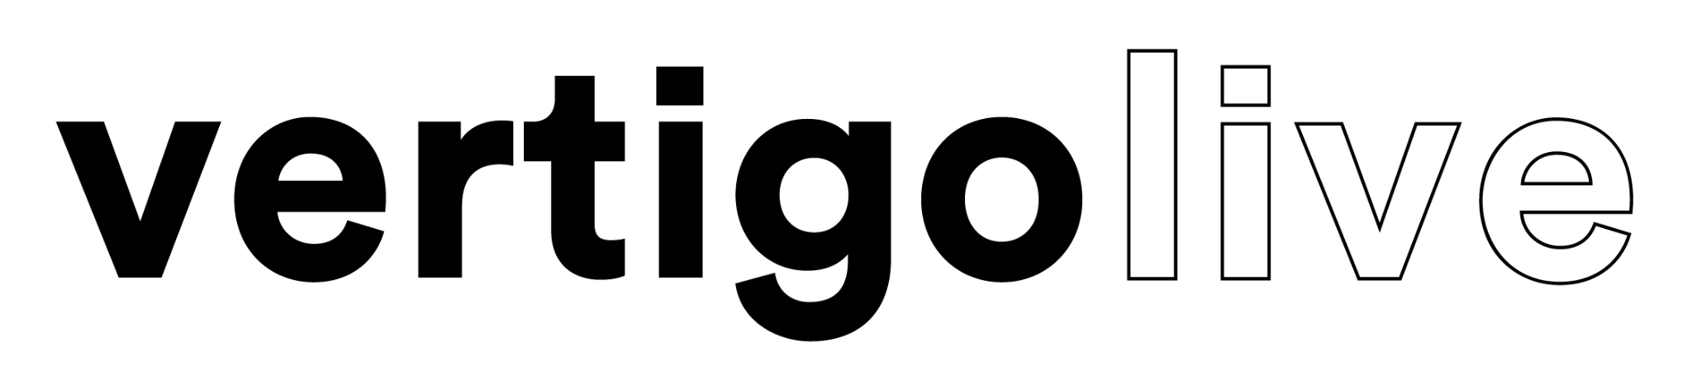
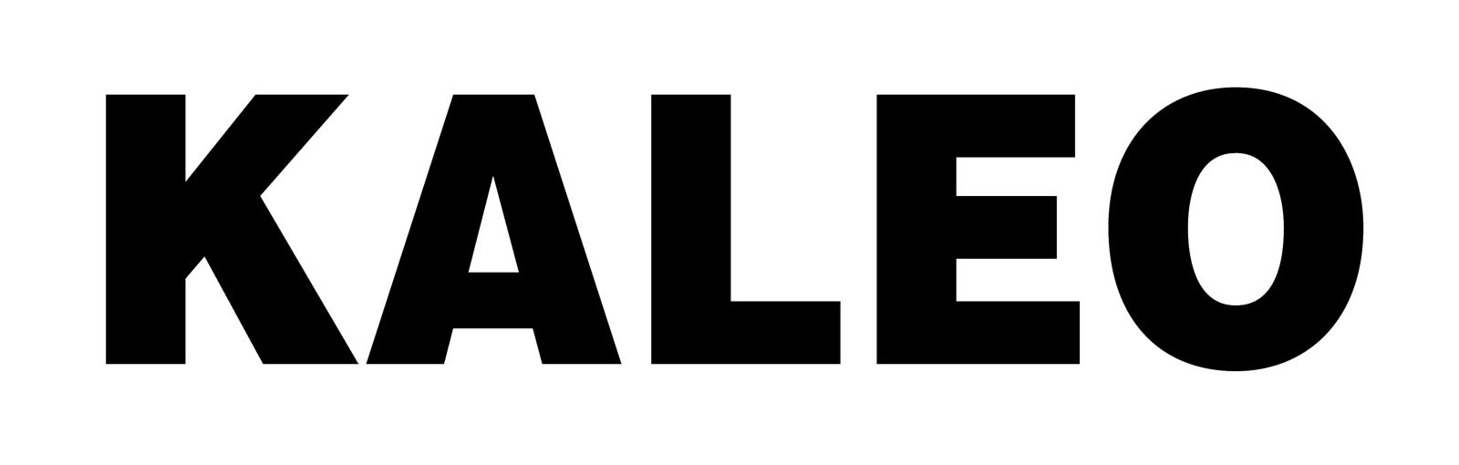
KALEO DELIVERS INCREDIBLE PERFORMANCE AT ROME’S HISTORIC ARCHEOLOGICAL PARK OF THE COLOSSEUM

MOMENTOUS NIGHT TO BE RELEASED AS DOCUMENTARY-CONCERT FILM

‘KALEO: VIVA ROMA IN THE SHADOW OF THE COLOSSEUM’
ARRIVES THIS SUMMER
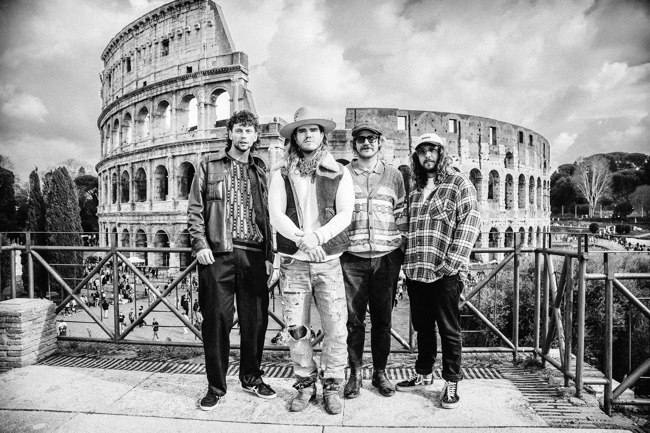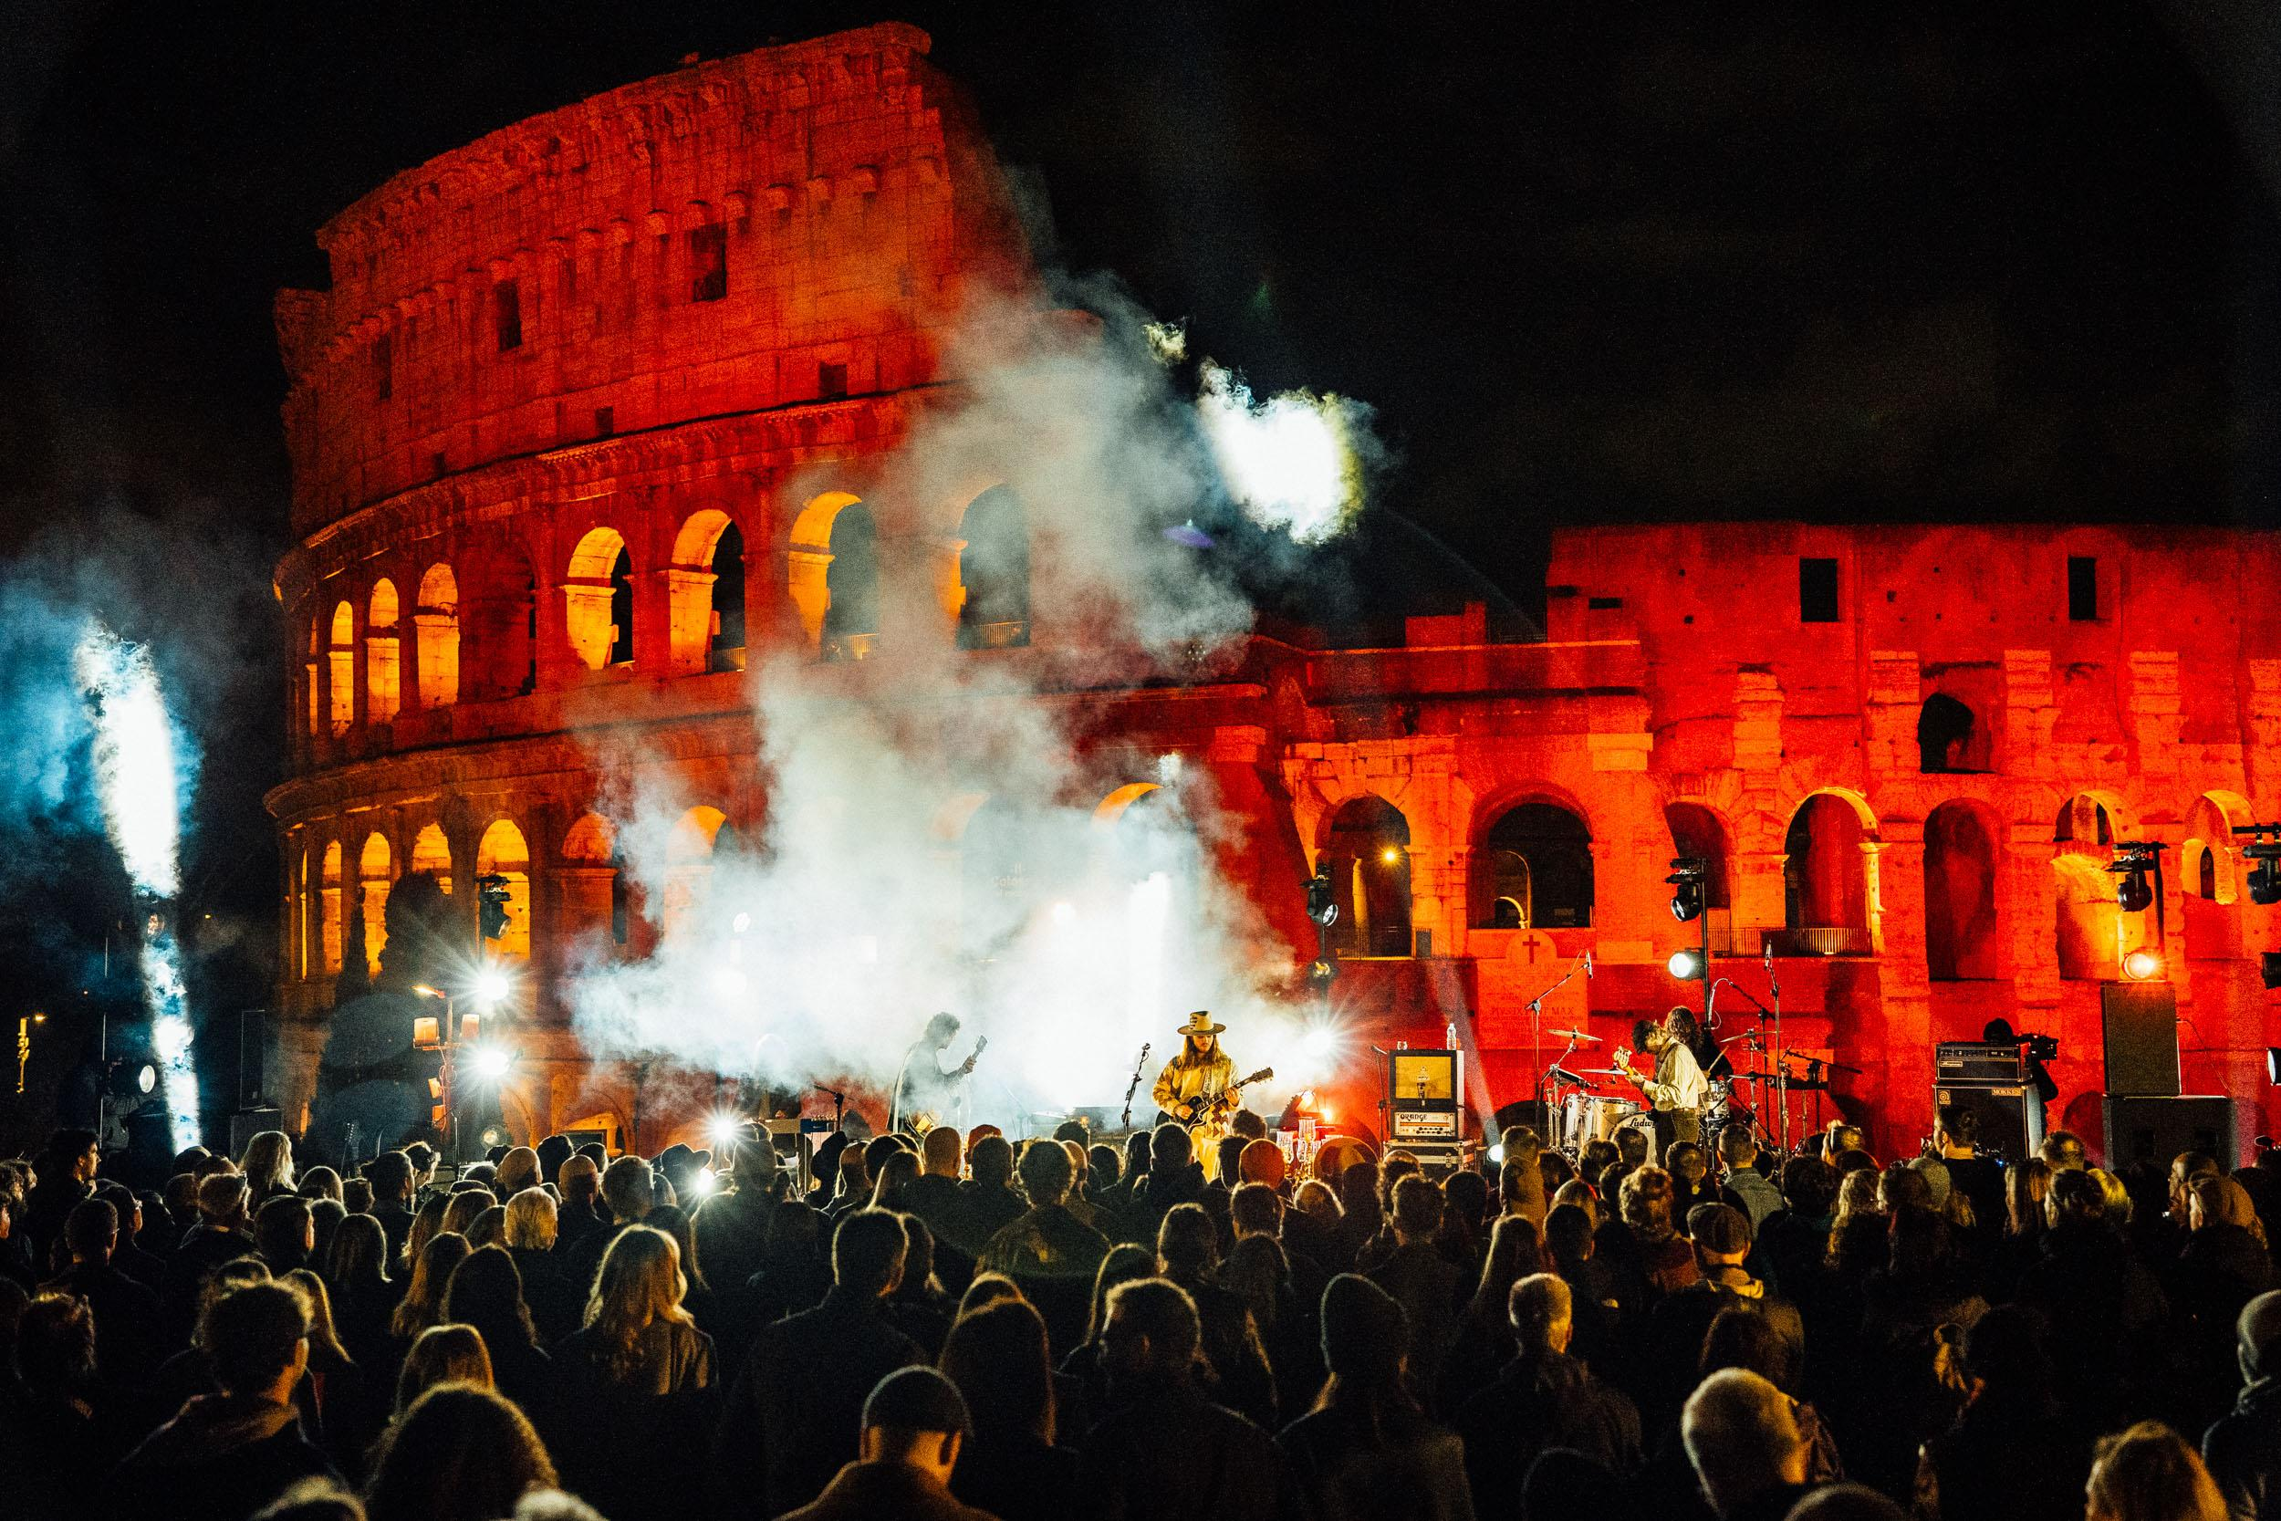
WATCH AN OFFICIAL TEASER OF THE PERFORMANCE HERE
DOWNLOAD HI-RES LIVE IMAGES HERE

March 4, 2024 - This past Saturday, March 2nd, 2024, GRAMMY-nominated Icelandic rockers KALEO celebrated their 10th anniversary by delivering a stunning live performance in front of 250 of their biggest fans at the Archeological Park of the Colosseum, Rome, and in the shadow of the world-famous amphitheater. Today, they’ve shared brilliant live images and video from the epic evening - watch an official teaser HERE.

Presented by VERTIGO LIVE, a leading producer of cinematic live experiences, the momentous night was captured on film and will be released as KALEO: Viva Roma in the Shadow of the Colosseum later this summer. The documentary-concert film marks the third chapter of the Vertigo LIve series and was helmed by GRAMMY & EMMY nominated director Giorgio Testi. The film will feature a blend of concert performance and documentary footage, celebrating a decade of KALEO.

The Colosseum is a UNESCO World Heritage Site, where performances in and around the grounds are INCREDIBLY rare. KALEO now join the ranks of Ray Charles, Stevie Wonder, Billy Joel, The Cure, Elton John, and Paul McCartney as the only artists to have ever performed an electric concert in front of this iconic monument. However, unlike those Hall of Fame artists, KALEO’s performance took place before a mere 250 fans making this the most unique experience the venue has ever seen.

The one night only event marked 10 years of phenomenal achievements from KALEO, who have amassed over 4+ Billion global streams, 60+ international certifications, countless sold-out headlining shows, appearances at such noteworthy festivals as Coachella, Lollapalooza and Bonnaroo plus a direct support slot opening for Rock & Roll Hall of Famers, the Rolling Stones.

JJ Julius Son of KALEO says, “I’m incredibly excited to have the opportunity of creating this once in a lifetime cinematic experience with Giorgio and the VERTIGO LIVE team, I’ve always wanted to perform at the Colosseum, so for me, this is a dream come true - and I can’t wait for our fans to see the film.”

Director Giorgio Testi says, “I’m a huge fan of KALEO and delighted to be able to collaborate with them in bringing JJ’s vision to life. Expect a film of gladiatorial proportions!”

For more details about the show visit here.

For more information contact;

VERTIGO LIVE: Kelly@lastmanmusic.com
KALEO: GlennFukushima@elektra.com | RossAnderson@elektra.com | SydneyWorden@elektra.com

About Vertigo Live;

VERTIGO LIVE, the revolutionary series developed by Lastman Media, is redefining the live concert film experience. With a focus on capturing legendary artists in iconic locations, each VERTIGO LIVE cinematic event is designed to deliver an undeniable WOW factor, reinventing the traditional concert film format in an innovative and disruptive way. To date, epic films have been created with music icons Duran Duran, Billy Idol and most recently Icelandic rockers, Kaleo. By blending documentary and performance footage, each film offers a compelling and engaging proposition for audience and artist alike. VERTIGO LIVE events also serve as powerful promotional tools for artists, providing marketing tentpoles to launch new events or tours and reach a global audience in today’s challenging and noisy musical landscape. VERTIGO LIVE is the visionary future of live concert films, setting a new standard for music entertainment. Legendary Artists, Iconic Locations, This is VERTIGO LIVE. www.thisisvertigo.live

About KALEO;

Since the release of their gold-certified breakthrough album, 2016’s A/B, Icelandic rock band KALEO—lead by frontman/songwriter JJ Julius Son—have taken their music around the world. The album spawned three hit singles – the GRAMMY-nominated “No Good,” the gold-selling “All The Pretty Girls” and the chart-topping, 2x Platinum-certified “Way Down We Go” which was used in over two dozen television shows from Grey’s Anatomy to Riverdale, leading the No. 1 single to top The Hollywood Reporter’s Top TV Songs chart. Their most recent album, 2019’s Surface Sounds featured the pair of lead Triple A No.6 singles “I Want More” and “Break My Baby.” After amassing over 4 Billion global streams, 60 international certifications, and countless sold-out headline shows spanning from Morrison, CO’s iconic Red Rocks to London and Moscow, KALEO has proven to be a worldwide phenomenon. Known for their electrifying live performances, KALEO completely sold out their first U.S. headline tour and was a standout at Coachella, Lollapalooza and Bonnaroo, and were even hand-picked to open stadium dates for the Rolling Stones. KALEO have also performed on television staples such as Late Night with Seth Meyers, Jimmy Kimmel Live!, The Late Show with Stephen Colbert, Good Morning America and more.

Keep an eye out for more from KALEO soon.

A SPECIAL THANKS TO PARCO ARCHEOLOGICO DEL COLOSSEO.

CONNECT WITH KALEO
Official Website | Facebook | Instagram | X

