GAMES WE PLAY UNVEILS ANXIOUSLY AWAITED DEBUT ALBUM
LIFE’S GOING GREAT VIA FUELED BY RAMEN/DCD2
LISTEN HERE

U.S. HEADLINE TOUR AND FALL OUT BOY SUPPORT DATES KICK OFF MARCH 15
TICKETS AVAILABLE HERE

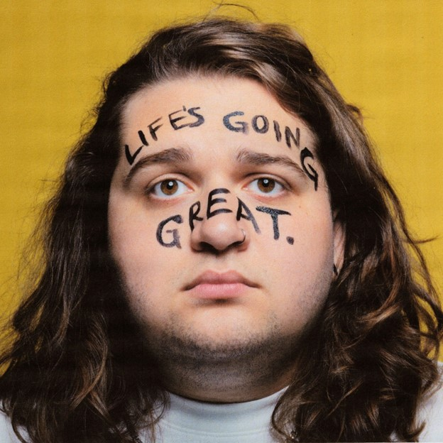
DOWNLOAD HI-RES PRESS ASSETS HERE

“2024 Artist To Watch” GRAMMY.com

“The one-man pop-punk powerhouse Games We Play produces nothing but feel-good pop-punk anthems” Alternative Press

“Big, catchy hooks and lyrics that are equal parts spiteful and playful” Consequence

“Emotionally self-aware lyrics, big heavy riffs and a brilliantly fun attitude” Rock Sound

“Radiating pop-punk-esque melodies that provide a mesmerizing atmosphere paired with glowing crisp vocals” New Noise

“Games We Play is going to be massive. Just a talented musician who has it all — catchy music, fun lyrics and an amazing stage presence.” LOUDWIRE

March 1, 2024 - Singer, songwriter, multi-instrumentalist, producer, and pop-punk provocateur Games We Play (a.k.a Emmyn Calleiro) has unveiled his anxiously-awaited debut album Life’s Going Great. The album is available on all streaming platforms HERE via Fueled By Ramen / DCD2.

About the momentous release Emmyn shares, “Starting games we play, having my dad play drums for my first show, dropping out of school, flyering highschools in Miami and begging kids to come to my shows, crashing my van on the first day of my first ever (attempted) tour in 2016, moving to nashville and then to LA, and posting tik toks were ALL leading up to this moment. It's a dream come true putting out a record on Fueled By Ramen/DCD2 alongside Pete Wentz. 14-year-old Emmyn's dream come true type stuff. I literally can't believe that sentence is even true.”

Life’s Going Great sees Emmyn confront the emotional whiplash of his early 20s. In less than two short years he went viral, signed to his dream record label, found a mentor in Fall Out Boy bassist Pete Wentz, and toured the world supporting his idols (YUNGBLUD, Fall Out Boy, All Time Low, The Band CAMINO). Simultaneously his personal life came crashing down -- he went through a major breakup, left Los Angeles and returned home to Nashville to live with his parents, and struggled with self-image. These highs and lows formed the basis of Life's Going Great. The album was originally set to arrive last year, but as things began taking a turn for the better again, Emmyn realized it wasn’t done, and decided to go back to the studio to finish telling the full story. Now, with introspection and a tad less sarcasm, life really is going great for Emmyn. Recorded across London, Nashville, and Los Angeles with creative kindred spirit and producer Larry Hibbitt (Marmozets, Nothing But Thieves, Dinosaur Pile-Up), the album continues to showcase Emmyn’s quick wit and aptitude for anthemic pop-punk song-craft.

Emmyn paved the way for Life’s Going Great with the hyper catchy “All My Untalented Friends (Ooo La La),” the emotionally charged “too young,” and the vulnerable earworm “Pretty Boy.” Also included on the album are Emmyn’s latest singles “Girl Shaped Crater,” which Rolling Stone hailed as a “song you need to know,” and the gleefully spiteful “Petty Enemy.”

Later this month, Emmyn will hit the road to support select dates of Fall Out Boy’s North American tour, followed by his own US headline run. Dubbed the Life’s Going Great Tour, dates kick off on March 27th in Detroit, making stops in Los Angeles, Nashville, New York, Philadelphia and more before wrapping in Boston on May 1st. See full tour routing below. For tickets and more information, visit gwp.lnk.to/tour.

Life’s Going Great Album Track List
1. The End
2. Typical Me
3. Girl Shaped Crater
4. Oh So Blue
5. Petty Enemy
6. Interlude (ft. Pete Wentz)
7. too young.
8. So Bad
9. Pretty Boy
10. Round & Round
11. Naked
12. All My Untalented Friends (Ooo La La)
13. Life’s Going Great

Games We Play Tour Dates
Life’s Going Great Tour
^ Supporting FOB, The Maine
*Headline Show

March 15, 2024 - Orlando, FL - Amway Center ^
March 16, 2024 - Jacksonville, FL - VyStar Veterans Memorial Arena ^
March 19, 2024 - Raleigh, NC - PNC Arena ^
March 20, 2024 - Baltimore, MD - CFG Bank Arena ^
March 22, 2024 - New York, NY - Madison Square Garden ^
March 24, 2024, Albany, NY - MVP Arena ^
March 26, 2024 - Grand Rapids, MI - Van Andel Arena ^
March 27, 2024 - Detroit, MI - Shelter *
March 29, 2024 - Chicago, IL - Cobra Lounge *
March 30, 2024 - Minneapolis, MN - 7th Street Entry *
April 2, 2024 - Denver, CO - Meow Wolf *
April 3, 2024 - Salt Lake City, UT - Kilby Court *
April 5, 2024 - Vancouver, BC - Wise Hall *
April 6, 2024 - Seattle, WA - Barboza *
April 7, 2024 - Portland, OR - Mission Theatre *
April 9, 2024 - Los Angeles, CA - El Cid *
April 10, 2024 - Phoenix, AZ - Valley Bar *
April 13, 2024 - Austin, TX - Empire Control Room *
April 14, 2024 - Dallas, TX - HOB- Cambridge Room *
April 16, 2024 - St. Louis, MO - Old Rockhouse *
April 17, 2024 - Nashville, TN - Eastside Bowl *
April 19, 2024 - Orlando, FL - The Social *
April 20, 2024 - Atlanta, GA - Purgatory The Masquerade *
April 23, 2024 - New York, NY - Gramercy Theatre *
April 24, 2024 - Washington, DC - The Atlantis *
April 25, 2024 - Philadelphia, PA - The Church *
April 27, 2024 - Toronto, ON - Velvet Underground *
April 28, 2024 - Columbus, OH - A&R Bar *
May 1, 2024 - Boston, MA - Brighton Music Hall *

ABOUT GAMES WE PLAY:
Games We Play a.k.a. Emmyn Calleiro brings pop punk back to the people. You could think of him as the pop punk everyman—kinda like Springsteen if he was weaned on blink-182. He writes about breakups, awkwardness, growing up, and living his dream with wide-eyed enthusiasm through the perspective of a seasoned pro. For as sharp as his hooks are, he’s also gleefully self-effacing (which makes him even more likable!). Moreover, he’ll play a Denny’s with just as much bombast and bravado as he would an arena (and he’s actually done both!). The Florida-born singer, songwriter, multi-instrumentalist, and producer relocated to Nashville in his teens and served up the independent Senior Year EP in 2018. Simultaneously, his sense of humor, relatability, and sharp songcraft endeared him to a rabid fan base on TikTok as “I Hope You’re Happy” caught fire. He wound up signing to Fueled By Ramen/DCD2 Records and dropped his major label debut EP, Get A Job, in 2022. Beyond reeling in tens of millions of streams, he incited the applause of Consequence, Alternative Press, Loudwire, Rock Sound, The Honey Pop, and more. Renowned for his live energy, he notably toured alongside everyone from All Time Low, The Band CAMINO, and State Champs to YUNGBLUD and Fall Out Boy. Now, he’s serving up a batch of undeniable and unforgettable anthems on his full-length debut, Life’s Going Great. Get ready to sing along to Games We Play.

Connect with Games We Play:
Instagram |X | Facebook | YouTube | TikTok

Press contacts:
Collin Citron / Collin.Citron@300elektra.com
Sydney Worden / Sydney.Worden@300elektra.com

