RISING COSMIC-AMERICANA SINGER-SONGWRITER CASSANDRA LEWIS
RELEASES MAJOR LABEL DEBUT SINGLE “LOST IN A DREAM”

LISTEN HERE | WATCH HERE

ANNOUNCES SIGNING TO ELEKTRA

DAVE COBB-PRODUCED ALBUM LOST IN A DREAM TO COME LATER THIS YEAR

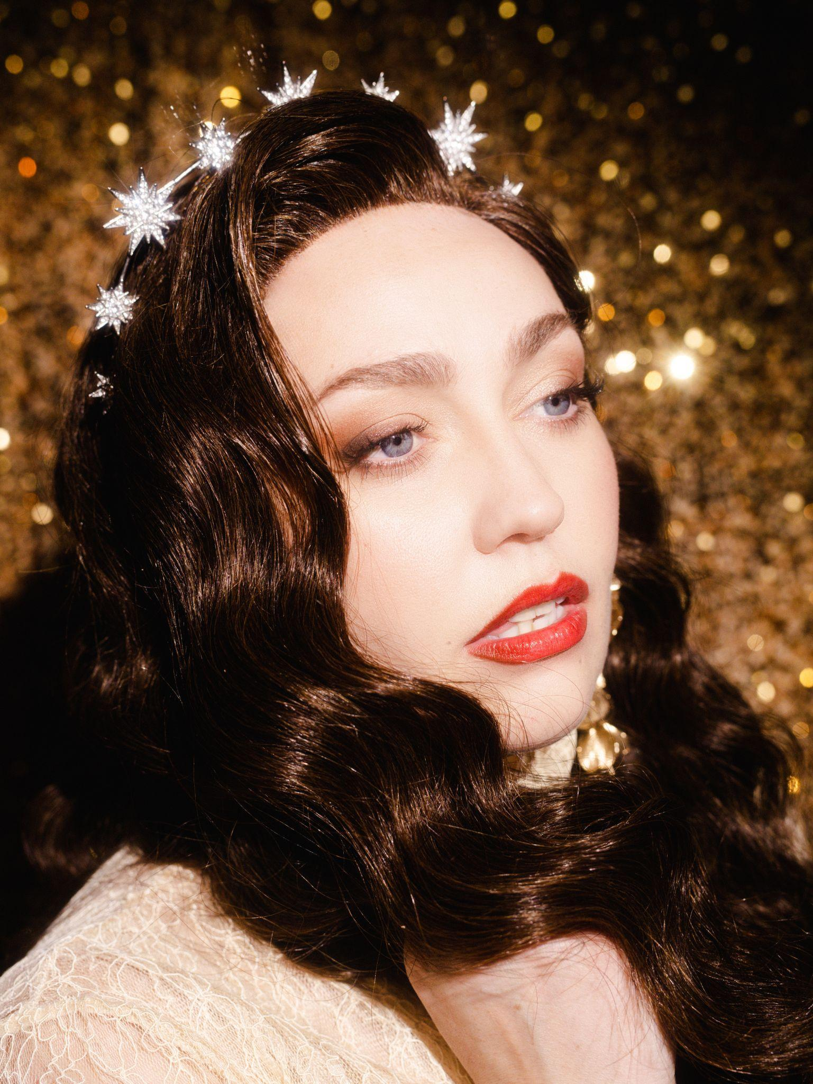
PHOTO CREDIT: ASHLEY OSBORN
DOWNLOAD HI-RES PRESS ASSETS HERE

(MARCH 22, 2024) - Rising cosmic Americana singer-songwriter Cassandra Lewis has shared her major label debut single “Lost In A Dream,” and announced her signing to Elektra/Low Country Sound in an exclusive interview with Consequence this morning. Co-written by Cassandra and Natalie Hemby, “Lost In A Dream” is like pulling back the curtain in The Wizard of Oz, revealing that your partner isn’t who you thought they were. Cassandra’s powerful vocals vividly convey the disillusionment and heartbreak of realizing that you’ve put someone on a pedestal they can’t stand on. The song is available now on all streaming platforms HERE. Additionally, Cassandra has shared a live version of the single now streaming on her official YouTube channel HERE, filmed in the same parking garage that led to her major label signing.

"’Lost in a dream’ is about the psychedelic nature of being stuck in the haze between reality and lies,” Cassandra explains. “Through toxic relationships, love, loss, addiction and redemption, we have all found ourselves closing chapters to stories that needed happy endings, so we gave them to ourselves. This song and the album is a complex story about the ways we can be deceived by our lovers and ourselves."

After releasing music independently for years, and being just about ready to give up, Cassandra wound up in an impromptu meeting with Elektra Records President Gregg Nadel, where she performed for him in Elektra’s parking garage. Killer acoustics aside, Nadel was immediately floored by Cassandra’s incredible voice, and enthralled by her story and personality.

"Cassandra has one of those voices that will stop you in your tracks, and, as a songwriter, her authenticity and vulnerability shine through,” Nadel comments. “This is an artist who knows who she is, and all of us at Elektra couldn’t be more thrilled to be a part of her journey."

After flying to Nashville to meet 9x-GRAMMY Award-winning producer Dave Cobb (Jason Isbell, Brandi Carlile, Sturgill Simpson, Chris Stapleton) at RCA Studio A, the deal was set. They met back up in Savannah, GA where they recorded Cassandra’s major label debut album Lost In A Dream, which will arrive later this year.

“Cassandra’s voice is absolutely stunning, I love the purity and beauty in it, it’s as if you’re hearing a timeless voice for the ages,” says Cobb.

"I had the great honor of working alongside Dave Cobb and Gregg Nadel who were brave enough to take me on and give me a home,” Cassandra adds. “We all agreed that this was the right team that could and should steward and deliver my new record, and I would have stayed on my indie path if not for this exact set up. Dave's style of analog, live room recording has long been a lynchpin in my own creative process. He makes a damn good record along with the rest of the band and crew, and I'm beyond excited to get this baby spinning in your dark room surrounded by your people."

Offering a cosmic blend of classic country, Americana, and psychedelic soul, Cassandra Lewis will call you into her journey of self-discovery, addiction, love affairs, and a fever dream of in-betweens. With a massive voice, real talk, and a wild storyteller’s wit, Cassandra describes herself as a “cosmic western queer taranti-noir fever dream making fine art & songs from trash,” and cites influences such as Dolly Parton, Patsy Cline, Janis Joplin and Etta Woods.

Cassandra Lewis
“Lost In A Dream”
AVAILABLE NOW
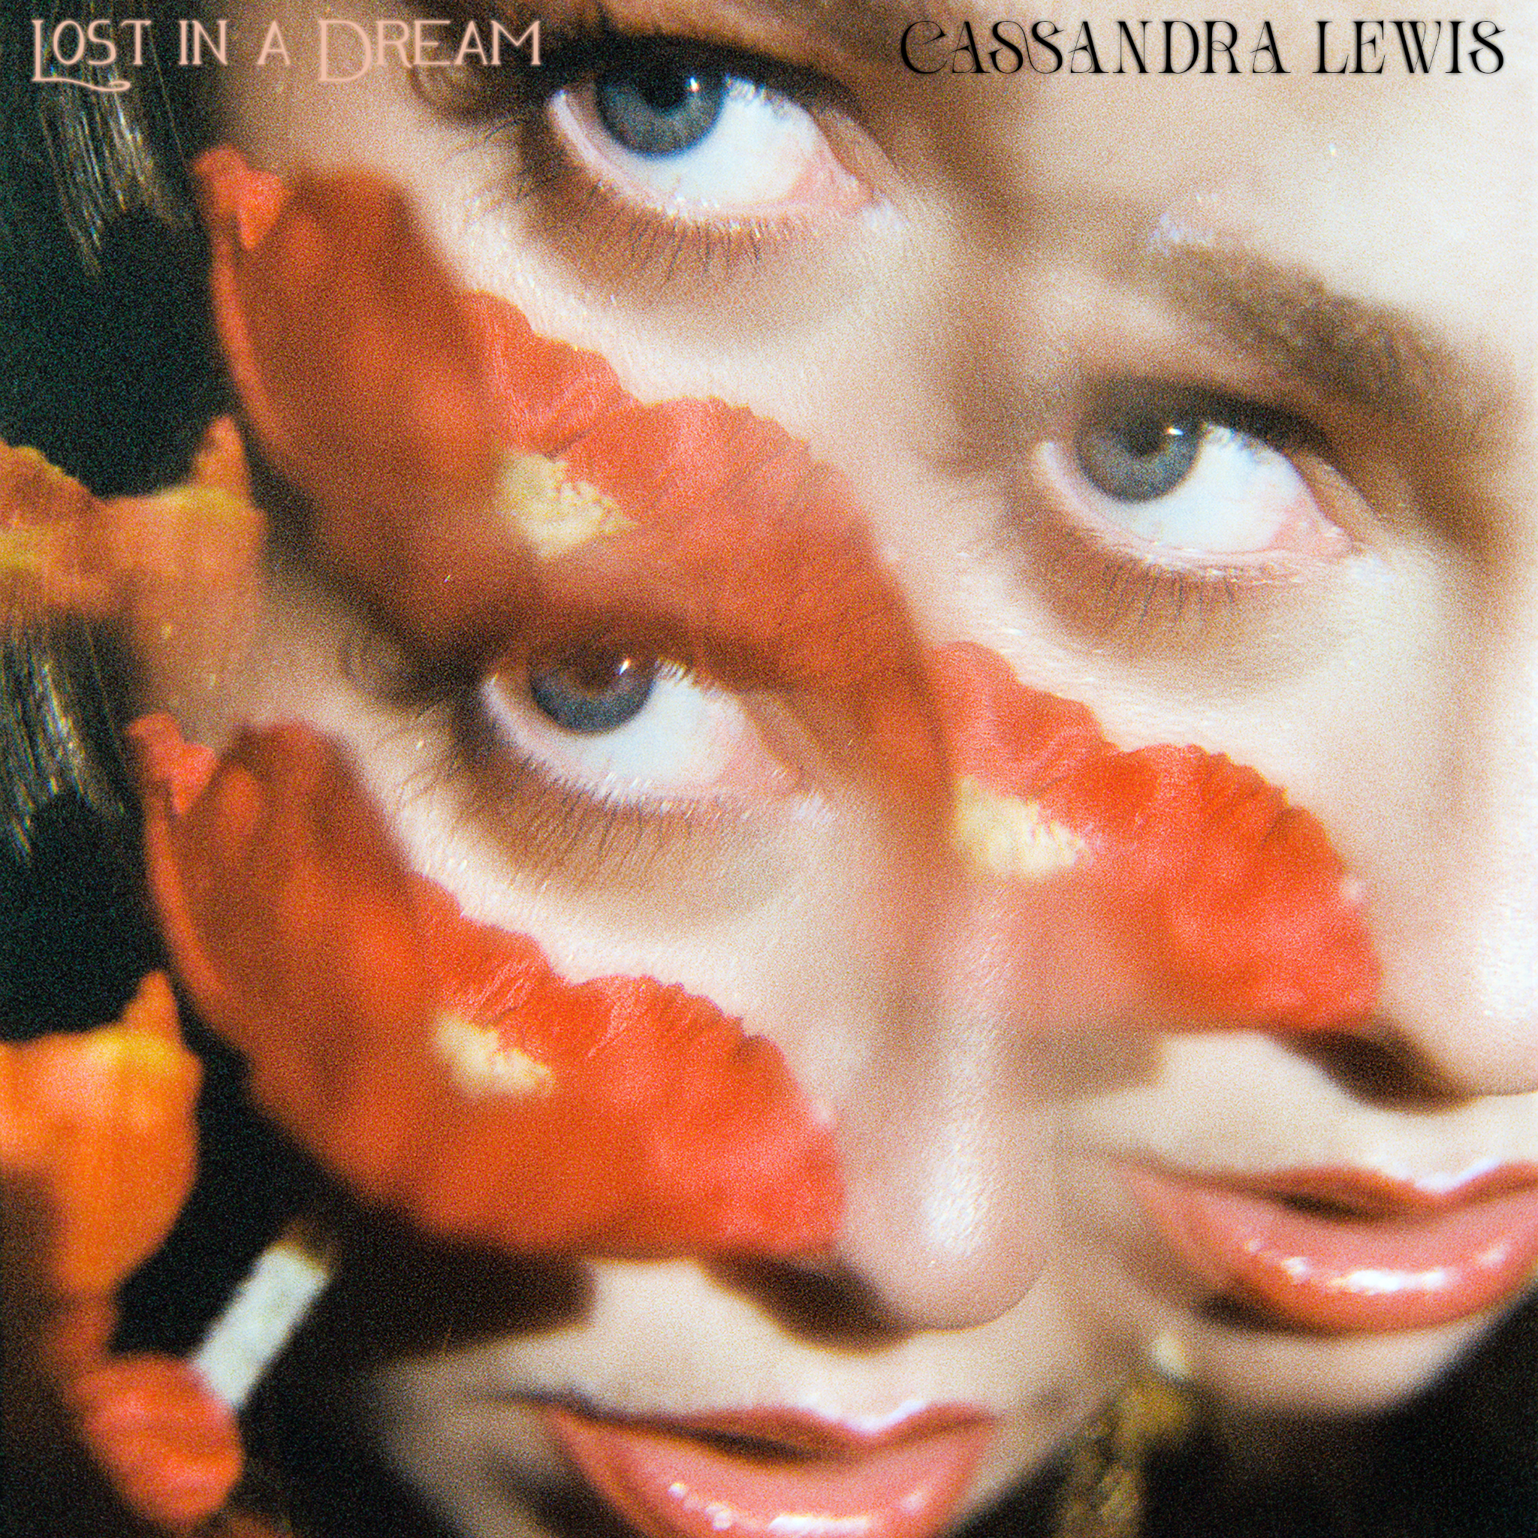
“LOST IN A DREAM” - SINGLE ARTWORK

CASSANDRA LEWIS 2024 TOUR DATES
* festival performance
March 22 - Boise, ID - Treefort Music Fest*
April 20 & 21 - Miramar Beach, FL - Moon Crush*
July 5 & 6 - ON, Canada - Mariposa Folk Festival*
September 26 & 27 - Sisters, OR - Sister’s Folk Festival*
September 29 - Franklin, TN - Pilgrimage Music & Cultural Festival*

ABOUT CASSANDRA LEWIS
Cassandra Lewis knows how to tell a story. She could go into detail about a childhood in constant motion, moving in a montage from Germany through Florida, Texas, and, eventually, Idaho among her family of “high mountain desert folk.” She shares memories of escaping loneliness and insecurity in front of the television set or tasting her first bit of fanfare as “a little yodeling cowgirl” at the town’s lone Walmart or retirement homes. There were moments of houselessness, working in countless restaurants, sleeping in a shared tent at a refugee camp, and selling joints “out of the back of a Subaru” that she lived out of with her rescue dog and cat after a wildfire burned down her farm in Mendocino. She found community in the Bay Area and if not for the integration of psilocybin and psychedelic medicine, she may have succumbed to the pitfalls of life instead of moving forward and using her pain to heal and forgive. She says she holds a deep gratitude for these dualities. “You can’t appreciate the light without living and breathing the dark.” She inhaled inspiration from cut-and-dry classic country and rock ‘n’ roll, smoked-out soulful psychedelia, and exhaled a shadowy signature sound—easily likened to a fever dream between Marty Robbins and Joni Mitchell. This is a new kind of cosmic Americana. She slung her songs for anyone who would listen only for a proverbial “last shot” to pay off by landing a deal with Elektra/Low Country Sound circa the Pandemic. Now, she’s taking this foundation and paving her own yellow brick road on her 2024 full-length album, Lost in a Dream.

CONNECT WITH CASSANDRA LEWIS:
WEBSITE / TIKTOK / INSTAGRAM / FACEBOOK / YOUTUBE

PRESS CONTACTS
Collin Citron - CollinCitron@elektra.com
Sydney Worden - SydneyWorden@elektra.com

