FOR IMMEDIATE RELEASE
January 16, 2024

BENDIGO FLETCHER ANNOUNCE NORTH AMERICAN HEADLINE TOUR

33-CITY TREK KICKS OFF MARCH 8
TICKETS AVAILABLE THIS FRIDAY HERE

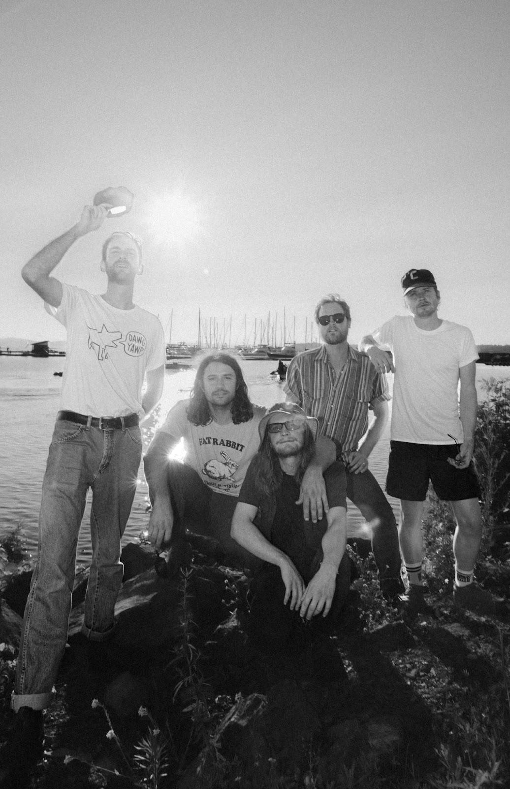
Photo credit: Nia Garza

Louisville, KY’s Bendigo Fletcher have announced they will embark on a North American headline tour this spring. The 33-city trek kicks off on March 8 in Indianapolis, visits major markets coast-to-coast, and wraps on May 11 in Cincinnati. Pre-sale tickets for the tour will be available beginning tomorrow, and general on-sale begins this Friday, January 19 at 10:00am ET HERE.

Last fall, Bendigo Fletcher surprised fans with a cover of Cults’ 2011 classic “Go Outside”. “Go Outside (From Natural Bridge State Resort Park)” is available to stream and download HERE via Elektra. Recorded live at Slade, KY’s Natural Bridge State Resort Park, the release was accompanied by a stunning visual of the band performing the song in the picturesque location. Watch HERE. Bendigo Fletcher encourages fans to support the Kentucky State Parks Foundation, a non-profit organization aimed at connecting residents and guests to the outdoors. The band also partnered with Kentucky Parks Club on a limited edition t-shirt, designed by frontman Ryan Anderson. The shirt is available now HERE.

“Go Outside (From Natural Bridge State Resort Park)” marked the first new music from Bendigo Fletcher since the release of their 2023 Fourth of July single “Uncle Mick’s Fireworks Extravaganza”. In 2022, Bendigo Fletcher released their four track Wingding EP. MUD professed, “Bendigo Fletcher is a beauty of a band, masterfully crafting stories and depicting what it is to be wonderfully human with folk-rock spectacularly infused with psychedelic twang.” The EP also earned praise from Consequence, The Bluegrass Situation, Entertainment Tonight, and more. Watch the band perform the EP’s lead single “Pterodactyl” live from La La Land Studios HERE.

Wingding followed Bendigo Fletcher’s 2021 debut album Fits Of Laughter. Highlighted by singles “Sugar In The Creek” and “Evergreen”, the album is available HERE via Elektra. Beyond amassing millions of streams, the album earned widespread critical acclaim. FLOOD Magazine hailed it as “Somewhere between the post-Woodstock folk scene of the ‘70s and that decade’s burgeoning hard rock movement,” and Music Connection dubbed it, “Alt-rock, country-flecked folk-rock soaked in LSD.” American Songwriter noted it as “Denser psych-rock with some remaining elements of Bendigo Fletcher’s drifting folk-Americana roots”, and Atwood Magazine praised “Fits Of Laughter soars with charming passion.

Last year, Bendigo Fletcher supported The Backseat Lovers on their Waiting To Spill Summer Tour. They also joined The Brook & The Bluff on a 7-week run which saw them perform to sold out crowds across North America. As a powerhouse live presence, the band has previously toured supporting Caamp, Mt. Joy, Rainbow Kitten Surprise, Shakey Graves, Madison Cunningham, and more.

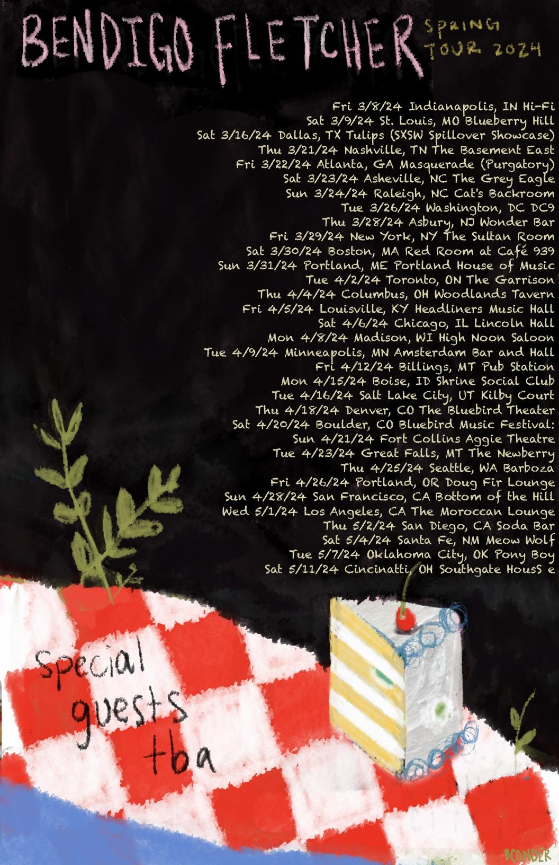

Bendigo Fletcher Tour Dates
March 08, 2024 - Indianapolis, IN - HI-FI Indy
March 09, 2024 - St. Louis, MO - Blueberry Hill
March 16, 2024 - Dallas, TX - Tulips
March 21, 2024 - Nashville, TN - Basement East
March 22, 2024 - Atlanta, GA - Masquerade (Purgatory)
March 23, 2024 - Asheville, NC - Grey Eagle
March 24, 2024 - Carrboro, NC - Cat’s Cradle Backroom
March 26, 2024 - Washington, DC - DC9
March 28, 2024 - Asbury, NJ - Wonder Bar
March 29, 2024 - New York, NY - Sultan Room
March 30, 2024 - Boston, MA - Cafe 939
March 31, 2024 - Portland, ME - Portland House of Music
April 02, 2024 - Toronto, ON - The Garrison
April 04, 2024 - Columbus, OH - Woodlands
April 05, 2024 - Louisville, KY - Headliners Music Hall
April 06, 2024 - Chicago, IL - Lincoln Hall
April 08, 2024 - Madison, WI - High Noon Saloon
April 09, 2024 - Minneapolis, MN - Amsterdam
April 12, 2024 - Billings, MT - Pub Station
April 15, 2024 - Boise, ID - Shrine Social Club
April 16, 2024 - Salt Lake City, UT - Kilby Court
April 18, 2024 - Denver, CO - Bluebird Theater
April 20, 2024 - Boulder, CO - Bluebird Music Festival*
April 21, 2024 - Fort Collins, CO - Aggie Theatre
April 23, 2024 - Great Falls, MT - The Newberry
April 25, 2024 - Seattle, WA - Barboza
April 26, 2024 - Portland, OR - Doug Fir
April 28, 2024 - San Francisco, CA - Bottom of the Hill
May 01, 2024 - Los Angeles, CA - Moroccan Lounge
May 02, 2024 - San Diego, CA - Soda Bar
May 04, 2024 - Santa Fe, NM - Meow Wolf
May 07, 2024 - Oklahoma City, OK - Ponyboy OKC
May 11, 2024 - Newport, KY - Southgate House Revival
*Festival Appearance

Bendigo Fletcher is: Ryan Anderson (lead vocals, guitar, banjo) - Andrew Shupert (backing vocals, lead guitar) - Evan Wagner (backing vocals, keys, guitar, auxiliary percussion) - Conner Powell (bass) - Chris Weis (drums).

BendigoFletcher.com
Facebook | Instagram | Twitter | YouTube

Bendigo Fletcher press contact:
Collin Citron | collin.citron@300elektra.com
Destiny Dominguez | destiny.dominguez@300elektra.com

