VICTORIA CANAL DEBUTS LIVE VIDEO FOR
“BRAVER (FEAT. MADISON CUNNINGHAM)”

NEW EP WELL WELL OUT NOW

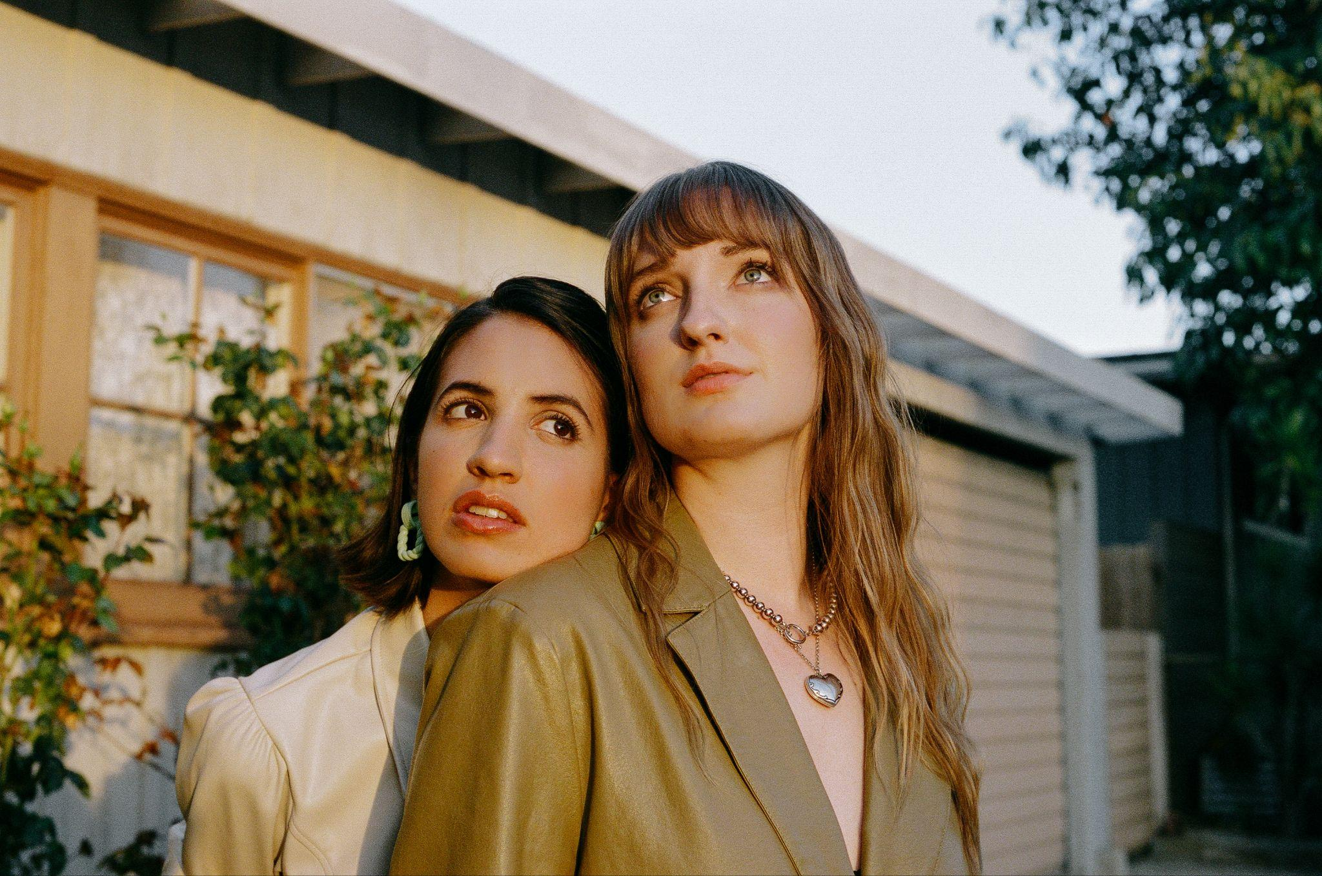
Hi-res assets here // photo credit: Caity Krone

“Canal’s ascendant career is built on her ability to unflinchingly capture feelings… Her directness about body image and mental health has brought her an audience of people a lot like her.”
– THE NEW YORKER

“perceptive, unflinching songs… as the world wakes up to her many talents.” – THE OBSERVER

“her gentle and ruminative form of songwriting is finally getting the recognition it deserves” - i-D

"a tender blend of goosebump-inducing balladry akin to the kind of cataclysmic intensity of artists like Phoebe Bridgers or Holly Humberstone" – NME

“WELL WELL makes it clearer than ever that she is taking the music world by storm — in her own right, on her own terms.” – 1883 MAGAZINE

"the 25-year-old fearlessly explores the darkest nooks and crannies of the soul” – FLOOD MAGAZINE

“WELL WELL represents her at her most vulnerable and her most brave” – GAY TIMES
NOVEMBER 15, 2023 – Singer/songwriter and multi-instrumentalist Victoria Canal has shared a live performance video for her song “Braver (feat. Madison Cunningham),” lifted from her recent EP WELL WELL.

Both Victoria and Madison star together in the video which affectionately tells the story of the life of Canal’s mother, from growing up poor in the South to falling in love with someone halfway across the world. An ode to the sacrifices of the generations that have come before us, and the love for the ones we hold close, Canal sings: “You’re braver than I’ve ever been… what I’d give to have known you back then.”

Of “Braver,” Victoria shares: “I wrote this song for my mom’s birthday last year as a little ode to her life story. Anyone who knows me knows how much it means to have Madison on this song… she’s my favorite songwriter out there right now, and I couldn’t be more honored that she agreed to be part of the recording.”

Madison adds: “Victoria has such a beautiful sense for song and melody. When she asked me to play and sing on this tune, the thrill of adding to something already so fully formed and delicate was a welcome challenge. Scanning for the least intrusive, most illuminating notes. It was an honor to be folded in.”

Watch the video for "Braver (feat. Madison Cunningham)"

Canal recently completed her debut headline tour of the UK, taking in shows across London, Manchester, Birmingham, Bristol and Glasgow, before heading on to play some headline European shows and a further run of support shows across the US with Sammy Rae and friends. Remaining 2023 live dates listed below.

A breakthrough year for Canal, she released her acclaimed EP WELL WELL, was profiled by The New Yorker, won the Rising Star award at the prestigious Ivor Novellos, which celebrates the craft of songwriters, composers and creators, was the recipient of an Attitude Pride Icon Award, supported Hozier across the UK and Europe, and was also named BBC Radio 1’s Future Artist for June.

After experiencing creative and emotional catharsis through the creation of her 2022 EP Elegy, WELL WELL finds Canal is turning the lens back on herself to look inwards: grown from heartache and made with unabashed honesty, these new songs find the artist at her most vulnerable—and her most courageous. Recent singles “Shape” and “She Walks In” were the first time she’d shared on the themes of body image and body dysmorphia, pertaining in part to her limb difference, while she describes “Company” as her “sweet gay love song.”

WELL WELL embraces the discomfort of self-analysis: “These days I’m writing mostly to confront things about myself in order to gain more of an understanding and acceptance of them,” she shares. “The phrase ‘WELL WELL’ struck me as a natural follow up to Elegy. I’ve grieved this person and now I’m dealing with what’s left,” Canal resolves, “I needed to stare myself in the face and realize that this is it. It’s a wounded rebirth.”

WELL WELL marks an expansion for Canal, not just thematically, but also with regard to collaborators. Working with the likes of S. Carey (Bon Iver), GRAMMY Award winners Madison Cunningham and Tony Berg helped push the musician creatively in a way she’s never experienced before. “In past projects I’ve been on my own or working with my buddies, which is amazing,” she remarks, “But this time I got to work with some of my heroes while also holding my own in the studio.” The artist attributes WELL WELL’s cohesive sound to her clear vision and the fact that everything was mixed at Sound City by veteran engineer Joseph Lorge (Blake Mills, Perfume Genius, Jon Batiste).

About Victoria Canal:
25 year-old singer, songwriter, producer and activist Victoria Canal makes soul-stirring, emotive pop music. Born in Munich, Spanish-American Canal says her international upbringing fostered her love for a nomadic life in music. A proud “third culture kid,” she lived everywhere from Shanghai, Tokyo, Amsterdam, London, and Dubai to Atlanta, New York, and Forth Worth, and is proud of her identity as a queer, disabled, mixed-heritage woman, which fuels much of her activism.

Last year Canal released her EP Elegy, which delicately dealt with themes of grief and death, and featured the single “swan song,” which Chris Martin of Coldplay hailed as ‘one of the best songs ever written’. She performed “swan song” on the recent series of Later… with Jools Holland, appearing alongside the likes of Self Esteem and The 1975.

Canal also made her television acting debut in acclaimed Apple TV+ anthology series Little America, starring in the season’s moving episode The Indoor Arm as a Spanish-speaking Salvadorian refugee in the 80s who comes to America to live with her sister. She also wrote “Bring It On,” the theme song for Apple TV+ series Best Foot Forward, based on the book by Paralympic skier Josh Sundquist.

VICTORIA CANAL
WELL WELL EP
AVAILABLE NOW
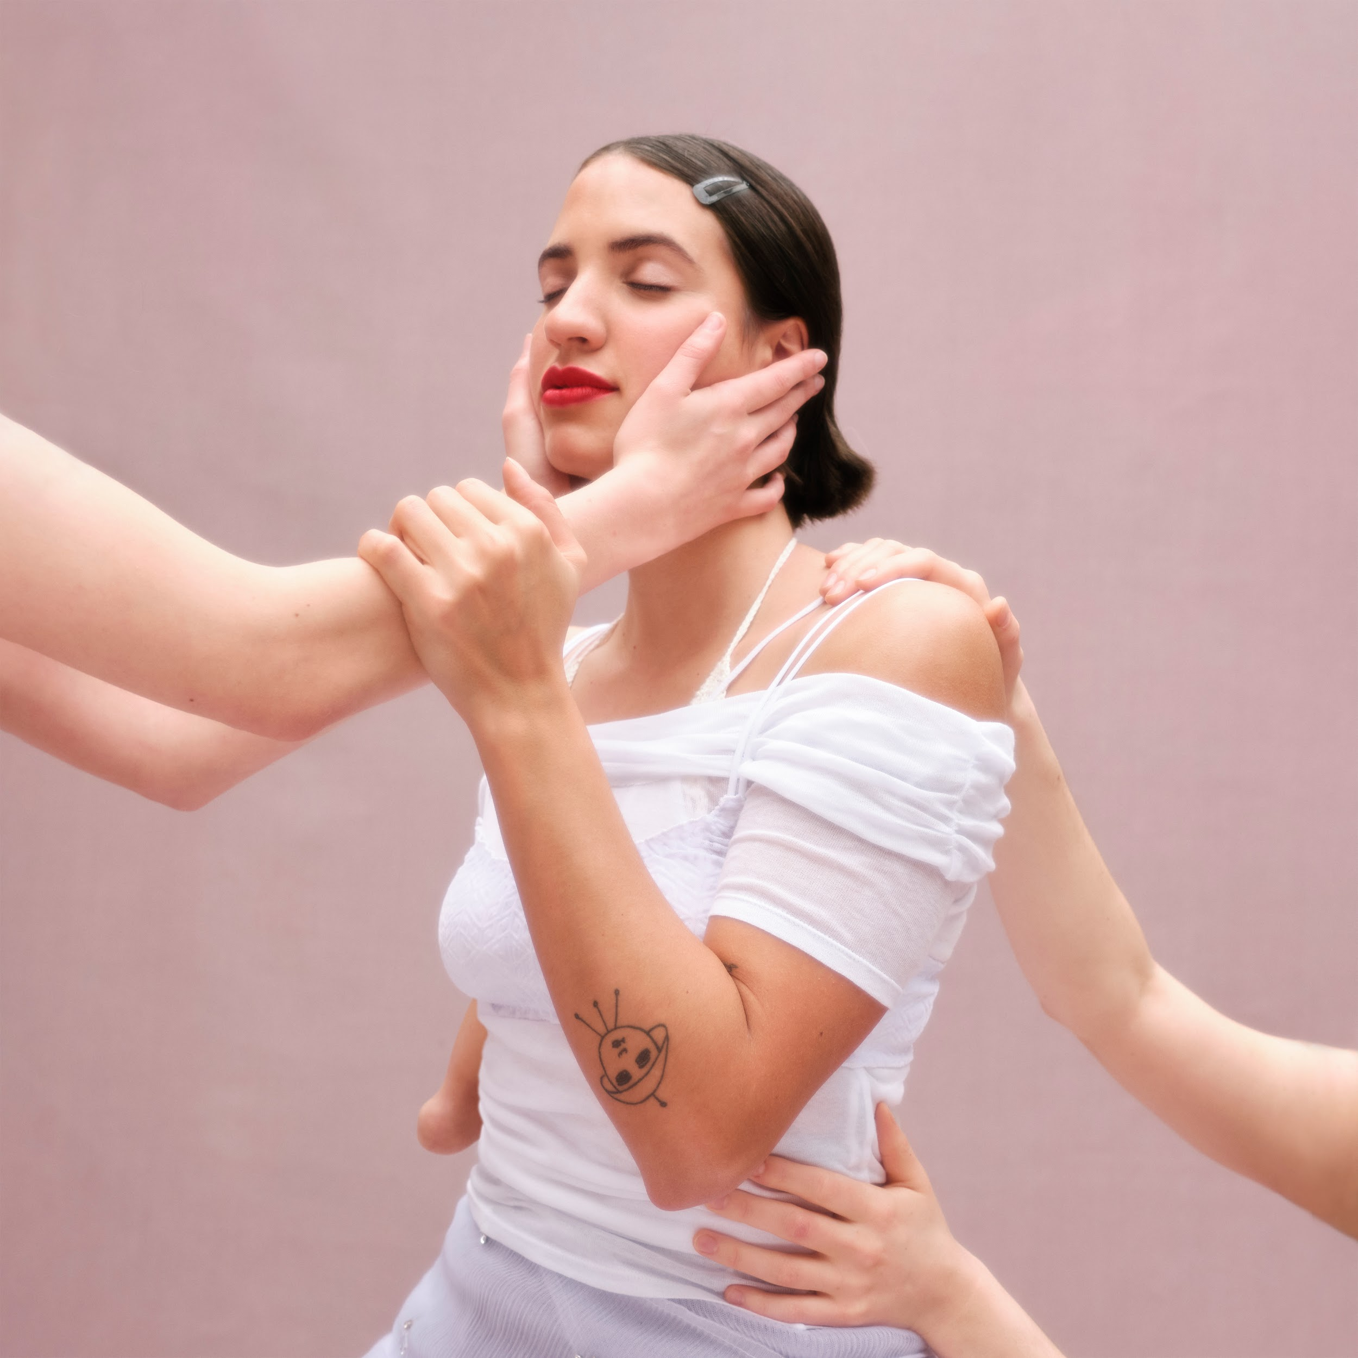

Tracklist:
- Shape
- She Walks In
- Braver (ft. Madison Cunningham)
- Yes Man (ft. S. Carey)
- Company
- Black Swan

CONNECT WITH VICTORIA CANAL
Instagram | Twitter | TikTok | Facebook | YouTube

For U.S. press inquiries please contact:
Sarah Goldstein / sarahgoldstein@elektra.com
Ross Anderson / rossanderson@elektra.com

