SYDNEY ROSE RELEASES DEBUT ALBUM ONE SIDED
OUT NOW VIA PUBLIC CONSUMPTION

“COOL GIRL” OFFICIAL MUSIC VIDEO STREAMING NOW

TOUR DATES SUPPORTING LEANNA FIRESTONE KICK OFF
NOVEMBER 24 IN DURHAM, NC

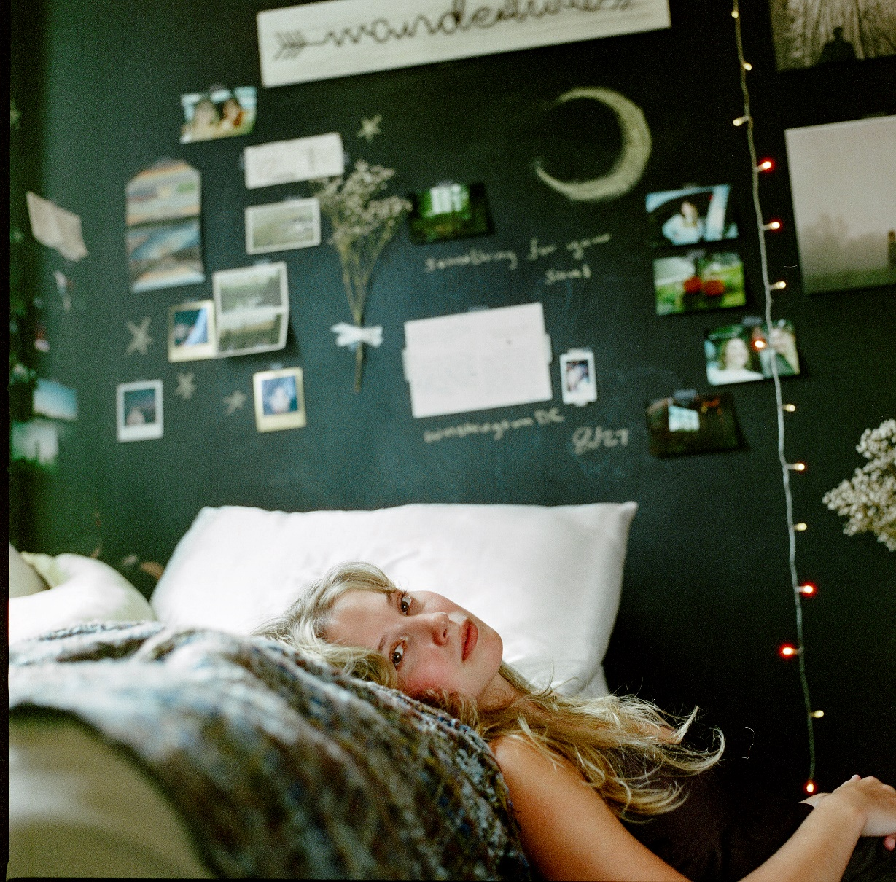
Download Press Assets HERE
NOVEMBER 10, 2023 – 20-year-old singer/songwriter Sydney Rose has shared her debut album One Sided. The 13-track effort is available now via Public Consumption and arrives alongside an official video for focus track “Cool Girl.” Directed by Syd Ostrander, the lo-fi visual is streaming now on Sydney’s official YouTube channel.
Written almost entirely by Rose, One Sided is about growth: growing up, growing apart, growing within. During a recent period of transition, Rose often found herself in solitude, writing music to work through her innermost feelings about the changes that had flooded her life. She had graduated from high school, left her childhood behind, lost meaningful relationships, and lost herself in the midst. Through all of this emotional commotion, the album was born.
Later this month, Sydney will kick off tour dates supporting Leanna Firestone’s “Least Favorite Only Child Tour.” The dates kick off November 24 in Durham, NC, hitting New York City’s Gramercy Theatre on December 6 before wrapping up in Boston, MA on December 7. Tickets for all dates are on sale now. For up-to-date ticketing information, please visit www.sydneyrosemusic.com.
Rose announced One Sided in September alongside single and video “You’d Be Stars (feat. chloe moriondo),” which premiered via FLOOD Magazine who celebrated the "breezy, late-summer exhalation." The track was followed by wistful single "The New Kid," which touches on the distance between friends and explores the idea of turning the page to a pending chapter of life.
In 2022, her debut EP You Never Met Me and its follow-up This Kind of Thing Doesn’t Last showcased intimate lyricism and a knack for candid honesty, with the help of understated synths, muted drum machines, and stacked harmonies. Now, with her debut album One Sided, Rose returns to her stripped-back acoustic roots, offering tenderhearted meditations on childhood, love, and the evolution of friendship, with a guitar in hand.
Earlier this year, Sydney shared several singles, including an intimate cover of The Killers’ iconic track “Mr. Brightside.” Spring release “I can’t live without you (feat. Charlie Oriain),” was coined by Sweety High as “a whispery, gorgeous ballad straight from the heart,” while Stereogum praised “Tell Him I Miss Him” as “lovely and delicate,” noting, “[the] achingly spare song … slowly layers on more instruments and effects without losing any heart.”
Sydney’s EP This Kind Of Thing Doesn’t Last arrived last fall alongside a self-directed official music video for focus track “Too Fast.” Her debut EP You Never Met Me arrived to critical acclaim, with PEOPLE Magazine naming her one of their Emerging Artists To Watch and Under The Radar attesting, “‘You Never Met Me’ is the sound of Rose finding herself in her music and introducing herself to the world, tracing all of the messy contours of teenage heartbreak in the process.”
(Album Art + Tracklisting Below)
SYDNEY ROSE 2024 TOUR DATES
All dates supporting Leanna Firestone

November 24 Durham, NC Motorco
November 25 Asheville, NC Grey Eagle
November 26 Charleston, SC Music Farm
November 28 Tampa, FL Crowbar
November 29 Orlando The Abbey
December 1 Pensacola, FL Handlebar
December 2 Birmingham, AL Saturn
December 3 Nashville, TN Eastside Bowl
December 6 New York NY Gramercy Theater
December 7 Boston, MA Paradise
SYDNEY ROSE
One Sided
AVAILABLE NOW
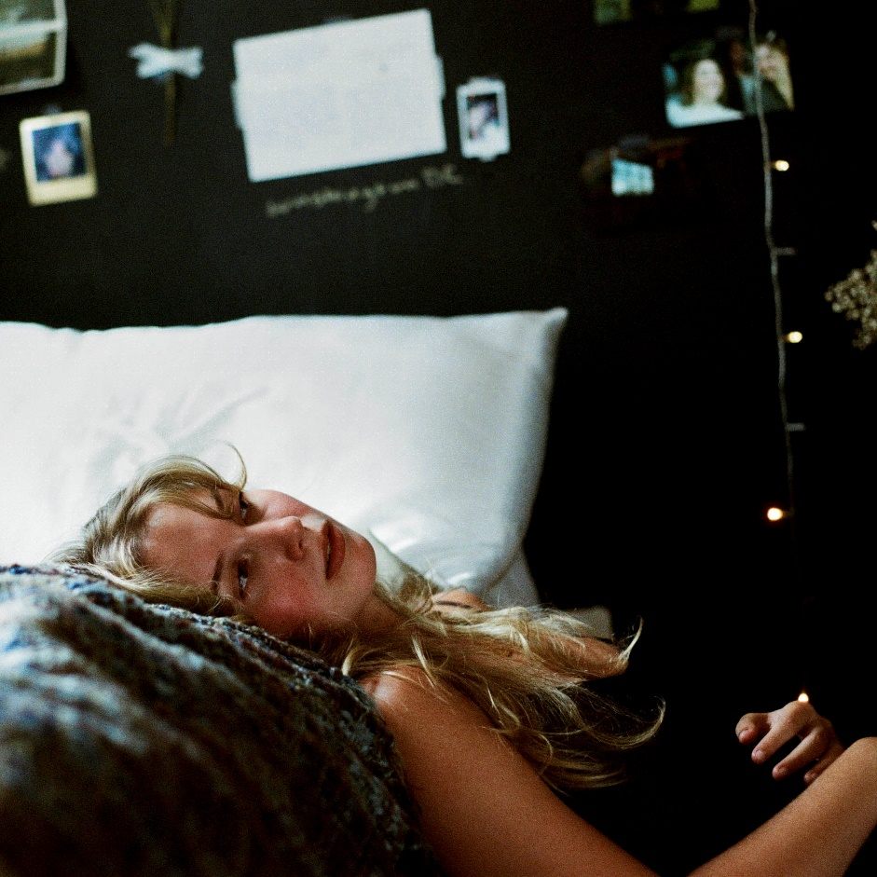
- Filing Our Papers
- Unmade Bed
- I Think of How It Ends
- The New Kid
- You’d Be Stars (feat. chloe moriondo)
- Pretty Words
- The House I Grew Up In
- Growing
- Same Car
- Cool Girl
- What Kind Of Winner
- Out Of Service
- Throwing Rocks

CONNECT WITH Sydney Rose
TIKTOK
YOUTUBE
INSTAGRAM

CONTACT:
Sarah Goldstein
SarahGoldstein@elektra.com

