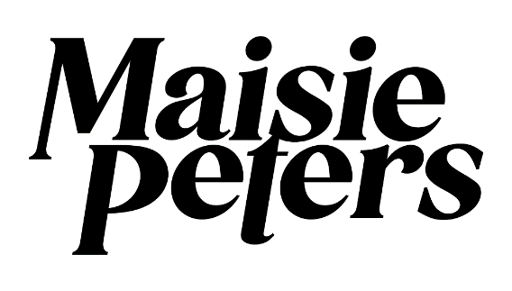
UNVEILS DELUXE EDITION OF UK NO.1 ALBUM THE GOOD WITCH
FEATURING SIX BRAND-NEW TRACKS

PERFORMS HER BIGGEST SOLD-OUT HEADLINE SHOW TO DATE AT
LONDON’S OVO ARENA WEMBLEY ON NOVEMBER 3RD

DOWNLOAD PRESS ASSETS HERE

“she has the songwriting chops to rival Olivia Rodrigo as Gen Z’s answer to Taylor Swift.” - BILLBOARD
“poised to be pop’s next big thing” – PEOPLE
“Peters displays a heightened sense of introspection and emotional range. If You Signed Up For This was directed at you, the listener, then The Good Witch gazes inward.” TEEN VOGUE
“Ed Sheeran’s musical protégé and BFF perfectly avoids any sophomore slump in her high-energy second album, pivoting away from love songs into her own Reputation era…Maisie proves she’s ready for a bigger spotlight—and that none of her exes are safe.” – COSMOPOLITAN
October 27th, 2023 – Today, rising British pop star Maisie Peters unveils a deluxe edition of her acclaimed UK No.1 album The Good Witch, featuring six brand-new tracks. Listen HERE. Maisie’s No.1 has made her the youngest British female solo act since 2014 to claim a #1, and the youngest artist to claim a #1 since Olivia Rodrigo’s Sour.

“Making ‘The Good Witch’ was one of the most magical experiences of my life and I knew from the beginning that there was more life in this record yet - I wasn’t finished telling certain stories,” Maisie shares. “‘You Signed Up For This’ and ‘The Good Witch’ feel like sister records to me, different in age and tone but forever intertwined by the person I was when I wrote both and over the past few years there have been songs I wrote that slipped through the cracks that I knew were special to me. I wanted to give them to you, to finish this year and open the door to some of my favourite tales I didn’t get to tell – ‘The Good Witch’ is not done yet.”

Wrapping up a landmark year, which saw Maisie make her debut at Chicago’s Lollapalooza, complete an extensive North American tour intertwined with dates opening for Ed Sheeran’s Mathematics tour, and deliver stunning network television performances on The Tonight Show with Jimmy Fallon, NBC’s Today, and Live with Kelly and Mark, Maisie will perform her biggest sold-out headline show to date at London’s OVO Arena Wembley next Friday, November 3rd.

‘THE GOOD WITCH (DELUXE)’ TRACKLIST
- The Good Witch
- Coming Of Age
- Watch
- Body Better
- Want You Back
- The Band And I
- You’re Just A Boy (And I’m Kinda The Man)
- Lost The Breakup
- Wendy
- Run
- Two Weeks Ago
- BSC
- Therapy
- There It Goes
- History Of Man
- Holy Revival
- Yoko
- The Song
- Guy On A Horse
- Truth Is
- The Last One

CONNECT WITH MAISIE:
YouTube | Instagram | Twitter | Facebook | TikTok

FOR MORE INFORMATION PLEASE CONTACT:
glennfukushima@elektra.com
rossanderson@elektra.com
sydneyworden@elektra.com

