PLATINUM SINGER-SONGWRITER JAKE SCOTT UNVEILS
DEBUT ALBUM LAVENDER – AVAILABLE NOW HERE

SPECIAL PERFORMANCE ON NBC’S TODAY SET FOR THURSDAY, OCTOBER 26
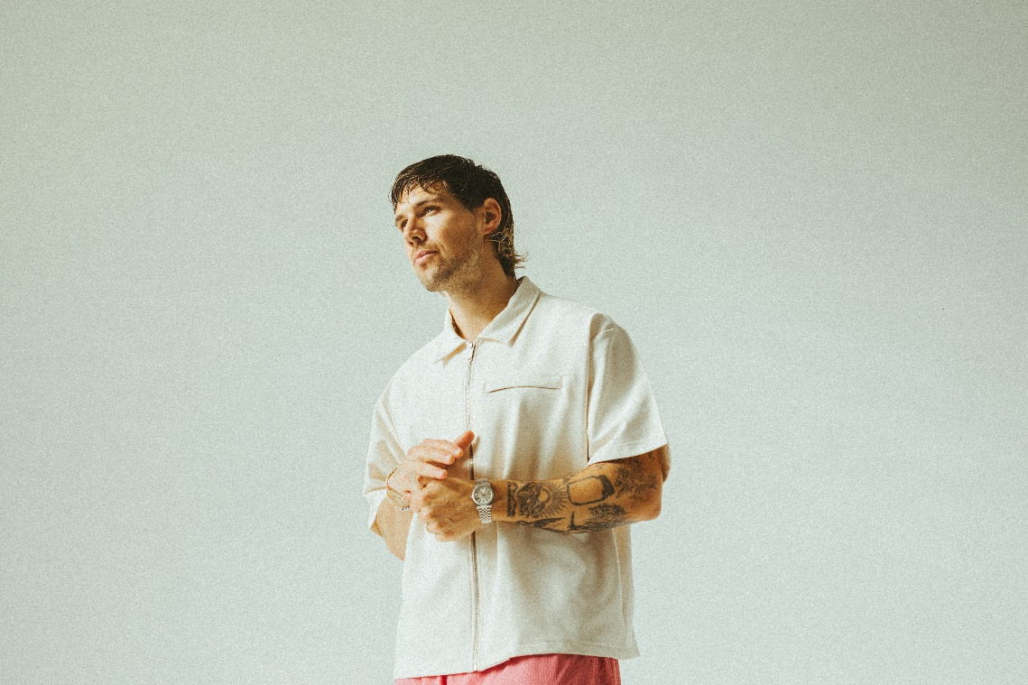
PHOTO CREDIT: CONNOR DWYER + RACHEL DWYER
DOWNLOAD PRESS PHOTO HERE
“With a knack for catchy melodies, his songs make for easy listening supported by buoyant pop production, heartfelt narratives, and a buttery voice to boot.” – BILLBOARD
“… rounded out by lyrical sincerity.” – CONSEQUENCE OF SOUND
“Scott is humble, but extremely talented” – AMERICAN SONGWRITER
Named one of PEOPLE MAGAZINE’s Emerging Artists (Spring 2022)
(OCTOBER 20, 2023) – LOS ANGELES, CA – Platinum pop singer-songwriter Jake Scott today unveiled his highly anticipated debut album Lavender, available now on all streaming platforms HERE. Jake is set to celebrate the release with a special network television performance of his touching slice-of-life single “One On The Way” on NBC’s TODAY next Thursday, October 26.

“I wanted Lavender to feel like nostalgia. Like a beginning and an end. Like magic,” Jake explains. “I’ve been building toward it for years - one song at a time, one step at a time, one experience at a time. And it’s finally here! I put every bit of my heart and soul into this album, and I hope you love it. I hope you see yourself in it. I hope it feels like magic.”

Inspired by his relationship with his wife Rachel and their growing family, Jake’s honest and unfiltered lyricism on Lavender evokes feelings of euphoria through a nostalgic lens. Jake assembled much of the album in his home studio, cowriting alongside various trusted collaborators and handling production on the majority of the tracks himself. Now, the record channels tender memories, and all kinds of truths for Jake. For as much as he continued to define his sound on Lavender, he also got a little closer to understanding who he is.

“In a lot of ways, making this album was a process of self-discovery,” Jake explains. “It was my first time sitting down to make an entire body of work. So, I kept asking myself, ‘What do I want to say?’ Over the course of making the record, there was a lot of growing—personally and artistically. The last two years were some of the hardest and best of my life. That bled over to my music. To me, Lavender is an authentic body of work that’s honest to the stories I’ve experienced and am currently living. I’m really proud of it.”

Jake paved the way for Lavender with “Married Young,” “Good Day,” “Come Close,” and “One On The Way” generating millions of streams and receiving praise from Billboard, Entertainment Tonight and more. He delivered a showstopping performance of “Married Young” on KTLA, while he graced the stage of TODAY with “Good Day.”

Off the heels of supporting Brett Young’s Dance With You tour in the U.S., Jake headlined Salt Lake City’s Sandy Amphitheatre this past weekend and shared a special preview of Lavender to a sold-out crowd of friends, family and superfans. Tomorrow, Saturday, October 21, Jake will be performing at Hollywood’s Hotel Café for a special Lavender album release show. For tickets and more information please visit www.lavenderthealbum.com.

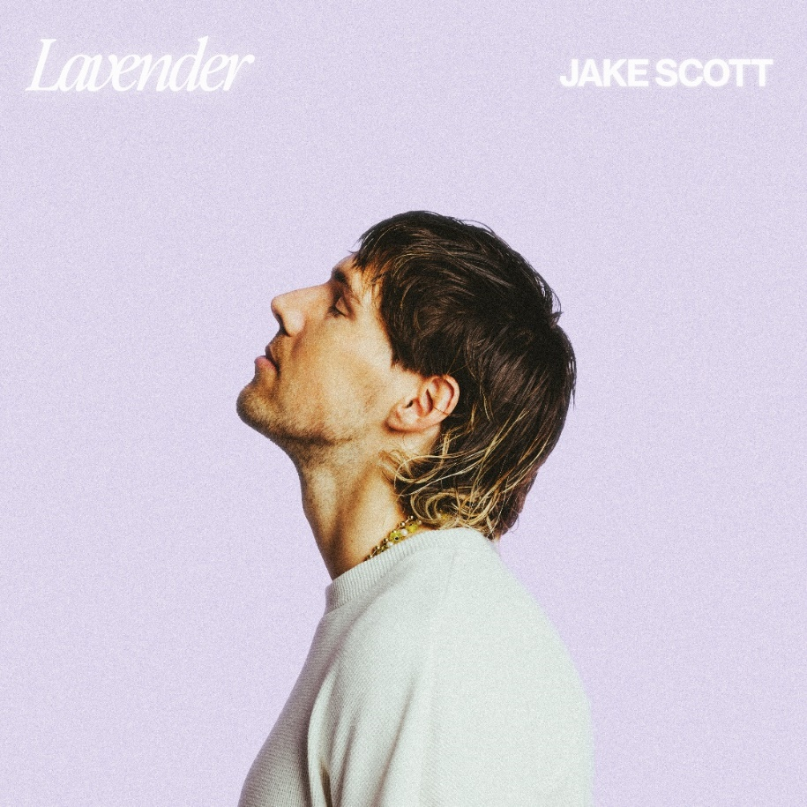
DOWNLOAD ALBUM ART HERE

LAVENDER TRACKLIST
1. Lavender
2. Sink In
3. Late Night Alibi
4. Out Of The Blue
5. Married Young
6. One On The Way
7. Forever 22
8. Good Day
9. Middle
10. Long Goodbye
11. Come Close
12. Don't Make It Easy
13. For You, I Will
14. Twice
15. It’s Gonna Be You
16. Ruby Hallelujah

2023 TOUR DATES
October 21, 2023 – Hollywood, CA – The Hotel Café

ABOUT JAKE SCOTT:

Jake Scott appeals to multiple senses with his nuanced, yet cinematic take on alternative pop. His lyrics are so honest and unfiltered you can practically see each story unfold right in front of you. Breezy melodies and lush guitars might conjure a memory you never want to end, while airy beat-craft pulls you back down to earth for a moment of introspection. Born and raised in Fayetteville, AR and based in Los Angeles, CA, the platinum-certified singer, songwriter, producer, and multi-instrumentalist consistently connects with audiences. Obsessed with music as a kid, he broke through the old-fashioned way—by grinding it out. Beginning in 2018, he chose to share one single per month independently until the end of 2020. Attracting a diehard fanbase, he caught the attention of Elektra Records and inked a deal with the label. Thus far, he has impressively tallied just shy of 1 billion total streams . He notably joined forces with Russell Dickerson for “She Likes It,” gathering nearly 300 million streams, picking up a 2x platinum certification from the RIAA, and landing a nomination for “Collaborative Video of the Year” at the CMT Awards. Meanwhile, he delivered unforgettable performances on TODAY, The Kelly Clarkson, and Good Morning America, to name a few. Beyond praise from American Songwriter, Billboard, PEOPLE MAGAZINE named him among its “Emerging Artists” in 2022. As a songwriter, his catalog has also expanded with cuts for Jason Mraz, Aloe Blacc, and Morgan Wallen. Packing houses coast-to-coast, he sold out every date of his first headline tour. In 2023, Jake brings a whole lot of heart back to pop music on his debut album, Lavender, and more to come.
FOLLOW JAKE SCOTT:
WEBSITE |LAVENDER | INSTAGRAM | FACEBOOK | TWITTER | YOUTUBE | TIKTOK
# # #
For more information on Jake Scott, please contact:
Ross Anderson
& Sydney Worden
Ross.Anderson@300Elektra.com | Sydney.Worden@300Elektra.com

