JADEN HOSSLER LAUNCHES NEW CHAPTER WITH “CHROME HEARTED”

NEW SINGLE & MUSIC VIDEO STREAMING NOW

LISTEN HERE | WATCH HERE

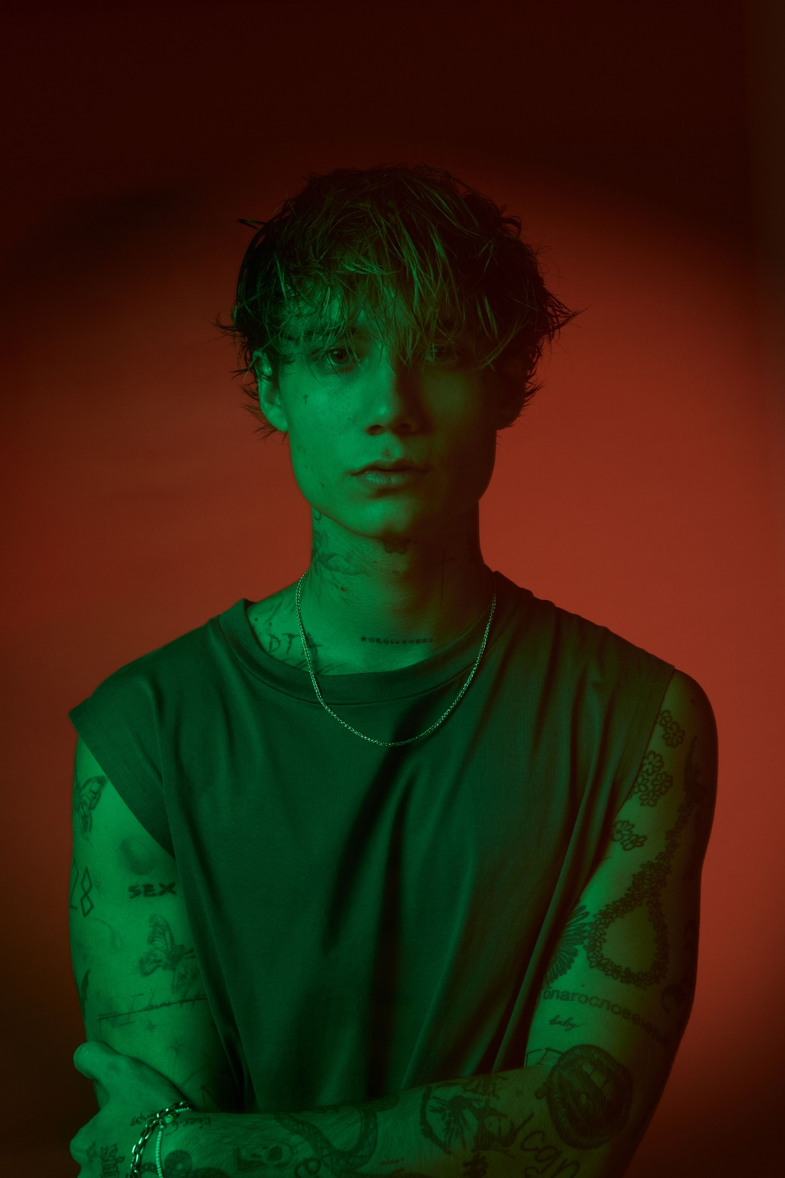
PHOTO CREDIT: JOYCE CHARAT
OCTOBER 6, 2023 – Jaden Hossler, the LA-based singer-songwriter best known for his work as jxdn, has ditched his alias and shared “Chrome Hearted,” a brand-new single available today on all streaming platforms via Travis Barker’s DTA Records. “Chrome Hearted” notably marks the beginning of a new chapter for Jaden who also co-directed the song’s official music video alongside Rachel Rinehardt – watch HERE.

Jaden spoke exclusively to Billboard about “Chrome Hearted,” his newfound sobriety, and how accepting his past has enabled his personal and artistic growth.
“Chrome Hearted” follows release of Jaden’s 2023 single “Elevated Heartbreak,” which arrived just days after Jaden entered a treatment facility to focus on his mental health.

Jaden’s celebrated debut album Tell Me About Tomorrow arrived in 2021 to critical acclaim and has since amassed more than one billion global streams to date. Upon its arrival, the album earned Jaden a #3 Alternative New Artist Albums, #5 Top New Artist Albums, and #11 Digital Albums on the Billboard charts. Furthermore, Jaden was included in Variety’s ‘Power of Young Hollywood’ 2021 Music impact list and Billboard’s ‘21 Under 21’ list for the two consecutive years he was eligible (2020 and 2021), in addition to garnering nominations for both a MTV VMA and MTV EMA in 2021.

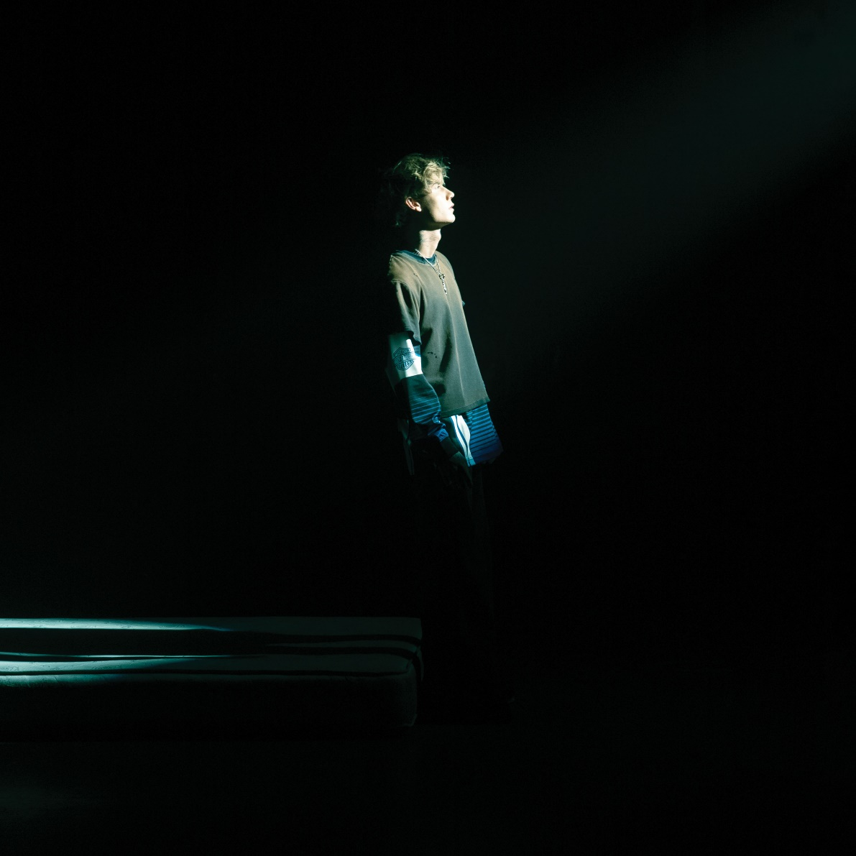
“CHROME HEARTED” – SINGLE ARTWORK

ABOUT JADEN HOSSLER:
You may recognize Jaden Hossler from his whirlwind breakout under the moniker of “jxdn,” but he’s about to tell his story now. Up to this point, he has reached gold status, tallied over one billion streams and counting, collaborated with icons, sold out headline tours, and garnered widespread acclaim. Raised by two pastors, Jaden spent the bulk of his childhood in Texas. Without much money or resources, he retreated into music as an escape. By the time he turned 14, the family relocated to Chattanooga, TN. As a senior in high school, he snuck out to a Juice WRLD concert (his first), and it changed his life. In 2020, he linked up with iconic blink-182 drummer and DTA Records founder Travis Barker who promptly signed him. He served up the gold-certified “ANGELS & DEMONS.” The latter also bulldozed the way for his 2021 full-length debut album, Tell Me About Tomorrow, highlighted by “SO WHAT!,” “BETTER OFF DEAD,” “TONIGHT” [feat. iann dior], and “WANNA BE” [feat. Machine Gun Kelly]. Beyond television performances on ELLEN and Jimmy Kimmel LIVE!, his showstopping MTV Push rendition of “Think About Me” garnered a nomination for “Push Performance of the Year” at the MTV VMAS. Plus, he packed houses on tour coast-to-coast. In between, he endured loss, struggled through mental health, faced addiction, and realized who he was meant to be all along. Armed with wisdom and a deliberate vision for the future, Jaden Hossler introduces himself now on a series of 2023 singles for DTA Records, beginning with “Chrome Hearted.”

CONNECT WITH JADEN HOSSLER:
WEBSITE / TIKTOK / INSTAGRAM / X / FACEBOOK / YOUTUBE / SPOTIFY / APPLE MUSIC

