CHRISTINA PERRI UNVEILS NEW LULLABY ALBUM
songs for pixie

STREAM/DOWNLOAD HERE

CELEBRATES PIXIE’S FIRST BIRTHDAY THIS WEEKEND

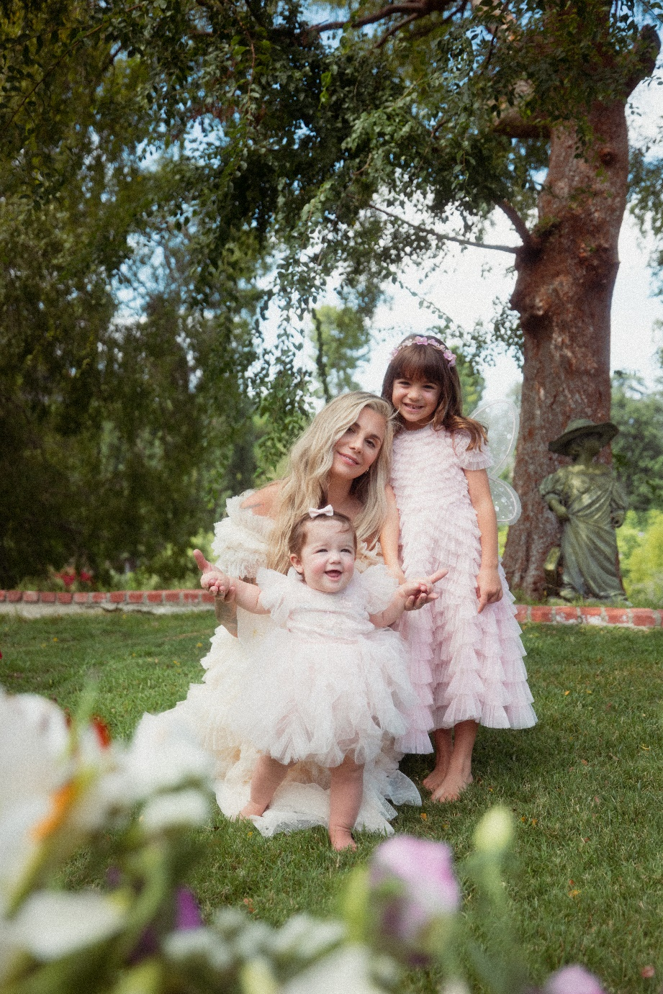
PHOTO CREDIT: ASHLEY OSBORN
DOWNLOAD HI-RES PRESS ASSETS HERE

(Los Angeles, CA – October 20, 2023) Today, Multi-platinum singer-songwriter Christina Perri has unveiled her brand new lullaby album, songs for pixie, in celebration of her daughter Pixie’s first birthday. The album features covers of songs from Stevie Wonder, Coldplay, Kacey Musgraves, The Greatest Showman and more, and is available now on all streaming platforms HERE.

“It’s here!! My 3rd lullaby album is out now. ‘songs for pixie’ was made, per tradition, in celebration of my daughter’s 1st birthday,” Perri explains. “These are all the songs I sing to her that we reimagined as lullabies, so I hope you sing them to your little ones as well. Enjoy!”

The new lullaby album follows Christina’s 2022 a lighter shade of blue, which was 8-years in the making with Christina’s last album Head or Heart being released in 2014. The deeply personal album followed Christina’s healing journey after losing her daughter Rosie. a lighter shade of blue was highlighted by singles “home,” “mothers” and “evergone,” the latter of which saw stunning national television performances on The Ellen DeGeneres Show and The Late Late Show with James Corden.

songs for pixie is Christina’s third lullaby album - each dedicated to one of her daughters - following her 2019 songs for carmella, also released in celebration of Carmella’s first birthday, and her 2021 song for rosie, released in honor of Rosie on what would have been her first birthday.

Stay tuned for more from Christina Perri very soon.

CHRISTINA PERRI - songs for pixie
AVAILABLE NOW
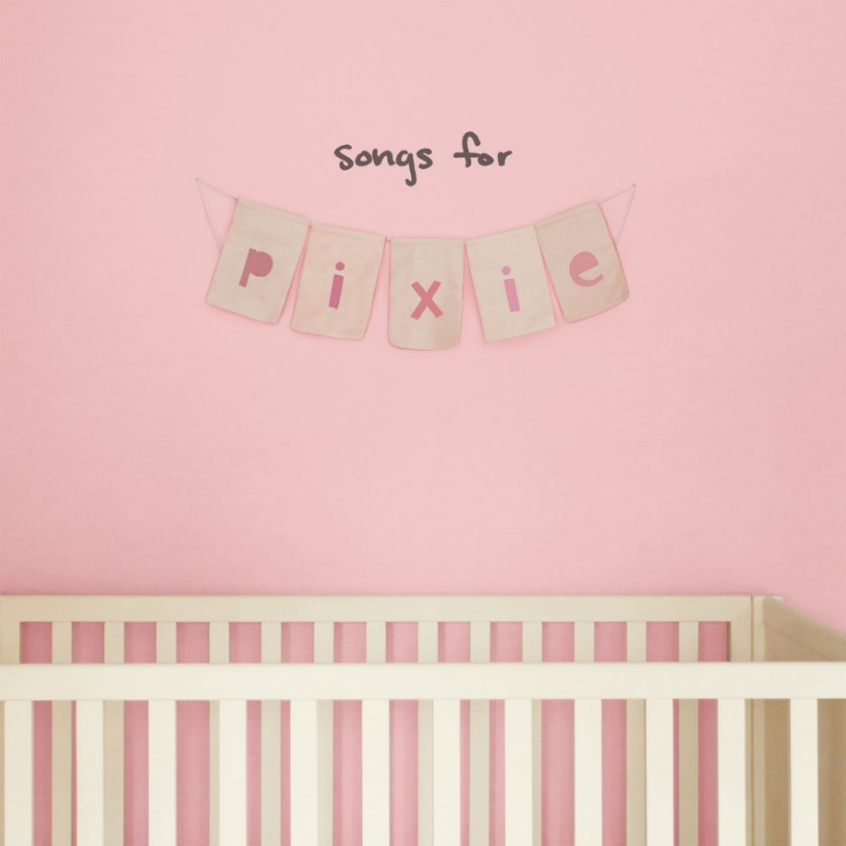

songs for pixie Tracklist:
1. you can fly
2. isn’t she lovely
3. rewrite the stars
4. pixie dust
5. twinkle twinkle
6. sweat pea
7. that’s amore
8. fix you
9. rainbow
10. you’ll be in my heart
11. que sera sera
12. goodnight sweetheart

About Christina Perri
Multi-platinum singer-songwriter Christina Perri has earned critical applause and an increasingly fervent fan following since the arrival of her extraordinary, platinum-certified, 2011 debut, lovestrong, which featured the 6x-platinum certified smash, “Jar of Hearts” and gold-certified “arms.” Perri followed lovestrong. with the worldwide hit single, “A Thousand Years,” exclusively featured on THE TWILIGHT SAGA: BREAKING DAWN – PART 1 & 2– ORIGINAL MOTION PICTURE SOUNDTRACKS. The RIAA diamond certified track was a multi-format radio favorite, and accompanied by an equally popular companion video, now boasting over 2 billion individual views via YouTube alone. HEAD OR HEART, Perri’s acclaimed gold-certified, second album, arrived in 2014, highlighted by the RIAA 3X platinum certified single, “Human.” In 2019, Perri returned with songs for carmella: sing-a-longs and lullabies, a collection of songs the acclaimed singer-songwriter sang to her daughter everyday, released on Carmella’s first birthday. She also released the poignant single “Tiny Victories,” a track she wrote for the HBO documentary FOSTER, which made its premiere in Spring 2019. In 2021, Christina shared songs for rosie in honor of her daughter on what would have been her first birthday. Most recently, last year Christina released her highly anticipated third full length album, a lighter shade of blue. The deeply personal album followed Christina’s healing journey after losing her daughter Rosie and was highlighted by singles “evergone,” “mothers” and “home.” This year Christina returns with songs for pixie, out now via Elektra Records.

CONNECT WITH CHRISTINA PERRI

CHRISTINAPERRI.COM
FACEBOOK
TWITTER
INSTAGRAM
YOUTUBE

MEDIA CONTACTS:

Glenn Fukushima & Sydney Worden
GlennFukushima@elektra.com | SydneyWorden@elektra.com

