LANDON BARKER SIGNS TO DTA RECORDS

RELEASES DEBUT SINGLE & MUSIC VIDEO “FRIENDS WITH YOUR EX”

LISTEN HERE | WATCH HERE

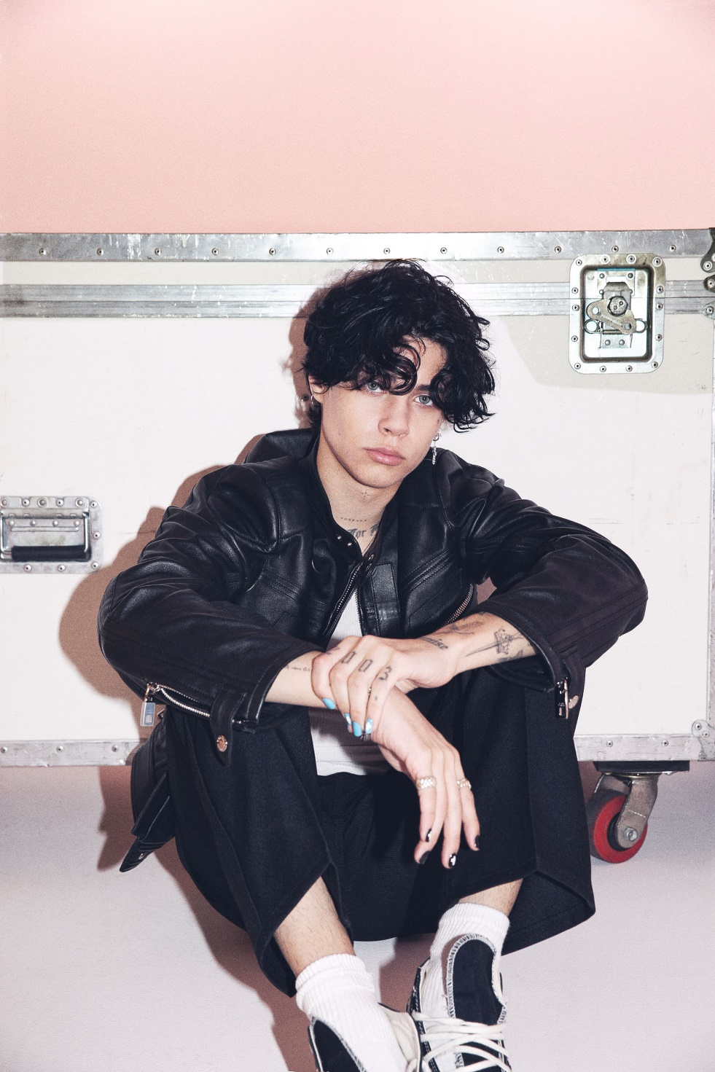
PHOTO CREDIT: NICO CORTEZ
SEPTEMBER 22, 2023 – Southern California-born and based singer, songwriter, multi-instrumentalist, and fashion maven Landon Barker has signed to DTA Records. He exclusively broke the news to Variety who first reported the signing.

Additionally, Landon has shared his debut single “Friends With Your EX,” available on all streaming platforms now via DTA Records [single artwork below]. It arrives with an official music video directed by Chris Villa, which sees Landon co-starring alongside his superstar girlfriend Charli D’Amelio with additional guest appearances from Joe Chavez, Michael Tua, Chazdon Jeffery, Carl Dawson, and Zack Lugo.

Produced and featuring drums by DTA Records Founder and Landon’s dad Travis Barker, the single illuminates the dynamic push-and-pull at the heart of his signature sound. On the track, acoustic guitar gives way to a wave of a distortion during the confessional chorus, “I was friends with your ex. You were with him when we met. Guess he hasn’t found out yet, but I know he’s gonna kill me when he sees me with you.”

Earlier this summer, Landon lit up the stage with a showstopping opening set at blink-182’s sold out show at BMO Stadium in Los Angeles, CA.

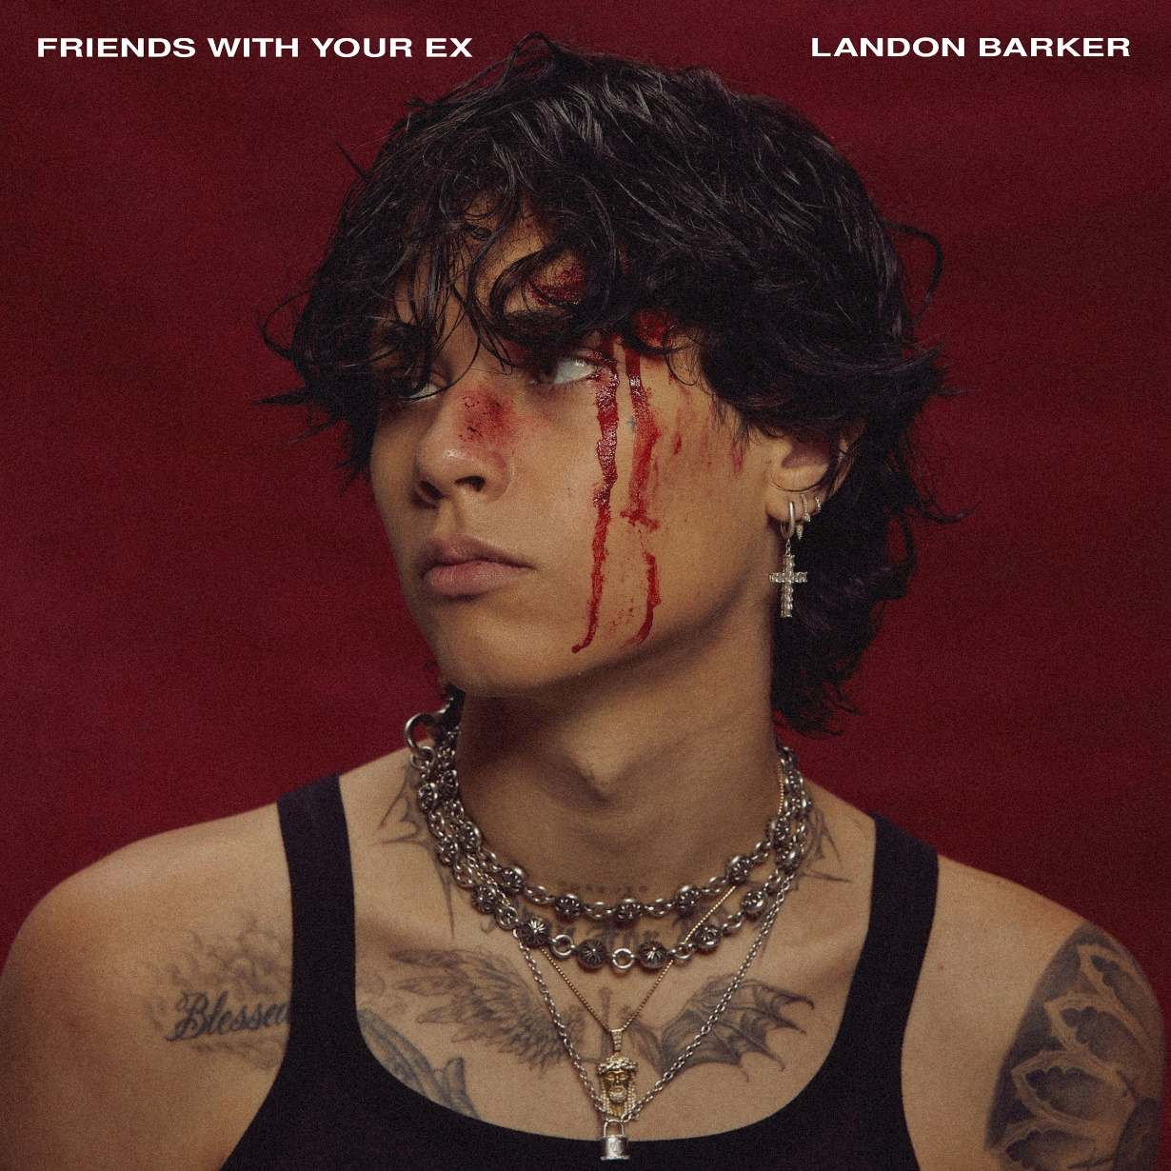
“FRIENDS WITH YOUR EX” – SINGLE ARTWORK

ABOUT LANDON BARKER:
Flaunting fiery and crunchy guitars, gritty vocals, and high-fashion flair, Landon Barker drives pop-punk into new territory at full speed. The Southern California-born and based singer, songwriter, multi-instrumentalist, and fashion maven channels the iconoclastic energy of old school punk through a Gen-Z lens. His lyrics cut just as deep as a 3AM breakup text, while his unapologetic aesthetic breaks boundaries. Landon grew up surrounded by music; his dad Travis, changed the face of pop-punk with blink-182. As a kid, Landon often played air guitar during their gigs. In 2011, he hit the stage for the first time, joining The Transplants during a raucous set at the annual Musink festival. Rock ‘n’ roll eventually called to him loud and clear. Travis asked Landon to lend his voice to a 2020 cover of the Misfits classic “Skulls.” Not long after, he collaborated with MGK on “die in california” [feat. Gunna, Young Thug, & Landon Barker] from 2022’s Mainstream Sellout, which bowed at #1 on the Billboard 200 and earned a GRAMMY® Award nod. He also appeared in his viral film Downfalls High and joined MGK on stage in front of a sold out crowd at Madison Square Garden. Without properly releasing solo music, he even sold out his first headline gig at the legendary Roxy on the Sunset Strip. 2023 sees Landon step into the spotlight with a series of singles for DTA Records, beginning with “Friends With Your EX,” which illustrates the dynamics of his sound and personality through incisive verses, blazing riffs, and confessional honesty. Expect much more coming soon.
CONNECT WITH LANDON BARKER:
TIKTOK / INSTAGRAM / SPOTIFY / APPLE MUSIC

