FINN ASKEW SIGNS TO ELEKTRA ENTERTAINMENT

SHARES NEW SONG “PERFECT COLOUR”

PHOTO CREDIT: ROSIE MATHESON

SEPTEMBER 22, 2022 – Finn Askew - the UK-born singer, songwriter, multi-instrumentalist, and producer – has announced his signing to Elektra Entertainment and shared his brand-new single “Perfect Colour” [single art below]. Co-written with James Essien, and produced by PRGRSHN (Stormzy, Aya Nakamura), “Perfect Colour” is available now on all streaming platforms with an official visualizer streaming on Finn’s YouTube channel.
Commenting on the news Finn remarked, “I’m really looking forward to this this next step in my career and I can’t wait to see what the future holds. Expect big things!” Expanding on the new music he added, “this next single “Perfect Colour” is a real special one for me, the lyrics, the beat, everything just feels perfect. I was lucky enough to have made it with two of the most talented people I know PRGRSHN & James Essien."
Just last month Finn shared “Used To This” - a stunning avant-pop song with fragments of alternative R&B, marking his first new music in over two years. Declared a “catchy hit in the making” by UPROXX, “Used To This” was produced by MOJAM, the Grammy award-winning songwriting and production duo whose credits include production for Sam Smith and Emeli Sandé.
About Finn Askew:
Guitar in hand and ambitious vision in mind, Finn Askew infuses irresistible pop melodies with focused storytelling and R&B grooves. The UK-born singer, songwriter, multi-instrumentalist, and producer confidently carries hooks over dynamic guitar passages as he zooms in on moments from his life. This simple balance has affirmed him as an outlier with a fresh and fiery style rooted in a tried-and-true classic approach. Growing up in the small town of Somerset, he devoured as much music as possible and penned songs at a prolific pace. In the midst of the Pandemic, he released “Roses”, and it caught fire. Taeyong of NCT 127 played it during a livestream and sang along, igniting Finn’s popularity. BTS vocalist Jungkook touted the song on social media, and it exploded to the tune of 65 million cumulative streams. In between, he dropped a pair of EPs, namely Peach and Tokyo. Of the latter, Clash professed, “Laden with colour and enormous potential, it’s an EP to soak up slowly.” Along the way, VEVO named him a DSCVR “Artist To Watch,” and he graced the stages of Reading + Leeds and The Great Escape. For as much as he disrupts genre fabric, he does so from the proven perspective of a troubadour. Amassing over 300 million streams and inciting the acclaim of Clash, NME, and many others, he’s already resonated on multiple continents and continues to break boundaries and subvert expectations with his new singles “Used to This” and “Perfect Colour.”

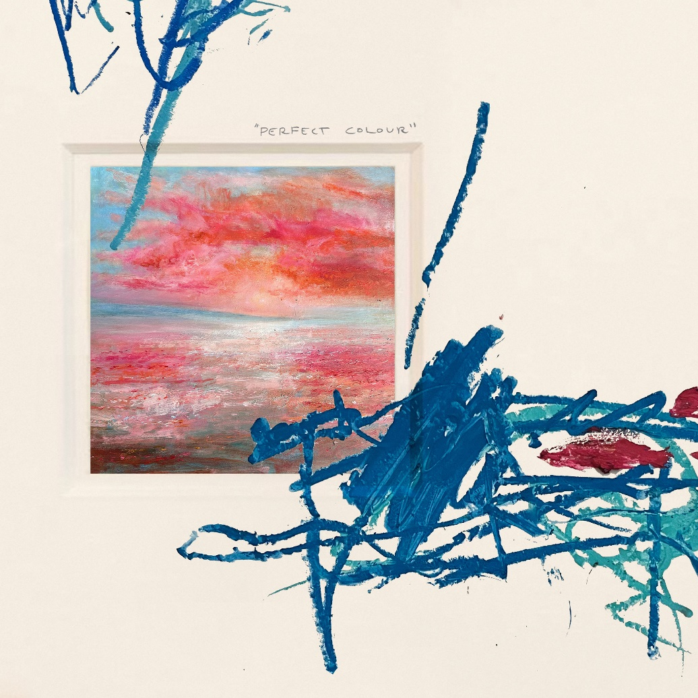
FINN ASKEW – “PERFECT COLOUR”

CONNECT WITH FINN ASKEW:
Instagram | X | TikTok | YouTube | Spotify | Apple Music

FINN ASKEW PRESS CONTACT:
Ross Anderson | Ross.Anderson@300Elektra.com
Sydney Worden | Sydney.Worden@300Elektra.com

