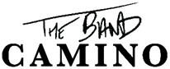

POP-ROCK TRIO ‘THE BAND CAMINO’ RELEASES HIGHLY ANTICIPATED NEW ALBUM THE DARK TODAY VIA DBLBLK/ELEKTRA ENTERTAINMENT

Listen Here

THE BAND KICKS OFF THEIR ‘SCREAMING IN THE DARK’ NORTH AMERICAN HEADLINE TOUR ON SEPTEMBER 14TH IN PHILADELPHIA

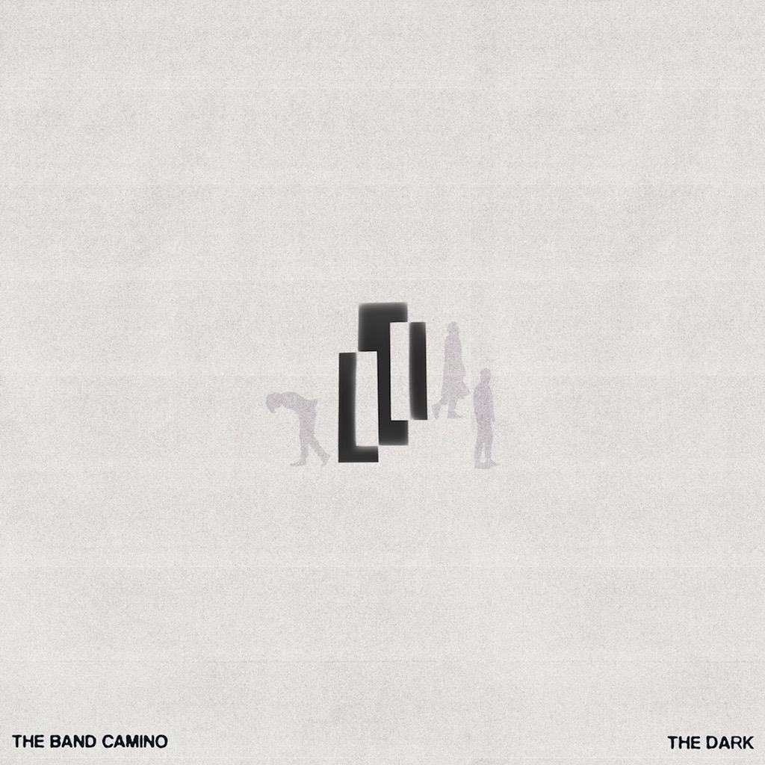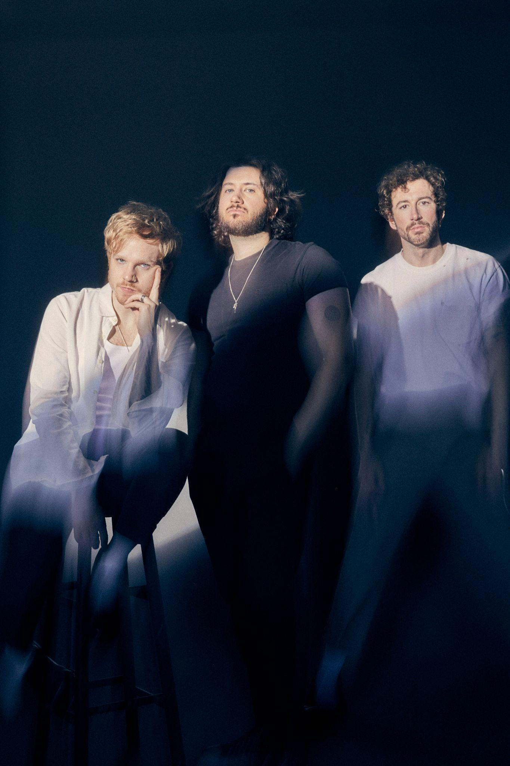

Hi-Res Cover Art: HERE | Press Photo: HERE (Credit to Jimmy Fontaine)

NASHVILLE (August 11, 2023) — Today, Nashville-based pop-rock trio, The Band CAMINO (comprised of Jeffery Jordan, Spencer Stewart, and Garrison Burgess) proudly reveal their awaited sophomore album, The Dark, available now via dblblk/Elektra Entertainment. Fueled by the band’s infectious, unguarded, guitar-driven sound that first captivated fans on tryhard (which spawned early fan favorites “Daphne Blue” and “See Through”) and their self-titled debut album, The Dark boldly challenges the complexities of life, love and self-discovery, inviting listeners along for the ride. Listen to The Dark HERE.

Following the release of their self-titled debut album in 2021, the band tapped in key collaborators Andrew Goldstein, Jordan Schmidt, Seth Ennis, Geoff Warburton, Jake Torrey, and Alysa Vanderhym to assemble what would become the The Dark, an expertly-crafted body of work emphasizing their undeniable impact in the pop-rock genre and beyond.

Initially teasing The Dark with first singles “Told You So,” “What Am I Missing,” “Last Man In The World” and “See You Later,” the band truly set the stage for the emotionally-charged musical exploration heard across the project’s 11 tracks. While “Afraid of the Dark” encapsulates the core theme in the hook, “You’re the reason I’m afraid of the dark,” the album as a whole takes listeners on the rollercoaster of events that lead to the darkness. From the passionate pursuits for connection on “Novocaine,” “See You Later” and “Last Man In The World,” to the baggage unpacked on “Three Month Hangover”, “It’s You (It’s You),” and “Same Page,” the trio masterfully turns darkness into light by juxtaposing introspective lyricism with intoxicating pop melodies, pushing the boundaries of their already impressive discography.

The Dark by The Band CAMINO Tracklist:
- Told You So
- What Am I Missing
- Save My Life
- Let It Happen
- It’s You (It’s You)
- Same Page
- See You Later
- Afraid of the Dark
- Novocaine
- Three Month Hangover
- Last Man In The World

To celebrate the release of The Dark, The Band CAMINO will hit 25 North American cities including Boston, New York, Los Angeles, Chicago, Toronto, Atlanta and Nashville on their ‘Screaming In The Dark’ tour. Kicking off in Philadelphia on September 14th, the tour will be supported by Bad Suns, Charlotte Sands, and TheWldlife. Tickets are available HERE.

The Band CAMINO’s ‘Screaming In The Dark’ Tour (dates/venues below):

September 14 | Philadelphia, PA* | The Met
September 15 | Washington DC* | The Anthem
September 16 | Boston, MA* | MGM Music Hall at Fenway
September 18 | New York, NY* | Hammerstein Ballroom
September 21 | Indianapolis, IN * | Murat Theatre
September 22 | Birmingham, AL* | Legacy Arena
September 24 | Grand Prairie, TX* | Texas Trust CU Theatre
September 26 | Phoenix, AZ* | Arizona Financial Theatre
September 27 | Los Angeles, CA* | Shrine Expo Hall
September 28 | San Francisco, CA* | The Warfield
September 30 | Orem, UT* | UCCU Center
October 2 | Denver, CO^ | The Mission Ballroom
October 4 | Omaha, NE^ | Steelhouse
October 6 | Kansas City, MO^ | Arvest Bank Theatre at The Midland
October 7 | Minneapolis, MN^ | Armory
October 8 | Chicago, IL^ | Byline Bank Aragon Ballroom
October 10 | Montreal, QC^ | Mtelus
October 12 | Toronto, ON^ | History
October 12 | Grand Rapids, MI^ | 20 Monroe Live
October 14 | Madison, WI^ | The Sylvee
October 16 | Columbus, OH^ | Kemba Live!
October 17 | Louisville, KY* | Paristown
October 19 | Columbia, SC^ | Township Auditorium
October 20 | Atlanta, GA^ | Coca-Cola Roxy
October 21 | Nashville, TN^ | Municipal Auditorium

* Charlotte Sands ^ The Wldlife

About The Band CAMINO
The Band CAMINO knows what lever to pull in order to move you and—quite possibly—turn your mood around. The Nashville-based trio—Jeffery Jordan [vocals, guitar], Spencer Stewart [vocals, guitar], and Garrison Burgess [drums]—crafts guitar-driven anthems punctuated by pop palatability and unfiltered honesty, transforming emotional turbulence into stadium-size singalongs. The group has perfected a patented sound across releases such as the My Thoughts On You EP [2016], Heaven EP [2017], tryhard EP [2019], and self-titled debut LP The BAND CAMINO [2021]. Among many fan favorites, “2 / 14” amassed 78 million Spotify streams followed by “See Through” with 52 million Spotify streams and “Daphne Blue” with 45 million Spotify streams. Taylor Swift touted them on her playlist, People predicted, “There is so much in store for this rising rock band,” and Billboard went as far as to christen them “Rock’s next big thing.” Beyond performances on The Kelly Clarkson Show and Jimmy Kimmel! Live, they’ve graced the bills of festivals such as Bonnaroo, Lollapalooza, Hangout, and many more. Meanwhile, the three-piece has vaulted to arena status, filling venues such as The Nashville Municipal Auditorium. After nearing 1 billion total streams, selling out tours, and earning widespread critical acclaim from the likes of Associated Press, Billboard, People, Rolling Stone, and more, the group continues to captivate on their second full-length offering, The Dark, available now via DBLBLK Records/Elektra Entertainment.

###

