SLIPKNOT RELEASE TWO NEW MUSIC VIDEOS AND SIX-TRACK EP

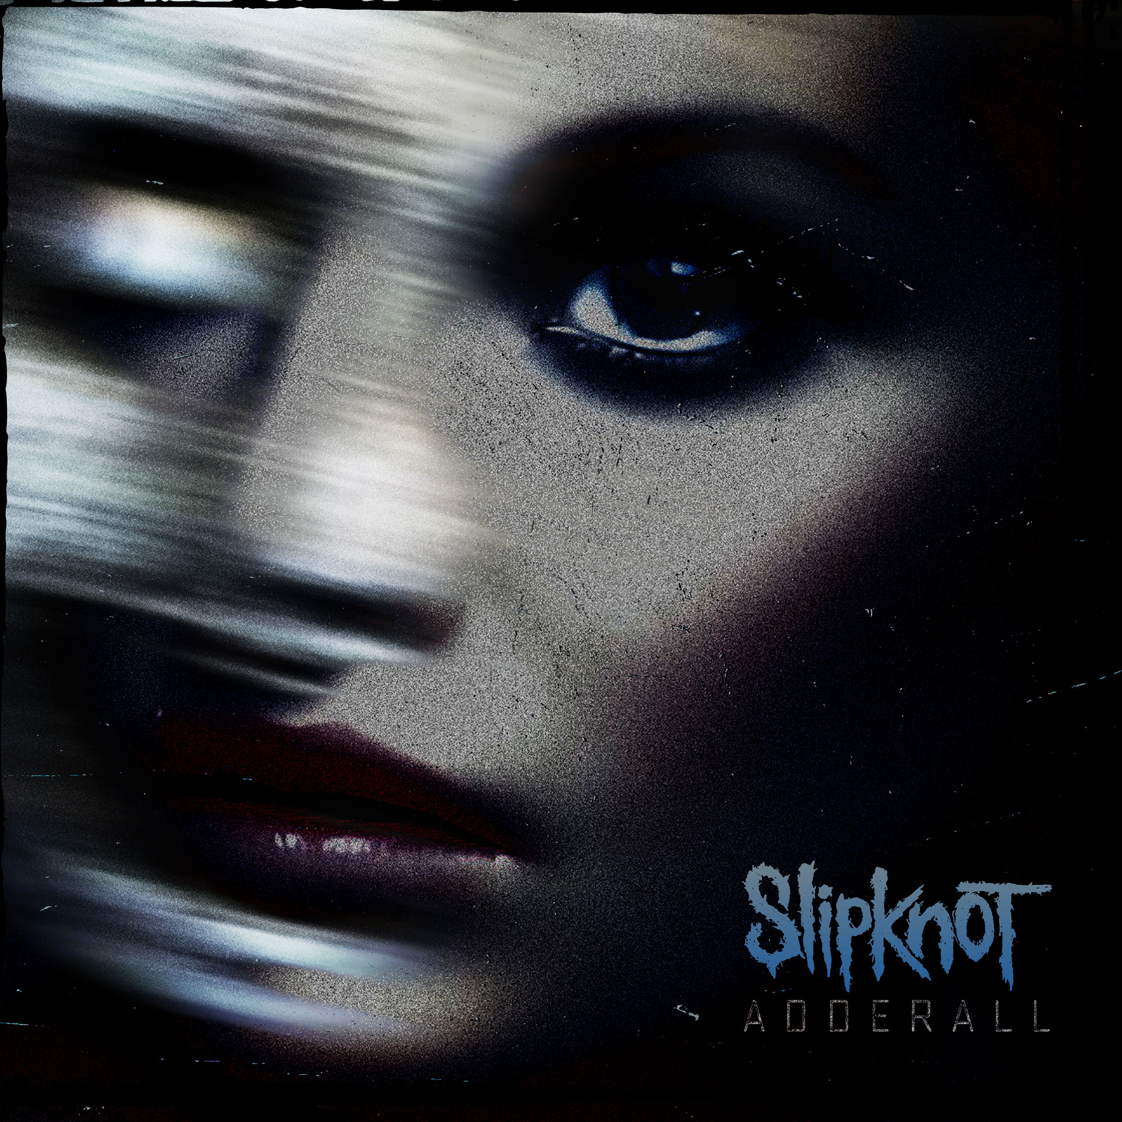

NEW ALBUM THE END, SO FAR AVAILABLE WORLDWIDE

JUNE 9, 2023 – SLIPKNOT have released two new music videos for unreleased music: “Memories (Adderall - Rough Demo)” can be found at www.slipknot1.com, while “Death March” can be found at www.youcantkillme.com. Both videos are directed by multidisciplinary artist and SLIPKNOT founding member, M. Shawn ‘clown’ Crahan. Alongside the videos, the band has released the Adderall EP, which collects alternate versions and reworkings of the band’s song “Adderall” (full track list below), along with non-LP tracks. The original studio version of “Adderall” is the lead-off track on SLIPKNOT’s latest album THE END, SO FAR.

Elaborating on the new EP and videos, clown remarked, “Deconstructing to continuously pave the way for evolution. At this point in the program nothing is safe.”

The Adderall EP follows “Bone Church,” a surprise standalone single released earlier this year with an accompanying M. Shawn ‘clown’ Crahan directed video piece titled “Yen – Director’s Cut (Bone Church),”– watch HERE. The “Bone Church” video has gone on to amass over one million views and counting.

Released this past September, Slipknot’s latest album THE END, SO FAR landed at #1 on Billboard’s Top Album Sales chart and at #2 on the Billboard 200, marking their sixth top 10-charting album on the Billboard 200. The album also made a stunning impact worldwide with #1 debuts in the United Kingdom, Australia, Germany, Switzerland, and Mexico, as well as Top 3 debuts in Canada, New Zealand, Finland, Sweden, Japan, and Belgium. THE END, SO FAR is available on limited edition vinyl, CD, and cassette, with physical bundles available at www.slipknot1.com.

“The gang choruses on ‘The Dying Song (Time To Sing)’ and ‘The Chapeltown Rag’ will cut right through any crowd of the Knotfest devoted,” raved the Los Angeles Times. The FADER declared “It absolutely rips,” adding “it feels more like they are simply waving goodbye to one chapter… and preparing for the decades to come.” “A punishing new elegy,” praised Rolling Stone with SPIN adding, “it checks all the boxes of the band’s latter-day sound.” NME asserted “you can almost feel them pushing themselves,” noting “their next left turn of an era could be their most daring yet.”

Produced By SLIPKNOT and Joe Barresi, THE END, SO FAR features the singles “The Dying Song (Time To Sing),” “Yen,” – both of which feature stunning music videos directed by the band’s own M. Shawn ‘clown’ Crahan - and “The Chapeltown Rag.” The collection sees one of the world’s most popular and deeply enigmatic bands relentlessly charting new ground as they continue to redefine, revitalize, and reimagine the scope of rock music.

THE END, SO FAR follows SLIPKNOT’s widely celebrated 2019 album WE ARE NOT YOUR KIND, which marked SLIPKNOT’s third consecutive #1 on the Billboard 200. The release made a massive global impact with #1 debuts in the Official Album Charts of twelve countries around the world, including the UK, Australia, Canada and Mexico, with Top 5 debuts in an additional twelve countries including Germany, France and Sweden.

Having recently wrapped their enormously popular sold-out KNOTFEST Roadshow tour, SLIPKNOT are
currently traversing the globe on a run of headlining festival dates which includes their own KNOTFEST Italy festival taking place June 25th. For tickets and more information on SLIPKNOT’s upcoming live dates, visit www.slipknot1.com.

[EP Track Listing Below]

ADDERALL EP
1. Death March
2. Adderall - No Intro
3. Adderall - Rough Demo
4. Red Or Redder
5. Adderall - Instrumental
6. Hard To Be Here

SLIPKNOT LIVE DATES 2023

JUN 10 - Greenfield Festival 2023 - INTERLAKEN, SWITZERLAND
JUN 11 - Download Festival 2023 - DERBY, UNITED KINGDOM
JUN 13 - Ziggo Dome - AMSTERDAM, NETHERLANDS*
JUN 14 - Rockhal - ESCH-SUR-ALZETTE, LUXEMBOURG*
JUN 16 - Copenhell Festival 2023 - COPENHAGEN, DENMARK
JUN 17 - Graspop Metal Meeting 2023 - DESSEL, BELGIUM
JUN 18 - Hellfest 2023 - CLISSON, FRANCE
JUN 20 - Barclays Arena - HAMBURG, GERMANY*
JUN 21 - Mercedes-Benz Arena - BERLIN, GERMANY*
JUN 24 – Königsplatz – MUNICH, GERMANY*
JUN 25 - KNOTFEST Italy 2023 - BOLOGNA, ITALY
JUN 27 - Arena of Nîmes - NÎMES, FRANCE*
JUN 29 - Evil Live Festival 2023 - LISBOA, PORTUGAL
JUN 30 - Resurrection Fest 2023 - VIVEIRO, SPAIN
JUL 14 - Rock Fest 2023 - CADOTT, WISCONSIN
JUL 16 – Inkcarceration Festival – MANSFIELD, OHIO
SEP 08 – Blue Ridge Rock Festival – ALTON, VRGINIA

*Headline Date

ABOUT SLIPKNOT:
There was never a band like SLIPKNOT, and there will never be another. Like a spore out of the Midwest,
they’ve quietly bloomed into the most uncompromising, undeniable, and unique presence on the planet whose influence transcends genres and generations. Since sowing the seeds for revolution in Iowa during 1999, these musical outliers have captured a GRAMMY Award alongside 10 nominations, scored 12 Platinum / 41 Gold album certifications around the world, and logged over 8.5 billion global streams and 3.5 billion video views to date - unprecedented for a rock act in this generation or any other. Rolling Stone cited the seminal platinum-selling 2001 album Iowa among “The 100 Greatest Metal Albums of All Time,” while The Ringer attested, “They’re the most important heavy band of their era.” In addition to marking the group’s third consecutive #1 debut on the Billboard Top 200, their sixth full-length album, WE ARE NOT YOUR KIND, bowed at #1 in twelve countries worldwide in 2019. Selling out shows on multiple continents, they deliver an irreplicable multi-sensory experience on tour and through their own festival KNOTFEST. With their seventh album THE END, SO FAR, SLIPKNOT are back, and nothing will be the same again.

For more information on SLIPKNOT, visit:
OFFICIAL WEBSITE |KNOTFEST | FACEBOOK | TWITTER | INSTAGRAM | YOUTUBE
APPLE MUSIC | SPOTIFY | AMAZON MUSIC | DISCORD

