FOR IMMEDIATE RELEASE
AUGUST 4, 2023

SAINT MOTEL UNVEIL RADIANT NEW SINGLE “FINE WINE”
LISTEN HERE

THE AWARDS SHOW TOUR CONTINUES ON SEPTEMEBER 13TH IN DALLAS, TX

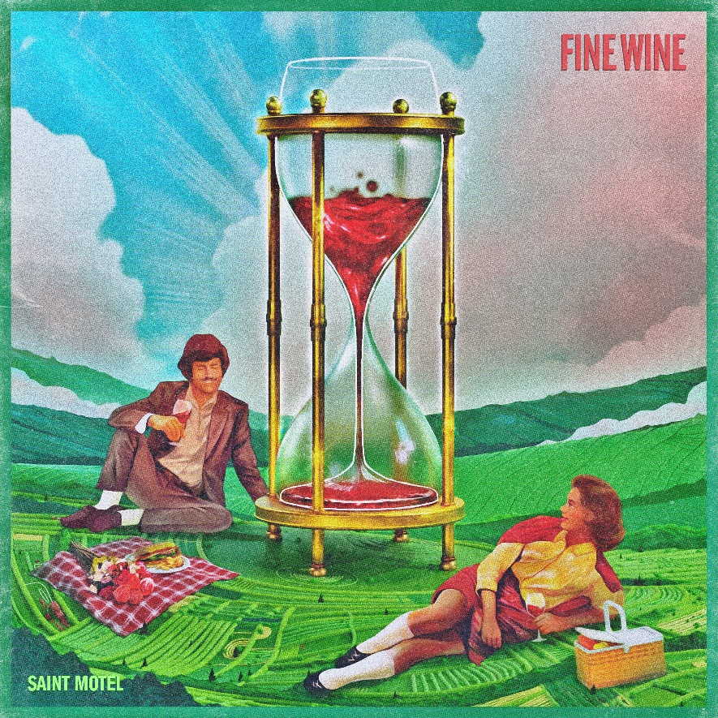
PRESS ASSETS HERE

Elektra Recording group Saint Motel have unveiled their radiant new single entitled “Fine Wine”. The song is available to stream and download beginning today HERE.

About “Fine Wine,” frontman A/J Jackson shares, “Like a punch in the gut and a slap on the back at the same time. Find peace in the chaos, see beauty in the impermanence, and cherish these moments that slip through your fingers like sand. Life’s a bottle you keep coming back to, savoring the taste of joy and heartache, knowing damn well it won't last, but you keep raisin' that glass anyway. Embrace the mess, 'cause it's all we got.”

The new standalone track follows the group’s recent single, “Everyone’s A Guru Now,” which marked the first new music from Saint Motel since the release of their acclaimed 2021 studio album The Original Motion Picture Soundtrack.

Earlier this Spring, Saint Motel wrapped the sold-out first leg of their 2023 tour, The Awards Show. Delivering an experience unlike any other trek the quartet have embarked upon, the very special tour gives fans the power to choose what the musicians play through partially fan-voted setlists. Bringing The Awards Show experience to fans around the world, Saint Motel livestreamed the run’s final sold-out date at New York City’s Webster Hall, where they delivered the live debut of “Everyone’s A Guru Now”. Next month, Saint Motel will embark on the second leg of The Awards Show tour kicking off September 13th at The Echo Lounge & Music Hall in Dallas, TX, and making stops in Phoenix, Los Angeles, Portland and more. Visit SaintMotel.com for more information.

In 2021, Saint Motel released their latest studio album The Original Motion Picture Soundtrack. The album arrived to widespread acclaim from People, SPIN, Paste, Ladygunn, Billboard, American Songwriter, and more, and saw the band deliver an unforgettable performance of lead single “Van Horn” on ABC’s Jimmy Kimmel Live!. Additionally, the band teamed up with the Fames Orchestra of Macedonia and renowned film composer Duke Bojadziev, to bring The Original Motion Picture Soundtrack to life in its entirety on stage during a global livestream. The show notably featured the film score transitions previously composed by Duke, live in the Macedonian capital of Skopje. In support of the LP, they headlined The Director’s Cut North American and European tours, selling out venues on both continents in 2021.

Be on the lookout for more news from Saint Motel soon.

THE AWARDS SHOW TOUR
August 19, 2023 - West Vancouver, BC - Ambleside Music Festival ^
August 27, 2023 – Columbus, OH - Wonderbus Festival ^
September 13, 2023 – Dallas, TX - The Echo Lounge & Music Hall
September 14, 2023 – Austin, TX - Emo's
September 16, 2023 – Englewood, CO - Gothic Theatre
September 18, 2023 – Phoenix, AZ - The Van Buren
September 19, 2023 - San Diego, CA - The Observatory North Park
September 20, 2023 - Santa Ana , CA - The Observatory & Constellation Room
September 22, 2023 - Los Angeles, CA - The Bellwether
September 23, 2023 - San Francisco, CA - The Fillmore
September 24, 2023 – Sacramento, CA - Ace of Spades
September 26, 2023 – Seattle, WA - The Neptune
September 27, 2023 – Portland, OR - McMenamin's Crystal Ballroom
^ Festival Performance

About Saint Motel
Joyfully blurring genres, Saint Motel showcase an opulent sound complimentary to their ambitious scope. Streamed and viewed over half-a-billion times, the platinum-selling Los Angeles quartet magnify this vision with immersive live experiences and one unpredictable move after another. The group initially came together at film school before introducing themselves on 2012’s Voyeur. Signing to Elektra Records, their 2014 My Type EP boasted both the gold-certified title track “My Type” and fan favorite “Cold Cold Man.” In 2016, saintmotelevision yielded the smash “Move.” Flipping the script once again, the musicians reimagined the record with a series of history-making first-of-their-kind innovations: an award-winning Virtual Reality version and an Augmented Reality version. In addition to unforgettable sets everywhere from Coachella and Lollapalooza to Bonnaroo, the boys lit up shows such as NBC’s TODAY, ABC’s Jimmy Kimmel Live!, and CBS’ The Late Late Show with James Corden, among others. In 2019, Saint Motel launched their most ambitious undertaking yet, unveiling their third full-length album in three parts. First up, they uncovered The Original Motion Picture Soundtrack Pt. 1 powered by the shimmy and shake of Alternative Top 15 lead single “Van Horn.” Between packing houses coast to coast on headline jaunts and earning acclaim from People, Billboard, and more, the four-piece rolled out Pt. 2 throughout 2020. Now, fans get the full picture of Saint Motel’s vision with the complete The Original Motion Picture Soundtrack studio album.

Saint Motel is: A/J Jackson (vocals), Aaron Sharp (guitar), Dak Lerdamornpong (bass), and Greg Erwin (drums).

CONNECT WITH SAINT MOTEL
WWW.SAINTMOTEL.COM
WWW.SAINTMOTEL.COM/NEWWORLD
TWITTER
FACEBOOK
YOUTUBE
INSTAGRAM
# # #
Saint Motel Press Contacts:
Glenn Fukushima (National)
Glenn.Fukushima@300elektra.com
Collin Citron (National)
Collin.Citron@300elektra.com
Sydney Worden (Tour/Online)
Sydney.Worden@300elektra.com

