BRANDI CARLILE’S NEW VERSION OF “CLOSER TO FINE” FEAT. CATHERINE CARLILE OUT NOW, FEATURED ON BARBIE THE ALBUM (BEST WEEKEND EVER EDITION)
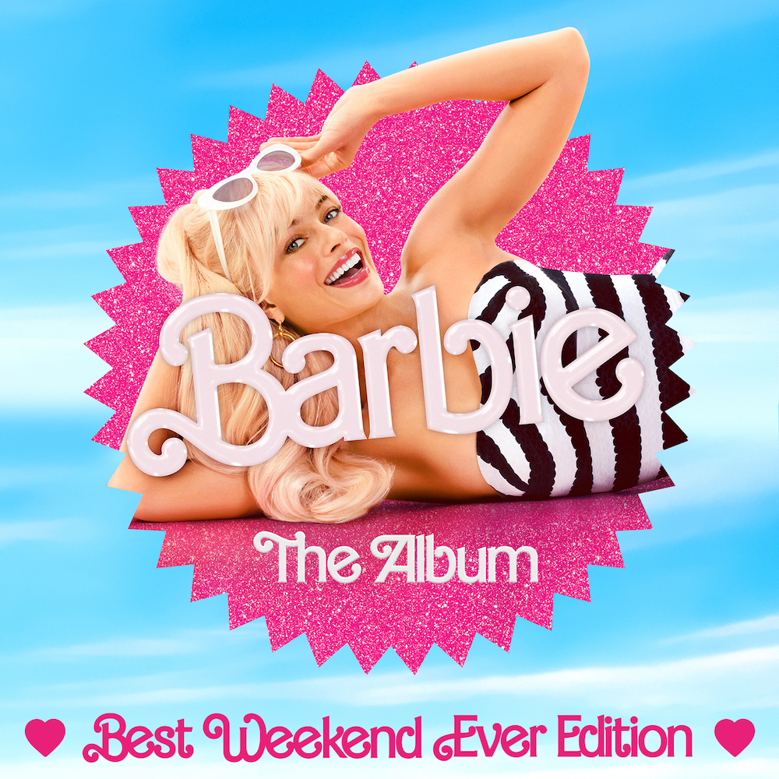
album cover art
July 21, 2023—Brandi Carlile’s new rendition of Indigo Girls’ “Closer to Fine,” featuring her wife, Catherine Carlile, is out today and featured on the new version of the Barbie movie soundtrack: Barbie The Album (Best Weekend Ever Edition). Produced by Carlile, who plays guitar, piano, keys, banjo and moog on the track, “Closer To Fine” also features special guest musicians Matt Chamberlain (drums) and Dave Mackay (keys). Listen/share HERE.
A 9x GRAMMY Award-winning singer, songwriter, performer, #1 New York Times Bestselling author and activist, Carlile is known as one of music’s most respected voices. Over the course of her acclaimed career, Carlile has released seven full-length albums including her most recent, 2021’s 3x GRAMMY Award-winning In These Silent Days. Additionally, Carlile continues her work as a renowned producer with several studio projects released this year including her show-stopping rendition of “Home,” which was featured on the final season of Ted Lasso, Brandy Clark’s new self-titled album and Tanya Tucker’s Sweet Western Sound, as well as Joni Mitchell’s forthcoming new album, Joni Mitchell At Newport (out July 28).
Known for her powerful live performances, Carlile recently held her once-in-a-lifetime “Echoes Through The Canyon” event at Washington’s Gorge Amphitheatre, which included her annual headline concert with special guests Marcus Mumford and Allison Russell, The Highwomen with special guest Tanya Tucker and Joni Mitchell’s “Joni Jam.” She will also perform select headline shows this year as well as several dates with P!NK as part of her stadium tour later this summer. See below for complete tour itinerary.
BRANDI CARLILE CONFIRMED TOUR DATES
July 22—Brookville, NY—Tilles Center for the Performing Arts+
July 24—Toronto, ON—Rogers Centre*
July 26—Cincinnati, OH—Great American Ball Park*
August 3—New York, NY—Citi Field*
August 4—Selbyville, DE—Freeman Arts Pavilion+
August 5—Pittsburgh, PA—PNC Park*
August 16—Detroit, MI—Comerica Park*
August 17—Madison, WI—Breese Stevens Field#
August 19—Fargo, ND—Fargodome*
August 21—Omaha, NE—Charles Schwab Field*
August 27—St. Louis, MO—Evolution Festival
August 29—St. Paul, MN—Minnesota State Fair^
August 31—Highland Park, IL—Ravinia Festival#
September 1—Interlochen, MI—Kresge Auditorium
September 8—Morrison, CO—Red Rocks Amphitheatre#
September 9—Morrison, CO—Red Rocks Amphitheatre**
September 14—Louisville, KY—Bourbon & Beyond Festival
September 16—Cuyahoga Falls, OH—Blossom Music Center‡
September 18—Philadelphia, PA—Citizens Bank Park*
September 19—Philadelphia, PA—Citizens Bank Park*
September 22—Nashville, TN—Geodis Park*
September 23—Huntsville, AL—Orion Amphitheater†
September 25—San Antonio, TX—Alamodome*
September 27—Houston, TX—Minute Maid Park*
September 29—Dallas, TX—Globe Life Field*
October 3—San Diego, CA—Snapdragon Stadium*
October 7—Las Vegas, NV—Allegiant Stadium*
October 9—Phoenix, AZ—Chase Field*
October 14—Los Angeles, CA—Hollywood Bowl
January 18-21, 2024—Barcelo Maya Resort, Mexico—Girls Just Wanna Weekend
*with P!NK
+special solo show
#with special guest Brandy Clark
^with special guest Wynonna Judd
‡with special guest Katie Pruitt
†with special guest Tanya Tucker
**with special guest Joy Oladokun
www.brandicarlile.com
FOR MORE INFORMATION ON BRANDI CARLILE, PLEASE CONTACT
ASHA GOODMAN 615.320.7753 OR CARLA SACKS 212.741.1000 AT SACKS & CO., ASHA.GOODMAN@SACKSCO.COM OR CARLA@SACKSCO.COM.
FOR MORE INFORMATION ON BARBIE THE ALBUM, PLEASE CONTACT ANGREW GEORGE, ANDREW.GEORGE@ATLANTICRECORDS.COM
CONNECT WITH BARBIE THE ALBUM:
BARBIETHEALBUM.COM | INSTAGRAM | TIKTOK | TWITTER | FACEBOOK | PRESS SITE

