THE BAND CAMINO RELEASE MUCH-ANTICIPATED NEW SINGLE “TOLD YOU SO”
LISTEN HERE
THE NEW SONG FOLLOWS THE BAND’S INCREDIBLE YEAR OF TOURING IN 2022, WITH AN ENTIRELY SOLD-OUT U.S. RUN
PLAYING BONNAROO ON SATURDAY, JUNE 17
MORE NEW MUSIC COMING SOON
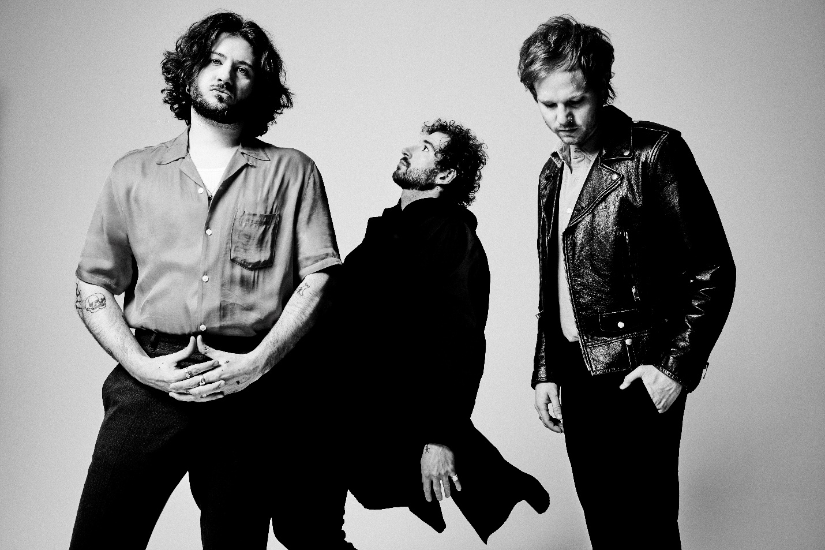
DOWNLOAD HI-RES PRESS IMAGE HERE
(CREDIT: JIMMY FONTAINE)
“…booming arena rock” –ROLLING STONE
“On the cusp of stardom” –ASSOCIATED PRESS
“The past year has been monumental for the group.” –GRAMMY.COM
“Rock’s Next Big Thing” –BILLBOARD
“There is so much in store for this rising rock band” –PEOPLE
“…there’s a magnetism to their performance. The Band CAMINO’s confidence evokes a veteran posture that preceded their self-titled debut album” –AMERICAN SONGWRITER
(February 21, 2023) – LOS ANGELES, CA – Nashville pop-rock trio The Band CAMINO today debut their highly-anticipated new single “Told You So,” available to stream/download HERE. An arena-sized rock anthem with heavy-hitting hooks, fiery riffs, and an instantly memorable chorus, the song underscores why the group have quickly become a must-watch artist on the ascent. “Told You So” also arrives on the heels of the band’s incredible year of touring in 2022, which saw them completely sell out their spring U.S. headline run and play their biggest headline show to date at The Factory in Dallas. The Band CAMINO have also been widely praised as a live sensation for their captivating, high-energy performances that have resonated with audiences nationwide.
“‘Told You So is about releasing the anger and frustration of wishing someone had just listened,” the band commented. “They're listening now, but it’s too late.”
In celebration of the new effort, The Band CAMINO will be embarking on a European headline tour (dates HERE), along with a home-state performance at Bonnaroo on Saturday, June 17. The three-piece is also in the studio working on new music. Stay tuned for more coming soon.
THE BAND CAMINO
“TOLD YOU SO”
AVAILABLE HERE
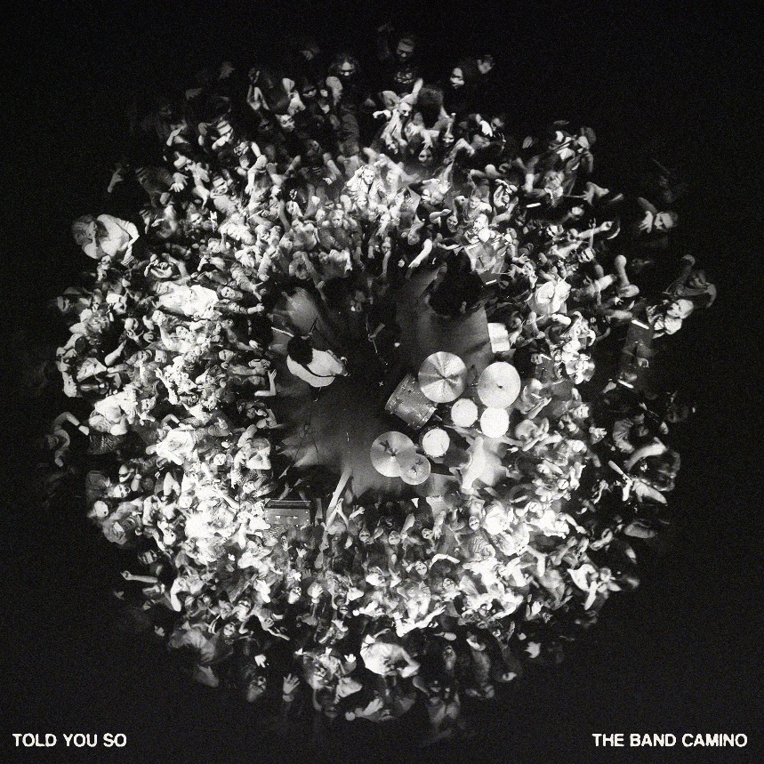
DOWNLOAD HI-RES ARTWORK HERE
ABOUT THE BAND CAMINO:
The Band CAMINO has blazed a permanent trail for themselves in music, garnering more than 500 million global streams to date and widespread acclaim. Since relocating from Memphis to Nashville in 2018, the band (singers/guitarists Jeffery Jordan and Spencer Stewart and drummer Garrison Burgess) has been honing their signature ‘Band Camino’ sound at the crossroads of pop and rock music. Their self-titled debut album (Sept. 2021) showcases the trio’s electrifying guitar-driven sound, first introduced on their anthemic EP tryhard in 2019, which spawned fan favorites “Daphne Blue” and “See Through.”
In addition to selling out multiple tours – including their largest headline run to date in 2022 – and hitting the major festival circuit with performances at Lollapalooza, Hangout, Forecastle, and Austin City Limits (where they were named a “breakout act” by Grammy.com), The Band CAMINO has developed a highly-engaged worldwide fanbase. Their growth has been largely stimulated by raw discovery, even catching the attention of Taylor Swift, who included the band’s reflective track “Berenstein” on her “Songs I’m Loving Right Now” playlist in 2018.
In 2021, the band made their national television debut performing “1 Last Cigarette” on Jimmy Kimmel Live! and “Underneath My Skin” on The Kelly Clarkson Show.
FOLLOW THE BAND CAMINO
Website | Instagram | Twitter | YouTube | TikTok

# # #
For more information on The Band CAMINO, please contact:
Nathalie Rubin, Elektra Entertainment
Nathalie.Rubin@300Elektra.com

