RYAN BEATTY ANNOUNCES NEW ALBUM CALICO
ARRIVING APRIL 28TH

NEW SINGLE “RIBBONS” OUT NOW

PRE-ORDER CALICO HERE / STREAM "RIBBONS" HERE

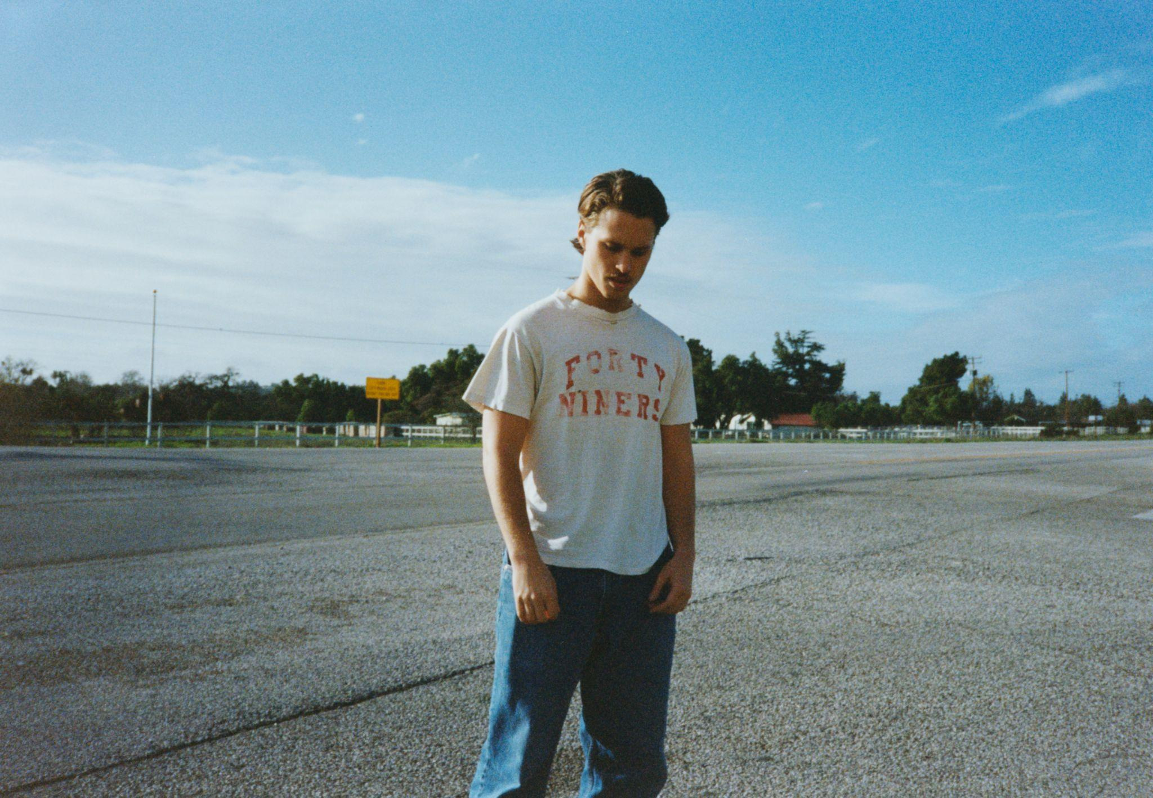
DOWNLOAD PRESS ASSETS HERE
Photo Credit: Lucas Creighton

what started as a night became a morning under the southern sun
became a citrus kiss became a crickets click became a cows howl behind the slaughterhouses door you
spun the car keys took your shirt off chewed two apples to the core turning red turning west
tipping the switchblade to roswell trucking through tucson my california called us in the distance
i saw your shadow i bared your cross i felt your heart i tasted your tongue in my teeth and
it became the perfect carnage of my feelings for you
- Ryan Beatty

MARCH 17, 2023 – Singer/songwriter Ryan Beatty has announced his third full-length album Calico, arriving April 28th via Elektra US/Atlantic Records UK (album art below). The announcement arrives alongside the release of new single, “Ribbons,” which is streaming now. Calico is available for preorder now.

A stunning introduction to the upcoming record, “Ribbons” opens with a delicate piano melody. Beatty’s warm, emotive vocals envelop the song as he leads to the album’s quiet proverb: “it’s brave to be nothing to no one at all.”

Calico rings in a new era for Ryan Beatty. Co-produced by Ryan and Ethan Gruska, Calico matches Ryan’s lyrical revelations with a luminously detailed sound that inspires endless fascination despite its great subtlety. The result is a timeless and transportive body of work, providing abundant space for the transformation and healing that led to its creation.

Calico moves further into the freeform, yet gracefully sculpted sound Ryan explored on 2020’s Dreaming of David. In bringing the album to life, he and Gruska mainly recorded at historic L.A. spot Valentine Recording Studios and at Rick Rubin’s Shangri-La, working with a lineup of musicians including guitarist Dylan Day (Jenny Lewis, Laura Veirs), drummer Matt Chamberlain (Lorde, Brandi Carlile), saxophonist Sam Gendel (Sylvan Esso, Perfume Genius), string arranger Rob Moose (FKA twigs, Laura Marling), and Bon Iver’s Justin Vernon, who contributed additional production and instrumentation.

Ryan also collaborated with revered Belgian artist Peter De Potter to bring the visuals around the upcoming album to life. Peter’s unique method of blending his photography and video with graphics resonates in art, fashion, and contemporary online culture. The addition of the Antwerp-based creative’s work on Ryan’s upcoming album compliments the poetic atmosphere he’s created for Calico.

An elegant body of work, Calico is the superb outcome of two devoted years of exploration, writing, and recording. Sharing the endless nuances of his interior life on his upcoming album, Ryan quietly explores the tension between protecting our hearts and longing for the type of connection that can only come from true vulnerability.

RYAN BEATTY
CALICO – OUT APRIL 28TH
PREORDER NOW

FOLLOW RYAN BEATTY
OFFICIAL SITE | INSTAGRAM | FACEBOOK | YOUTUBE

For US press inquiries, please contact:
Sarah Goldstein / sarahgoldstein@elektra.com
Glenn Fukushima / glennfukushima@elektra.com

