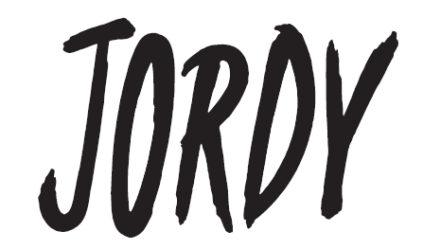
JORDY SHARES INCLUSIVE NEW SINGLE “STORY OF A BOY”
WHICH INTERPOLATES “ABSOLUTELY (STORY OF A GIRL)” BY NINE DAYS
+ ANNOUNCES THE RELEASE OF HIS ANTICIPATED SOPHOMORE ALBUM BOY – OUT FRIDAY, 4/21
LISTEN TO THE SONG + PRE-SAVE THE LP HERE
WATCH THE MUSIC VIDEO HERE, FEATURING JOHN HAMPSON OF NINE DAYS
JORDY EARNED NOMINATIONS AT THIS YEAR’S GLAAD MEDIA AWARDS AND QUEERTY AWARDS
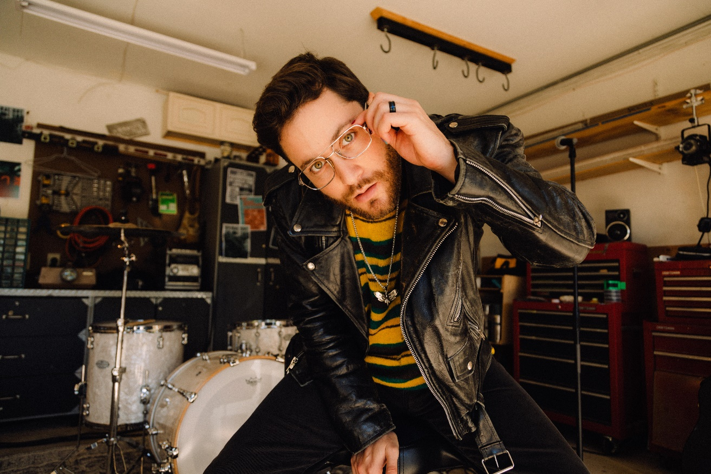
DOWNLOAD HI-RES IMAGE HERE | CREDIT: DANTE VELASQUEZ
“A rising talent with a knack for turning self-reflection into blissful (and relatable) pop.” –THE HUFFINGTON POST
“…instantly catchy” –BILLBOARD
“A big, bright new voice in pop” –PAPER
“…fresh, angel-voiced” –VMAN
“The gay pop star we’ve been waiting for” –THE ADVOCATE
(January 26, 2023) – LOS ANGELES, CA – Fast-rising, acclaimed pop artist JORDY is excited to share his new single “Story of a Boy.” The inclusive and instantly captivating song interpolates Nine Days’ era-defining 2000 hit “Absolutely (Story of a Girl).” The result is a modern, queer version of the classic that evokes nostalgia, while also giving representation and visibility to the next generation of LGBTQ+ youth. “In short, this song is what I needed as a kid,” said JORDY. “Story of a Boy” will also appear on the artist’s much-anticipated sophomore album BOY, which JORDY today revealed will be out on Friday, April 21.
Click HERE to listen to “Story of a Boy” and pre-save the new album, and read more about JORDY’s process creating the song in his exclusive with Rolling Stone. Ahead of the release, JORDY also earned nominations at the 34th Annual GLAAD Media Awards for “Outstanding Breakthrough Music Artist, and the Queerty Awards for “Best Music Video” (for “i get high”).
The companion music video for “Story of a Boy” is out today as well. The early-aughts inspired visual (available to watch HERE) features a special guest cameo from John Hampson, the frontman of Nine Days and writer of the original hit song.
“Honoring John’s writing and artistry, I thought it would be cool to see the original voice come together with a newer queer artist to further the message,” JORDY added. “When we asked him about appearing in the music video, he was so down and excited. Much love to John for being so involved and supportive.”
“I loved the idea of flipping the song around from ‘Story of a Girl’ to ‘Story of a Boy,’ so I was already all in before I even met JORDY,” says Hampson. “The song means something special to me, and JORDY’s version means something special to him – and now me, as well.”
Since the release of his debut album Mind Games, JORDY’s heart-on-his sleeve approach to modern pop music has amassed 100M+ career streams, sold-out shows across the U.S. – including one at LA’s famed Troubadour – major festival performances, critical praise in the press, and a devoted following on TikTok with his candid and authentic videos, often chronicling the growing pains of young adulthood. With BOY, the 27-year-old singer-songwriter creates a relatable body of work that channels these mixed feelings into high-impact pop anthems and delicate, heartfelt ballads about what to say to a crush, the ups and downs of mental health, the trials and tribulations of being a third wheel, the inevitability of getting older, and why it’s okay to move on.
“On the cover of the record, you can see me leaning back as I grab my tie – to me, the image is a symbol of adulthood pulling at my neck. Sometimes being a grown up is exciting and exhilarating, but sometimes it’s really, really hard,” JORDY explained.
He continued, “When you’re young, you look at adults and envy their wisdom and experience; but here I am, 27 years old, and there are many days where I feel lost. It makes me think about how when you’re young, all you want is to be older, and once you get older, all you want is to stay young.”
More original songs from BOY will be coming soon. Keep up with JORDY on his socials (linked below) in the meantime.
JORDY
BOY – Arriving Friday, April 21, 2023
PRE-SAVE HERE
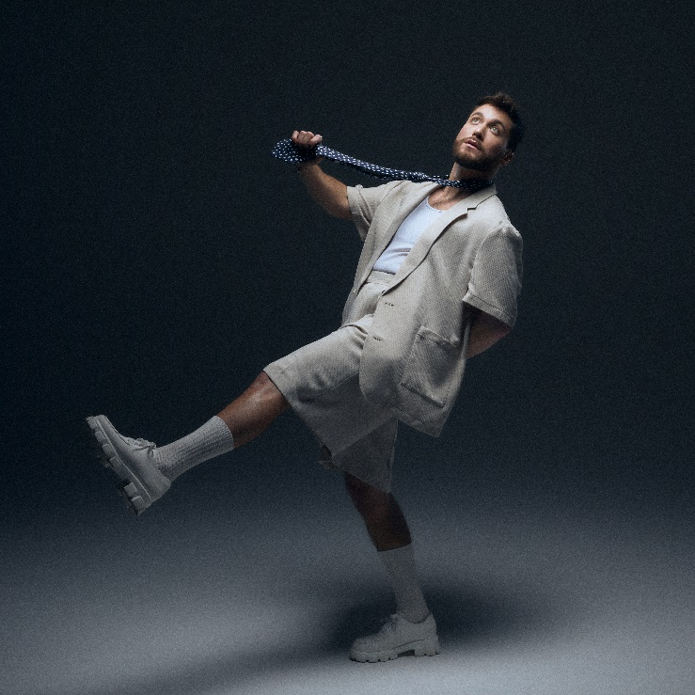
HI-RES ALBUM ARTWORK AVAILABLE HERE

ABOUT JORDY:
Through dynamic, diverse, and diaristic songwriting, JORDY amplifies the back-and-forth of his internal conversation as loudly as possible, penning plainspoken lyrics and belting them with no shortage of personality. In 2018, he broke through with the independent single “Just Friends,” tallying 18+ Spotify and counting. He maintained his momentum with “Close To You,” reeling in another 13+ million streams. His 2021 full-length debut, Mind Games, spawned the relatable “Long Distance,” which lit up TikTok. In its wake, he made his national television debut with a showstopping performance on The TODAY Show and later earned a nomination at the iHeartRadio Music Awards in the “Social Star” category. Piling up north of 100 million streams, JORDY holds nothing back on his second full-length album, BOY [out Friday, 4/21]. He initially heralded the LP with a trio of standouts songs in 2022 – “Dry Spell,” “IDK SH!T,” and “i get high.” BOY’s lead single “Story of a Boy” flips the story and sound of a familiar anthem—Nine Days’ “Story of a Girl”—with a fresh, fiery, and inclusive spirit that hints at much more to come.

FOLLOW JORDY:
WEBSITE | INSTAGRAM | TWITTER | TIKTOK | FACEBOOK
# # #
For more information on JORDY, please contact:
Nathalie Rubin, Elektra Entertainment
Nathalie.Rubin@300Elektra.com
For more information on John Hampson / Nine Days, please contact:
Eileen Thompson-Ray, Mojo Music Publishing
eileen.thompsonray@gmail.com

