Fall Out Boy Reveals So Much (For) Stardust Tracklist

Band’s New Album Arrives March 24, 2023

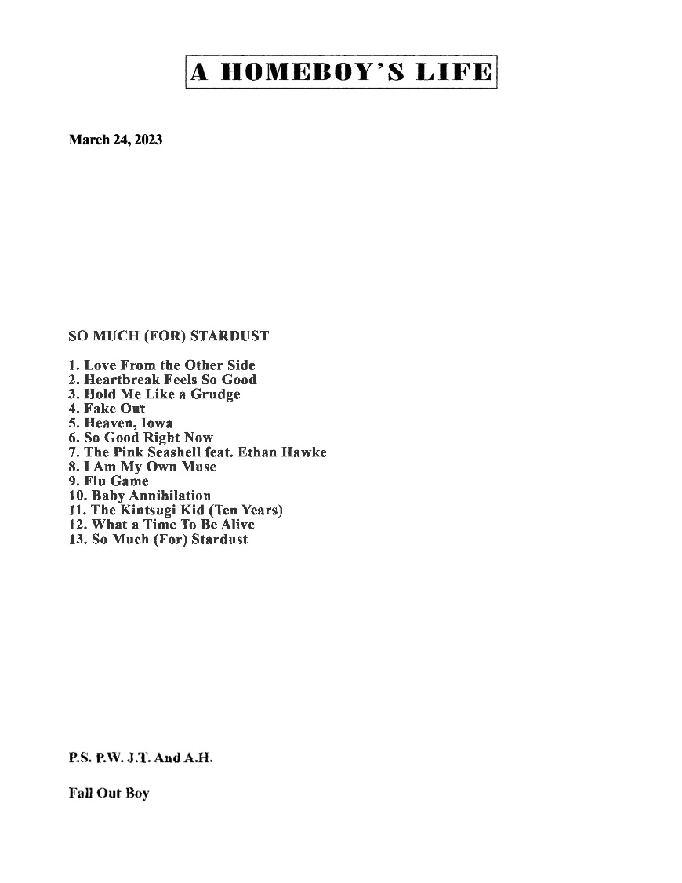
So Much (For) Stardust Album Art: Download Here
Fall Out Boy press image (credit Pamela Littky): Download Here

March 3, 2023 – After weeks of sending mysterious seashells with single tracks listed inside, GRAMMY Award-nominated and multi-platinum selling rock band Fall Out Boy dropped the tracklist for their highly anticipated new album So Much (For) Stardust today:

So Much (For) Stardust Tracklist:
- Love From the Other Side
- Heartbreak Feels So Good
- Hold Me Like a Grudge
- Fake Out
- Heaven, Iowa
- So Good Right Now
- The Pink Seashell feat. Ethan Hawke
- I Am My Own Muse
- Flu Game
- Baby Annihilation
- The Kintsugi Kid (Ten Years)
- What a Time To Be Alive
- So Much (For) Stardust

Earlier this week, Fall Out Boy landed their first career No. 1 single at Alternative Radio with “Love From the Other Side” topping both the Mediabase and Billboard Alternative Airplay charts dated February 25 & March 4, respectively. “Love From the Other Side” also marks the band’s 7th Billboard Alternative Airplay Top 10.

So Much (For) Stardust will arrive March 24, 2023 on Fueled By Ramen/Elektra/DCD2 Records and is available for pre-order here.

This summer, Fall Out Boy will hit the road for their highly anticipated worldwide So Much For (Tour) Dust global headline tour, which kicks off June 21 at Chicago’s famed Wrigley Field and continues across North America in the summer and the UK & Europe in October and November. Multiple dates have been added (Los Angeles, London, Cardiff) due to overwhelming demand. For full details on tour dates, visit www.falloutboy.com/tour.

So Much (For) Stardust is Fall Out Boy’s first new studio album since 2018’s M A N I A, which garnered a GRAMMY nomination for Best Rock Album and marked their third consecutive and fourth overall #1 album. So Much (For) Stardust is available for pre-order here.

# # #

