**Fall Out Boy Releases New Album *So Much (For) Stardust***

**Band’s 8th Studio Album** [**Available Everywhere Now**](https://falloutboy.lnk.to/somuchforstardust)

**Unveils New Music Video for “Hold Me Like a Grudge” –** [**Watch Now**](https://youtu.be/1rAQGxRFvN0)

**Performances on *The Tonight Show Starring Jimmy Fallon*, *Good Morning America* and More**

**So Much For (Tour) Dust Headline Trek Launches June 21 at Wrigley Field**

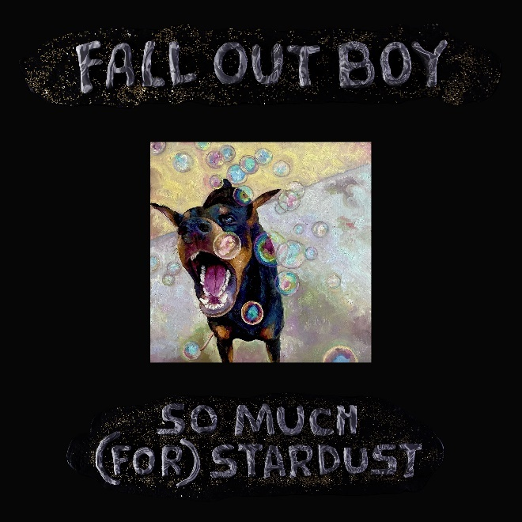

*So Much (For) Stardust* Album Art: [Download Here](https://www.dropbox.com/s/fgnw9w89wbamoku/FOB%20-%20So%20Much%20%28For%29%20Stardust%20-%20Cover.jpg?dl=0)

Fall Out Boy press image (credit Pamela Littky): [Download Here](https://www.dropbox.com/s/tpvhwcy8dx1dxqf/FOB_Press%20Image%202023%20-%20credit%20Pamela%20Littky.jpg?dl=0)

**March 24, 2023** – Today, GRAMMY Award-nominated and multi-platinum selling rock band **Fall Out Boy** release their 8th studio album ***So Much (For) Stardust***, available everywhere now on Fueled By Ramen/Elektra/DCD2 Records. Listen to the brand new record [here](https://falloutboy.lnk.to/somuchforstardust).

This morning, the band also dropped the music video for a brand new track **“Hold Me Like a Grudge**” – the continuation to “This Ain’t A Scene (It’s an Arms Race)” and third in the trilogy of Fall Out Boy music videos that began with “Dance Dance.” Watch [here](https://youtu.be/1rAQGxRFvN0).

Directed by Brendan Walter, the video follows an alternate timeline in which Pete breaks his leg after jumping off the stage at the end of the “This Ain’t A Scene (It’s an Arms Race)” video. The band continued to record music, but eventually all went their separate ways until Pete gets a call from a future version of himself, beginning an epic quest to repair a rip in the space time continuum in the Fall Out Boy universe.

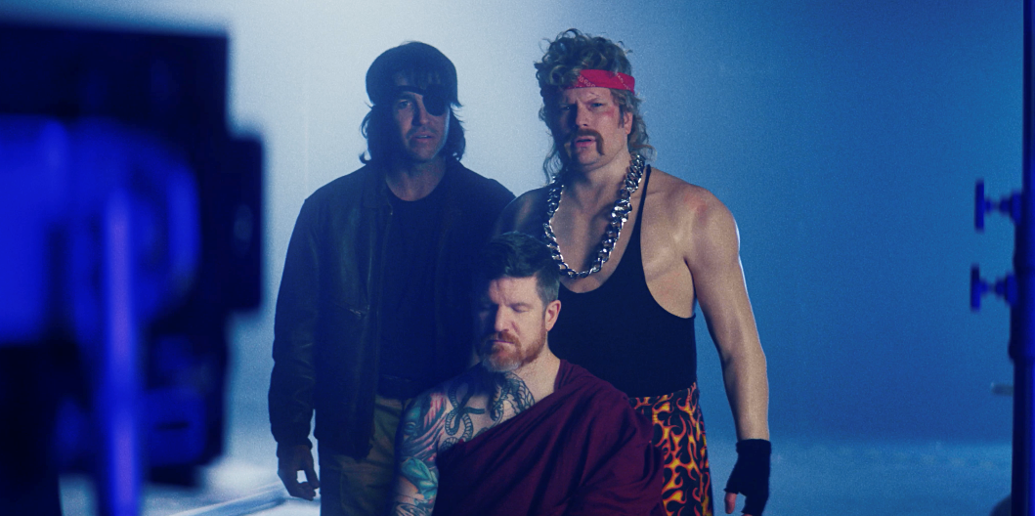

Fall Out Boy performed the broadcast debut of **“Hold Me Like a Grudge”** on *The Tonight Show Starring Jimmy Fallon* last night on NBC, bringing the music video to life through costumes from the video and kicking the performance off with a key Easter egg. Watch the performance [here](https://www.youtube.com/watch?v=BahWrtvv9zw).

*Photo Credit: Todd Owyoung/NBC*

While at Studio 6B, they joined Jimmy Fallon and The Roots to form the (temporary) supergroup Cluck Cluck Boy and deliver a very special performance of their 4x platinum hit “Sugar, We’re Goin Down” – watch [here](https://youtu.be/nTvc0YWQFYE?t=251).

*Photo Credit: Todd Owyoung/NBC*

This morning, Fall Out Boy performed **“Love From the Other Side”** – the album’s worldwide smash lead single, with which they landed their first career No. 1 single at Alternative Radio earlier this month – on *Good Morning America –* watch [here](https://www.goodmorningamerica.com/culture/video/fall-boy-performs-love-side-gma-98095121). **“Love From the Other Side”** marks the band’s 7th *Billboard* Alternative Airplay Top 10. Other highlights of release week included visits to Audacy, Z100’s *Elvis Duran and the Morning Show*, and an exclusive SiriusXM Town Hall. Pete and Patrick also sat down with Zane Lowe for [Fall Out Boy: The Zane Lowe Interview](https://www.youtube.com/watch?v=XPz7tcK6BSU) on Apple Music.

­­

***So Much (For) Stardust***’s global launch included a trip across the Atlantic last week for a flurry of sold out shows, listening events and promotion in the UK and Germany. After meeting fans at Berlin's [Planetarium](https://www.instagram.com/p/Cp0O37uu9x2/?utm_source=ig_web_copy_link), the band then headed to the UK with Manchester being the first of the stops. Andy, Patrick and Pete visited [Manchester United's Old Trafford Stadium](https://www.instagram.com/p/CqIxGPHtWcz/), were met by hundreds of fans at HMV and then played a packed out, intimate show at [Band On The Wall](https://www.instagram.com/p/Cp3AlSUubqn/?utm_source=ig_web_copy_link) to rave reviews. In London, they visited Radio 1, Radio X, MTV, and Banquet Records, among others, and took to the stage at Heaven, London's legendary club. The sold-out, critically acclaimed show saw them play new music effortlessly mixed with Fall Out Boy classics spanning their 20+ year career.

On ***So Much (For) Stardust*** – which has already started receiving critical and fan acclaim alike – the band reunited with renowned producer **Neal Avron**, whom they worked with on three previous albums: *From Under the Cork Tree*, *Infinity on High* and *Folie à Deux*. ***So Much (For) Stardust*** is Fall Out Boy’s first new studio album since 2018’s *M A  N  I  A,* which garnered a GRAMMY nomination for Best Rock Album and marked their third consecutive and fourth overall #1 album.

This summer, Fall Out Boy will hit the road for their highly anticipated worldwide **So Much For (Tour) Dust** global headline tour, which kicks off June 21 at Chicago’s famed Wrigley Field and continues across North America in the summer and the UK & Europe in October and November. Multiple dates have been added (Los Angeles, London, Cardiff) due to overwhelming demand. For full details on tour dates, visit [www.falloutboy.com/tour](http://www.falloutboy.com/tour).

***So Much (For) Stardust* Tracklist:**

1. Love From the Other Side
2. Heartbreak Feels So Good
3. Hold Me Like a Grudge
4. Fake Out
5. Heaven, Iowa
6. So Good Right Now
7. The Pink Seashell feat. Ethan Hawke
8. I Am My Own Muse
9. Flu Game
10. Baby Annihilation
11. The Kintsugi Kid (Ten Years)
12. What a Time To Be Alive
13. So Much (For) Stardust

# # #