Fall Out Boy Announces New Album
So Much (For) Stardust
Arriving March 24, 2023

New Single “Love From The Other Side” Available Now
Watch The Music Video Here

Band To Perform “Love From The Other Side” Tonight on Jimmy Kimmel Live!

So Much (For) Stardust Available For Pre-Order Now

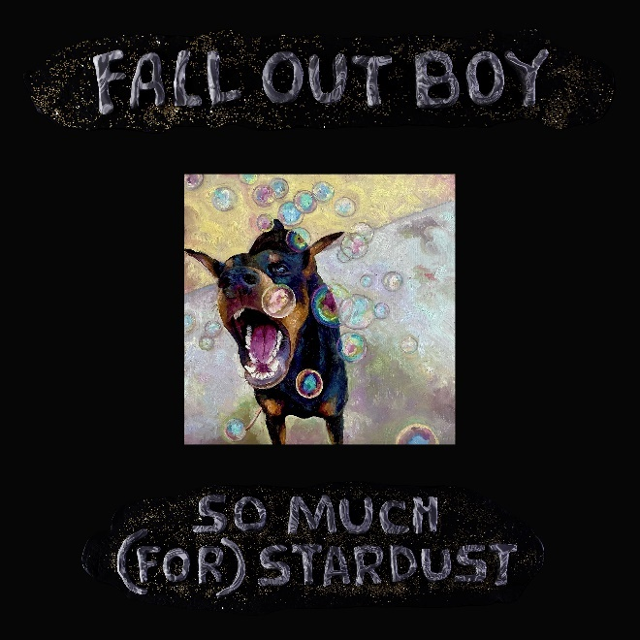
So Much (For) Stardust Album Art: Download Here
Fall Out Boy press image (credit Pamela Littky): Download Here

January 18, 2023 - Today, GRAMMY Award-nominated and multi-platinum selling rock band Fall Out Boy announced that their eighth studio album So Much (For) Stardust will arrive March 24, 2023 and provided the first glimpse of the new music with the release of the record’s first single “Love From The Other Side.” Listen to “Love From The Other Side” here and pre-order So Much (For) Stardust here. In tandem with the song’s release, the band also unveiled the music video - directed by David Braun and Open The Portal. Watch the video here.

“Technology has made it really easy to make records much more quickly these days. There’s nothing wrong with that, and that spontaneity can be exciting,” shares FOB’s Patrick Stump. “But we wanted to get back to the way we used to work. We wanted to make a record that was really lovingly crafted and deliberate and patiently guided – like someone cooked you a delicate meal. I’m not a very proud guy, but I’m pretty proud of this record.”

So Much (For) Stardust marks a homecoming for the band on multiple fronts; the first of which found the band reuniting with renowned producer Neal Avron, whom they’ve worked with on three previous albums (From Under the Cork Tree, Infinity on High, Folie à Deux). On working with Avron for this record, Stump notes: “Neal not only taught us how to make records, but has a unique capacity to really take time and focus on a record. We thought it was a no-brainer to work with him again, on a record where that was very important to us, and he was gracious enough to agree to work with us.”

Additionally, So Much (For) Stardust will be released on Fueled By Ramen/Elektra – Fall Out Boy’s first album with the label since their 2003 debut album Take This to Your Grave, which celebrates its 20th anniversary on May 6.
“Our band has been an ongoing art project for twenty years and we know there have been many inception points along that journey,” says FOB’s Pete Wentz. “We wanted to create an album that merged those points together – something new, but carved from our foundation. Fueled By Ramen and Elektra seemed like the perfect home for this.”
“We’re incredibly excited to welcome back Fall Out Boy to the Fueled By Ramen family. It’s been twenty years since the release of their debut album on Fueled By Ramen, and it’s a true pleasure to be working together again. Growing up in Chicago, I had the privilege of watching Fall Out Boy play DIY venues around the city, eventually growing into the global superstars we know them as today,” says Johnny Minardi, VP of A&R for Fueled By Ramen/Elektra. “They are a truly special band that has altered the landscape of rock music and who continually evolve with each new release. They have made an incredible album and we can’t wait for the world to hear it.”
Tonight, the band will appear on Jimmy Kimmel Live! to perform the broadcast debut of “Love From The Other Side.” Jimmy Kimmel Live! airs on ABC at 11:35/10:35c, and is available next day on Hulu. Pete and Patrick will also appear on The Zane Lowe Show on Apple Music this morning to discuss the new single.
Anticipation for the record started brewing in November, after a mysterious ad appeared in the Chicago Tribune and continued building with multiple teaser sites in December, the latter of which featured a clay animation video titled “A Claymation Fall Out Boy Celebration” on Christmas that included a quick audio preview of “Love From The Other Side” for eagle-eared fans. On January 11, the band officially revealed the single’s release date just days before they took the stage at the 2023 iHeartRadio ALTer EGO on Saturday in Los Angeles, CA.

So Much (For) Stardust is Fall Out Boy’s first new studio album since 2018’s M A N I A, which garnered a GRAMMY nomination for Best Rock Album and marked their third consecutive and fourth overall #1 album.

Most recently, Fall Out Boy embarked on THE HELLA MEGA TOUR in July 2021 alongside Green Day & Weezer, playing live in front of over 1 million fans on a sold-out global stadium tour. The U.S. leg included numerous sold out stadium gigs – including renowned venues like Chicago’s Wrigley Field, Boston’s Fenway Park and Los Angeles’ Dodger Stadium. Critical and fan acclaim poured in, with USA Today hailing it “the most stacked line-up of any rock tour in 2021,” Billboard noting that each night was “serving up a buffet of hits in front of one of the largest concert crowds,” and Rolling Stone calling it “wildly entertaining.” The tour was nominated for both Major Tour of the Year and Best Rock Tour at the Pollstar Awards in 2021. The international leg of the tour took place throughout the summer of 2022.

# # #

About Fall Out Boy
Fall Out Boy have cemented their position as one of rock music’s biggest-selling bands. In January 2023, Fall Out Boy announced that their eighth studio album So Much (For) Stardust will be released March 24, 2023 on Fueled By Ramen/Elektra. The album marks the band’s first new album in more than five years. In July 2021, Fall Out Boy embarked on THE HELLA MEGA TOUR alongside Green Day & Weezer, playing live in front of over 1 million fans on a sold-out global stadium tour and marking the first time the three bands had headed out on the road together. The U.S. leg included numerous sold out stadium gigs – including renowned venues like Chicago’s Wrigley Field, Boston’s Fenway Park and Los Angeles’ Dodger Stadium. Critical and fan acclaim poured in, with USA Today hailing it “the most stacked line-up of any rock tour in 2021,” Billboard noting that each night was “serving up a buffet of hits in front of one of the largest concert crowds,” and Rolling Stone calling it “wildly entertaining.” The tour was nominated for both Major Tour of the Year and Best Rock Tour at the Pollstar Awards in 2021. The international leg of the tour took place throughout the summer of 2022. Fall Out Boy’s seventh studio album M A N I A debuted at #1 on the Billboard 200 in January 2018 and garnered a GRAMMY nomination for Best Rock Album. The record marked the band’s third consecutive and fourth overall #1 album respectively and featured the global smash “The Last of the Real Ones. In 2015, Fall Out Boy released their platinum, sixth studio album AMERICAN BEAUTY/AMERICAN PSYCHO, which debuted at #1 on the Billboard 200 and peaked at #1 on iTunes in more than 22 countries upon its January 2015 release. The album’s first two singles “Centuries” and “Uma Thurman” have been RIAA-certified 4x and 2x platinum, respectively. AMERICAN BEAUTY/AMERICAN PSYCHO followed the GRAMMY-nominated band’s gold-certified album SAVE ROCK AND ROLL, which debuted at #1 on the Billboard 200 and #1 on iTunes in 27 countries upon its April 2012 release and features the multiplatinum hit “My Songs Know What You Did In The Dark (Light Em Up)” and hit “Alone Together.” SAVE ROCK AND ROLL was the band’s second #1 debut; Platinum selling “Infinity On High” topped the chart in 2007 which followed multi-platinum breakthrough album “From Under The Cork Tree” released in 2005. They were most recently nominated for a 2019 MTV Video Music Award for BEST ROCK VIDEO (“Bishops Knife Trick”) and have won FAVORITE ARTIST: ALTERNATIVE ROCK at the 2015 American Music Awards, BEST ROCK VIDEO at the 2015 MTV Video Music Awards and BEST ALTERNATIVE BAND at the 2014 People’s Choice Awards. Fall Out Boy has also written the song “Immortals,” featured in the Oscar®-nominated Disney hit movie Big Hero 6, which topped the box office upon its November 2014 release and has already surpassed $222 million at the domestic U.S. box office and topped $650 million globally. Hailing from Chicago, Fall Out Boy—Patrick Stump (vocals/guitar), Pete Wentz (bass), Joe Trohman (guitar) and Andy Hurley (drums)—has appeared on the cover of Rolling Stone and other prestigious publications. They have performed on Saturday Night Live, The Tonight Show Starring Jimmy Fallon, The Today Show, America’s Got Talent, The Voice, Late Night with Jimmy Fallon, The Tonight Show with Jay Leno, Conan, The Late Show with David Letterman, Jimmy Kimmel Live!, Good Morning America and many more. More information can be found at www.falloutboy.com.

