Fall Out Boy’s “Love From The Other Side” Hits No. 1 at Alternative Radio

Achievement Marks Band’s First Career Alternative No. 1 & Seventh Overall Alternative Airplay Top 10

Listen to “Love From The Other Side” Here & Watch The Music Video Here

New Album So Much (For) Stardust Arrives March 24, 2023

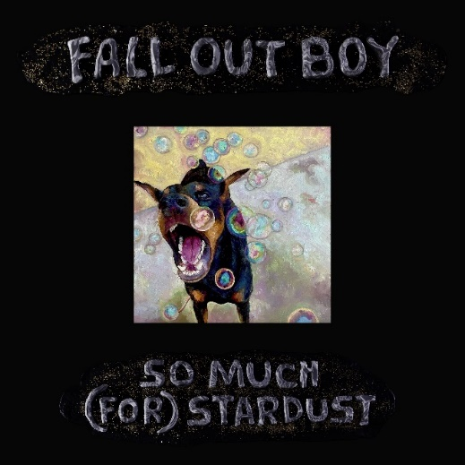
So Much (For) Stardust Album Art: Download Here
Fall Out Boy press image (credit Pamela Littky): Download Here

February 27, 2023 – GRAMMY Award-nominated and multi-platinum selling rock band Fall Out Boy have landed their first career No. 1 single at Alternative Radio with “Love From The Other Side” topping both the Mediabase and Billboard Alternative Airplay charts dated February 25 & March 4, respectively. “Love From The Other Side” also marks the band’s 7th Billboard Alternative Airplay Top 10.

“Love From The Other Side” was released January 18 alongside the announcement that the band’s highly anticipated 8th studio So Much (For) Stardust would arrive March 24, 2023 on Fueled By Ramen/Elektra/DCD2 Records. Listen to “Love From The Other Side” here and watch the music video here.

The single’s release set off set of an immediate wave of unprecedented excitement from fans worldwide that shows no signs of slowing, having amassed 25 million global streams to date and widespread critical success.

Jack Saunders of BBC Radio 1 cited that “Love From The Other Side” is “Fall Out Boy just doing what they do best…” and hailing the band as “titans of Rock and Roll.” Alternative Press proclaims the song as “anthemic rock territory… with razor-sharp hooks, inventive guitars, timely lyrics, and, of course, the otherworldly vocal prowess of Patrick Stump.” Consequence has praised that the track “pushes guitars back to the forefront, while demonstrating the band hasn’t lost any of their flair for the dramatic.” SPIN has called it “bombastic,” while Harper’s BAZAAR has declared it one of the Best Songs of 2023.

This summer, Fall Out Boy will hit the road for their highly anticipated worldwide So Much For (Tour) Dust global headline tour, which kicks off June 21 at Chicago’s famed Wrigley Field and continues across North America in the summer and the UK & Europe in October and November. Multiple dates have been added (Los Angeles, London, Cardiff) due to overwhelming demand. For full details on tour dates, visit www.falloutboy.com/tour.

So Much (For) Stardust is Fall Out Boy’s first new studio album since 2018’s M A N I A, which garnered a GRAMMY nomination for Best Rock Album and marked their third consecutive and fourth overall #1 album. So Much (For) Stardust is available for pre-order here.

# # #

Press Contacts
For Fall Out Boy:
Natasha Desai | natasha@fullcov.com

For Elektra/Fueled By Ramen:
Glenn Fukushima | Glenn.Fukushima@300elektra.com

