CAFUNÉ SHARE NEW SINGLE “PERSPECTIVE”

2023 NORTH AMERICAN HEADLINE TOUR WITH SPECIAL GUESTS BATHE UNDERWAY

DEBUT ALBUM RUNNING OUT NOW

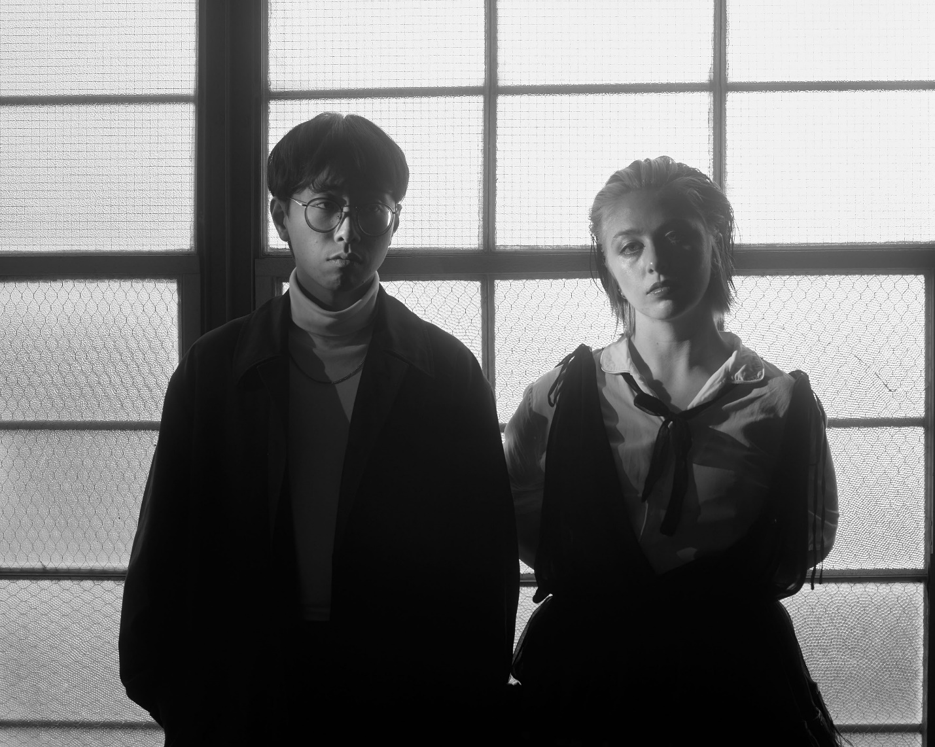
PHOTO CREDIT: SAM WILLIAMS

“Delicate, dazed indie-pop” - THE FADER
“Blonde-esque minimalist guitar swoon” – STEREOGUM
“Dreamy new sophisti-pop” - GORILLA VS. BEAR
“Infectious and bittersweet” - BILLBOARD
“Mesmerizing bedroom pop.” – UPROXX

MARCH 3, 2023 – Cafuné - the NYC-based duo of singer/songwriter Sedona Schat and writer/producer Noah Yoo – have released a new standalone single titled “Perspective,” which is available today on all streaming platforms and accompanied by a visualizer. “Perspective” is co-produced by Imad Royal (Doja Cat, Carly Rae Jepsen) and finds Schat and Yoo reckoning with close relationships that have become almost unrecognizable.
Elaborating on the new song, the band shared, “‘Perspective’ came about from conversations we were having about the death of relationships in our respective lives and the disorientation that can come with shifting into a new season of life without someone who was once your everything.”

“Perspective” marks the first new music from Cafuné since their signing to Elektra Records and the release of their 2021 debut album Running, which is now available on vinyl. Originally released via Cafuné’s own Aurelians Club label, Running features the band’s platinum certified breakout hit “Tek It,” which reached the Top 5 at Alternative Radio, hit #1 on Billboard’s “Bubbling Under Hot 100” chart, and has since logged over 320 million streams to date.

Cafuné are currently in the midst of their 2023 North American headline tour with special guests Bathe. The dates continue tonight in Portland, OR and extend through late March with stops in Seattle, Los Angeles, Nashville, New York City and other major markets across the U.S. [Full Itinerary Below]. Cafuné notably supported CHVRCHES on their 2022 North American headline tour. For tickets and more information on Cafuné’s upcoming tour dates, visit www.wearecafune.xyz.

Sedona Schat and Noah Yoo have been recording alternative pop songs together as Cafuné since their days as NYU students in the mid-2010s. Self-produced and almost entirely recorded by the duo at their homes, mostly during the pandemic, their debut album Running is a record born in isolation. It peers out at a world that feels like it’s on the precipice of disaster, considering what it means to get older, to carve out a future for yourself. It’s a labor of the duo’s friendship, of doing the work and trying to figure out what the way forward is, even when it seems like there’s no end in sight. It’s a record of growing old and growing up, of making something you can move to—whether you’re alone in a room, in a sweaty club with all of your friends, or driving away to someplace better.

[Single Artwork / Tour Itinerary Below]

“PERSPECTIVE” - SINGLE ARTWORK

CAFUNÉ
2023 NORTH AMERICAN TOUR
WITH SPECIAL GUESTS BATHE

Mar 3 - Polaris Hall - Portland, OR
Mar 4 - Barboza - Seattle, WA [SOLD OUT]
Mar 6 - Rickshaw Stop - San Francisco, CA [SOLD OUT]
Mar 8 - The Echo - Los Angeles, CA [SOLD OUT]
Mar 9 - Constellation Room - Santa Ana, CA [SOLD OUT]
Mar 10 - Valley Bar - Phoenix, AZ [LOW TICKETS]
Mar 13 - Dada - Dallas, TX [SOLD OUT]
Mar 20 - The Masquerade - Atlanta, GA [SOLD OUT]
Mar 21 - The Basement East - Nashville, TN
Mar 24 - Songbyrd Music House and Record Cafe - Washington, DC [SOLD OUT]
Mar 25 - The Foundry at The Fillmore - Philadelphia, PA
Mar 26 - Brighton Music Hall - Boston, MA [LOW TICKETS]
Mar 28 - The Bowery Ballroom - New York, NY [LOW TICKETS]

CONNECT WITH CAFUNÉ:
Website | Instagram | Twitter | TikTok | Facebook | YouTube | Spotify | Apple Music

CAFUNÉ PRESS CONTACTS:
Ross Anderson | Ross.Anderson@300Elektra.com
Sydney Worden | Sydney.Worden@300Elektra.com

