BRANDI CARLILE’S NEW DELUXE ALBUM IN THE CANYON HAZE OUT TODAY, IMAX LIVE CONCERT EVENT TONIGHT
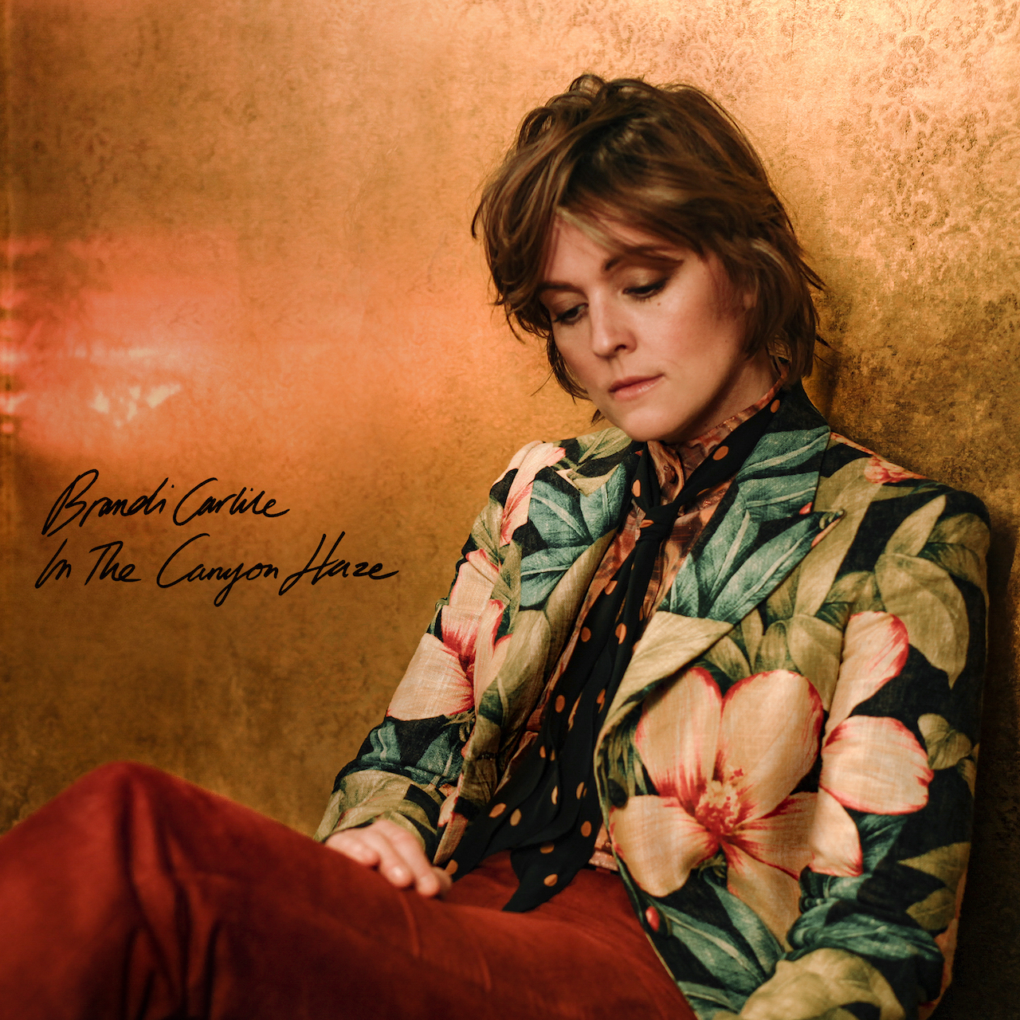
September 28, 2022—In The Canyon Haze, the anticipated new deluxe edition of Brandi Carlile’s acclaimed #1 album, In These Silent Days, is out today on Low Country Sound/Elektra Records. Stream/purchase HERE. Produced by Carlile and the twins, Phil and Tim Hanseroth, and recorded at their home barn studio, the expanded album features new reimagined Laurel Canyon-inspired versions of each song from the original album plus a special rendition of David Bowie’s “Space Oddity.”
In celebration of the release, Carlile will perform a special, one-night-only IMAX Live concert tonight at 9:00pm ET/6:00pm PT. Directed by Sam Wrench (Billie Eilish, Mary J. Blige) and broadcast live overlooking L.A.’s storied Laurel Canyon neighborhood to over 100 IMAX theatres nationwide, “Brandi Carlile: In The Canyon Haze - Live from Laurel Canyon” will feature an intimate and exclusive concert experience with Carlile and her band performing the lushly reimagined songs from the deluxe album for the very first time. Tickets are on-sale now, full details can be found at imax.com/brandicarlile.
A special CD bundle featuring the new deluxe album and an accompanying 80-page paperback archive will be available starting Friday, November 25 and is now available for pre-order. The book features never-before-seen photos and handwritten notes from the studio, photo shoots, video sets, television performances, life on the road and much more. Additionally, limited-edition deluxe vinyl will also be available exclusively at indie retail starting November 25 and everywhere you buy music the following Friday, December 2.
Already receiving critical attention, the new version of Carlile’s current single, “You and Me on the Rock (In the Canyon Haze)” featuring her wife, Catherine Carlile, recently debuted, of which Rolling Stone praises, “a lovely, stripped-down take on the song that puts Catherine’s low harmonies next to Brandi’s soaring leads. The sparse instrumental bed shimmers like city lights in the distance but it still retains the intimacy and warmth of a living-room performance.”
Carlile is currently in the midst of her extensive “Beyond These Silent Days” headline tour with upcoming shows at Boston’s TD Garden and New York’s Madison Square Garden and will kick off the 48th season of “Austin City Limits” this Saturday, October 1 on most PBS stations.
In These Silent Days, which was originally released last October, was inspired by the mining of Carlile’s own history while writing last year’s #1 New York Times Best Selling memoir, Broken Horses (Crown). Of the album, Variety praises, “Carlile effortlessly glides between octaves while, somehow, still sounding completely conversational—the everyday diva we didn’t know we needed until she showed up at our door…a vocal tour de force,” while Billboard asserts, “the emotion that Carlile projects is unbridled, unfettered joy in the face of hard times—and it’s the exact boost of positivity that will make you want to listen again and again” and Vulture declares, “one of the biggest voices in the genre.” The album also appeared on “Best of 2021” lists at NPR Music, Variety, Rolling Stone, Billboard, Entertainment Weekly, SPIN, USA Today, Stereogum and many more.
In the months since the release, the six-time Grammy Award-winning singer, songwriter, performer, producer and New York Times Best Selling author made her debut as the musical guest on NBC’s “Saturday Night Live” (performing “Broken Horses” and “Right On Time”), returned to “The Ellen DeGeneres Show” to guest host and debut “You And Me On The Rock,” and debuted “This Time Tomorrow” on “The Late Show with Stephen Colbert.” She also performed “Right On Time” during the 64th Annual GRAMMY Awards earlier this year, where the song was nominated for Record of the Year and Song of the Year. Additionally, this past November, Carlile performed Mitchell’s legendary album Blue in its entirety at Carnegie Hall. Of the sold-out performance, Billboard proclaims, “an extraordinary concert…who better to take on this homage but Carlile, who has taken up Mitchell’s still brightly burning torch, as one of the finest songwriters and singers of this era.”
photo credit: Pamela Neal
In These Silent Days follows Carlile’s 2018 breakthrough GRAMMY Award-winning album, By The Way, I Forgive You, which Rolling Stone declared, “…an Adele-meets Joni Mitchell tour de force.” In the years since—in addition tocollaborative projects with Elton John, The Highwomen, Tanya Tucker, Soundgarden, Alicia Keys, Dolly Parton, Barry Gibb, Leslie Jordan, Brandy Clark and more—she has earned six Grammy Awards recognizing her work as a performer, songwriter and producer, was awarded Billboard’s Women In Music “Trailblazer Award,” CMT’s Next Women of Country “Impact Award” and received multiple recognitions from the Americana Music Association Honors & Awards including 2021’s Artist of the Year, 2020’s Album of the Year (Highwomen), Group of the Year (The Highwomen) and Song of the Year (“Crowded Table”) and 2019’s Artist of the Year. Moreover, the audiobook version of Carlile’s memoir was recently highlighted as one of Libro.fm’s top 10 bestselling audiobooks of 2021.
In addition to their work as a band, Carlile and the Hanseroth twins remain committed to social activism and advocacy. Together they are founders of the Looking Out Foundation, which amplifies the impact of music by empowering those without a voice with varied initiatives including campaigns focused on Children in Conflict/War Child, The IF Project, Fund Racial Justice and more. To date, they have raised over $3 million for grassroots causes.
IN THESE SILENT DAYS (DELUXE EDITION)
IN THE CANYON HAZE TRACKLIST
1. Right On Time
2. You And Me On The Rock feat. Catherine Carlile
3. This Time Tomorrow
4. Broken Horses
5. Letter To The Past
6. Mama Werewolf
7. When You’re Wrong
8. Stay Gentle
9. Sinners Saints And Fools
10.Throwing Good After Bad
11. Space Oddity
BRANDI CARLILE CONFIRMED TOUR DATES
October 7—Durham, NC—Durham Performing Arts Center+
October 8—Greenville, SC—Peace Center Concert Hall+
October 9—Charlottesville, VA—Ting Pavilion+
October 21—Boston, MA—TD Garden#
October 22—New York, NY—Madison Square Garden#
January 9-13, 2023—Riviera Maya, Mexico—Girls Just Wanna Weekend 4 (SOLD OUT)
+special solo performance
#with special guest Brittany Howard
www.brandicarlile.com

