BRANDI CARLILE’S DELUXE ALBUM IN THE CANYON HAZE OUT SEPTEMBER 28,
NEW VERSION OF “YOU AND ME ON THE ROCK” FEAT. CATHERINE CARLILE OUT TODAY
PERFORMANCE THIS MORNING AS PART OF NBC’S “TODAY SHOW” SUMMER CONCERT SERIES
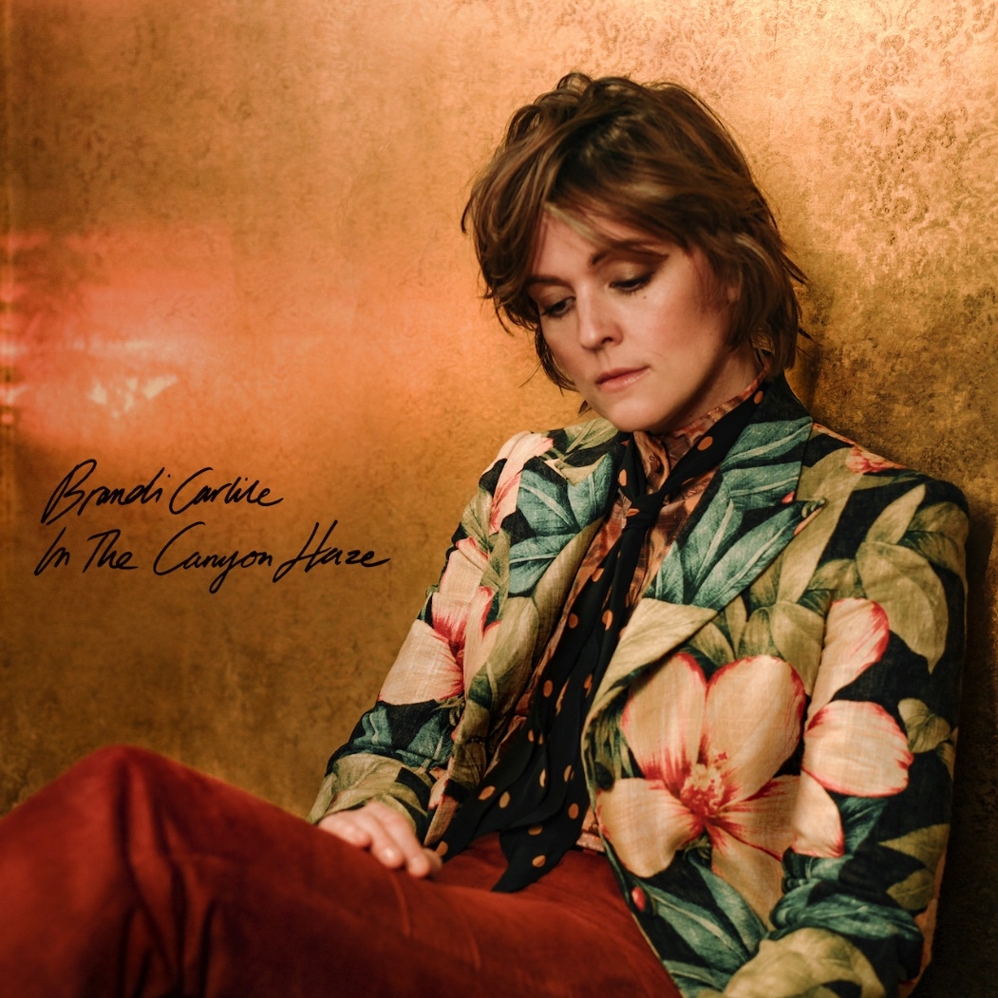
Deluxe cover art
September 2, 2022—A new deluxe edition of Brandi Carlile’s acclaimed #1 album, In These Silent Days, entitled In The Canyon Haze will be released September 28 on Low Country Sound/Elektra Records. Produced by Carlile and the twins, Phil and Tim Hanseroth, and recorded at their home barn studio, the expanded album features new reimagined Laurel Canyon-inspired versions of each song from the original album plus a special rendition of David Bowie’s “Space Oddity.” In advance of the release, the new version of Carlile’s current single, “You and Me on the Rock (In the Canyon Haze)” featuring her wife, Catherine Carlile, is out today. Listen/share HERE.
Earlier today, Carlile and her band made their debut on NBC’s “TODAY Show” “Citi Concert Series” performing “Broken Horses” and “You And Me On The Rock” as well as fan favorites, “The Joke” and “The Story.”
In The Canyon Haze is now available for pre-save and CD pre-order. A limited-edition deluxe vinyl will be available exclusively at indie retail starting Friday, November 25 and everywhere you buy music the following Friday, December 2. Full pre-order details available here.
Of the new project, Carlile shares,
“I knew I wanted to offer our fans more than just the usual ‘bonus track’ that always feels like a creative way to ask fans to buy your album twice! So, the twins and I locked ourselves in the attic studio in my barn just like the old days…and we reimagined our entire record.
Inspired by these past few life altering years of ‘Joni Jams,’ I conjured up imagery from the infamous music scene in Laurel Canyon…
I could see the cast of California Dreamers with embroidered flowers and peace signs on their backs drifting through a polaroid haze. I could smell the marijuana and the incense. I could hear the CSN harmonies traveling through the canyon from Lookout Mountain and the accompanying laughter of Mama Cass. I could hear the reverb of aged wood and the dulcimer being strummed like a drum. The familiar chord progressions, confessions and communal spirit that would birth timeless songs…songs we all wish we had written. I could feel the liberation, the friction and freedom from modern day digital distractions that laid such fertile ground at the feet of west coast poets and troubadours.”
Carlile is currently in the midst of her extensive “Beyond These Silent Days” headline tour with upcoming shows at Colorado’s Red Rocks Amphitheatre (two nights), Boston’s TD Garden and New York’s Madison Square Garden among many others.
In These Silent Days was inspired by the mining of Carlile’s own history while writing last year’s #1 New York Times Best Selling memoir, Broken Horses (Crown). Of the album, Variety praises, “Carlile effortlessly glides between octaves while, somehow, still sounding completely conversational—the everyday diva we didn’t know we needed until she showed up at our door…a vocal tour de force,” while Billboard asserts, “the emotion that Carlile projects is unbridled, unfettered joy in the face of hard times—and it’s the exact boost of positivity that will make you want to listen again and again” and Vulture declares, “one of the biggest voices in the genre.” The album also appeared on “Best of 2021” lists at NPR Music, Variety, Rolling Stone, Billboard, Entertainment Weekly, SPIN, USA Today, Stereogum and many more.
In the months since the release, the six-time Grammy Award-winning singer, songwriter, performer, producer and New York Times Best Selling author made her debut as the musical guest on NBC’s “Saturday Night Live” (performing “Broken Horses” and “Right On Time”), returned to “The Ellen DeGeneres Show” to guest host and debut “You And Me On The Rock,” and debuted “This Time Tomorrow” on “The Late Show with Stephen Colbert.” She also performed “Right On Time” during the 64th Annual GRAMMY Awards earlier this year, where the song was nominated for Record of the Year and Song of the Year. Additionally, this past November, Carlile performed Mitchell’s legendary album Blue in its entirety at Carnegie Hall. Of the sold-out performance, Billboard proclaims, “an extraordinary concert…who better to take on this homage but Carlile, who has taken up Mitchell’s still brightly burning torch, as one of the finest songwriters and singers of this era.”
photo credit: Pamela Neal
In These Silent Days follows Carlile’s 2018 breakthrough GRAMMY Award-winning album, By The Way, I Forgive You, which Rolling Stone declared, “…an Adele-meets Joni Mitchell tour de force.” In the years since—in addition to collaborative projects with Elton John, The Highwomen, Tanya Tucker, Soundgarden, Alicia Keys, Dolly Parton, Barry Gibb, Leslie Jordan, Brandy Clark and more—she has earned six Grammy Awards recognizing her work as a performer, songwriter and producer, was awarded Billboard’s Women In Music “Trailblazer Award,” CMT’s Next Women of Country “Impact Award” and received multiple recognitions from the Americana Music Association Honors & Awards including 2021’s Artist of the Year, 2020’s Album of the Year (Highwomen), Group of the Year (The Highwomen) and Song of the Year (“Crowded Table”) and 2019’s Artist of the Year. Moreover, the audiobook version of Carlile’s memoir was recently highlighted as one of Libro.fm’s top 10 bestselling audiobooks of 2021.
In addition to their work as a band, Carlile and the Hanseroth twins remain committed to social activism and advocacy. Together they are founders of the Looking Out Foundation, which amplifies the impact of music by empowering those without a voice with varied initiatives including campaigns focused on Children in Conflict/War Child, The IF Project, Fund Racial Justice and more. To date, they have raised over $3 million for grassroots causes.
IN THESE SILENT DAYS (DELUXE EDITION) IN THE CANYON HAZE TRACKLIST
1. Right On Time
2. You And Me On The Rock feat. Catherine Carlile
3. This Time Tomorrow
4. Broken Horses
5. Letter To The Past
6. Mama Werewolf
7. When You’re Wrong
8. Stay Gentle
9. Sinners Saints And Fools
10.Throwing Good After Bad
11. Space Oddity
BRANDI CARLILE CONFIRMED TOUR DATES
September 9—Morrison, CO—Red Rocks Amphitheatre* (SOLD OUT)
September 10—Morrison, CO—Red Rocks Amphitheatre† (SOLD OUT)
September 16—Louisville, KY—Bourbon & Beyond Festival
September 18—Los Angeles, CA—BeachLife Ranch
September 21—Richmond, VA—Music at Maymont+
September 22—Atlanta, GA—Fox Theatre‡
September 24—Franklin, TN—Pilgrimage Festival
September 25—Bridgeport, CT—Sound on Sound Festival
October 7—Durham, NC—Durham Performing Arts Center+
October 8—Greenville, SC—Peace Center Concert Hall+
October 21—Boston, MA—TD Garden#
October 22—New York, NY—Madison Square Garden#
January 9-13, 2023—Riviera Maya, Mexico—Girls Just Wanna Weekend 4 (SOLD OUT)
*with special guests Lucius and Allison Russell
†with special guests Indigo Girls and Allison Russell
+a special solo performance
‡with special guest Amy Ray Band
#with special guest Brittany Howard

www.brandicarlile.com

