BRANDI CARLILE CONFIRMS EXCLUSIVE IMAX LIVE CONCERT EXPERIENCE “BRANDI CARLILE: IN THE CANYON HAZE – LIVE FROM LAUREL CANYON” ON SEPTEMBER 28
TICKETS ON-SALE NOW
NEW DELUXE ALBUM IN THE CANYON HAZE OUT SEPTEMBER 28
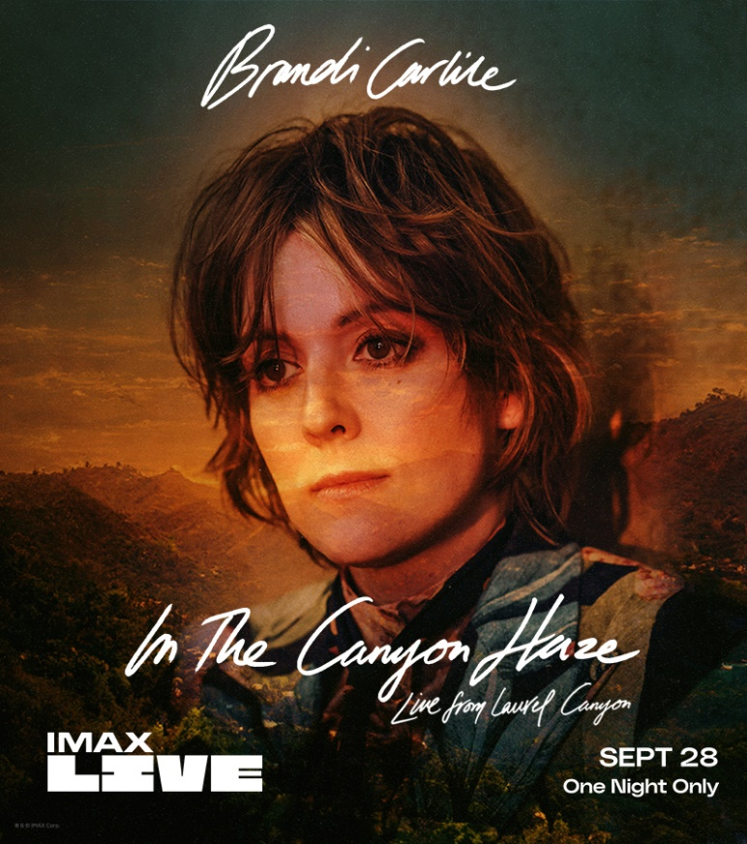
September 9, 2022—In celebration of her anticipated new deluxe album, In The Canyon Haze, Brandi Carlile will perform a special, one-night-only IMAX Live concert on the record’s release day, September 28, at 9:00pm ET/6:00pm PT. Directed by Sam Wrench (Billie Eilish, Mary J. Blige) and broadcast live overlooking L.A.’s storied Laurel Canyon neighborhood to over 100 IMAX theatres nationwide, “Brandi Carlile: In The Canyon Haze - Live from Laurel Canyon” will feature an intimate and exclusive concert experience with Carlile and her band performing the lushly reimagined songs featured on the deluxe album for the very first time. Tickets are on-sale now, full details can be found at imax.com/brandicarlile.
Of the performance, Carlile shares:
“I’ve made a terrifying and beautiful commitment to livestream a complete performance of my new project In the Canyon Haze to IMAX theatres across the country. The music and harmonies are complex and lush…anything could happen. You will hear these songs like you’ve never heard them before and I expect that it’ll be one of the most potent and welcome challenges of my career to bring this to you in such stark detail. Live is live. Rock and roll is a risk and I’m HERE for it!
Together, with our incredibly talented director Sam Wrench, we hope to deliver an enhanced and intimate cinematic experience that hasn’t been attempted before. Along with my band and some very special guests, I’m going to be performing In The Canyon Haze in its entirety, set against the fertile ground of Laurel Canyon and the music scene that inspired this reimagined album.
The best part is that our audience will be there to join us in community for this one-night-only performance, live and in real time in state-of-the-art IMAX theatres. This is the one and only time I wish I was in the audience instead of on the stage!
We hope you enjoy this film as much as we’re going to enjoy bringing this music to life on the big screen. Get your tickets right away! I’ll see you all in the canyon.”
Produced by Carlile and the twins, Phil and Tim Hanseroth, and recorded at their home barn studio, In The Canyon Haze features reimagined Laurel Canyon-inspired versions of each song from Carlile’s acclaimed 2021 album, In These Silent Days, plus a special rendition of David Bowie’s “Space Oddity.” Out September 28 on Low Country Sound/Elektra Records, the record is now available for pre-save and CD pre-order. A limited-edition deluxe vinyl will be available exclusively at indie retail starting Friday, November 25 and everywhere you buy music the following Friday, December 2. Full pre-order details available here.
In advance of the release, the new version of Carlile’s current single, “You and Me on the Rock (In the Canyon Haze)” featuring her wife, Catherine Carlile, debuted last week, of which Rolling Stone praises, “a lovely, stripped-down take on the song that puts Catherine’s low harmonies next to Brandi’s soaring leads. The sparse instrumental bed shimmers like city lights in the distance but it still retains the intimacy and warmth of a living-room performance.” Additionally, Carlile and her band made their debut on NBC’s “TODAY Show” “Citi Concert Series” this past Friday performing “Broken Horses” and “You And Me On The Rock” as well as fan favorites, “The Joke” and “The Story.”
Carlile is currently in the midst of her extensive “Beyond These Silent Days” headline tour with upcoming shows at Colorado’s Red Rocks Amphitheatre (two nights), Boston’s TD Garden and New York’s Madison Square Garden among many others.
In These Silent Days, which was originally released last October, was inspired by the mining of Carlile’s own history while writing last year’s #1 New York Times Best Selling memoir, Broken Horses (Crown). Of the album, Variety praises, “Carlile effortlessly glides between octaves while, somehow, still sounding completely conversational—the everyday diva we didn’t know we needed until she showed up at our door…a vocal tour de force,” while Billboard asserts, “the emotion that Carlile projects is unbridled, unfettered joy in the face of hard times—and it’s the exact boost of positivity that will make you want to listen again and again” and Vulture declares, “one of the biggest voices in the genre.” The album also appeared on “Best of 2021” lists at NPR Music, Variety, Rolling Stone, Billboard, Entertainment Weekly, SPIN, USA Today, Stereogum and many more.
In the months since the release, the six-time Grammy Award-winning singer, songwriter, performer, producer and New York Times Best Selling author made her debut as the musical guest on NBC’s “Saturday Night Live” (performing “Broken Horses” and “Right On Time”), returned to “The Ellen DeGeneres Show” to guest host and debut “You And Me On The Rock,” and debuted “This Time Tomorrow” on “The Late Show with Stephen Colbert.” She also performed “Right On Time” during the 64th Annual GRAMMY Awards earlier this year, where the song was nominated for Record of the Year and Song of the Year. Additionally, this past November, Carlile performed Mitchell’s legendary album Blue in its entirety at Carnegie Hall. Of the sold-out performance, Billboard proclaims, “an extraordinary concert…who better to take on this homage but Carlile, who has taken up Mitchell’s still brightly burning torch, as one of the finest songwriters and singers of this era.”
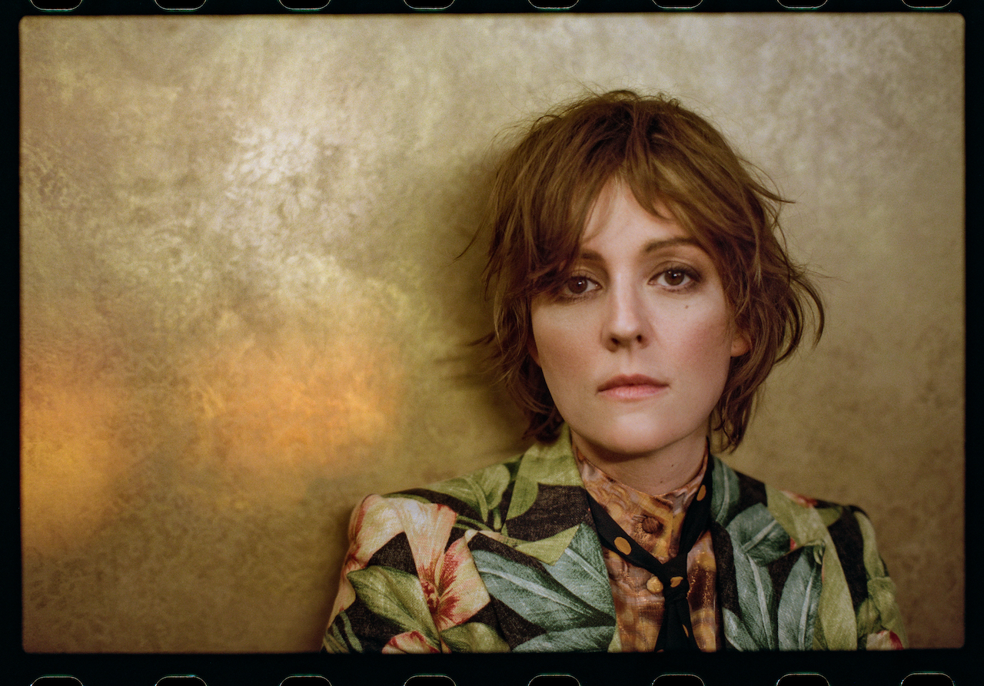photo credit: Pamela Neal
In These Silent Days follows Carlile’s 2018 breakthrough GRAMMY Award-winning album, By The Way, I Forgive You, which Rolling Stone declared, “…an Adele-meets Joni Mitchell tour de force.” In the years since—in addition tocollaborative projects with Elton John, The Highwomen, Tanya Tucker, Soundgarden, Alicia Keys, Dolly Parton, Barry Gibb, Leslie Jordan, Brandy Clark and more—she has earned six Grammy Awards recognizing her work as a performer, songwriter and producer, was awarded Billboard’s Women In Music “Trailblazer Award,” CMT’s Next Women of Country “Impact Award” and received multiple recognitions from the Americana Music Association Honors & Awards including 2021’s Artist of the Year, 2020’s Album of the Year (Highwomen), Group of the Year (The Highwomen) and Song of the Year (“Crowded Table”) and 2019’s Artist of the Year. Moreover, the audiobook version of Carlile’s memoir was recently highlighted as one of Libro.fm’s top 10 bestselling audiobooks of 2021.
In addition to their work as a band, Carlile and the Hanseroth twins remain committed to social activism and advocacy. Together they are founders of the Looking Out Foundation, which amplifies the impact of music by empowering those without a voice with varied initiatives including campaigns focused on Children in Conflict/War Child, The IF Project, Fund Racial Justice and more. To date, they have raised over $3 million for grassroots causes.
IN THESE SILENT DAYS (DELUXE EDITION)
IN THE CANYON HAZE TRACKLIST
1. Right On Time
2. You And Me On The Rock feat. Catherine Carlile
3. This Time Tomorrow
4. Broken Horses
5. Letter To The Past
6. Mama Werewolf
7. When You’re Wrong
8. Stay Gentle
9. Sinners Saints And Fools
10.Throwing Good After Bad
11. Space Oddity
BRANDI CARLILE CONFIRMED TOUR DATES
September 9—Morrison, CO—Red Rocks Amphitheatre* (SOLD OUT)
September 10—Morrison, CO—Red Rocks Amphitheatre† (SOLD OUT)
September 16—Louisville, KY—Bourbon & Beyond Festival
September 18—Los Angeles, CA—BeachLife Ranch
September 21—Richmond, VA—Music at Maymont+
September 22—Atlanta, GA—Fox Theatre‡
September 24—Franklin, TN—Pilgrimage Festival
September 25—Bridgeport, CT—Sound on Sound Festival
October 7—Durham, NC—Durham Performing Arts Center+
October 8—Greenville, SC—Peace Center Concert Hall+
October 21—Boston, MA—TD Garden#
October 22—New York, NY—Madison Square Garden#
January 9-13, 2023—Riviera Maya, Mexico—Girls Just Wanna Weekend 4 (SOLD OUT)
*with special guests Lucius and Allison Russell
†with special guests Indigo Girls and Allison Russell
+a special solo performance
‡with special guest Amy Ray Band
#with special guest Brittany Howard
www.brandicarlile.com

