ALEC BENJAMIN RELEASES
“PAPER CROWN”
NEW VERSION OF FAN FAVORITE

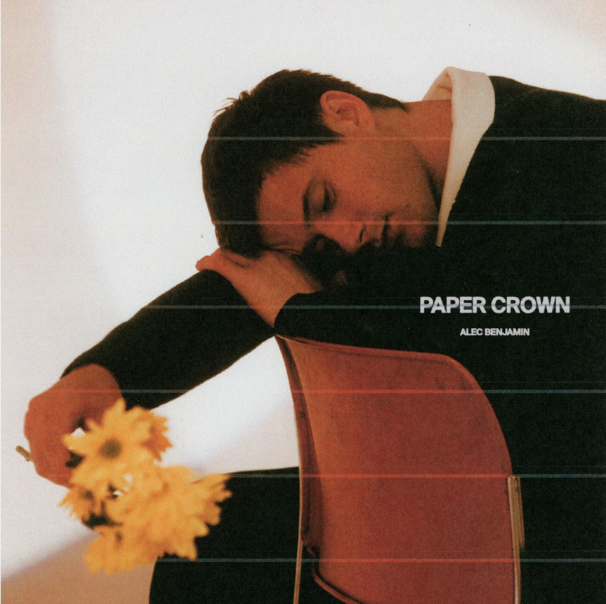
Singer-songwriter Alec Benjamin releases a new version of the fan-favorite track “Paper Crown,” out now via Elektra. Listen to the track HERE. Watch the lyric video HERE.

Alec says, “This is a very special song for me and I can’t wait for the world to hear it ❤.“

The original version of “Paper Crown” was Alec’s first release off his mixtape Narrated For You (2018). Billboard declared it as “nostalgia-inducing,” and Teen Vogue claimed the track would, “charm you senseless,” Since then, it has been a long-time fan-favorite and regularly requested during Alec’s live performances and through social media.

Alec also recently released the Mandarian version of his (Un)Commentary track “Shadow Of Mine” called “Ying Zi Dui Shou (Shadow Of Mine)” ft. Duan Aojuan. Listen to it HERE.

Alec released his latest album (Un)Commentary in April 2022, which was met with praise by fans and critics alike. “A storyteller who’s mastered the art of turning everyday heartbreak into compelling pop songs,” raved PAPER Magazine, while TIME went on to call Alec “a pop storyteller for the next generation.” Benjamin has an already impressive resume which includes 8B+ global streams, 12M+ social media followers across his platforms, 70M+ in playlist reach, and 1.4B+ YouTube views on his channel. Alec has achieved notable success with his tracks “Let Me Down Slowly” (Triple-Platinum), “Water Fountain” (Platinum), and “Oh My God” (Gold).
Alec recently wrapped up the 28-city North American leg (including Alec’s debut performances at this year’s Coachella Valley Music and Arts Festival) of The (Un)Commentary Tour and is currently continuing The (Un)Commentary World Tour across Asia and Latin America into the top of next year.

