NOTHING,NOWHERE.
SHARES NEW TRACK “CYAN1DE” FEAT. PETE WENTZ

OFFICIAL MUSIC VIDEO STREAMING NOW

ON TOUR ACROSS EUROPE THIS FALL

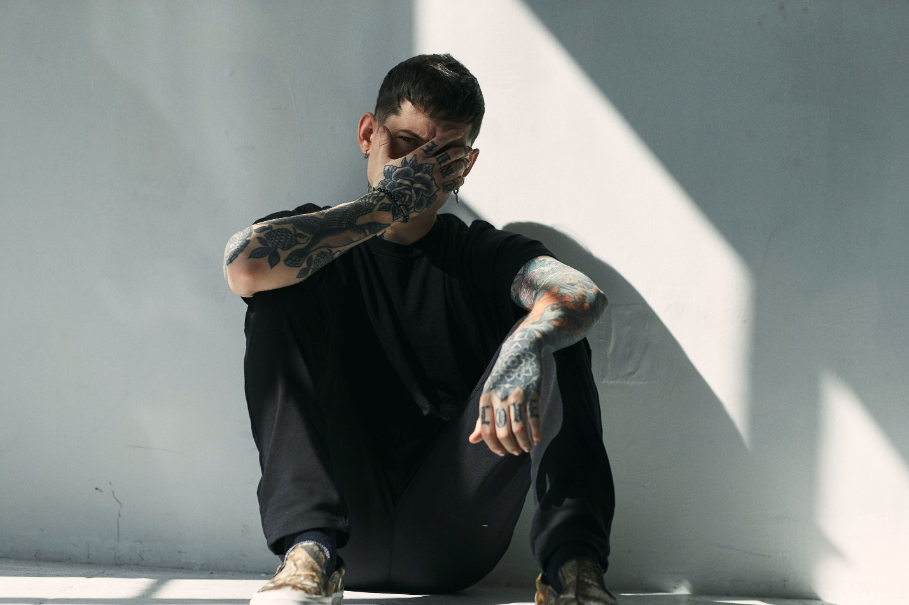
PHOTO CREDIT: JONATHAN WEINER

NOVEMBER 4, 2022 – DCD2 / Fueled By Ramen artist nothing,nowhere. has shared the brand new track “CYAN1DE” which features Pete Wentz of Fall Out Boy. “CYAN1DE” is available today on all streaming platforms and is joined by an official music video created by Gabor Toth (@gabxtoth) – which is now streaming on Fueled By Ramen’s official YouTube channel – watch it HERE.

Once again, nothing,nowhere. boldly evolves on “CYAN1DE” ushering in a new era for the Vermont based project. Speaking on the collaboration, nothing,nowhere. revealed, “Simply put, I’m proud of this song. Pete is a legend and I couldn’t be more excited for the future of nothing,nowhere.”

Wentz added “‘CYAN1DE’ reminds me of the first heavy music I got into and the bands I would scrawl on my trapper keeper at school. It’s an honor to be a part of this process and this song.”

“CYAN1DE” follows nothing,nowhere.’s recent standalone releases “M1SERY_SYNDROME,” which features Buddy Nielsen of Senses Fail and “MEMORY_FRACTURE” which is joined by an official music video directed by Eric “Shade” Balderose of Code Orange.

nothing,nowhere. packed venues on his 2022 North American headline run earlier this year. Next up, he touches down in the UK and Europe for a full-scale tour through November and December [tour itinerary below]. For tickets and more information on nothing.nowhere’s upcoming live dates, visit www.nothingnowhere.net.

Last year saw the release of nothing,nowhere.’s celebrated new album TRAUMA FACTORY. Available on all streaming platforms, TRAUMA FACTORY finds nothing,nowhere. once again emerging from darkness, shedding external expectation, and moving forward into the glow of pure creation. TRAUMA FACTORY is highlighted by “fake friend,” nothing,nowhere.’s first song ever to enter Billboard’s “Alternative Airplay” chart. The track is joined by a Mason Mercer directed official music video which spirals over nothing,nowhere.’s seamless alchemy of alternative, pop, rap, and punk.

The New York Times hailed TRAUMA FACTORY track, “DEATH,” as a “Scabrous, immensely satisfying emotional expurgation from Joe Mulherin that deploys early Beastie Boys drums and Rage Against the Machine bark-rapping in service of a rap-rock revival bathed in righteousness.” CLASH declared, “While human suffering or pain isn’t joyous, the special craft of nothing,nowhere. most certainly is,” and FLOOD praised album cut “lights (4444)” for its “minimalist trap beat,” adding it “sounds like a GothBoiClique single steeped in a turn-of-the-century boy-band aesthetic.” The FADER hailed early single “blood” (Feat. KennyHoopla and JUDGE) as “a strapping collaboration,” while UPROXX avowed, “it’s clear that there’s a lot more going into Joe Mulherin’s production style,” celebrating the song’s “hip-hop beats and a driving distorted bass line.”

nothing,nowhere. summarized the body of work detailing, “TRAUMA FACTORY is an accumulation of songs written during a confusing time. it is about accepting the present and following your true north through the pain and suffering of human life,” nothing,nowhere. revealed He added, “I wanted to make an album that was truly genreless and inspire others to challenge themselves artistically. I believe the most inspiring art is unpredictable and unrestrictive. to me that’s what TRAUMA FACTORY is.”

nothing,nowhere. is the musical endeavor of Vermont songwriter, singer and guitarist Joe Mulherin. For Mulherin, nothing,nowhere. is about a connection. It’s one he finds with fans around the world, who gather to see him play on tour and to listen to his songs online. It’s that connection that urges the singer to place his fears aside and step onstage each night to share his art. He sees the potential to help, to make a change, however small it may be and that is why he brings his music out of the Vermont wildness.

[SINGLE ART / TOUR ITINERARY BELOW]

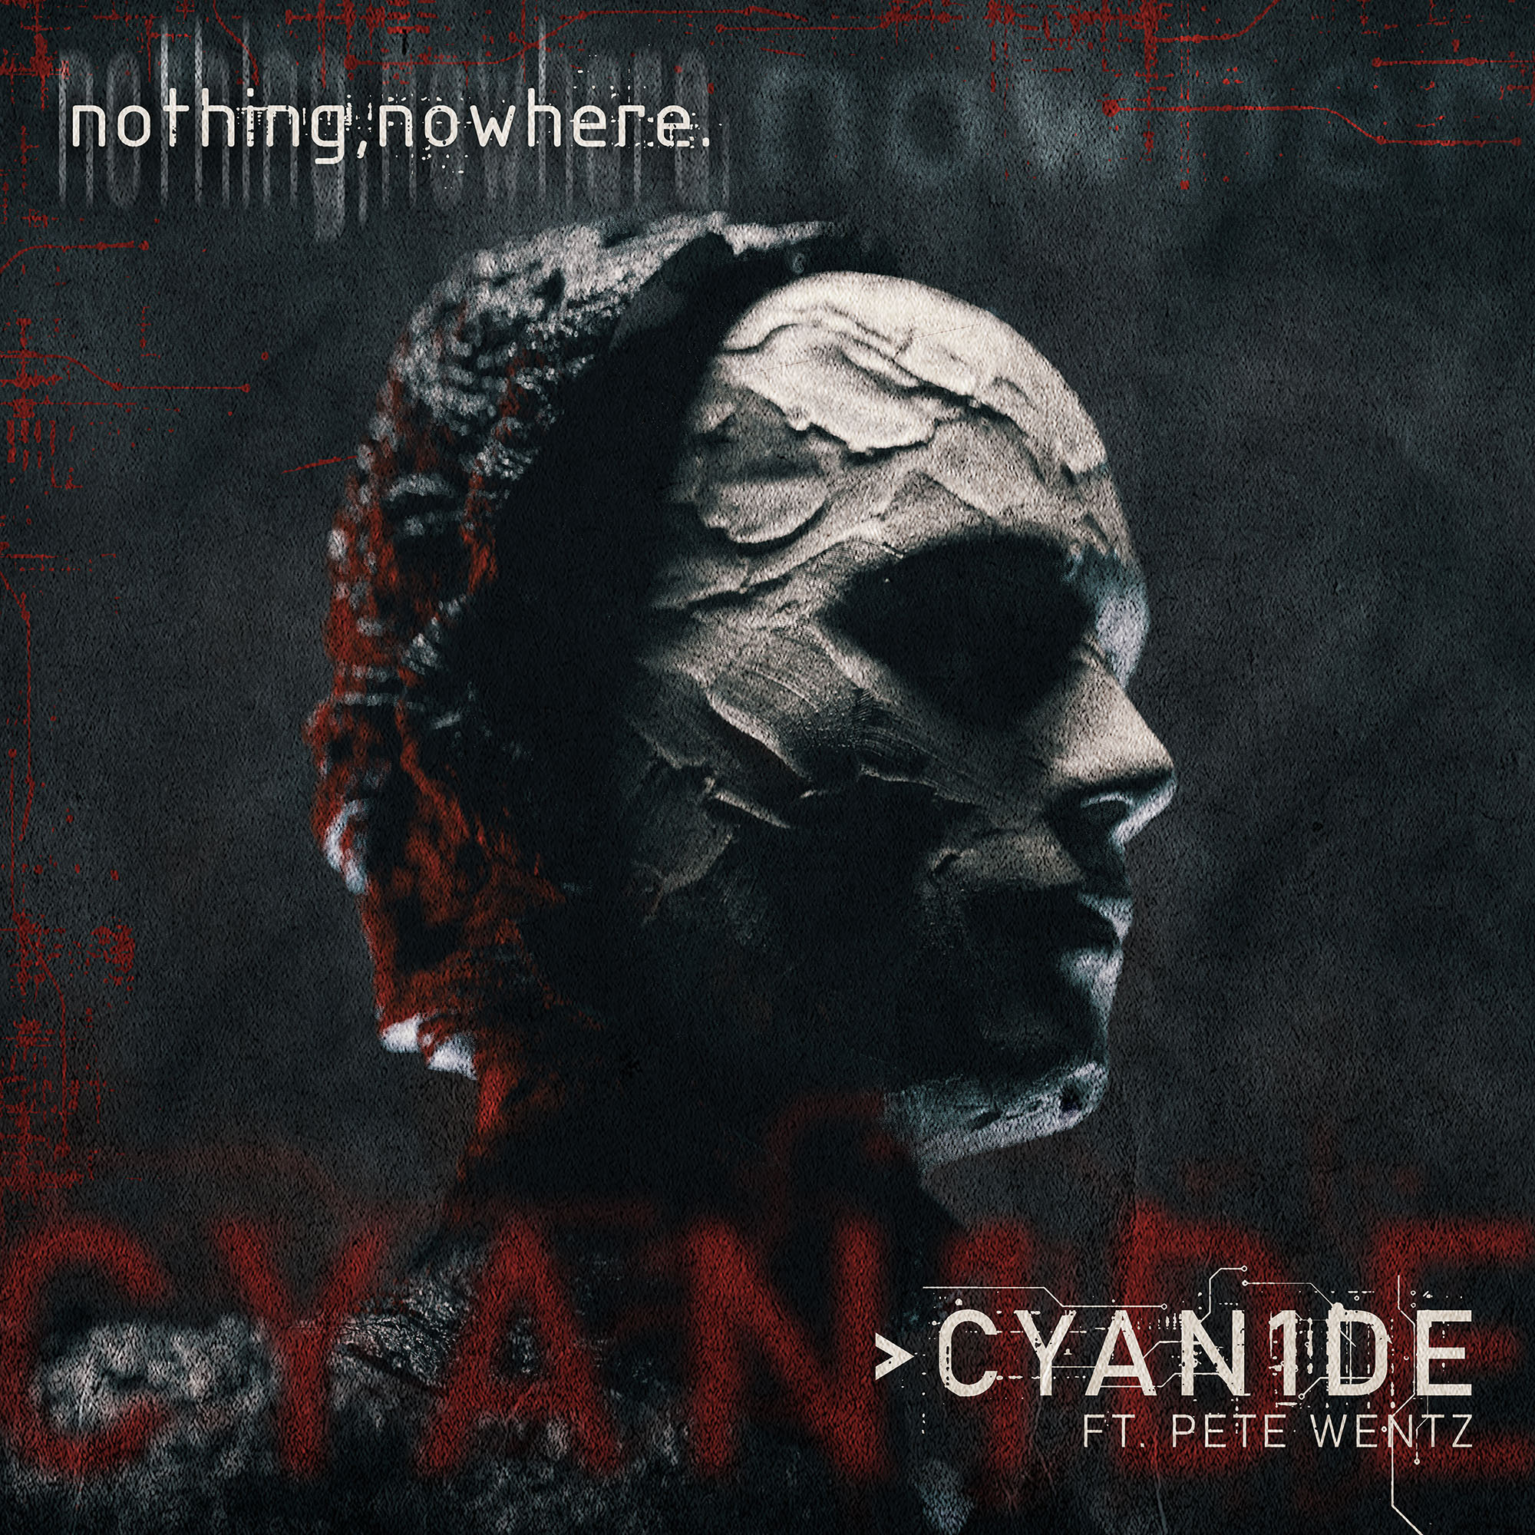

NOTHING,NOWHERE. 2022 HEADLINE DATES

NOV 12 - LEEDS, UNITED KINGDOM – THE KEY CLUB
NOV 13 - OXFORD, UNITED KINGDOM - O2 ACADEMY OXFORD
NOV 14 - NOTTINGHAM, UNITED KINGDOM – BODEGA (SOLD OUT)
NOV 15 - NEWCASTLE UPON TYNE, UNITED KINGDOM – CLUNY (SOLD OUT)
NOV 17 - GLASGOW, UNITED KINGDOM - SWG3 (SOLD OUT)
NOV 18 - MANCHESTER, UNITED KINGDOM - MANCHESTER ACADEMY (SOLD OUT)
NOV 19 - DUBLIN, IRELAND - THE ACADEMY, MIDDLE ABBEY STREET
NOV 20 - BELFAST, UNITED KINGDOM - LIMELIGHT
NOV 22 - BIRMINGHAM, UNITED KINGDOM - O2 ACADEMY BIRMINGHAM
NOV 23 - BRISTOL, UNITED KINGDOM - THE FLEECE
NOV 24 - CAMDEN, UNITED KINGDOM - ELECTRIC BALLROOM
NOV 26 - BRUSSELS, BELGIUM - ANCIENNE BELGIQUE (SOLD OUT)
NOV 27 - COLOGNE, GERMANY – KANTINE (SOLD OUT)
NOV 28 - HAARLEM, NETHERLANDS - PATRONAAT
NOV 30 - COPENHAGEN, DENMARK - PUMPEHUSET
DEC 01 - HAMBURG, GERMANY - UEBEL & GEFAHRLICH
DEC 02 - BERLIN, GERMANY - GRETCHEN
DEC 03 - WARSAW, POLAND - KLUB PROXIMA
DEC 05 - PRAGUE, CZECH REPUBLIC - LUCERNA
DEC 06 - BUDAPEST, HUNGARY - AKVARIUM KLUB
DEC 07 - VIENNA, AUSTRIA - GRELLE FORELLE
DEC 09 - MILAN, ITALY - MAGNOLIA
DEC 10 - ZURICH, SWITZERLAND - EXIL CLUB
DEC 11 - MUNICH, GERMANY - FREIHEITSHALLE
DEC 12 - PARIS, FRANCE - LES ETOILES (SOLD OUT)
DEC 14 - MADRID, SPAIN - SALA NAZCA
DEC 15 - BARCELONA, SPAIN - SALA LA NAU

For more information on nothing,nowhere.:
OFFICIAL – YOUTUBE – SPOTIFY – APPLE MUSIC
SOUNDCLOUD – FACEBOOK – INSTAGRAM – TWITTER

Contact:
Ross Anderson / RossAnderson@Elektra.com

