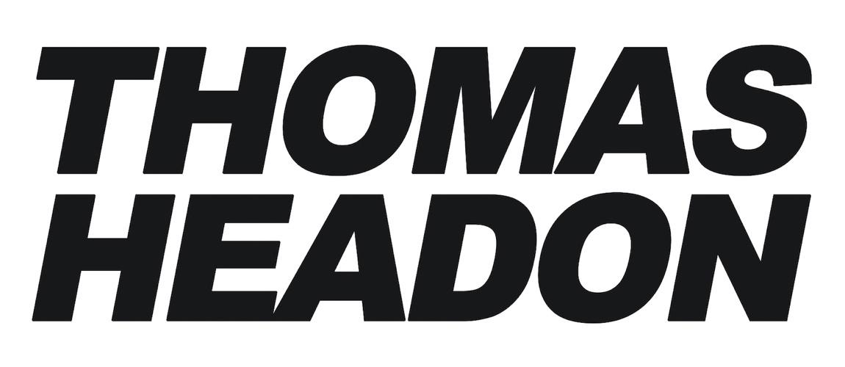
SHARES NEW SINGLE “GEORGIA”

NORTH AMERICAN CO-HEADLINE TOUR
WITH ALFIE TEMPLEMAN CURRENTLY UNDERWAY

Download Press Assets HERE

“The competition best start taking lessons – Thomas Headon is starting to run away with the game.” - Dork
"pop prodigy" - Notion
“fast rising star” - DIY
“bubbling new bedroom pop” - Clash
“A star on the rise” - The Line of Best Fit

NOVEMBER 9, 2022 – Breakout star Thomas Headon has shared brand-new single “Georgia,” out now via Elektra. “Georgia” captures youthful romance in all its forms and is another clear example of why Thomas keeps on rising. The track arrives alongside an official visualizer, which is streaming now on Thomas’s official YouTube channel.

Earlier this week, Thomas kicked off his highly anticipated co-headline North American tour with good friend Alfie Templeman. The trek hits New York City’s Gramercy Theatre on November 16th before wrapping up in Toronto, ON on November 21st (tour itinerary below). The dynamic pair are ready to deliver a raucous set of live shows, where Thomas will be performing all the tracks from his acclaimed Victoria EP as well as previewing tracks from his next project. For up-to-date ticketing information, please visit www.alfietempleman.com or www.thomasheadon.com.

“We’ve actually been sitting on this song for over a year now. I wrote it by myself with my little acoustic guitar in London, then finally produced it up into 100 different versions with my friend Stephen months later, finally landing on this one. It’s actually not even about someone called Georgia, it’s more pointed towards the US state… also which I have nothing to do with, but it’s a metaphor. Anyway it’s my favorite song of mine to date, I hope people like it.” - Thomas Headon

Thomas Headon was born in London and raised in Melbourne, but dreamt of moving back to the city to pursue music. Thomas’ mum told him he had a year to get a “proper job” otherwise he would have to return home. Arriving in London at the start of 2020, Thomas started to build an incredibly loyal community online with his off-kilter live sessions, tongue-in-cheek charm and remarkable songwriting ability. Learning to write and produce on his own, Thomas had already released two self-written and self-produced EP’s, ‘The Greatest Hits’ and ‘The Goodbye EP’ (including lauded single ‘UrbanAngel1999’ which features on Netflix’s hit series Heartstopper) in 2020 before releasing the Victoria EP which cemented his place as a “proper star” in music.

The Victoria EP saw Thomas channel memories of a few months living in London into five inimitable tracks that evoke the sense of having nothing but the whole world ahead of you, with singles that included the Radio 1-playlisted ‘Strawberry Kisses’, ‘Nobody Has To Know’ & ‘Victoria’ (which stars Bridgerton-lead Charithra Chandran in the video). Since its release, Thomas has earned over 90M streams worldwide and been chosen as one of Amazon Music's Artists to watch for 2022 and MTV Push's Ones to Watch for 2022. One of the first artists to curate Spotify’s Our Generation playlist, Thomas’ blend of playful alternative pop that speaks to the Gen-Z experience has been compared to the likes of the 1975’s Matty Healy (NME), and critically praised by Triple J, who named him a “seriously impressive force in pop music,” as well as BBC Radio 1’s Jack Saunders, Clara Amfo, Greg James & Jordan North. The artist has also collaborated with American singer-songwriter Lizzy McAlpine on his single “Bored,” as well as Chloe Moriondo and Alfie Templeton on the brilliant “Dizzy,” which racked up praise from Billboard, E!, Entertainment Tonight, FLOOD Magazine and more.

The past year has seen Thomas perform a storm of live shows which kicked off with his incredible headline dates around the UK last November, which included two sold-out nights at London’s Heaven, and packed-out shows across the US & Australia. He supported icons Sigrid (who he met after his first UK festival gig at Reading & Leeds 2021) on her European tour and Elton John at BST Hyde Park, which launched a summer of showstopping festival dates including Boardmasters, TRNSMT, Live at Leeds & many more.

ALFIE TEMPLEMAN AND THOMAS HEADON
“2 BRITISH FRIENDS 1 NORTH AMERICA”
2022 CO-HEADLINE TOUR DATES

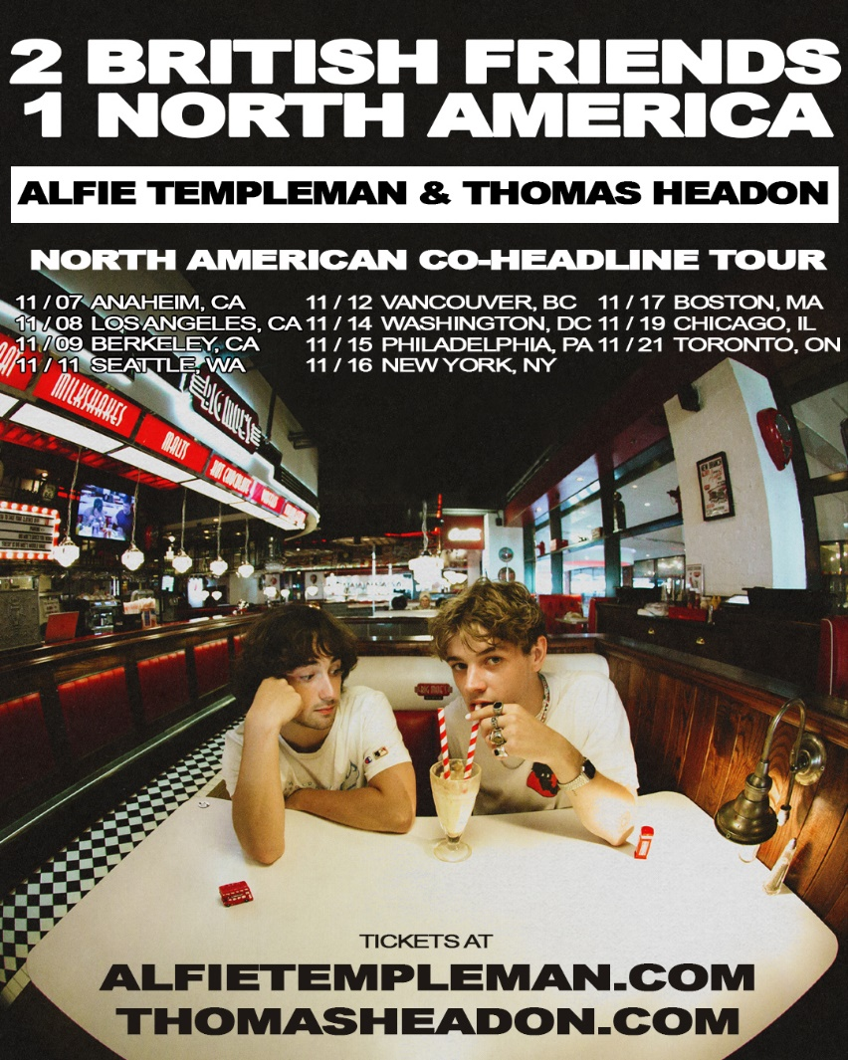
Nov-09 Berkeley, CA Cornerstone
Nov-11 Seattle, WA Madame Lou's
Nov-12 Vancouver, BC Rio Theatre
Nov-14 Washington, DC Union Stage
Nov-15 Philadelphia, PA First Unitarian Church
Nov-16 New York, NY Gramercy Theatre
Nov-17 Boston, MA Brighton Music Hall
Nov-19 Chicago, IL Bottom Lounge
Nov-21 Toronto, ON Velvet Underground

THOMAS HEADON
“GEORGIA”
AVAILABLE NOW

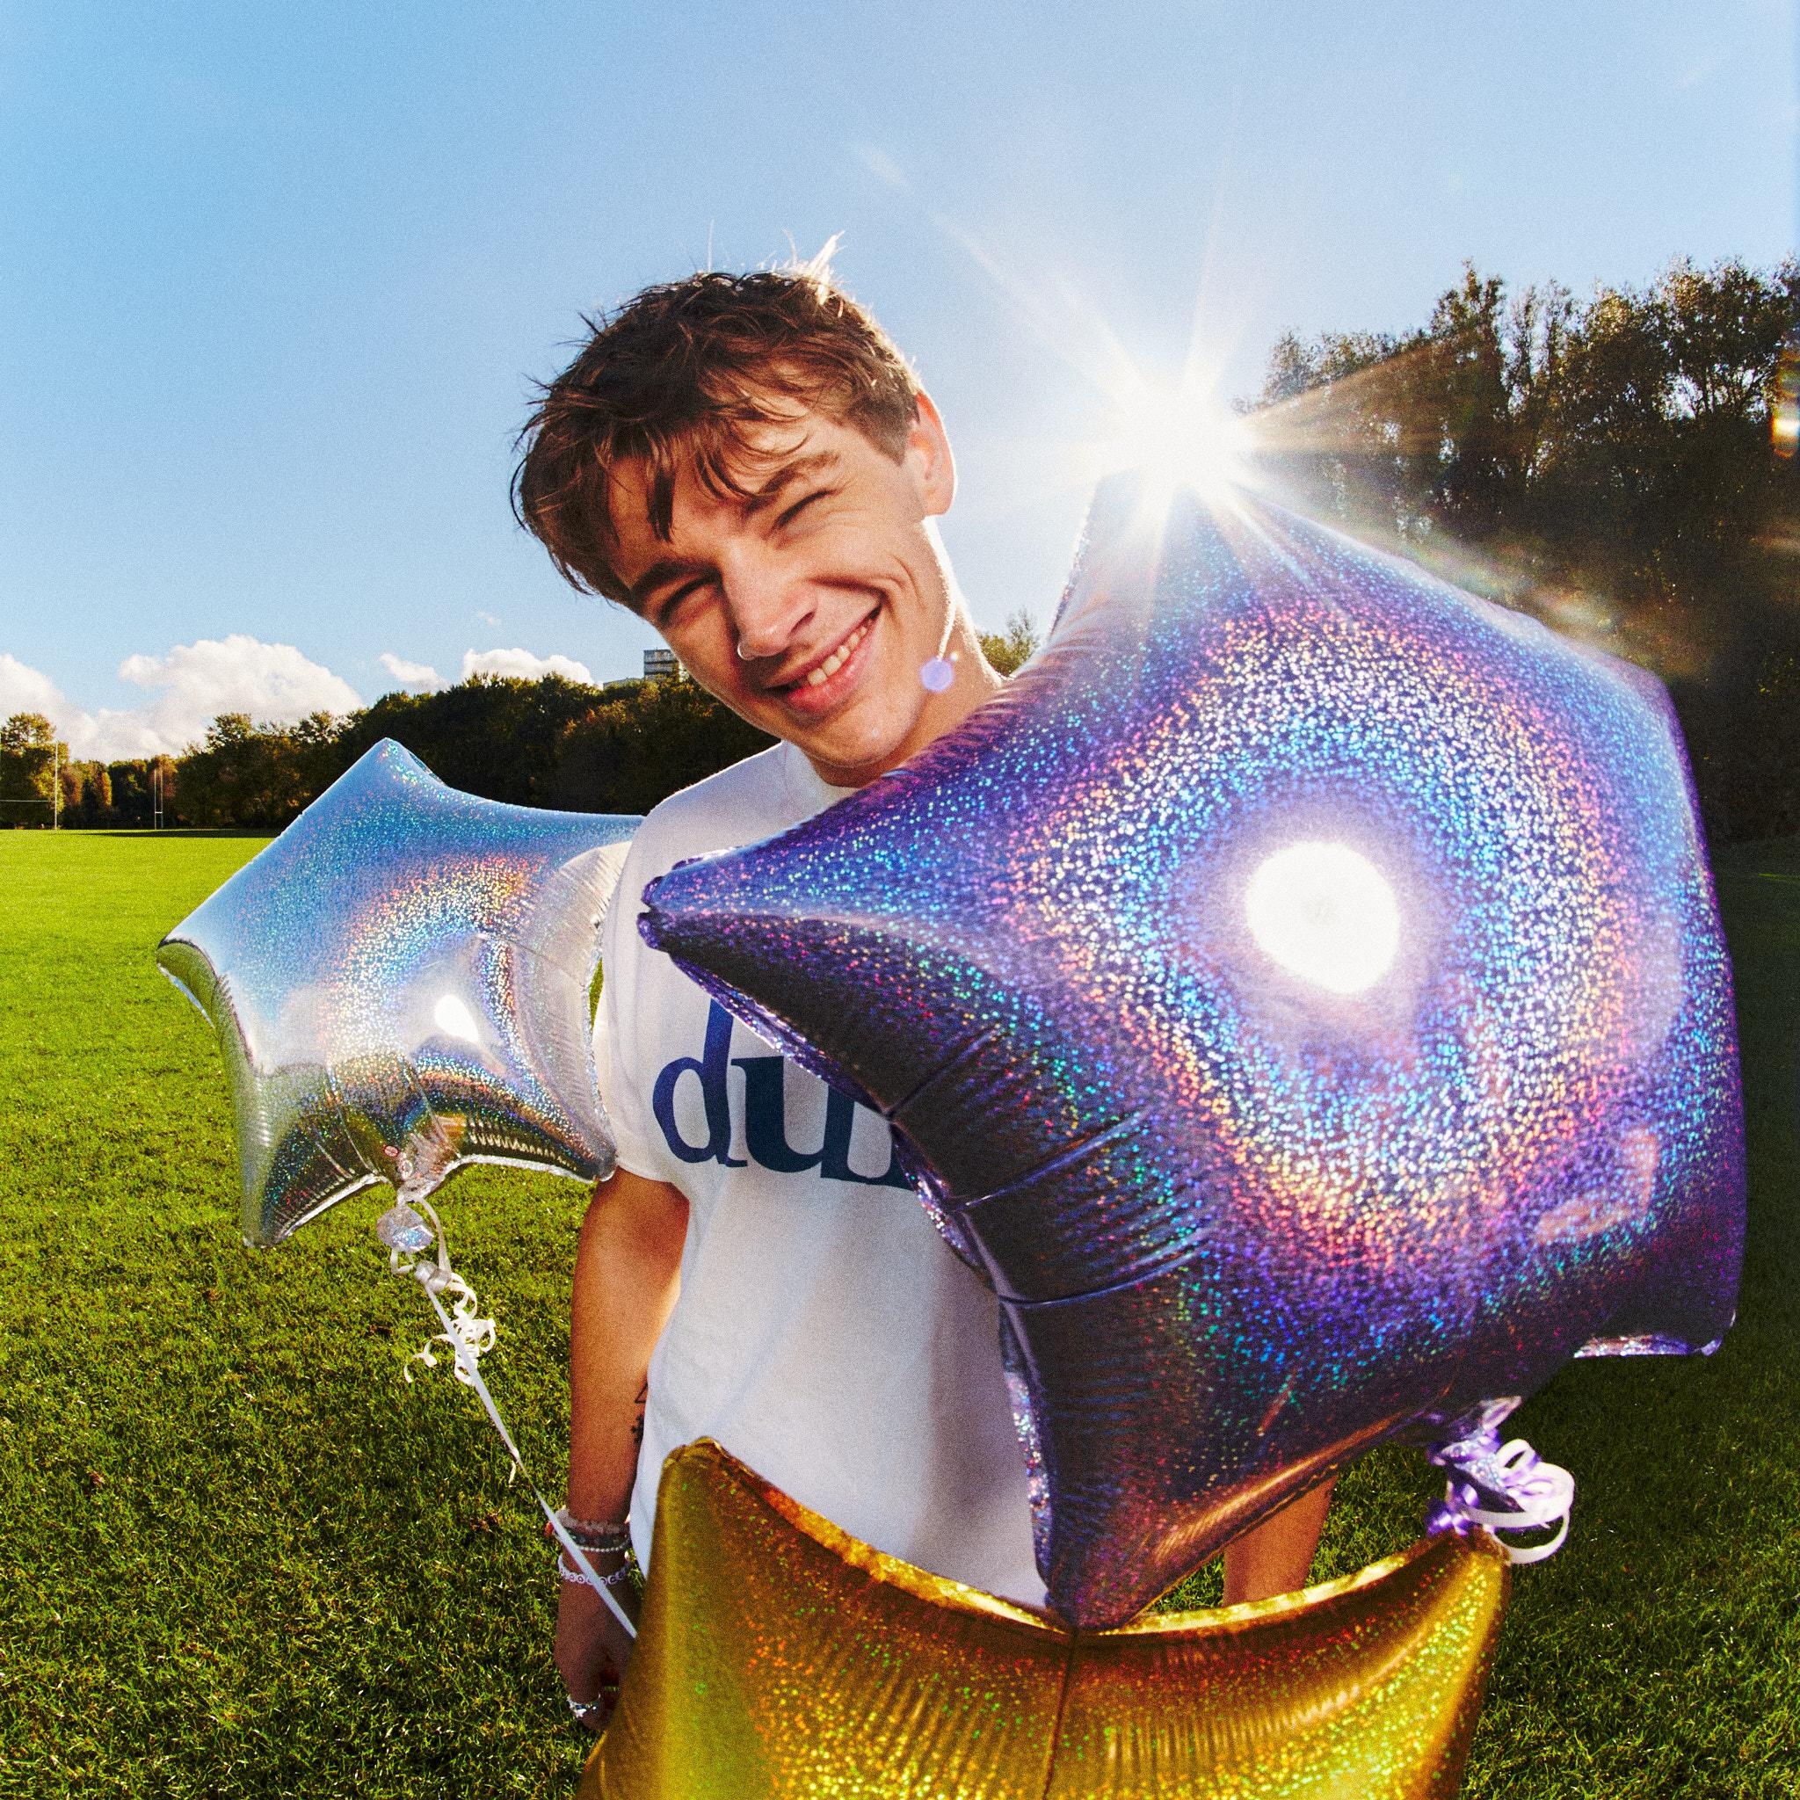

CONNECT WITH THOMAS HEADON
WEBSITE | INSTAGRAM | TIKTOK | TWITTER | YOUTUBE | SPOTIFY | APPLE

Media Contact:
Sarah Goldstein
sarahgoldstein@elektra.com

