ANNA OF THE NORTH RELEASES
ALBUM ‘CRAZY LIFE’
LISTEN HERE
WATCH HERE
VISIT ANNA’S HOUSE HERE

+ 2023 HEADLINE ‘CRAZY’ TOUR ANNOUNCED +
+ ALBUM RELEASE PERFORMANCES IN NYC (11.14) & LA (11.16) +
TICKETS HERE
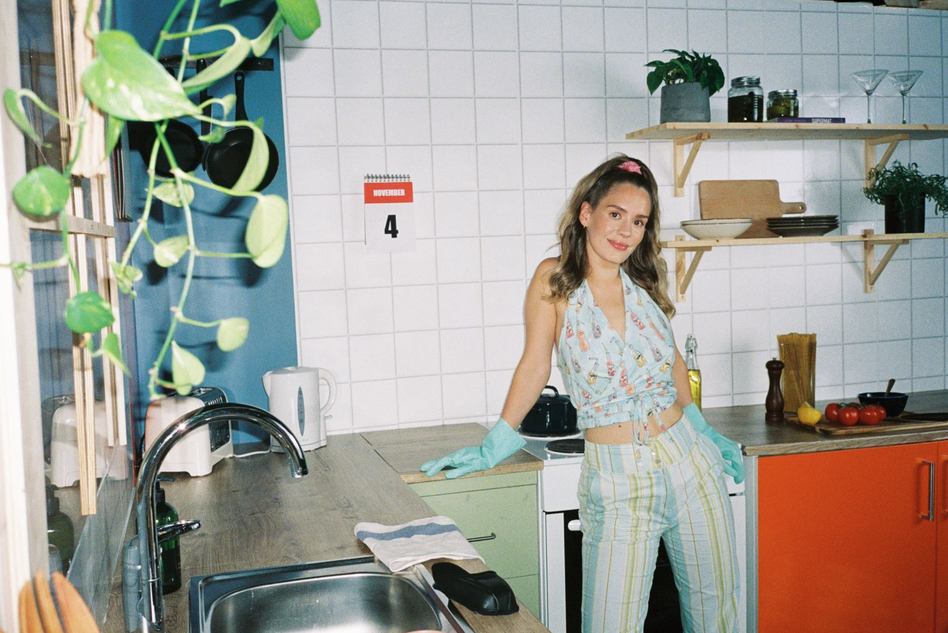
November 4, 2022 – Today, Anna of the North releases her third-studio album Crazy Life. Featuring 11 highly anticipated tracks, Crazy Life is an electric body of work displaying the inner workings of Anna of the North’s journey throughout the years. Listen to Crazy Life HERE.

Crazy Life transcends the Norwegian artist’s ability to find comfort in vulnerability by inviting listeners into her world and illustrating exactly how it's done. Uncovering iridescence in mundanity, Anna of the North offers confessional and relatable lyrics with clarity, confidence and a splash of shimmer.

“The album is about everything, nothing, and all in between,” she observes. “It’s about those small things we don’t necessarily talk about—like the days where you lie on the couch because you can’t get out of the house. As humans, we’re complex. What I love thinking about is the fact that when I let these songs out in to the universe, people will connect with them in different ways. Some people will cry to them; other people will have sex to them. That’s the beautiful thing about music. I’ve definitely gone into some territory inside of me that I haven’t in the past.”

Giving these themes concrete form as a “house,” Anna teamed up with Australian designer Montana Kitching. The artwork for each of the previously released singles corresponds to a place in the “house,” and the Vinyl brings the vision to life. While "Dandelion” introduced viewers to Anna’s living room, complete with her fluffy dog and thriving plants, "Bird Sing" captured the image directly outside Anna's bedroom window, giving you a 360- look at Anna's dwelling. “Nobody” gives a stark overview of Anna’s bedroom and the messy bed and leftover cereal that we’ve all been privy to at some point. Explore the full house HERE.

“The character in the house is legit caught in a time loop,” she explains. “Many of the songs are about being stuck and how it’s hard to get out of your own patterns. The only thing that calms her is music, so she writes an album, finishes it, and she’s suddenly out. It’s like music is a portal back to the real world.”

In the end, Anna chronicles life in all of its insanity, glory, and bliss.

Additionally, in celebration of the album release, Anna of the North announces a headlining European and North American tour, hitting cities such as Paris, Chicago, San Francisco and more. Anna also invites you to two intimate album release performance dates- Baby’s All Right in New York City on Monday, November 14th and The Moroccan Lounge in Los Angeles on Wednesday, November 16th.

With 550M+ streams under her belt, co-signs from Tyler, the Creator, Dua Lipa, Alina Baraz, Rejjie Snow, Steve Lazy and more, Anna of the North is the pop star who has been hiding in plain sight.

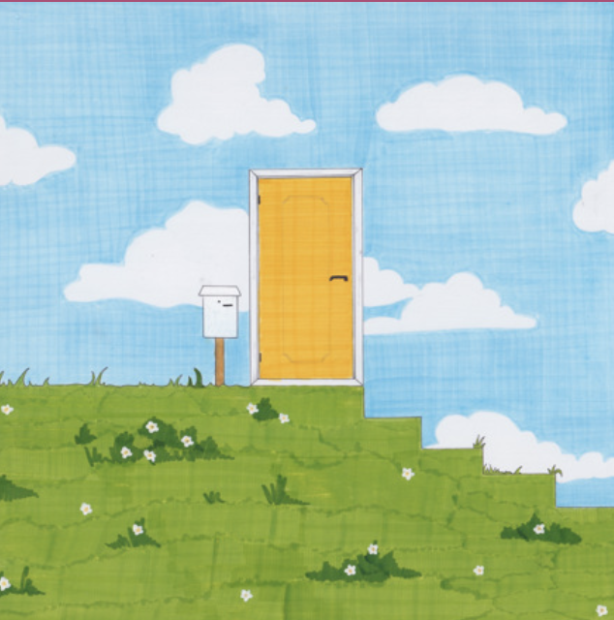

CRAZY LIFE TRACK-LIST
1. Bird Sing
2. I Do You
3. Nobody
4. Listen
5. Living Life Right
6. Red Light
7. No Good Without U
8. Dandelion
9. Meteorite
10. 60 Seconds
11. Let Go
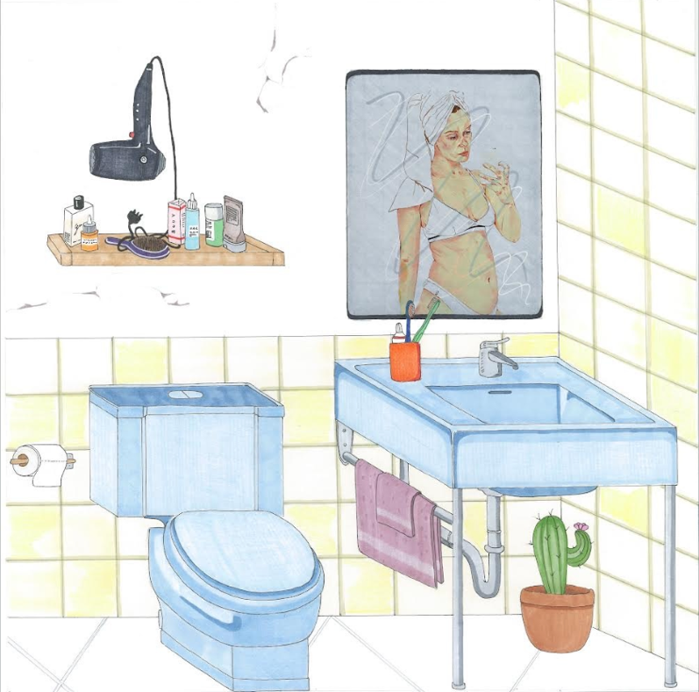
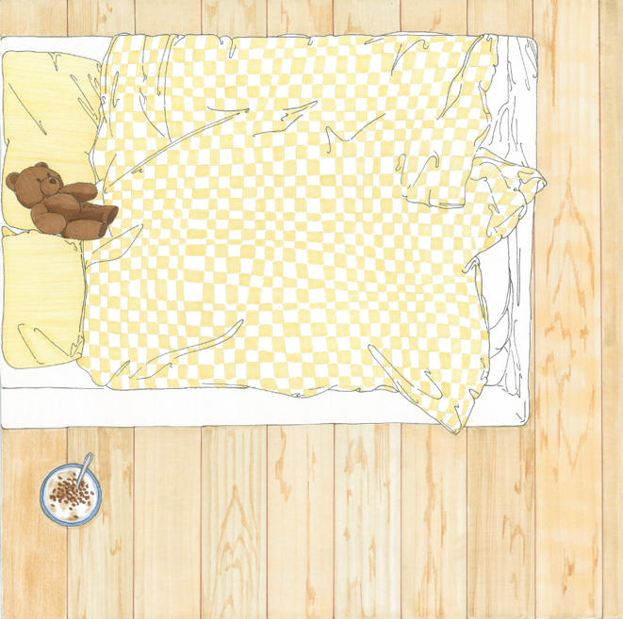

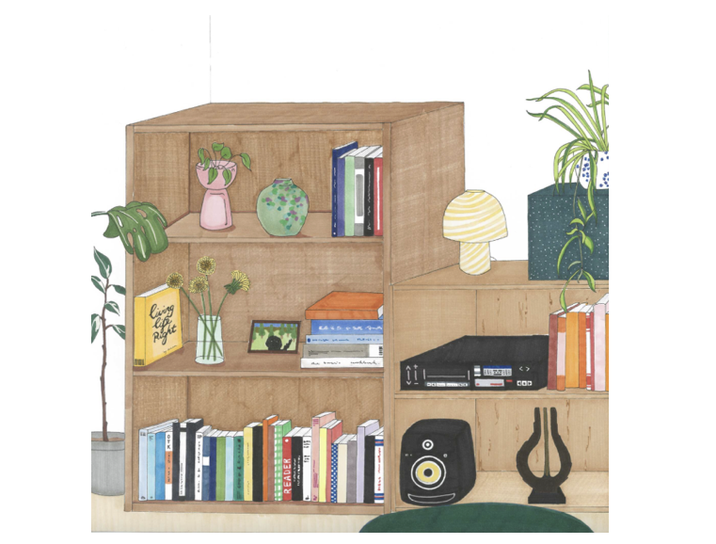
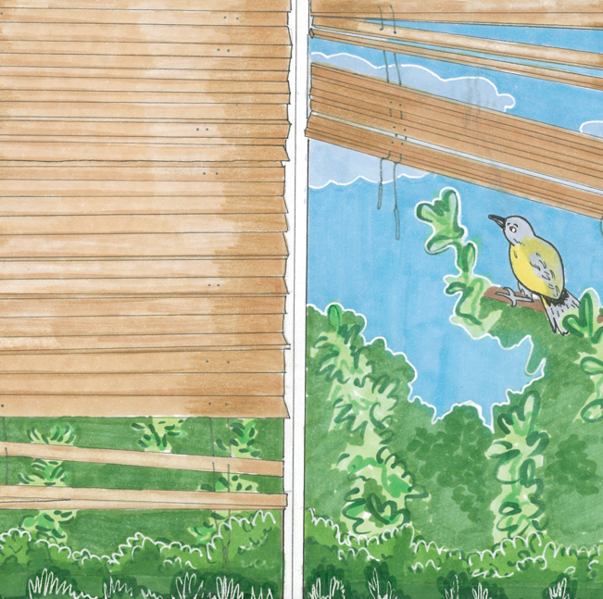
2023 ‘CRAZY’ TOUR
DATE | CITY | VENUE
Thursday, March 16, 2023 | Washington, DC | Union Stage
Saturday, March 18, 2023 | New York, NY | To Be Announced
Tuesday, March 21, 2023 | Boston, MA | Brighton Music Hall
Thursday, March 23, 2023 | Montreal, QC | LeStudio TD
Friday, March 24, 2023 | Toronto, ON | Velvet Underground
Sunday, March 26, 2023 | Chicago, IL | Lincoln Hall
Wednesday, March 29, 2023 | Los Angeles, CA | El Rey Theatre
Thursday, March 30, 2023 | San Francisco, CA | The Independent
Saturday, April 1, 2023 | Portland, OR | Doug Fir Lounge
Sunday, April 2, 2023 | Seattle, WA | Barboza

about Anna of the North
Anna of the North makes the kind of music you can take along with you on the dancefloor, on a long drive with a loved one, or in the dead of night when you’re alone and need someone to understand how you feel. Trading her native Norway for Australia on a whim, she gained the nickname “Anna of the North,” underwent a creative awakening, and returned home with a renewed sense of purpose. Since 2014, she’s quietly emerged as an alternative pop phenomenon. She captivated listeners with a pair of acclaimed albums—Lovers [2017] and Dream Girl [2019]. The latter’s title track “Dream Girl” soundtracked Apple’s Global iPad Pro campaign “Float,” earned a Norwegian Grammy, and landed a sync in the third installment of NETFLIX’s blockbuster To All The Boys series, To All The Boys…Always & Forever, enshrining her as the only artist to contribute music to all three films. Tyler, The Creator recruited her to feature on the platinum-certified “Boredom” and lend background vocals to “911 / Mr. Lonely” [feat. Frank Ocean & Steve Lacy] from his GRAMMY® Award-nominated Flower Boy. Dua Lipa invited her to join forces for the “IDGAF (Anna of the North Remix),” and G-Eazy enlisted her for “Pick Me Up” from his platinum-certified epic The Beautiful & The Damned. Beyond praise from Variety, The FADER, Billboard, NME, and UPROXX, her voice powered songs from HULU’s Rosaline Original Motion Picture Soundtrack by Drum & Lace and Ian Hultquist. Now, she opens up more than ever on her 2022 third full-length offering, Crazy Life [Elektra Entertainment].
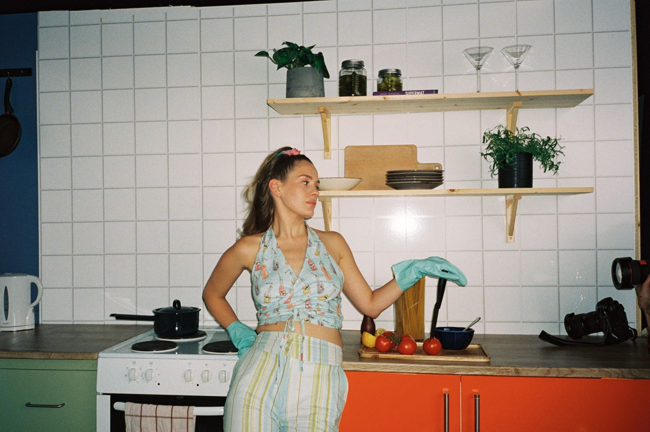
follow Anna of the North:
TikTok | Instagram | YouTube | Facebook

