WATCH TURNSTILE MAKE THEIR LATE NIGHT TV DEBUT
PERFORMING “MYSTERY” & “T.L.C. (TURNSTILE LOVE CONNECTION)”
ON LATE NIGHT WITH SETH MEYERS

GLOW ON STAKES ITS CLAIM AS ONE OF THE “BEST ALBUMS OF 2021”

“THE TURNSTILE LOVE CONNECTION TOUR”
FEATURING SPECIAL GUESTS CITIZEN, CEREMONY, EKULU, TRUTH CULT, COCO & CLAIR CLAIR
GETS UNDERWAY FEBRUARY 22ND IN SAN FRANCISCO, CA

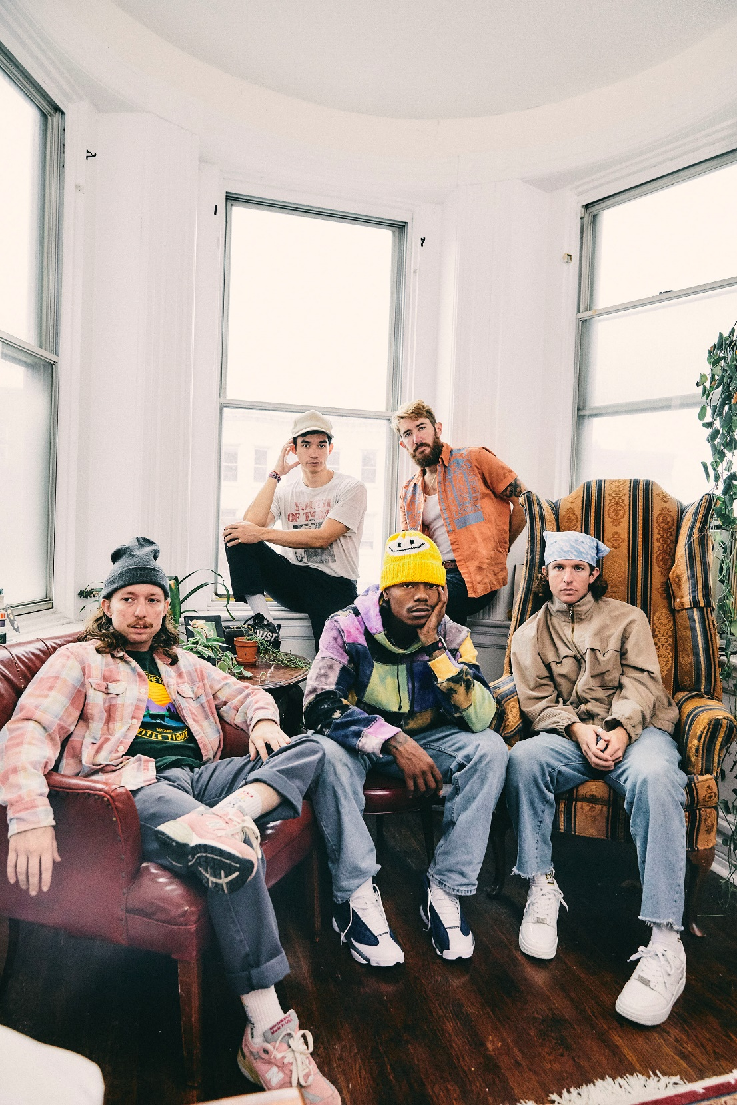
PHOTO CREDIT: JIMMY FONTAINE

DECEMBER 16, 2021 – TURNSTILE made their late night TV debut last night, performing “MYSTERY” and “T.L.C. (TURNSTILE LOVE CONNECTION)” on Late Night with Seth Meyers - Watch it HERE. Both tracks are featured on the band’s widely celebrated new album GLOW ON, which is staking its claim as one of the year’s top releases, earning “Best of 2021” honors from: NPR, Rolling Stone, Pitchfork, Billboard, Stereogum, SPIN, Vulture, The FADER, The Ringer, The Washington Post, Esquire, FLOOD, Uproxx, Consequence, Paste, Revolver and more.

Furthermore, TURNSTILE recently announced a run of 2022 North American headline tour dates in support GLOW ON. Deemed “THE TURNSTILE LOVE CONNECTION TOUR,” the largely sold-out spring run will feature special guests Citizen, Ceremony, Ekulu, Truth Cult, and Coco & Clair Clair [full itinerary below]. For tickets and more information on TURNSTILE’s upcoming international tour dates, visit www.turnstilehardcore.com.

Recorded with producer Mike Elizondo and co-produced by TURNSTILE vocalist Brendan Yates, GLOW ON
finds TURNSTILE once again charting new ground for hardcore, expanding stylistic boundaries and celebrating new possibilities. GLOW ON is 15 tracks devoid of borders, boundaries, or entry obstacles, only abundant imagination, heart, and grooves plucked from all corners of the musical spectrum.

GLOW ON includes the singles “FLY AGAIN,” “BLACKOUT,” “HOLIDAY,” “NO SURPRISE,” “MYSTERY,” and “T.L.C. (TURNSTILE LOVE CONNECTION),” the latter four of which appear on TURNSTILE’s TURNSTILE LOVE CONNECTION EP and companion short film. GLOW ON also includes guest features from Blood Orange on “ALIEN LOVE CALL,” “LONELY DEZIRES,” with additional vocal contributions on “ENDLESS.”

Selected as Stereogum’s Album Of The Week, Senior Editor Tom Breihan wrote “Before GLOW ON, TURNSTILE were already a truly special band, a ray of exploding energy. With this album, they’ve hit dizzy new heights…They’ve made a classic. I can’t even imagine what they’ll do next.” Pitchfork awarded the album ‘Best New Music’ attesting “The Baltimore band’s spectacular fourth record is all groove, riffs, and passion,” with The Recording Academy noting “The through line of all this is a lack of fear—of pushback, of resistance, of excommunication—that defines TURNSTILE.” NPR observed, “TURNSTILE has the ability to lure even the most poptimistic listener with spectacular hooks,” and Vulture hailed GLOW ON as “one of the best rock albums of the year.” Billboard affirmed “Ready or not, TURNSTILE is breaking through,” with FLOOD hailing the album as “An unforgettable magnum Opus.”

Always more appeal than demand, more liberation than limitation, TURNSTILE extended their hand in 2018 with TIME & SPACE. Recorded with producer Will Yip, TIME & SPACE marked Turnstile’s Roadrunner Records debut and saw the band exploding the most outsized tropes of hardcore with tremendous heart. The album earned “Best of 2018” honors from The New Yorker, The New York Times, Rolling Stone, NPR Billboard and more, with GQ naming TIME & SPACE one of “The Best Albums That Shaped the 2010s.”

Reminding us that all music is dance music, TURNSTILE linked up with Australian producer Mall Grab in 2020 to release SHARE A VIEW, a collaborative EP of three reimagined TIME & SPACE tracks – “Generator,” “Real Thing,” and “I Don’t Wanna Be Blind.”

Comprised of Brendan Yates (Vocals), Franz Lyons (Bass/Vocals), Brady Ebert (Guitars), Pat McCrory (Guitars), and Daniel Fang (Drums), TURNSTILE’s brand of youth-minded, youth-driven hardcore punk is intent on breaking down barriers, sonically and ideologically.

[TOUR ITINERARY BELOW]

“THE TURNSTILE LOVE CONNECTION TOUR”
2/22 – 2/25 with Citizen and Coco & Clair Clair
4/26 – 5/29 with Citizen, Ceremony, Ekulu, and Truth Cult

2/22 - San Francisco, CA - The Regency Ballroom (SOLD OUT)
2/23 - San Francisco, CA - The Regency Ballroom (SOLD OUT)
2/24 - Los Angeles, CA - The Novo (SOLD OUT)
2/25 - Los Angeles, CA - The Novo (SOLD OUT)
4/25 - Englewood, CO - Gothic Theatre (SOLD OUT)
4/26 - Englewood, CO - Gothic Theatre (SOLD OUT)
4/27 - Salt Lake City, UT - Soundwell (SOLD OUT)
4/29 - Vancouver, BC - The Rickshaw Theatre (SOLD OUT)
4/30 - Seattle, WA - The Showbox (SOLD OUT)
5/2 - Portland, OR - Roseland Theater (SOLD OUT)
5/4 - Albuquerque, NM - El Rey Theatre
5/6 - Austin, TX - Stubb’s Waller Creek Amphitheater (SOLD OUT)
5/7 - Dallas, TX - Amplified Live
5/9 - Atlanta, GA - The Masquerade (SOLD OUT)
5/10 - Nashville, TN - Brooklyn Bowl (SOLD OUT)
5/12 - Milwaukee, WI - The Rave
5/13 - Minneapolis, MN - Varsity Theater (SOLD OUT)
5/14 - Lawrence, KS - The Granada Theater**
5/17 - Detroit, MI - Majestic Theatre (SOLD OUT)
5/18 - Cleveland, OH - Agora Theatre
5/19 - Toronto, ON - The Phoenix Concert Theatre (SOLD OUT)
5/21 - Worcester, MA – Palladium (SOLD OUT)
5/22 - Queens, NY - Knockdown Center* (SOLD OUT)
5/23 - Brooklyn, NY - Brooklyn Steel (SOLD OUT)
5/24 - Philadelphia, PA - The Fillmore Philadelphia (SOLD OUT)
5/26 - Washington, DC- 9:30 Club (SOLD OUT)
5/29 - Washington, DC- 9:30 Club (SOLD OUT)

* With Beach Fossils and Special Interest
**No Ceremony

Connect with TURNSTILE:
WEBSITE / INSTAGRAM / FACEBOOK / TWITTER / YOUTUBE / SPOTIFY / APPLE MUSIC

