WHITE REAPER ANNOUNCE NEW ALBUM ASKING FOR A RIDE

SHARE NEW SONG & MUSIC VIDEO - “PAGES”

ANNOUNCE 2023 NORTH AMERICAN HEADLINE TOUR WITH SPECIAL GUESTS
NARROW HEAD, MILITARIE GUN, TAIPEI HOUSTON & MAMALARKY

ASKING FOR A RIDE ARRIVES JANUARY 27TH

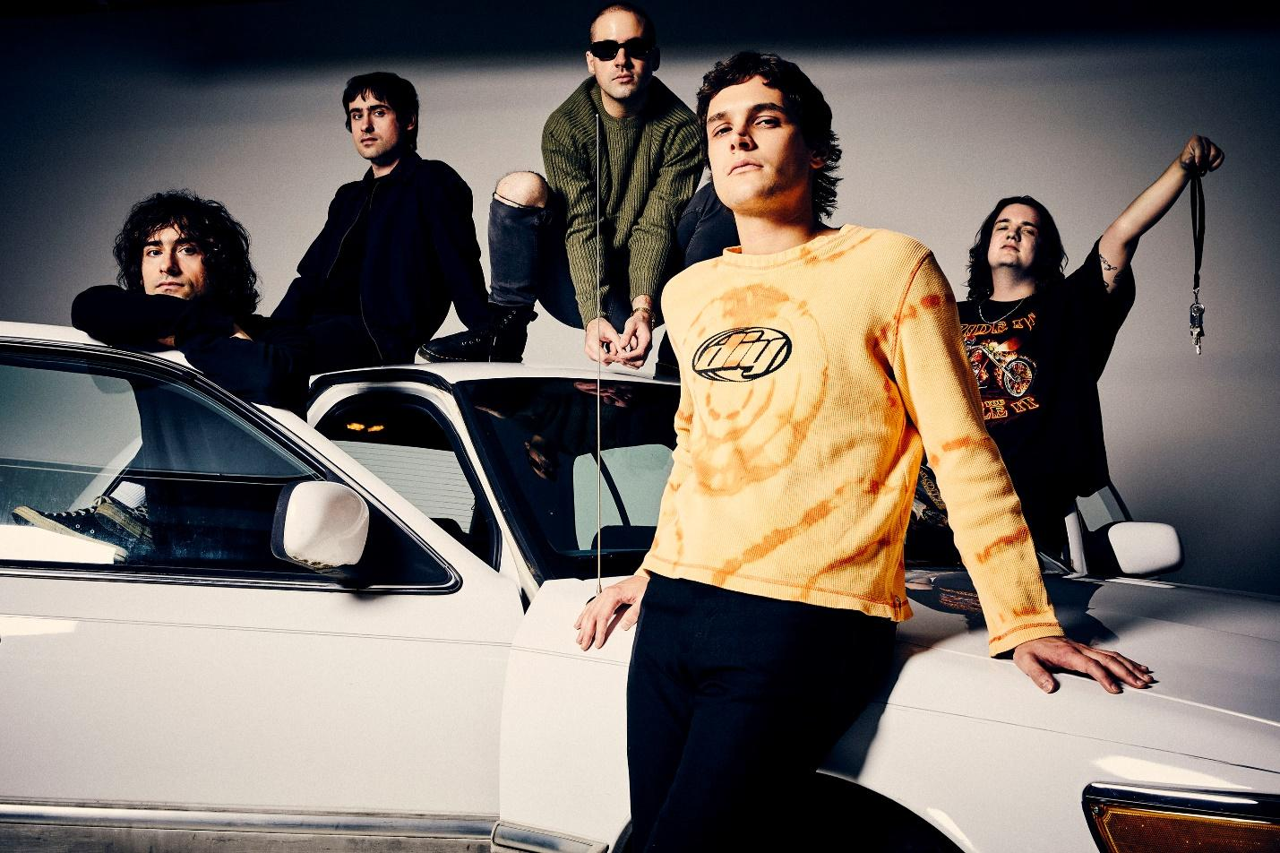
PHOTO CREDIT: JIMMY FONTAINE

OCTOBER 26, 2022 – White Reaper have announced details of their new album Asking for a Ride, which will be released January 27th on Elektra Entertainment and is available for pre-order today [album art / track listing below]. The band have also shared the new song, “Pages” which is available now on all streaming platforms and joined by a Lance Bangs directed music video – watch it HERE.

Elaborating on “Pages” and Asking for a Ride, vocalist / guitarist Tony Esposito remarked, “It seems like ‘Pages' could’ve easily existed on one of our earlier records, it’s just a few chords and a simple melody; but because of that, I’d say that it’s pretty unique to the rest of our new album. We can’t wait to show everyone what we’ve been working on.”

Director Lance Bangs commented on the “Pages” video adding, “White Reaper are a joy to make things with, 5 guys that are good company in recording studios, house parties, live shows, and anywhere else you can spend time among them. We had a great experience shooting saturated color motion picture film on handheld cameras for the ‘Real Long Time’ video for their previous album, and I wanted to get everyone together for an outdoor daylight look in one of my favorite architectural public spaces, the Keller Fountain in Portland Oregon. It was designed in the late 60s and opened to the public in 1970. It’s an enduring free space where people can spend time. We filmed on a bright, warm afternoon and conjured up a video that feels like the song: dynamic, catchy, genuine.”

Recorded and largely self-produced in Nashville with the help of close friend and engineer Jeremy Ferguson, Asking for a Ride finds the Louisville band taking a more direct and in-your-face approach, prioritizing the collection’s raw energy and its ability to translate live through ripping and nervy compositions. It’s White Reaper at their most exciting - dialing up the chrome-plated riffs and monster hooks – a welcome reminder of just how much fun rock music can be.

“We ask ourselves: ‘Does it sound good when we play it in the room together?’ And if it does, those are the songs we want to pursue,” Esposito noted.

Guitarist Hunter Thompson concurred: “We started to recognize how we operate best as a band.”

The band teased additional new music from their forthcoming LP in an album trailer released earlier this week - watch it HERE.

In addition to the news of their forthcoming album, White Reaper have also revealed plans for a run of 2023 North American headline tour dates . The upcoming “Asking for a Ride” tour will feature special guests Narrow Head, Militarie Gun, Taipei Houston, and Mamalarky on select dates, and will kick off February 7th [tour itinerary below]. Pre-sale tickets for the tour are available today, with general on-sale for tickets beginning Friday, October 28th. The forthcoming dates will see White Reaper’s long awaited return to touring after having spent years living on the road, headlining and supporting some of their idols – Pearl Jam, Weezer, and The Killers – while making festival appearances at Lollapalooza, Austin City Limits and more. For tickets and more information on White Reaper’s upcoming tour dates, visit www.whitereaperusa.com.

Comprised of Tony Esposito (guitar / vocals), Ryan Hater (keyboards), Sam Wilkerson (bass), Nick Wilkerson (drums), and Hunter Thompson (guitar), Asking for a Ride follows White Reaper’s 2019 album You Deserve Love, which marked a new career peak for the Louisville band. The collection was led by the number one alternative radio hit, “Might Be Right,” which the band later made their network TV debut performing on ABC’s Jimmy Kimmel LIVE!. A collection of smart, sharply-written songs of doubt, dislocation, and elusive and often complicated love, The New York Times observed, “The Kentucky quintet White Reaper blends the winking gravitas of ‘70s arena rock with garage-y power pop… enjoy the trip back,” while GQ applauded the release as “the perfect companion for all your nice weather fun.” Equal parts glam and grit, You Deserve Love found the band expanding on the songcraft laid down on 2017’s critically acclaimed The World’s Best American Band, which landed on Noisey’s “100 Best Albums of 2017” and Pitchfork’s “20 Best Rock Albums of 2017,” earning an 8.0 album score.

[ Album Artwork / Tracklisting / Tour Itinerary Below]

ASKING FOR A RIDE
ALBUM ARTWORK + TRACKLISTING

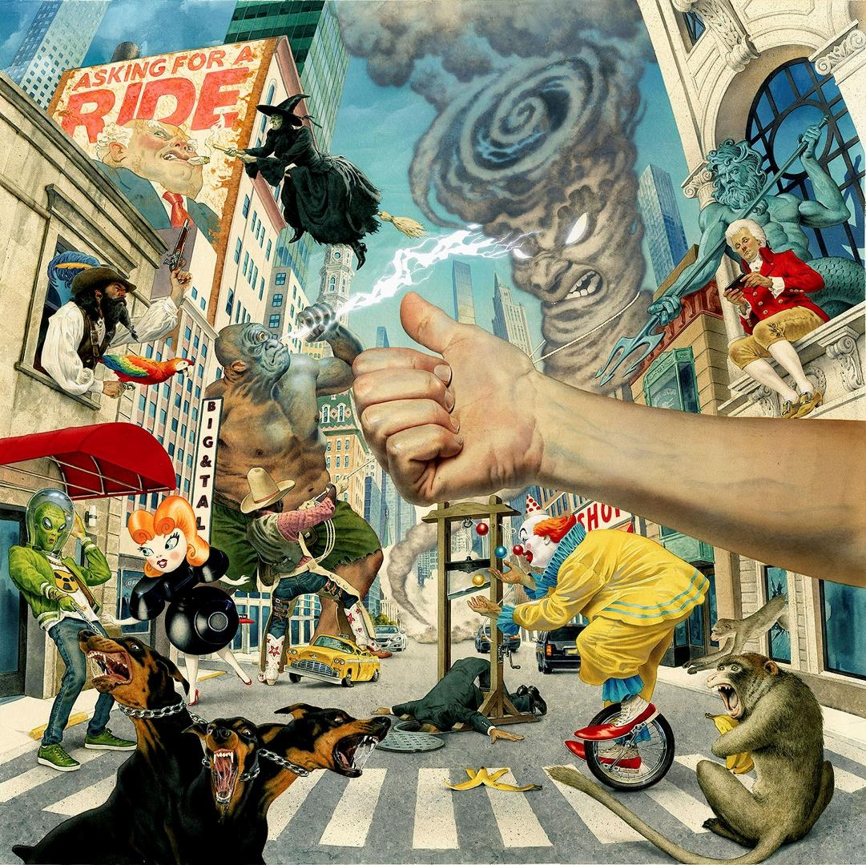
ARTWORK BY MARK STUTZMAN

- Asking for a Ride
- Bozo
- Fog Machine
- Getting into Trouble w/ the Boss
- Funny Farm
- Pink Slip
- Heaven or Not
- Crawlspace
- Thorn
- Pages

WHITE REAPER NORTH AMERICAN HEADLINE TOUR 2023
WITH SPECIAL GUESTS NARROW HEAD, MILITARIE GUN, TAIPEI HOUSTON, & MAMALARKY ON SELECT DATES

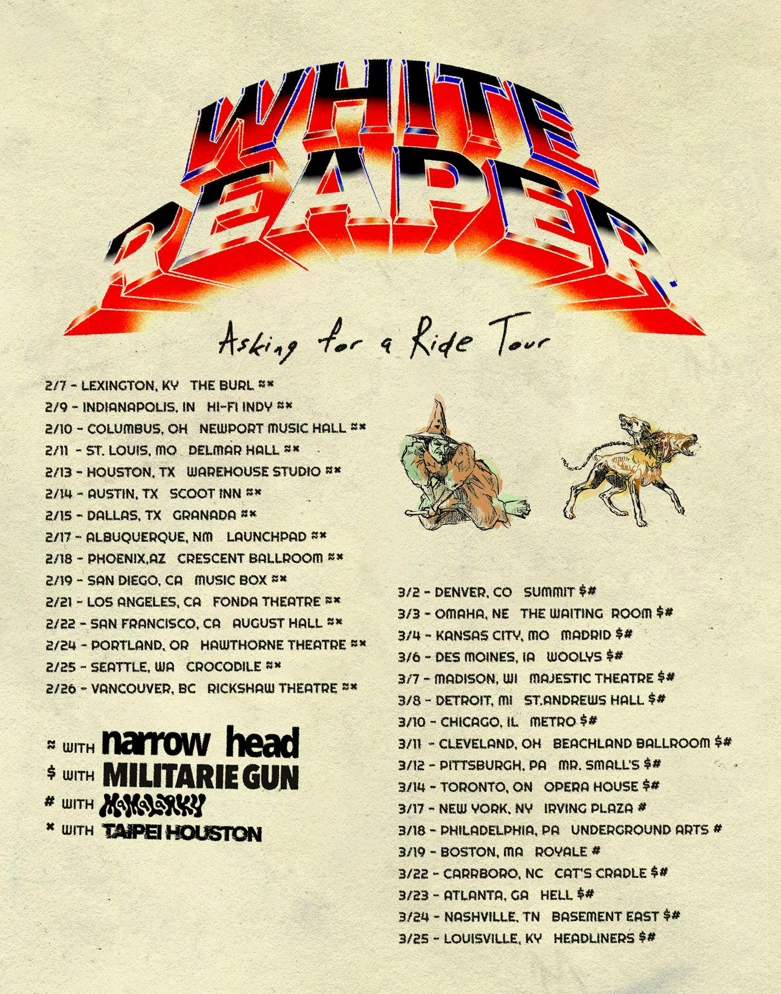

February 7 - Lexington, KY - The Burl +#
February 9 - Indianapolis, IN - HI-FI Indy +#
February 10 - Columbus, OH - Newport Music Hall +#
February 11 - St Louis, MO - Delmar Hall +#
February 13 - Houston, TX - Warehouse Studio +#
February 14 - Austin, TX - Scoot Inn +#
February 15 - Dallas, TX - Granada +#
February 17 - Albuquerque, NM - Launchpad +#
February 18 - Phoenix, AZ - Crescent Ballroom +#
February 19 - San Diego, CA - Music Box +#
February 21 - Los Angeles, CA - Fonda Theatre +#
February 22 - San Francisco, CA - August Hall +#
February 24 - Portland, OR - Hawthorne Theatre +#
February 25 - Seattle, WA - Crocodile +#
February 26 - Vancouver, BC - Rickshaw Theatre +#
March 2 - Denver, CO - Summit *&
March 3 - Omaha, NE - The Waiting Room *&
March 4 - Kansas City, MO - Madrid *&
March 6 - Des Moines, IA - Woolys *&
March 7 - Madison, WI - Majestic Theatre *&
March 8 - Detroit, MI - St. Andrews Hall *&
March 10 - Chicago, IL - Metro *&
March 11 - Cleveland, OH - Beachland Ballroom *&
March 12 - Pittsburgh, PA - Mr Smalls *&
March 14 - Toronto, ON - Opera House *&
March 17 - New York, NY - Irving Plaza &
March 18 - Philadelphia, PA - Underground Arts &
March 19 - Boston, MA - Royale &
March 22 - Carrboro, NC - Cat's Cradle *&
March 23 - Atlanta, GA - Hell *&
March 24 - Nashville, TN - Basement East *&
March 25 - Louisville, KY - Headliners *&

+ Narrow Head
# Taipei Houston
* Militarie Gun
& Mamalarky

Connect with White Reaper:
WEBSITE / FACEBOOK / TWITTER / INSTAGRAM / YOUTUBE / SPOTIFY / APPLE MUSIC
Contact:
GLENN FUKUSHIMA / ROSS ANDERSON / COLLIN CITRON

