Quarters of Change Release
“To Let Go”
LISTEN HERE
WATCH HERE

+CURRENTLY ON TOUR WITH BAD SUNS+
+Debut LP Into The Rift released on July 19th with contributions from the legendary Tom Lord-Alge & Mikey Freedom Hart (of Bleachers)+
New York, NY (October 28, 2022) – Today, Quarters of Change unveil a new track "To Let Go" - Listen HERE.
Joining a catalogue of infectious hits, "To Let Go" introduces the band’s emotional side, as lead singer, Ben Roter, sings about the tragic loss of his birth father. The track has proven to be a crowd favorite on Quarters of Change current cross-country tour, which they’ve been on alongside rock heavyweights Bad Suns.
The track arrives in the wake of single “Blue Copper” and their debut album Into The Rift. The LP, which features eleven electric and cathartic tracks, introduced and solidified Quarters of Change as a standout quartet going beyond the typical conventions and traditional boundaries of genre to take the rock scene by storm. The group has already seen an exponential rise in all areas, including a 350% increase in streaming consumption year-to-date. Shoutouts from celebrity fans such as Joe Jonas, Fred Durst, and Lewis Capaldi have also helped catapult the group into the limelight.
From standalone singles such as "T Love" and "Dead" to newer songs such as "Ms. Dramatic," the versatile debut body of work is as tempestuous as it is melodic. "Dead" meshes an upbeat chorus with the group's quintessential shredding guitar while "Sex" is a groovy display of emotional lyrics. "Sex" is praised by Billboard as a "slow-burning, psychedelic track [that] highlights the depths of the group’s range as musicians." The product is a debut LP that successfully encapsulates the contrived chaos that is Quarters of Change.
Catch the group's undeniable stage presence at an upcoming live show - tour dates HERE.
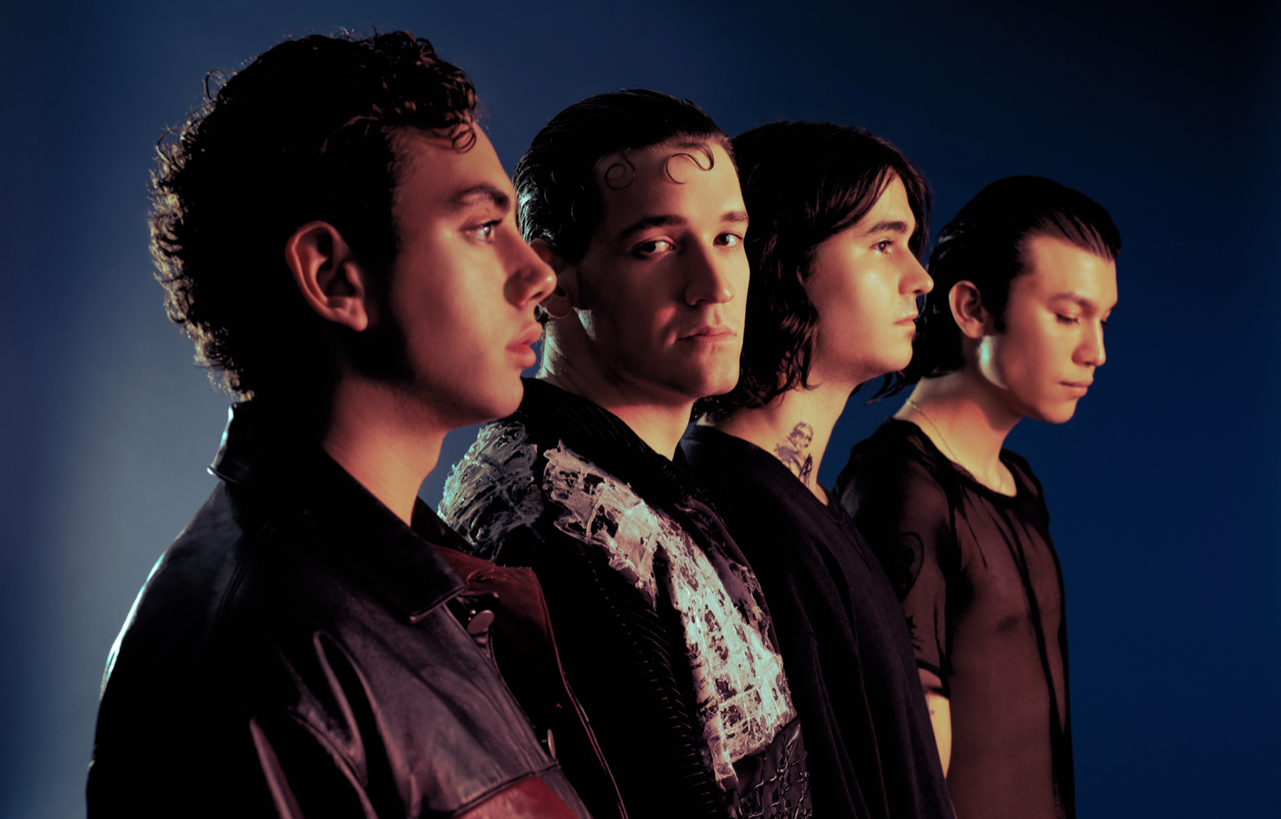
ABOUT QUARTERS OF CHANGE
Quarters of Change is the Brooklyn based quartet leading the charge on New York City’s rock resurgence, and redefining what it means to be a rock star.
Composed of Ben Acker, Attila Anrather, Jasper Harris, and Ben Roter, Quarters of Change started in 2017 as a high school cover band, performing iconic rock songs of the 90s and 00s. It wasn’t until their junior year that they began writing original material, pulling influence from groups like The Strokes and Rage Against The Machine, and creating their own original sound. Within a year, the band had signed a deal with Warner/300 Entertainment, released streaming favorites like “Kiwi," and played sold out shows at renown venues like Bowery Ballroom and Webster Hall.
Now, armed with a record deal and an undeniable slew of songs, Quarters of Change is poised to be alternative rock’s next big thing. Keep an eye out for their self-written debut LP, Into The Rift, with contributions from legendary producers Tom Lord-Alge and Mikey Freedom Hart (Bleachers), out now.
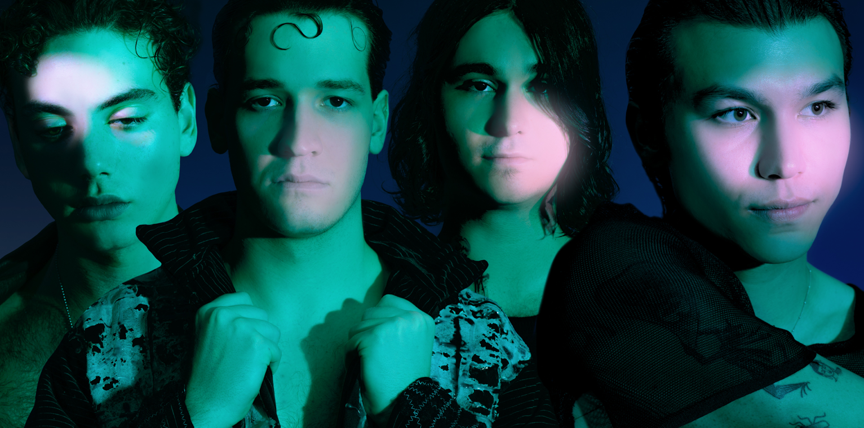
Photo Credit: Zachary Olewnicki
KEEP UP WITH QUARTERS OF CHANGE
TikTok | Instagram | Twitter

# # #

