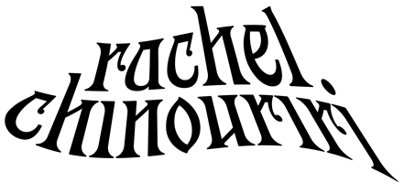
BREAKOUT INDIE-POP ARTIST RACHEL CHINOURIRI SHARES UPLIFTING NEW SINGLE
“I’M NOT PERFECT (BUT I’M TRYING)”
LISTEN HERE | WATCH THE MUSIC VIDEO HERE
MORE NEW MUSIC COMING SOON

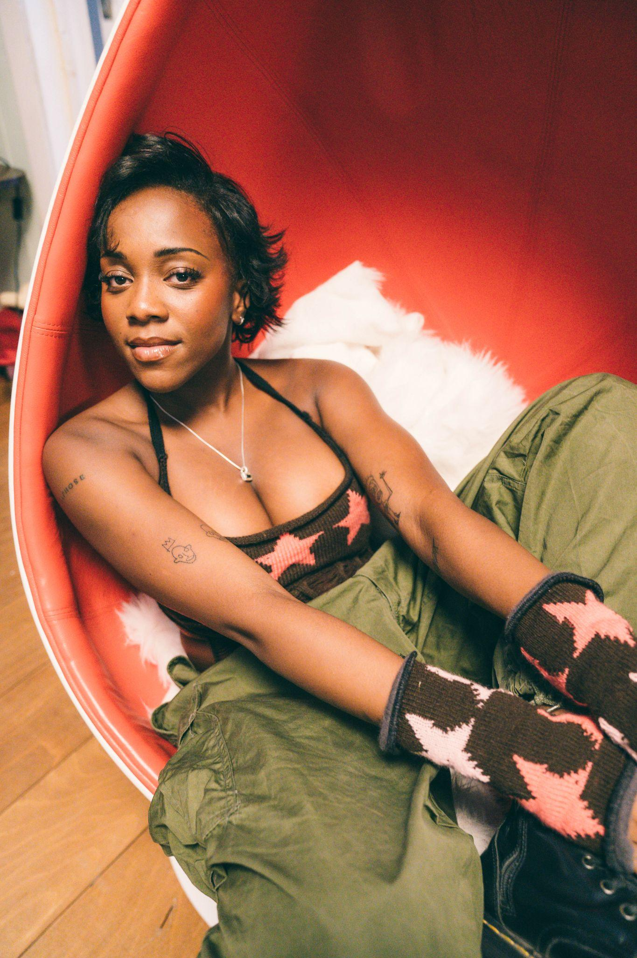
Photo credit: Alice Backham
Hi-res press assets HERE
“…one of the warmest, fully enveloping pop introductions in recent memory” - BILLBOARD
“Chinouriri’s glowing voice and wistful lyrics create a sonically boundless landscape” - CONSEQUENCE

“…honest lyrics and enchanting vocals” - NYLON

“[‘All I Ever Asked’] is catchy because of its coolness. It chirps and flows in a nonchalant manner, adorned with a swaying beat that sounds perfect underneath Chinouriri’s soaring soprano.” - UPROXX

(October 28, 2022) – LOS ANGELES, CA – Fast-rising alternative indie-pop artist Rachel Chinouriri has shared her relatable new single “I’m Not Perfect (But I’m Trying),” an uplifting reminder to herself to have the confidence to dive into new situations, despite what the voice in the back of her head may be telling her. With a driving rhythm and sparkling, upbeat synth-pop heart, the new offering sees Chinouriri lean fully into her indie sensibilities and is a taste of exciting things to come next year, including her much-anticipated debut album. “I’m Not Perfect (But I’m Trying)” is available on all digital platforms and arrives alongside a companion music video complete with classic Y2K fashion. Watch it HERE.

Of the new track, Chinouriri explained, "I wanted to write a song about the hesitation before diving into a situation. I was reflecting on the self-doubt I have sometimes but also the desire to always jump straight into things. It’s the realization and acceptance of being perfectly imperfect. This life is full of motion and keeping up isn’t always easy. But I remind myself to just go for it in order to grow as a human being and experience new and amazing things."

“I’m Not Perfect (But I’m Trying)” follows Chinouriri’s acclaimed EP Better Off Without, released in May via Elektra Entertainment – featuring standout singles “All I Ever Asked” and “Happy Ending” – along with her stunning COLORS session with the vulnerable “Thank You For Nothing.” 2022 has also seen Rachel embark on a headline tour of the UK, hit the U.K. festival circuit and share the stage with the likes of Remi Wolf, Tems, Sam Fender, Bloc Party, and more. The success of her critically lauded 2021 EP Four° In Winter marked Chinouriri’s capabilities as a stylistic amalgamator, and received praise across the likes of BBC Radio 1, The Guardian, Dazed, NME, and theneedledrop’s Anthony Fantano – who named the EP his #1 project of 2021.

2023 is set to be Rachel’s biggest year to date. Stay tuned for more new music coming soon.

RACHEL CHINOURIRI
“I’M NOT PERFECT (BUT I’M TRYING)”
AVAILABLE HERE
FOLLOW RACHEL CHINOURIRI:
Instagram | Facebook | Twitter | TikTok | YouTube
# # #
MEDIA CONTACTS:
Nathalie Rubin & Sarah Goldstein
Nathalie.Rubin@300Elektra.com | Sarah.Goldstein@300Elektra.com

