MEET ME @ THE ALTAR RETURN WITH NEW SINGLE
“SAY IT (TO MY FACE)”
OFFICIAL VIDEO STREAMING NOW

DEBUT ALBUM SET TO ARRIVE EARLY 2023

CURRENTLY SUPPORTING MUNA’S NORTH AMERICAN TOUR

PERFORMING THIS OCTOBER AT SAN DIEGO, CA’S TWITCHCON ALONGSIDE MEGAN THE STALLION AND KIM PETRAS

AND HIGHLY ANTICIPATED WHEN WE WERE YOUNG FESTIVAL
IN LAS VEGAS, NV

DOWNLOAD PRESS ASSETS HERE
Photo credit: Jonathan Weiner

“One of the most exciting young pop bands in the United States” – The FADER

“One of 2021’s most exciting new rock acts” – Rolling Stone

“Meet Me @ The Altar is the future of pop-punk” – NYLON

“Your new pop punk obsession” – Buzzfeed

“Some of the most promising, exciting pop-punk in recent memory” – Stereogum

SEPTEMBER 30, 2022 – Critically acclaimed pop-punk trio Meet Me @ The Altar have returned with new single “Say It (To My Face).” Propelled by a gang-vocal fueled chorus, “Say It (To My Face)” arrives as the first taste of music from the band’s forthcoming debut album, which is set to arrive early next year. Directed by Jack Campise, the single is accompanied by an official music video which follows the band’s journey to confront an internet troll. “Say It (To My Face)” is available now via Fueled By Ramen, with the video streaming now on Fueled By Ramen’s official YouTube channel.

Meet Me @ The Altar expanded on the single, “The song is essentially a diss track to all of our haters. We all have a love/hate relationship with the internet - it quite literally brought us together, but people also use the internet as a crutch to help mask their insecurities behind a screen and try to project them on us a lot of the time. They never seem to have the guts to actually say it to our faces.

The video serves as a real time portrayal of who we envision as the culprits when we see hateful comments left on our social media accusing us of everything from being industry plants to not playing our own instruments - like a Catfish-style expose to go see how your bullies are actually living (usually not well).”

The group continued, “When our fans listen to this song and encounter bullies in their day-to-day life, we want them to remember that those people are only cruel because they’re hurting! Part of growing up is figuring out how to not internalize anyone else’s bad vibes and just loving yourself instead.”

Meet Me @ The Altar is currently on tour with MUNA in support of their North American headline dates, which include three nights at New York City’s Irving Plaza and two nights at The Wiltern in Los Angeles, CA. The trio is also slated to perform at the 2022 TwitchCon San Diego party as part of an all-women lineup that includes Megan The Stallion and Kim Petras, as well as the highly anticipated When We Were Young festival in Las Vegas, NV this October (full tour itinerary below). A complete list of upcoming live dates and ticket information can be found HERE. The band has previously supported Green Day, Jxdn, KennyHoopla and more on tour, delivered an unforgettable set at Lollapalooza earlier this summer, and was recently tapped as one of PEOPLE Magazine’s Emerging Artists To Watch.

Meet Me @ The Altar’s major label debut EP Model Citizen was released last August via Fueled By Ramen and arrived to widespread critical acclaim. Rolling Stone hailed the EP’s lead single “Feel A Thing” as “a blistering track filled with flurries of double-kick drum hits and crunchy guitar riffs.” The FADER touted the track as “widescreen and anthemic,” while UPROXX declared the song “a reminder of why pop-punk became so popular in the first place.”

Upon the release of the EP’s second track, “Brighter Days (Are Before Us),” FLOOD Magazine proclaimed “the punchy single has an optimistic spirit,” while Brooklyn Vegan asserted “it’s got no shortage of huge hooks.” Additional praise came from Consequence who featured the band as their Artist of The Month, and The New York Times Magazine who profiled the group following the EP’s release.

Crossing state lines and breaking all kinds of boundaries, the group’s members—Edith Victoria [vocals], Téa Campbell [guitar], and Ada Juarez [drums]—initially met online, bonding over the likes of Paramore and Twenty One Pilots and agreeing on a need for more representation in pop punk. Instead of waiting for somebody else to do it, they stepped up and became that representation as three proud women of color playing lightning fast riffs, pounding out double kicks, and chanting huge hooks.

MEET ME @ THE ALTAR 2022 TOUR DATES
All dates supporting MUNA except ^

SEPTEMBER
30 New York, NY Irving Plaza

OCTOBER
01 New York, NY Irving Plaza
02 New York, NY Irving Plaza
04 Detroit, MI Majestic Theatre
06 Kansas City, MO The Truman
08 San Diego, CA TwitchCon ^
10 Houston, TX House Of Blues
11 Dallas, TX The Echo Lounge & Music Hall
13 Santa Fe, NM Santa Fe Brewing Company
15 Boulder, CO Boulder Theater
16 Englewood, CO Gothic Theatre
17 Salt Lake City, UT The Depot
19 Phoenix, AZ The Van Buren
22 Las Vegas, NV When We Were Young ^
23 Las Vegas, NV When We Were Young ^
24 San Francisco, CA The Fillmore
25 Los Angeles, CA The Wiltern
26 Los Angeles, CA The Wiltern
29 Las Vegas, NV When We Were Young ^

MEET ME @ THE ALTAR
“Say It (To My Face)”
AVAILABLE NOW

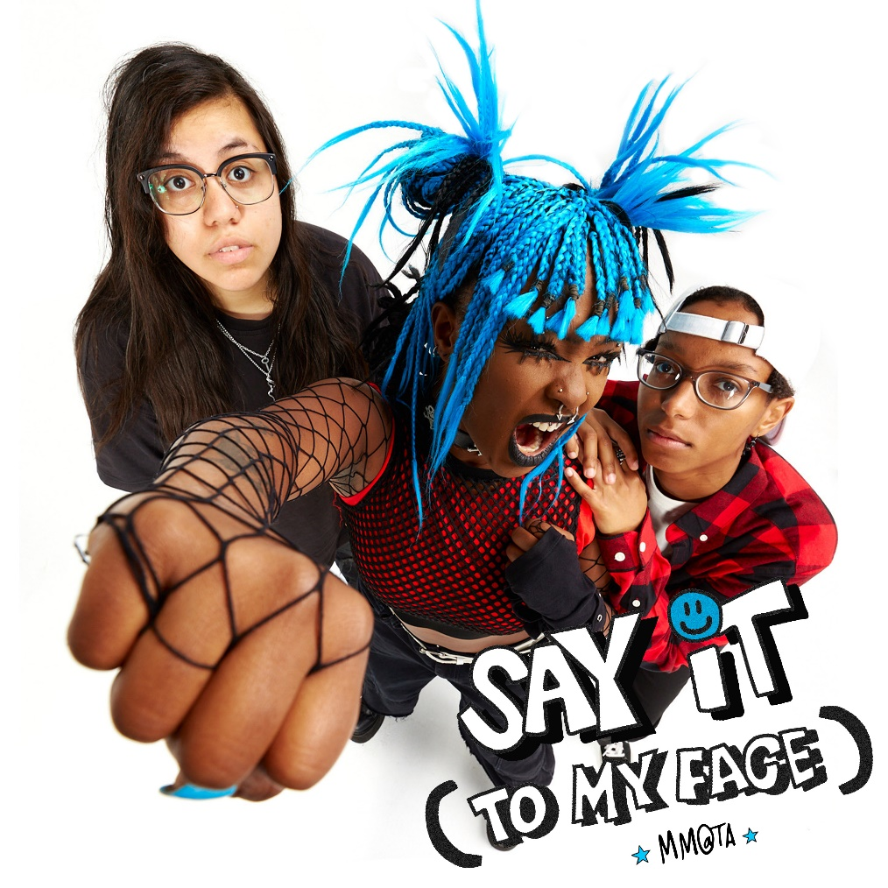

ABOUT MEET ME @ THE ALTAR:
Meet Me @ The Altar present a new musical and cultural paradigm for pop punk. The Florida-based trio—Edith Victoria [vocals], Téa Campbell [guitar], and Ada Juarez [drums]—write the kinds of anthems that you can scream along to at a festival, head-bang to in a club, or sit with while in your feelings at home. The women may have met via YouTube - in true modern-day fashion - but the band shares a classic mission. Flipping the script for rock music and its culture, they bring together elements of Warped Tour-era punk, 2010s pop, and easycore. In 2020, early champions such as Halsey, Alex Gaskarth of All Time Low and Dan “Soupy” Campbell of The Wonder Years came forward as the trio inevitably inked a deal with Fueled By Ramen. On the heels of singles “Garden” and “Hit Like A Girl,” widespread tastemaker praise followed from The FADER, Rolling Stone, Nylon, Stereogum and more. Meanwhile, Vulture predicted, “Meet Me @ The Altar make a convincing case that the future of pop-punk is Black, Latina, and female.” While amassing critical acclaim, they tirelessly wrote and recorded their 2021 major label debut EP Model Citizen. The group now returns with “Say It (To My Face),” the first single from their upcoming debut album set to arrive in 2023.

# # #

CONNECT WITH MEET ME @ THE ALTAR
MeetMeAtTheAltar.com
Facebook
Instagram
Twitter
YouTube

Press Contacts:
Collin Citron / CollinCitron@Elektra.com
Sarah Goldstein / SarahGoldstein@Elektra.com

