**HASTINGS RETURNS WITH BRAND NEW SINGLE “BLAME THE BRAKES”**

**LISTEN** [**HERE**](https://hastings.lnk.to/blamethebrakes)

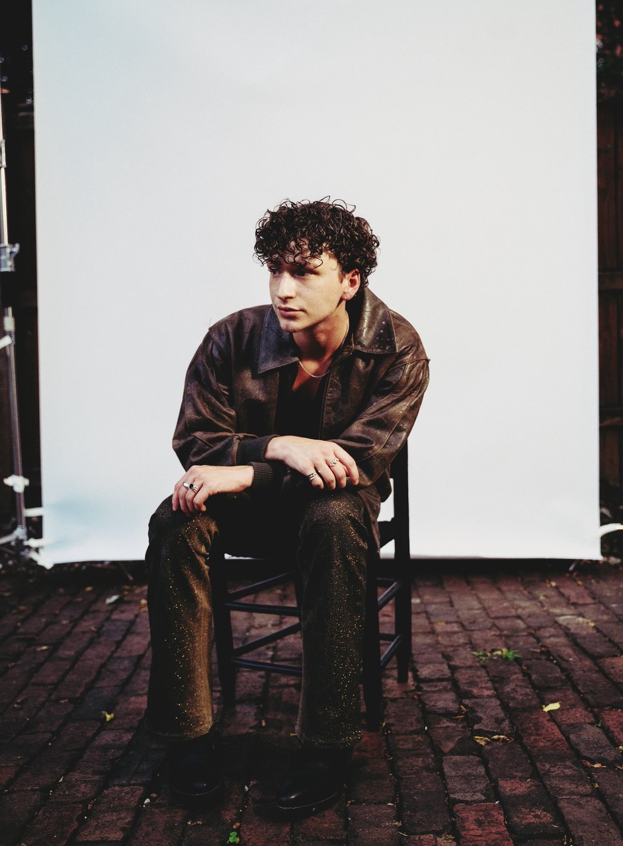

*Photo credit: Chase Denton*

**SEPTEMBER 30, 2022** - Rising Nashville-based singer, songwriter, and producer **Hastings** has returned with his brand new single “[Blame The Brakes](https://hastings.lnk.to/blamethebrakes).” The propulsive track is available to stream and download beginning today [HERE](https://hastings.lnk.to/blamethebrakes) via DBLBLK Records.

“I write every song in hopes that someone will relate to what I feel,” shares Hastings. “This song specifically is about a lack of communication and being afraid of, or bad at commitment.  I’ve been sitting on this song for a while so it feels so good to finally have it out.”

“Blame The Brakes”marks Hastings’ second single of 2022. In June, he released the addictive track **“**[Hurt My Feelings](https://youtu.be/VaWQ2iwqPLw)**”** alongside an official visualizer. Earlier this month, Hastings surprised fans with a feature on the track “[Killing Me](https://youtu.be/aqimKWgFPUk)” on Swedish duo NOTD’s new *NOTED…EP.* “Killing Me” is available to stream and download now. Watch a visualizer for the track [HERE](https://youtu.be/VaWQ2iwqPLw).

Hastings’ recent singles follow his debut [*Hastings* EP](https://hastings.lnk.to/Hastings), which was released last year and arrived to immediate critical praise. **Billboard** applauded his first-ever single “[Heart’s Not In It](https://hastings.lnk.to/heartsnotinit),” noting, “*‘Heart’s Not In It’ shows off his easy, immediate melodicism… the interplay between a looped guitar riff and thwacking synths explodes into a glorious pop sing-along*.” **Teen Vogue** praised the “*funky, guitar-based track*” in their Best New Music list, while **The Honey Pop** proclaimed, “*We have a feeling you’re going to be hearing his name for a long time*.” “[Chapstick](https://hastings.lnk.to/Chapstick)” was championed by **Sweety High** for its “*irresistible chorus*,” while “[Blank Me](https://www.youtube.com/watch?v=BQzDV0a5z_I&feature=youtu.be)” became an instant fan-favorite in Hastings’ live show. *Hastings* EP is available to stream and download now [HERE](https://hastings.lnk.to/Hastings).

Hastings made his live debut earlier this year supporting The Band CAMINO on the first leg of the The Tour CAMINO. The five-week trek saw him perform to sold out crowds across North America at venues including Los Angeles’s The Novo and New York City’s Terminal 5. Hastings recently spoke with tourmates The Band CAMINO and flor about the run in an exclusive interview with **SPIN**. Watch [HERE](https://www.spin.com/2022/06/band-camino-flor-hastings-artist/). The Band CAMINO also welcomed him onstage to perform “Roses”, which he co-wrote, at Nashville, TN’s famed Ryman Auditorium. Watch [HERE](https://www.instagram.com/p/CUNs-7MrJn6/).

Hastings is expected to return to the road in the coming months. Stay tuned for upcoming tour dates.

**HASTINGS**

**“BLAME THE BRAKES”**

[**AVAILABLE NOW**](https://hastings.lnk.to/blamethebrakes)

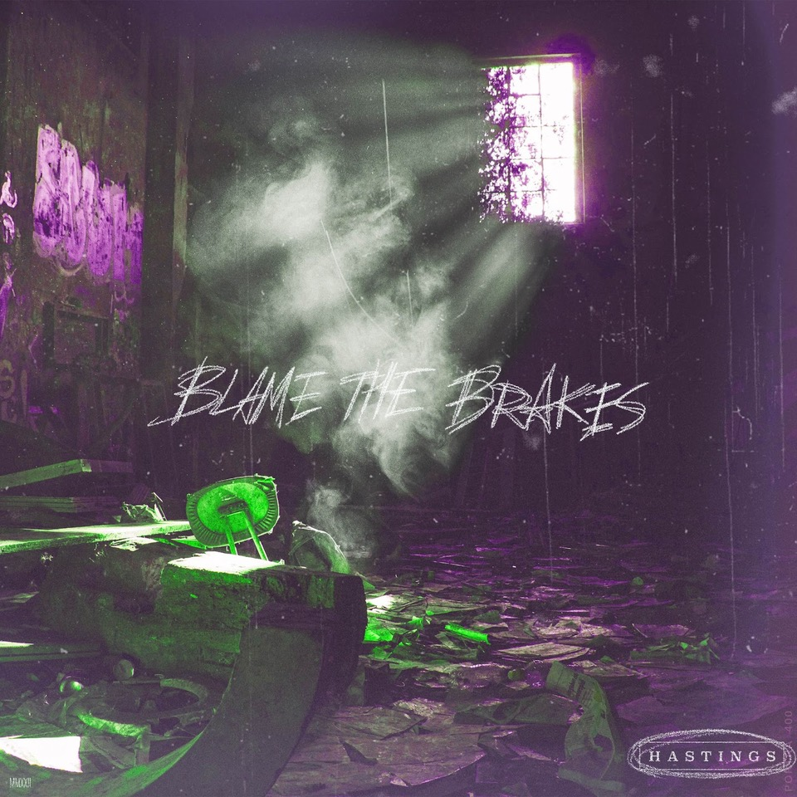

**About Hastings:**

Every once in a while, you’ll hear a song that nudges you to walk across the room and introduce yourself to a stranger, FaceTime your ex, or even change your life. Hastings strives to make those kinds of songs. The Nashville-based singer, songwriter, multi-instrumentalist, and producer couples straightforward lyrical eloquence with guitar-shaped soundscapes and traffic-stopping vocal acrobatics. Growing up between Florida, Michigan, and Tennessee, he cut his teeth by playing drums on his father’s worship team at the age of three before learning guitar and piano. After getting his drivers license at 16-years-old, he asked his parents to let him move to Nashville to pursue music - and his dad tossed him the keys. Hastings integrated himself into the city’s scene slowly but surely, in between finishing his GED. During 2018, he serendipitously met Garrison Burgess of The Band CAMINO and wound-up living with him and spending countless hours writing and recording together. Behind the scenes, he co-wrote the single “Roses” for The Band CAMINO and “Don’t Blame Me” for Kingston Hythe. Simultaneously, his solo demos caught the attention of DBLBLK Records. Now, he presents a sharp and scorching signature style on his debut *Hastings* EP and 2022 singles “Hurt My Feelings” and “Blame The Brakes”.

**CONNECT WITH HASTINGS**

[Website](https://nam04.safelinks.protection.outlook.com/?url=https%25253A%25252F%25252Fwww.imhastings.com%25252F&data=04%25257C01%25257CSydneyWorden%252540elektra.com%25257Ccaa65cc1de844667766b08d993d1f025%25257C8367939002ec4ba1ad3d69da3fdd637e%25257C0%25257C0%25257C637703352188602624%25257CUnknown%25257CTWFpbGZsb3d8eyJWIjoiMC4wLjAwMDAiLCJQIjoiV2luMzIiLCJBTiI6Ik1haWwiLCJXVCI6Mn0%25253D%25257C1000&sdata=pu0%25252BWjs1DfWrTaauDAXbc4elGQ%25252FPER4RRJbLbJyqiYA%25253D&reserved=0)

[Instagram](https://nam04.safelinks.protection.outlook.com/?url=https%25253A%25252F%25252Fwww.instagram.com%25252Fimhastings%25252F&data=04%25257C01%25257CSydneyWorden%252540elektra.com%25257Ccaa65cc1de844667766b08d993d1f025%25257C8367939002ec4ba1ad3d69da3fdd637e%25257C0%25257C0%25257C637703352188602624%25257CUnknown%25257CTWFpbGZsb3d8eyJWIjoiMC4wLjAwMDAiLCJQIjoiV2luMzIiLCJBTiI6Ik1haWwiLCJXVCI6Mn0%25253D%25257C1000&sdata=5DKgPKsynwLNjg%25252BWIrXC3aYl5grM0AT8gtIXXY%25252FgGYY%25253D&reserved=0)

[YouTube](https://nam04.safelinks.protection.outlook.com/?url=https%25253A%25252F%25252Fwww.youtube.com%25252Fchannel%25252FUCOiD5tZQ6MlNjom-eGCsgXA%25252Ffeatured&data=04%25257C01%25257CSydneyWorden%252540elektra.com%25257Ccaa65cc1de844667766b08d993d1f025%25257C8367939002ec4ba1ad3d69da3fdd637e%25257C0%25257C0%25257C637703352188612620%25257CUnknown%25257CTWFpbGZsb3d8eyJWIjoiMC4wLjAwMDAiLCJQIjoiV2luMzIiLCJBTiI6Ik1haWwiLCJXVCI6Mn0%25253D%25257C1000&sdata=jWWYDBIc1%25252F%25252B3StTCc7SwQz9Q8E4T9ubABeujYoEs%25252B9M%25253D&reserved=0)

[Twitter](https://nam04.safelinks.protection.outlook.com/?url=https%25253A%25252F%25252Ftwitter.com%25252Fimhastingss&data=04%25257C01%25257CSydneyWorden%252540elektra.com%25257Ccaa65cc1de844667766b08d993d1f025%25257C8367939002ec4ba1ad3d69da3fdd637e%25257C0%25257C0%25257C637703352188612620%25257CUnknown%25257CTWFpbGZsb3d8eyJWIjoiMC4wLjAwMDAiLCJQIjoiV2luMzIiLCJBTiI6Ik1haWwiLCJXVCI6Mn0%25253D%25257C1000&sdata=Tr6lTKbqjTrGHOjEw%25252FhNUOIVze0zN0aiNDcbhjlK2J4%25253D&reserved=0)

[TikTok](https://nam04.safelinks.protection.outlook.com/?url=https%25253A%25252F%25252Fwww.tiktok.com%25252F%252540imhastingss%25253F&data=04%25257C01%25257CSydneyWorden%252540elektra.com%25257Ccaa65cc1de844667766b08d993d1f025%25257C8367939002ec4ba1ad3d69da3fdd637e%25257C0%25257C0%25257C637703352188622610%25257CUnknown%25257CTWFpbGZsb3d8eyJWIjoiMC4wLjAwMDAiLCJQIjoiV2luMzIiLCJBTiI6Ik1haWwiLCJXVCI6Mn0%25253D%25257C1000&sdata=L%25252Fw4jdMytbT%25252FBpAHvBpyHDU%25252F%25252BxsNErHm8iNdl5F8Yuc%25253D&reserved=0)

**For all press inquiries, please contact:**

Sarah Goldstein - [sarahgoldstein@elektra.com](mailto:sarahgoldstein@elektra.com)

Collin Citron - [collincitron@elektra.com](mailto:collincitron@elektra.com)