FOR IMMEDIATE RELEASE

OCTOBER 21, 2022

**BENDIGO FLETCHER RELEASE NEW *WINGDING* EP**

**LISTEN** [**HERE**](https://bendigofletcher.lnk.to/wingding) **VIA ELEKTRA RECORDS**

**LYRIC VIDEO FOR “BROKEN ROUTINE” AVAILABLE NOW**

**WATCH** [**HERE**](https://youtu.be/sChbBC4t0BY)

**NORTH AMERICAN TOUR WITH MADISON CUNNINGHAM CURRENTLY UNDERWAY**

**TICKETS FOR FALL HEADLINE TOUR AVAILABLE NOW** [**HERE**](https://www.bendigofletcher.com/)

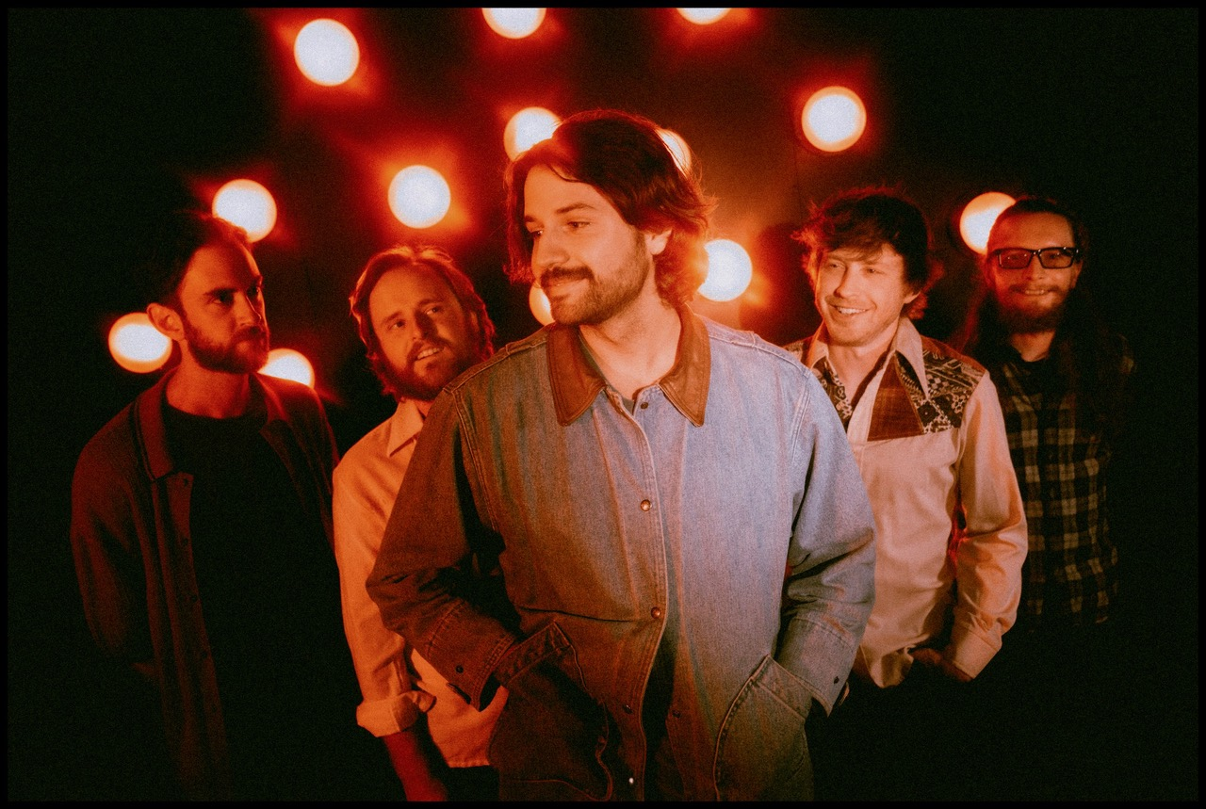

*Photo credit: Aubrey Denis*

Louisville, KY’s **Bendigo Fletcher** have released their anxiously awaited new [***Wingding* EP**](https://bendigofletcher.lnk.to/wingding). The four-track collection is available to stream and download beginning today [HERE](https://bendigofletcher.lnk.to/wingding) via Elektra Records. To celebrate the EP’s release, Bendigo Fletcher have unveiled an official lyric video for the track “[Broken Routine](https://youtu.be/sChbBC4t0BY)”. Watch it on the band’s YouTube channel [HERE](https://youtu.be/sChbBC4t0BY).

“We hope to provide a few moments of musical distractions for anyone who needs them,” shares Bendigo Fletcher frontman Ryan Anderson. “The EP dances between confession and fabrication for what feels like a cleanse of imagination. It’s a relief to share a few more stories from that place.”

Shapeshifting on an axis between folk, alternative, country, and soul, Bendigo Fletcher’s lofty melodies soar above earthy instrumentationon *Wingding*. Charmed with psychedelic flourishes, yet tightly rooted in tried-and-true songcraft, the Louisville quintet continues to instantly transfix across the EP’s four tracks. Once again, the band teamed with producer and original Wilco/Uncle Tupelo drummer Ken Coomer in his Nashville, TN Cartoon Moon Recording Studio. The band enlisted Grizzly Bear bassist and producer Chris Taylor (tracks 2,3,4) and Geoff Piller (track 1) to mix the EP.

Ahead of their appearance at Newport Folk Festival 2022, Bendigo Fletcher previewed *Wingding* with the release of “[Pterodactyl](https://youtu.be/mZsX-0SW0VQ)”. Last month, the band unveiled the EP’s second single “[Strange Encounters](https://youtu.be/aSDe_qpSSW0)”. The EP’s early releases arrived to praise from *Consequence,* *The Bluegrass Situation*, *Entertainment Tonight*, and more.

*Wingding* follows Bendigo Fletcher’s 2021 debut album [*Fits Of Laughter*](https://bendigofletcher.lnk.to/fitsoflaughter). Highlighted by singles “[Sugar In The Creek](https://www.youtube.com/watch?v=kP9RJnmniDU)” and “[Evergreen](https://youtu.be/anSo2V8XADE)”, the album is available [HERE](https://bendigofletcher.lnk.to/fitsoflaughter) via Elektra Records. Beyond amassing millions of streams, the album earned widespread critical acclaim. *FLOOD Magazine* hailed it as  *“Somewhere between the post-Woodstock folk scene of the ‘70s and that decade’s burgeoning hard rock movement*,*”* and *Music Connection* dubbed it, *“Alt-rock, country-flecked folk-rock soaked in LSD*.*” American Songwriter* noted it as *“Denser psych-rock with some remaining elements of Bendigo Fletcher’s drifting folk-Americana roots*”, and *Atwood Magazine* praised “*Fits Of Laughter soars with charming passion.”*

Bendigo Fletcher is currently on the road in North America supporting Madison Cunningham. The tour will visit New York City’s Webster Hall this evening, before concluding on October 24 at Chicago, IL’s Thalia Hall. Next up, Bendigo Fletcher will embark on a North American headline tour that will kick off on October 26 in Pittsburgh, PA and wrap on December 11 in Jacksonville, FL. Tickets for the band’s headline tour are available now [HERE](https://www.bendigofletcher.com/). A complete list of upcoming tour dates can be found below. Renowned for their inimitable live performances, Bendigo Fletcher has previously supported Anderson East, Rainbow Kitten Surprise, Shakey Graves, and more on tour.

**BENDIGO FLETCHER - *WINGDING* EP**

[**LISTEN HERE**](https://bendigofletcher.lnk.to/wingding)

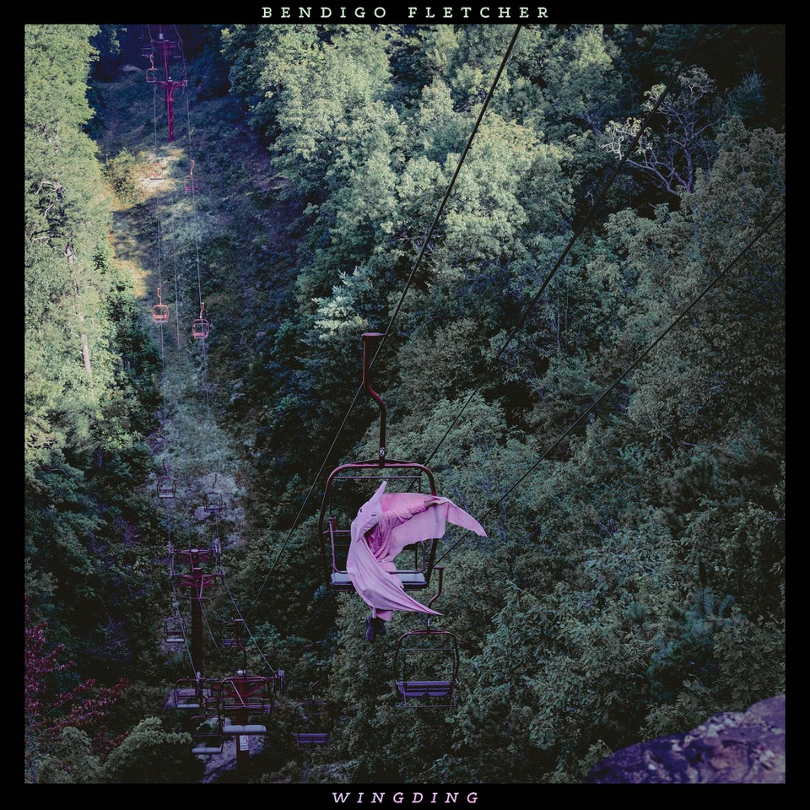

***Wingding* EP Tracklisting**

1. Strange Encounters

2. Juniper Moore

3. Broken Routine

4. Pterodactyl

**Bendigo Fletcher Tour Dates**

**Supporting Madison Cunningham**

October 21, 2022 - New York, NY - Webster Hall

October 22, 2022 - Washington, DC - Capital Turnaround

October 24, 2022 - Chicago, IL - Thalia Hall

**Headline Dates**

October 26, 2022 - Pittsburgh, PA - Club Cafe

October 27, 2022 - Albany, NY - Lark Hall

October 30, 2022 - Burlington, VT - Higher Ground

October 31, 2022 - Toronto, ON - The Garrison

November, 01, 2022 - Buffalo, NY - 9th Ward

November 03, 2022 - Morgantown, WV - 123 Pleasant

November 04, 2022 - Cleveland, OH - Mahall’s

December 01, 2022 - St. Louis, MO - Blueberry Hill

December 02, 2022 - Columbus, OH - The Summit Music Hall

December 03, 2022 - Indianapolis, IN - HiFi Indy

December 07, 2022 - Memphis, TN - 1884 Lounge

December 09, 2022 - Tampa, FL - Crowbar

December 10, 2022 - Charleston, SC - Charleston Pour House

December 11, 2022 - Jacksonville, FL - 1904 Music Hall

Bendigo Fletcher is: Ryan Anderson (lead vocals, guitar, banjo) - Andrew Shupert (backing vocals, lead guitar) - Evan Wagner (backing vocals, keys, guitar, auxiliary percussion) - Conner Powell (bass) - Chris Weis (drums).

[BendigoFletcher.com](https://nam04.safelinks.protection.outlook.com/?url=http%25253A%25252F%25252Fbendigofletcher.com%25252F&data=04%25257C01%25257CSydneyWorden%252540elektra.com%25257C496651e9ae1c4829030008d95e5ab6bc%25257C8367939002ec4ba1ad3d69da3fdd637e%25257C0%25257C0%25257C637644565979480132%25257CUnknown%25257CTWFpbGZsb3d8eyJWIjoiMC4wLjAwMDAiLCJQIjoiV2luMzIiLCJBTiI6Ik1haWwiLCJXVCI6Mn0%25253D%25257C1000&sdata=DwnjXSoisNE7dEIwJsn0Ol9pXmx3ckFc4n%25252BMPRTyboc%25253D&reserved=0)

[Facebook](https://nam04.safelinks.protection.outlook.com/?url=https%25253A%25252F%25252Fwww.facebook.com%25252Fbendigofletcher%25252F&data=04%25257C01%25257CSydneyWorden%252540elektra.com%25257C496651e9ae1c4829030008d95e5ab6bc%25257C8367939002ec4ba1ad3d69da3fdd637e%25257C0%25257C0%25257C637644565979490127%25257CUnknown%25257CTWFpbGZsb3d8eyJWIjoiMC4wLjAwMDAiLCJQIjoiV2luMzIiLCJBTiI6Ik1haWwiLCJXVCI6Mn0%25253D%25257C1000&sdata=NXO3zPwFKZPGOypH4vElUmn%25252BvEY4oQvxFgbugfmiZYo%25253D&reserved=0) | [Instagram](https://nam04.safelinks.protection.outlook.com/?url=https%25253A%25252F%25252Fwww.instagram.com%25252Fbendigofletcher%25252F%25253Fhl%25253Den&data=04%25257C01%25257CSydneyWorden%252540elektra.com%25257C496651e9ae1c4829030008d95e5ab6bc%25257C8367939002ec4ba1ad3d69da3fdd637e%25257C0%25257C0%25257C637644565979490127%25257CUnknown%25257CTWFpbGZsb3d8eyJWIjoiMC4wLjAwMDAiLCJQIjoiV2luMzIiLCJBTiI6Ik1haWwiLCJXVCI6Mn0%25253D%25257C1000&sdata=ZPbgTr7oOdLZKpc9nJeWq8%25252FlxhP7q8X%25252FdCkY%25252BY35bvQ%25253D&reserved=0) | [Twitter](https://nam04.safelinks.protection.outlook.com/?url=https%25253A%25252F%25252Ftwitter.com%25252Fbendigofletcher%25253Flang%25253Den&data=04%25257C01%25257CSydneyWorden%252540elektra.com%25257C496651e9ae1c4829030008d95e5ab6bc%25257C8367939002ec4ba1ad3d69da3fdd637e%25257C0%25257C0%25257C637644565979490127%25257CUnknown%25257CTWFpbGZsb3d8eyJWIjoiMC4wLjAwMDAiLCJQIjoiV2luMzIiLCJBTiI6Ik1haWwiLCJXVCI6Mn0%25253D%25257C1000&sdata=kJRRkKaOhgjDEezX5MFmnHCsNVdAnsYapraqslfWeZI%25253D&reserved=0) | [YouTube](https://nam04.safelinks.protection.outlook.com/?url=https%25253A%25252F%25252Fwww.youtube.com%25252Fchannel%25252FUCqWvWwv7K8kq3PZnygVG1BA&data=04%25257C01%25257CSydneyWorden%252540elektra.com%25257C496651e9ae1c4829030008d95e5ab6bc%25257C8367939002ec4ba1ad3d69da3fdd637e%25257C0%25257C0%25257C637644565979500120%25257CUnknown%25257CTWFpbGZsb3d8eyJWIjoiMC4wLjAwMDAiLCJQIjoiV2luMzIiLCJBTiI6Ik1haWwiLCJXVCI6Mn0%25253D%25257C1000&sdata=je%25252BQcsx%25252FcO5DWK8iMgiiY1CecLP7inplAOftW9IWaqo%25253D&reserved=0)