

**For Immediate Release**

**BAILEY ZIMMERMAN’S DEBUT EP *LEAVE THE LIGHT ON*AVAILABLE EVERYWHERE NOW**

**Current Single “Fall In Love” Top 10 at Country Radio**

**Grand Ole Opry Debut Set For November 4th**

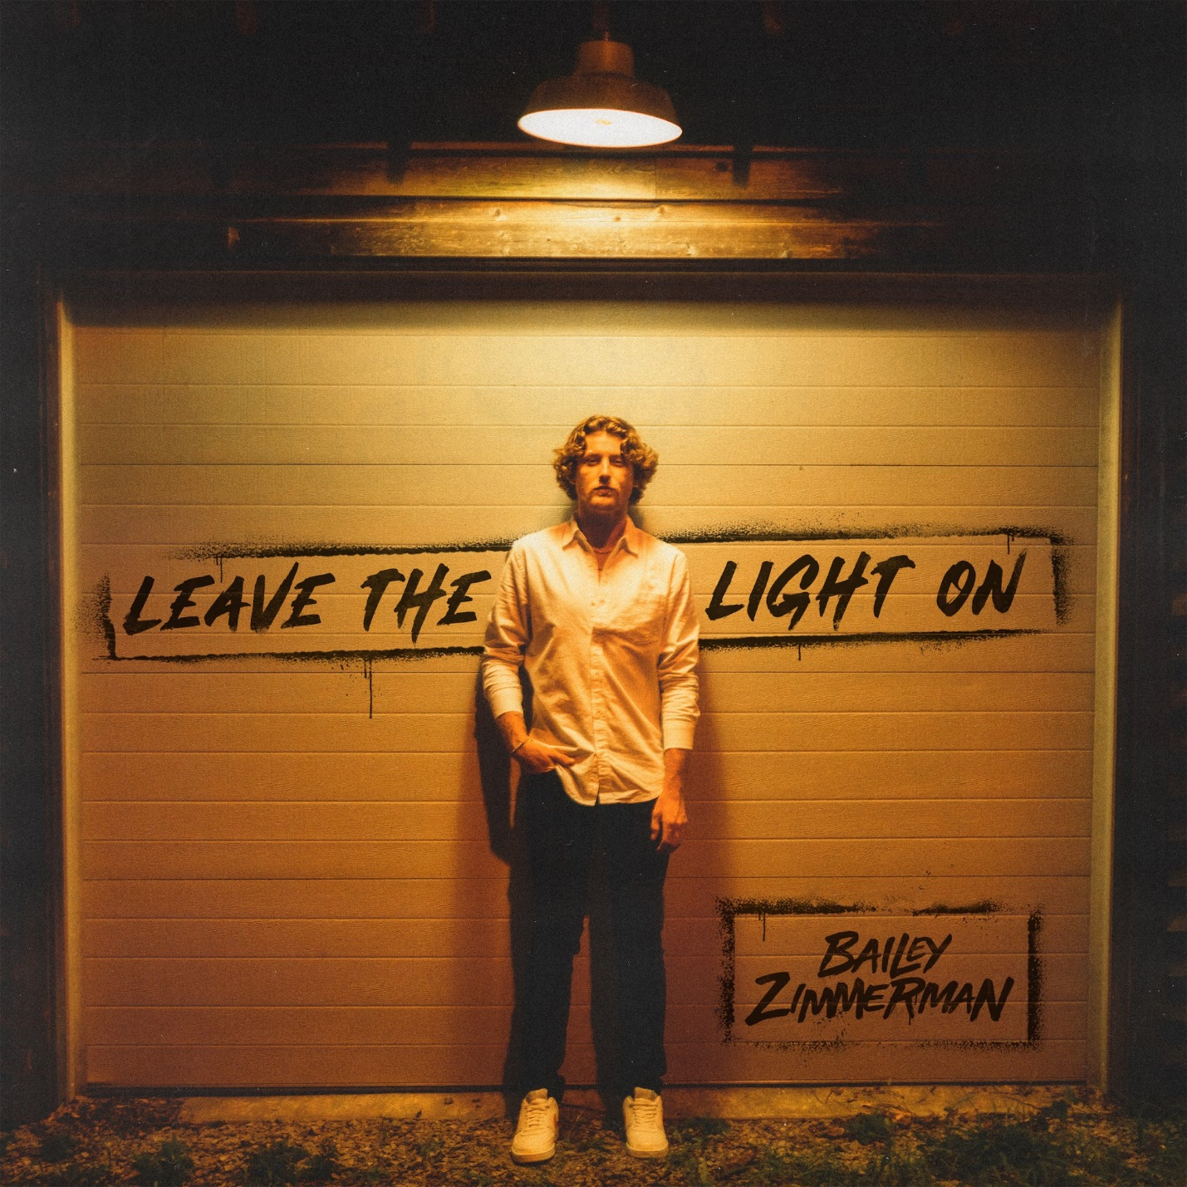

[Download Hi-Res Here](https://nam04.safelinks.protection.outlook.com/?url=https%253A%252F%252Fwarnermusicgroup.box.com%252Fs%252Fs2qocdh92hc2v3wmgfro1cdi8cztr88s&data=05%257C01%257CAnna.Pittman%2540wmg.com%257C39e0550162fe491e293908daad34dcec%257C8367939002ec4ba1ad3d69da3fdd637e%257C0%257C0%257C638012739796616994%257CUnknown%257CTWFpbGZsb3d8eyJWIjoiMC4wLjAwMDAiLCJQIjoiV2luMzIiLCJBTiI6Ik1haWwiLCJXVCI6Mn0%253D%257C3000%257C%257C%257C&sdata=tgsNy18IjfOMWuwnkA5EPZZYcV2Y%252B%252F2fYyEWuaW%252FuCg%253D&reserved=0)

**NASHVILLE, Tenn. – (October 14, 2022) –**[***Leave The Light On***](https://baileyzimmerman.lnk.to/leavethelighton), the debut EP fromskyrocketing breakout country artist **Bailey Zimmerman,**is available everywhere today ([LISTEN HERE](https://baileyzimmerman.lnk.to/leavethelighton)).The project’s lead single, “**Fall In Love,**” is also now within the Top 10 at country radio, making it the fastest debut song to reach the Top 10 in five years. Propelled by nearly 300 million streams to date worldwide, it is the 9th most-streamed country song of the year and currently Top 10 on *Billboard*’s Hot Country Songs chart and Top 30 on their all-genre Hot 100 chart.

The track listing also features standouts like “Rock And A Hard Place” and “Where It Ends,” which both reached the Top 10 of *Billboard’*s Hot Country Songs chart as well. *Leave The Light On*also includes his most recent release “Never Leave,” hailed by *Los Angeles Magazine*as a song that “will make a fan even out of those who aren’t country-listening regulars.”

Set to make his debut on the historic Grand Ole Opry stage November 4th, Zimmerman continues to “forge new territory for a modern country crossover” (*Billboard*). He has earned a constantly rising total of more than 700 million global streams to date and currently ranks Top 10 on *Billboard’s*Country Songwriters chart and Top 30 on their all-genre Artist 100 Chart.

Before his whirlwind rise since releasing his very first song in 2021, the twenty-two-year-old was born and raised in the small town of Louisville, IL. He grew up listening to hour after hour of country radio on long hauls across state lines with his father, who owned a trucking business, while back at home his mom instilled in him a life-long appreciation for the power chords and edgy vocals of 80’s hair rock. But it was time spent at the family’s car dealership where he learned the art of telling stories, listening to Grandpa Zimmerman and his oldest friends, who would sit and tell stories capture people’s attention with their words.

At the age of sixteen, Zimmerman got his first job at the local meat processing plant and hasn’t stopped working since. From long hours on the gas pipeline, to late nights of backbreaking roadwork, he embodies the old school American values of hard work and dependability and applies the same steadfast mentality to his music. Through his plainspoken charm, contagious enthusiasm and genuine portrayal of life on the back roads, the up-and-comer has already attracted a loyal and passionate fan base. With more new music on the horizon, featuring the grit and gravel of his unmistakably Southern drawl, Zimmerman will continue to showcase the straightforward authenticity for which he is known and loved.

***LEAVE THE LIGHT ON*TRACK LISTING**

1. Intro

2. Never Leave

3. Waiting

4. House On Fire

5. From The Fall

6. Trainwreck

7. Fall In Love

8. Rock And A Hard Place

9. Where It Ends