

**For Immediate Release**

**BAILEY ZIMMERMAN SHATTERS RECORDS WITH BIGGEST STREAMING COUNTRY DEBUT EVER**

***Leave The Light On* EP Also Becomes Most Streamed All-Genre Debut of the Year**

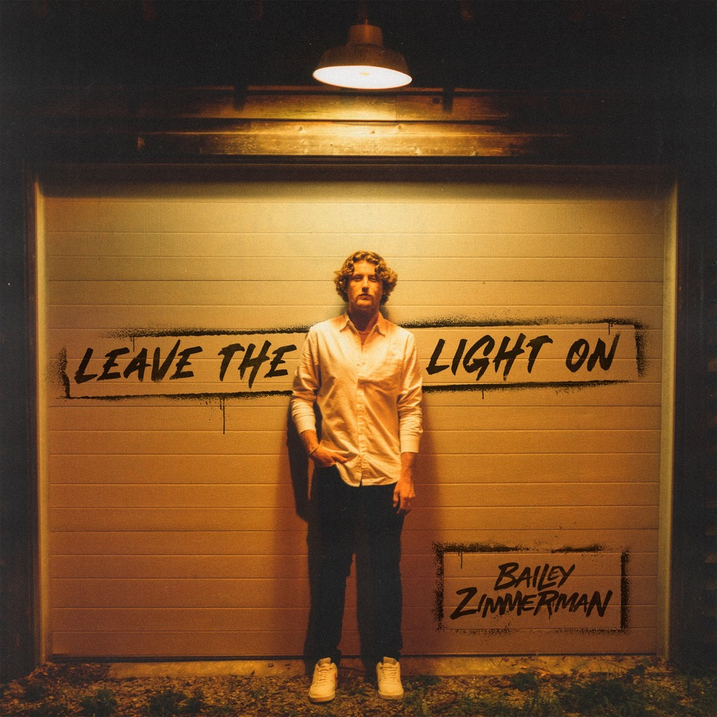

[Download Hi-Res Here](https://warnermusicgroup.box.com/s/s2qocdh92hc2v3wmgfro1cdi8cztr88s)

**NASHVILLE, Tenn. – (October 24, 2022) – Bailey Zimmerman** has made history. His very first full-length release, ***Leave The Light On*** ([LISTEN HERE](https://baileyzimmerman.lnk.to/leavethelighton)), is not only the **most-streamed all-genre debut of the year**, but also the **biggest streaming country debut of all time**. The EP arrived at **No. 2** on Billboard’s Top Country Albums chart and **No. 9** on the all-genre Billboard 200 chart.

Zimmerman joins **Zach Bryan** and **Luke Combs** as the **only country artists this year to earn more than 1 million streams on each track during street week** alone. The track listing features standouts like “Trainwreck,” co-written with **Morgan Wallen** and “**Rock And A Hard Place**,” which ranked as the highest non-Morgan Wallen country song premiere of the year upon release and reached the Top 10 of *Billboard’*s Hot Country Songs chart as well. The project’s lead single, “**Fall In Love,**” is racing towards the Top 5 at country radio and already the fastest debut song to reach the Top 10 at in five years. Propelled by more than 300 million streams to date worldwide, it is the 9th most-streamed country song of the year and currently Top 10 on *Billboard*’s Hot Country Songs chart and Top 20 on their all-genre Hot 100 chart.

Set to make his debut on the historic Grand Ole Opry stage November 4th, Zimmerman continues to “forge new territory for a modern country crossover” (*Billboard*). He has earned a constantly rising total of more than 700 million global streams to date and currently ranks Top 10 on *Billboard’s* Country Songwriters chart and Top 30 on their all-genre Artist 100 Chart.

Before his whirlwind rise since releasing his very first song in 2021, the twenty-two-year-old was born and raised in the small town of Louisville, IL. He grew up listening to hour after hour of country radio on long hauls across state lines with his father, who owned a trucking business, while back at home his mom instilled in him a life-long appreciation for the power chords and edgy vocals of 80’s hair rock. But it was time spent at the family’s car dealership where he learned the art of telling stories, listening to Grandpa Zimmerman and his oldest friends, who would sit and tell stories capture people’s attention with their words.

At the age of sixteen, Zimmerman got his first job at the local meat processing plant and hasn’t stopped working since. From long hours on the gas pipeline, to late nights of backbreaking roadwork, he embodies the old school American values of hard work and dependability and applies the same steadfast mentality to his music. Through his plainspoken charm, contagious enthusiasm and genuine portrayal of life on the back roads, the up-and-comer has already attracted a loyal and passionate fan base. With more new music on the horizon, featuring the grit and gravel of his unmistakably Southern drawl, Zimmerman will continue to showcase the straightforward authenticity for which he is known and loved.

***LEAVE THE LIGHT ON*TRACK LISTING**

1. Intro

2. Never Leave - *Bailey Zimmerman, Gavin Lucas, Mary Kutter, Chris Sligh, Austin Shawn*

3. Waiting - *Bailey Zimmerman, Gavin Lucas, Austin Rakesh Shawn*

4. House On Fire - *Bailey Zimmerman, Gavin Lucas, Austin Rakesh Shawn*

5. From The Fall - *Dylan John Wolfe, Gavin Lucas, Austin Rakesh Shawn*

6. Trainwreck - *Bailey Zimmerman, Gavin Lucas, Sergio Sanchez, Morgan Wallen*

7. Fall In Love - *Bailey Zimmerman, Gavin Lucas, Austin Rakesh Shawn*

8. Rock And A Hard Place - *Heath Warren, Jacob Hackworth, Jet Harvey*

9. Where It Ends - *Bailey Zimmerman, Joe Spargur, Grant Averill*