**THE FRONT BOTTOMSRELEASE *THERESA* EP**

**LATEST INSTALLMENT OF THE BAND’S *GRANDMA SERIES* STREAMING NOW**

**FALL NORTH AMERICAN HEADLINE TOUR KICKS OFF SEPTEMBER 14TH**

**PHOTO CREDIT: MARK JAWORSKI**

**SEPTEMBER 2, 2022** – Fueled By Ramen band The Front Bottoms have released the *Theresa* EP.  Available today on [all streaming platforms](https://tfb.lnk.to/theresa), the *Theresa* EP continues the group’s fan favorite *Grandma* EP series and features the singles “[More Than It Hurts You](https://tfb.lnk.to/morethanithurtsyou)” and “[Hello World](https://youtu.be/o3kkMVMOlVo).”

The five song collection serves as the third installment of the band’s popular *Grandma* EP series and features new recordings of never before released fan favorite songs.  During 2014, the guys unveiled the *Rose* EP named in honor of drummer Mat Uychich’s late grandmother who passed the same year. Four years later, the *Ann* EP followed in 2018 named after guitarist and vocalist Brian Sella’s grandmother. *Theresa* finds The Front Bottoms continuing the tradition by reheating tracks from their earliest days and properly releasing them for the first time [EP Artwork / Tracklisting Below].

In support of *Theresa*, The Front Bottoms will return to the road for a five-week headline tour across North America which will feature support from special guests The Joy Formidable, Mobley and Motherfolk on select dates. The new dates are set kick off at Mulcahy’s in Wantagh, NY, and will see the band visiting major markets coast-to-coast with stops at festivals such as *Riot Fest* in Chicago, IL on September 17th, and *Austin City Limits* in Austin, TX on October 15th. For tickets and more information on the upcoming dates, visit [www.thefrontbottoms.com](http://www.thefrontbottoms.com).

Earlier this summer, The Front Bottoms headlined a special sold out three show residency at Jersey City’s White Eagle Hall. The Jersey City shows marked the first live performances from The Front Bottoms since the 2021 iteration of their popular year-end bash, *Champagne Jam*.  Last years’ annual holiday festival was held at The Strand in Providence, RI and saw The Front Bottoms celebrating the 10-year anniversary of their breakthrough self-titled debut album.

Last year, The Front Bottoms shared the standalone singles “[Lover Boy](https://tfb.lnk.to/LoverBoy)” and “[Voodoo Magic](https://tfb.lnk.to/VoodooMagic),” the latter of which the band enlisted Matt Skiba of Blink-182 and Alkaline Trio to play guitar on.

Comprised of guitarist/vocalist Brian Sella and drummer Mathew Uychich, The Front Bottomshave gripped listeners and press around the world with their ragged honesty and emotional urgency. In 2020, The Front Bottoms released their celebrated album, [*In Sickness & In Flames*](https://tfb.lnk.to/InSicknessAndInFlames), a twelve song collection produced by Mike Sapone. **NME** attested, “*In Sickness & In Flames* is a defining work that showcases a sonic universe, rather than a structured set of songs, expertly capturing the inescapable tension of 2020.”  **A.V. Club** declared, “The Front Bottoms are as vibrant as ever on *In Sickness & In Flames*, a reliably great collection of folk-punk anthems that rattle the soul with crunchy riffs, electrifying hooks, and Brian Sella’s idiosyncratic lyricism, which remains as amiable as it is anxiety-ridden.” **UPROXX** added “*In Sickness & In Flames* features the band’s biggest choruses to date, anchored with hooks and deeply personal songwriting that will turn heads,” while **The FADER** hailed it as, “a celebration of sorts for a band perennially on the fringes of a major breakthrough.” **The Alternative** detailed, “While *In Sickness & In Flames* was written prior to the pandemic, so much of it feels so tethered to our present collective experience, from the introspection and reflective growth that is showcased in the songwriting, to the sweeping highs and lows of the music itself. This album is the perfect companion piece to the anxiety of standing in the face of uncertainty.”

**[EP Artwork / Tracklisting / Tour Itinerary Below]**

**THE FRONT BOTTOMS**

***THERESA***

1. More Than it Hurts You

2. The Bongo Song

3. Hello World

4. The Supply of Power

5. The Winds

**2022 NORTH AMERICAN TOUR DATES**

***WITH SPECIAL GUESTS THE JOY FORMIDABLE, MOBLEY & MOTHERFOLK ON SELECT DATES***

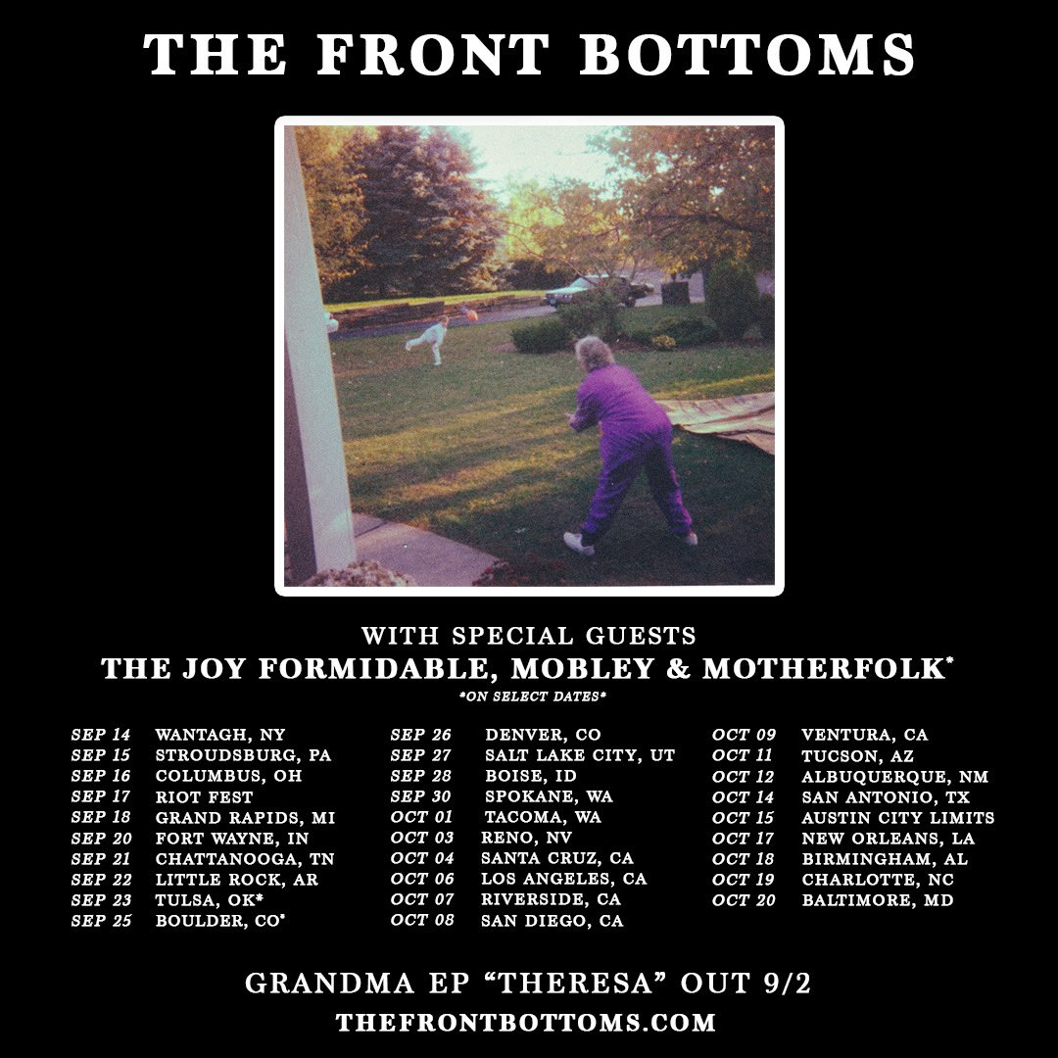

9/14      Wantagh, NY                   Mulcahy’s  
9/15      Stroudsburg, PA              Sherman Theater  
9/16      Columbus, OH                 Kemba Live  
9/17      Chicago, OH                    Riot Fest#  
9/18      Grand Rapids, MI            20 Monroe  
9/20      Fort Wayne, IN                Piere’s  
9/21      Chattanooga, TN             The Signal  
9/22      Little Rock, AR                 The Hall  
9/23      Tulsa, OK                         Cain’s Ballroom*  
9/25      Boulder, CO                     Boulder Theater*

9/26      Denver, CO                      Summit  
9/27      Salt Lake City, UT            Union  
9/28      Boise, ID                          Knitting Factory  
9/30      Spokane, WA                  Knitting Factory  
10/1      Tacoma, WA                    Temple Theater  
10/3      Reno, NV                         Cargo  
10/4      Santa Cruz, CA                Catalyst  
10/5      Los Angeles, CA              Hollywood Forever Cemetery  
10/7      Riverside, CA                   Riverside Music Hall

10/8      San Diego, CA                  The Observatory North Park  
10/9      Ventura, CA                     Majestic Theater  
10/11    Tucson, AZ                       Rialto  
10/12    Albuquerque, NM           El Rey Theater  
10/15    Austin, TX                        Austin City Limits#  
10/17    New Orleans, LA             HOB NOLA  
10/18    Birmingham, AL              Iron City  
10/19    Charlotte, NC                  Fillmore  
10/20    Baltimore, MD                Ram’s Head

12/3-4  Phoenix, AZ                     Zona Music Festival#

# Festival Date

* With The Joy Formidable, Mobley & Motherfolk

**CONNECT WITH THE FRONT BOTTOMS:**

[WWW.THEFRONTBOTTOMS.COM](https://WWW.THEFRONTBOTTOMS.COM)

[FACEBOOK](https://www.facebook.com/thefrontbottoms)

[INSTAGRAM](https://www.instagram.com/thefrontbottoms/)

[TWITTER](https://twitter.com/thefrontbottoms)

[WWW.FUELEDBYRAMEN.COM](http://WWW.FUELEDBYRAMEN.COM)