**PANIC! AT THE DISCO RELEASES MUSIC VIDEO FOR “SUGAR SOAKER”**

**STARRING BRENDON URIE &** [**FRIENDS**](https://www.instagram.com/p/ChlW1URu1Wn/)

[**WATCH HERE**](https://youtu.be/hXzFiHsPS7A)

**NEW ALBUM *VIVA LAS VENGEANCE* OUT NOW**

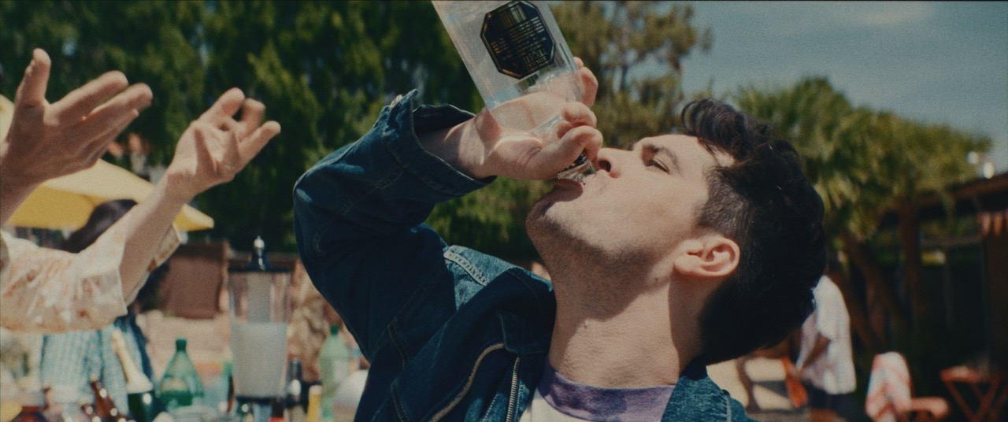

[**WATCH THE OFFICIAL MUSIC VIDEO HERE**](https://youtu.be/hXzFiHsPS7A)

**For more, please visit:**

[panicatthedisco.com](https://panicatthedisco.com/)

[Facebook](http://facebook.com/panicatthedisco) | [Twitter](http://twitter.com/panicatthedisco) | [Instagram](http://instagram.com/panicatthedisco) | [YouTube](http://youtube.com/panicatthedisco)

[dcd2records.com](http://www.dcd2records.com/)

[fueledbyramen.com](http://www.fueledbyramen.com/)