**PANIC! AT THE DISCO RELEASES NEW SONG AND MUSIC VIDEO “DON’T LET THE LIGHT GO OUT”**

**LISTEN** [**HERE**](https://patd.lnk.to/dontletthelightgoout) **| WATCH** [**HERE**](https://youtu.be/SC43FgG3wnA)

**NEW ALBUM *VIVA LAS VENGEANCE* OUT FRIDAY**

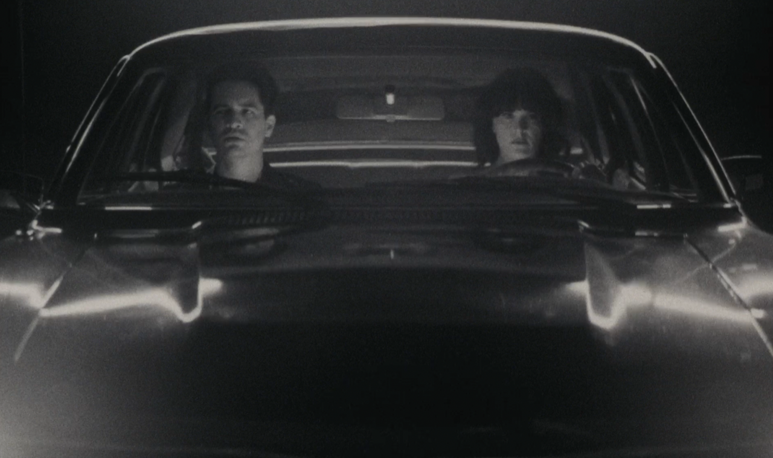

**WATCH THE OFFICIAL MUSIC VIDEO** [**HERE**](https://youtu.be/SC43FgG3wnA)

**LISTEN** [**HERE**](https://patd.lnk.to/dontletthelightgoout)

**For more, please visit:**

[panicatthedisco.com](https://panicatthedisco.com/)

[Facebook](http://facebook.com/panicatthedisco) | [Twitter](http://twitter.com/panicatthedisco) | [Instagram](http://instagram.com/panicatthedisco) | [YouTube](http://youtube.com/panicatthedisco)

[dcd2records.com](http://www.dcd2records.com/)

[fueledbyramen.com](http://www.fueledbyramen.com/)